The Effect of Judicial Decisions on Issue Salience and Legal Consciousness in Media Serving the LGBTQ+ Community

Online Appendix

Christine M. Bailey, Paul M. Collins, Jr. (Corresponding Author), Jesse H. Rhodes, and Douglas Rice
University of Massachusetts Amherst

A1. Identifying Articles Involving Judicial Decisions
The articles under analysis were extracted from ProQuest’s LGBT Magazine Archive. They come from five periodicals of historical and current significance to the LGBTQ+ community. The Advocate is the nation’s longest-running and highest circulation magazine serving the LGBTQ+ community (Streitmatter 1993), with a circulation ranging from 88,000 to 140,000 during the period of study (Abelson 2000). Attesting to its significance, The Advocate receives coverage in prominent mainstream media outlets like the New York Times, Newsweek, and the Wall Street Journal (e.g., Gadd 2012). Erie Gay News is a prominent regional media outlet that serves the LGBTQ+ community of Erie, Pennsylvania, Western New York, Eastern Ohio, and the surrounding areas (Erie Gay News 2023). Just for Us was dedicated to connecting people around the world to improve the life of LGBTQ+ families. It was the official newsletter of Just for Us, a predecessor of COLAGE (Children of Lesbians and Gays Everywhere) (COLAGE 2023). RainbowWeddingNetwork is focused on same-sex weddings and issues surrounding marriage equality and brands itself “as the world’s most extensive LGBTQ+ wedding resource” (RainbowWeddingNetwork 2023). Transgender Tapestry covered topics relating to gender, transitioning, medical care, and popular culture, published by the International Foundation for Gender Education for and by members of the transgender community (International Foundation for Gender Education 2023).
As these descriptions reveal, the LGBTQ+ media we use as our primary data source cover a wide range of topics. While our focus is on stories related to judicial decisions, none of these periodicals are focused specifically on legal or political issues. Instead, they devote substantial coverage to lifestyle, music, movies, personal ads, health, religion, and many other topics.
As a result, we needed to narrow down the subset of articles that could plausibly be related to court decisions. To do this, we followed scholarship that examines coverage of judicial decisions that narrow a large corpus of text (such as newspapers, congressional legislation, and political speeches) based on the term “court” or more specific analogues, such as “Supreme Court” (e.g., Clark 2009; Clark, Lax, and Rice 2015; Collins and Eshbaugh-Soha 2019; Epstein and Segal 2000; Vining and Wilhelm 2011). This research affirms that the word “court” is a valid way of identifying text that has to do with judicial decisions. For instance, Collins and Eshbaugh-Soha (2019) demonstrate that the word “court” overwhelmingly appears in presidential speeches that address judicial decisions, more so than any other search term, and that the name of specific cases almost never appear in such speeches. Extracting articles from these periodicals using the term “court” generated the 1,229 articles that serve as the basis of our empirical analyses.

A2. Processing the Corpus
We downloaded the articles from the LGBT Magazine Archive as PDF documents featuring the images of each magazine page comprising each matching article. Having collected the documents, we used optical character recognition (OCR) software to convert the PDF files to plain text format. Because the articles are downloaded as images, accurately converting them to the text format appropriate for analysis is demanding. Many magazine pages feature unusual formatting, multiple articles, and even advertisements, all of which introduce challenges for OCR. To enable collection of article-level metadata for use in the quantitative analyses described below, we wrote an automated program that extracts certain information about each article, including the article source, the page numbers on which the article appeared, the total length of the article in terms of pages, the year of publication, the date of publication, the section (if available), and the publisher.

A3. Selecting the Number of Topics
As we note in the main text, selecting the appropriate number of topics is an open question in natural language processing research. Here, we rely on a number of criteria to evaluate model fit across different specifications of the number of topics. In Figure A1, we plot a series of diagnostic values for models estimated with 6, 12, and 18 topics, respectively. By way of interpretation, higher values of held-out likelihood, semantic coherence, and the lower bound are considered better, while lower values for residuals are considered better. There is a tradeoff, however, in that most models can explain more variation by (i.e., perform better on tasks like reducing residuals) by increasing the number of topics, while they are also likely to perform worse on other criteria (i.e., the semantic coherence of the estimated topics) by virtue of the increase in the number of topics. Therefore, the choice is a tradeoff between fit and interpretability. Here, we select 12 topics, given the strong performance on Semantic Coherence, and the associated declining (or slowing of) improvement in other criteria.
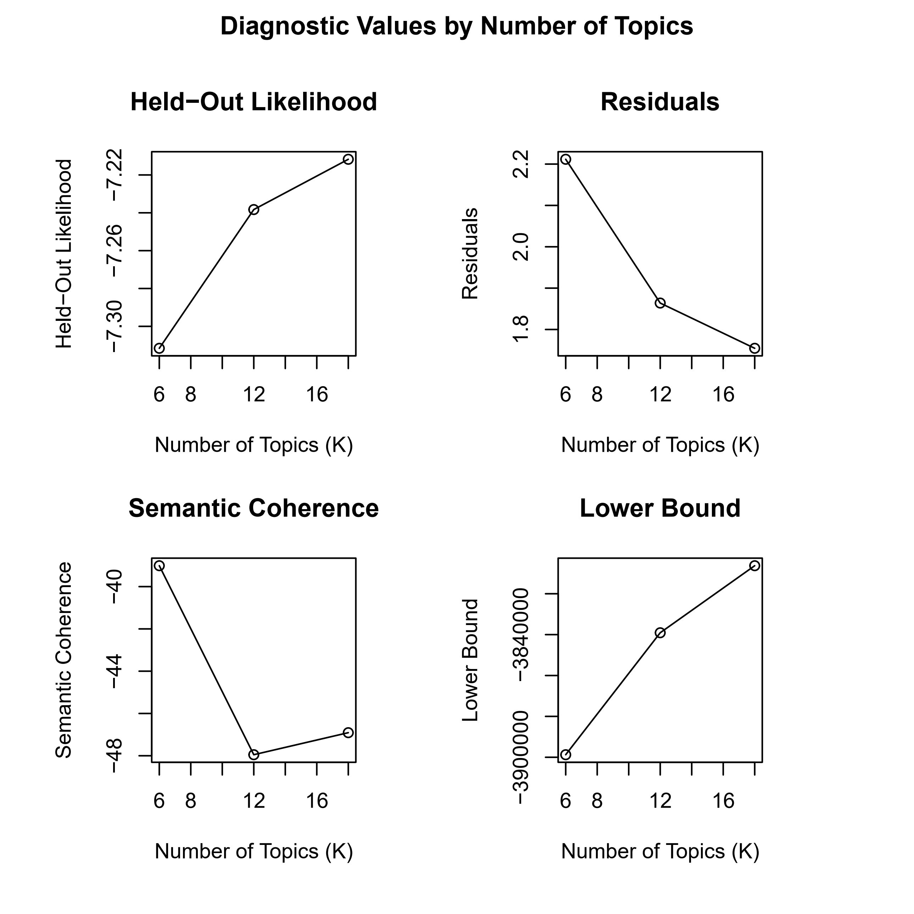
Figure A1: Diagnostic Plot for 6, 12, and 18 Topic STM Models of The Advocate’s Articles
Given the closeness of the call between a 12 and 18 topic model, we additionally evaluated the two against one another by employing a comparison of the exclusivity (i.e., how unique terms are within a topic) and their coherence (i.e., how frequently those terms appear together). In Figure A2, we plot the topic-specific scores for each topic from both models; topics from the 12-topic model are indicated by circles, whereas topics from the 18-topic model are triangles. Given the poor performance of topics 13 and 17 across the two criteria, we settle on the 12-topic model.
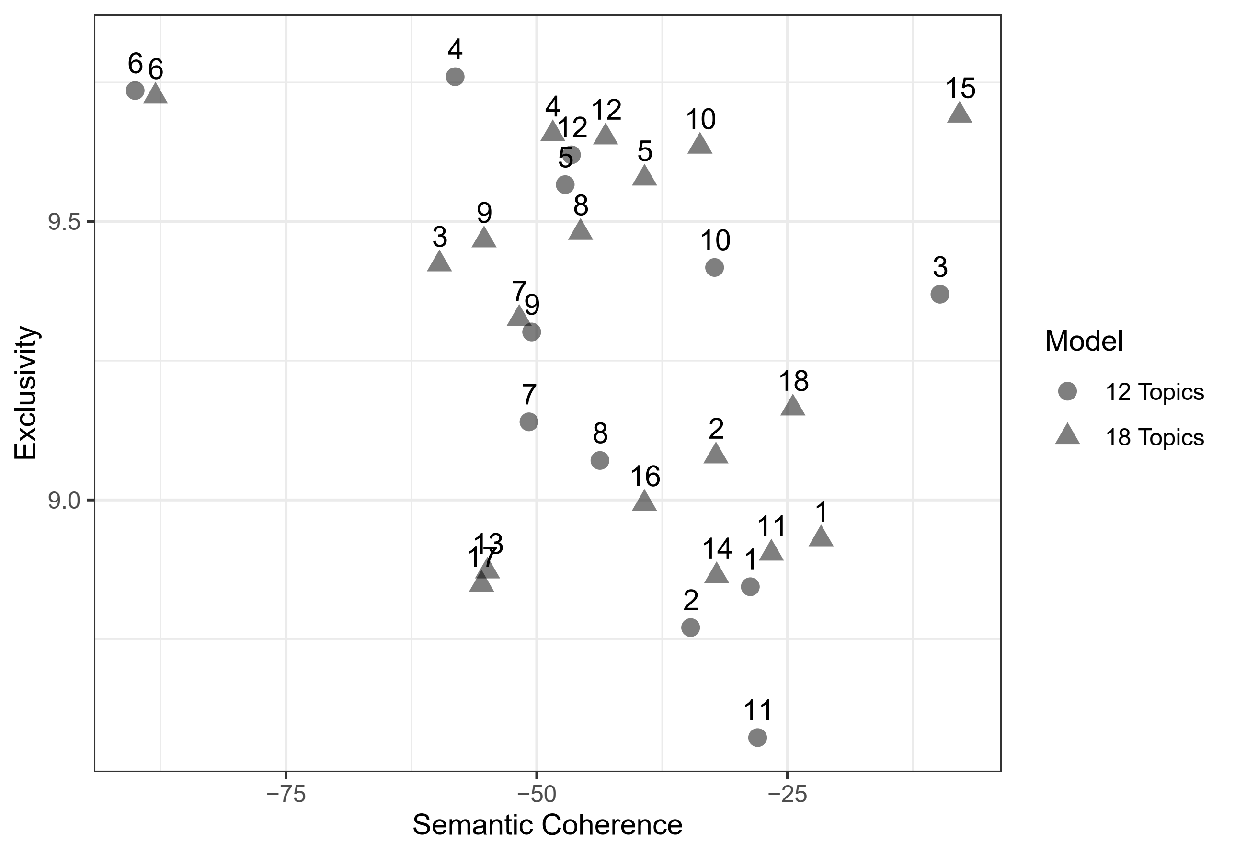
Figure A2: Scatterplot of Model Performance for 12 and 18 Topic STMs
A4. Full Model Results
In the manuscript, we focus our attention on the two topics most closely related to our theoretical expectations: Same-Sex Marriage and Domestic Relations. However, as discussed above, our STM identified 12 topics. Here, we present the full results from the 12 topic structural topic model estimated in the paper. Each panel in Figure A3 corresponds with a topic estimated from the STM; topic names are created by concatenating the top four terms for each topic on the basis of their FREX scores (i.e., a weighted measure of the term’s frequency within and exclusiveness to that topic). Two topics of potential interest relate to the exclusion of the LGBTQ+ community (“scouts_military_scout_boy”) and to political situations (“bush_democrats_election_republicans”). In neither case do we see any significant relationship with the court decisions. For those curious, the topic “ve_ted_brian_guy” relates to the television show Queer as Folk.

Figure A3: Full Topic Model Results from 12 Topic STM of Articles
(see Table A1 for coefficient tables)

A5. Full Regression Model Results
Table A1 reports the full regression model results that are reported in Figure 2 in the manuscript, and Table A2 reports the full regression model results that are reported in Figure 3 in the manuscript.
 | Dependent Variable
 | Same-Sex Marriage | Domestic Relations
Lawrence | 0.100* | 0.007
 | (0.044) | (0.041)
Goodridge | 0.083 | -0.079
 | (0.057) | (0.050)
Lofton | 0.109* | -0.081*
 | (0.048) | (0.042)
Erie | 0.084 | -0.012
 | (0.021) | (0.019)
Just for Us | -0.005 | 0.084
 | (0.062) | (0.061)
Rainbow Wedding | 0.170* | -0.026
 | (0.071) | (0.047)
Tapestry | -0.004 | -0.039
 | (0.029) | (0.025)
Spline(Date) 1 | -0.054 | -0.097
 | (0.075) | (0.066)
Spline(Date) 2 | 0.136* | -0.062
 | (0.065) | (0.054)
Spline(Date) 3 | -0.231* | 0.211*
 | (0.137) | (0.116)
Spline(Date) 4 | -0.281* | 0.018
 | (0.072) | (0.059)
Spline(Date) 5 | 0.142 | 0.097
 | (0.120) | (0.094)
Constant | 0.059* | 0.131*
 | (0.032) | (0.030)
R² | 0.059 | 0.079
Adj. R² | 0.049 | 0.069
Num. obs. | 1229 | 1229
*p < 0.05, one-tailed
Table A1: Results from Models of Topic Prevalence
Dependent Variable
 | Ensemble | Gen. Inq. | Lexicoder | NRC
Lawrence | 0.080* | 0.088* | -0.005 | 0.157*
 | (0.044) | (0.046) | (0.058) | (0.046)
Goodridge | -0.031 | -0.038 | -0.025 | -0.032
 | (0.051) | (0.053) | (0.067) | (0.053)
Lofton | 0.049 | 0.041 | 0.058 | 0.047
 | (0.048) | (0.050) | (0.063) | (0.050)
Total Pages | 0.009* | 0.003 | 0.010* | 0.013*
 | (0.003) | (0.003) | (0.004) | (0.003)
Erie | 0.031 | 0.146* | -0.113* | 0.058*
 | (0.021) | (0.022) | (0.028) | (0.022)
Just for Us | 0.217* | 0.219* | 0.279* | 0.153*
 | (0.060) | (0.063) | (0.080) | (0.063)
Rainbow Wedding | 0.200* | 0.156* | 0.247* | 0.199*
 | (0.058) | (0.060) | (0.077) | (0.061)
Tapestry | -0.004 | -0.044 | -0.048 | 0.080*
 | (0.030) | (0.031) | (0.040) | (0.031)
Spline(Date) 1 | -0.024 | -0.077 | 0.069 | -0.065
 | (0.077) | (0.080) | (0.101) | (0.080)
Spline(Date) 2 | 0.031 | 0.030 | 0.002 | 0.041
 | (0.064) | (0.066) | (0.084) | (0.066)
Spline(Date) 3 | -0.045 | -0.081 | 0.122 | -0.176
 | (0.131) | (0.136) | (0.173) | (0.137)
Spline(Date) 4 | -0.155* | -0.180* | -0.124 | -0.161*
 | (0.072) | (0.074) | (0.095) | (0.075)
Spline(Date) 5 | 0.133 | 0.071 | 0.276* | 0.052
 | (0.109) | (0.113) | (0.144) | (0.114)
Constant | 0.224* | 0.331* | 0.101* | 0.241*
 | (0.035) | (0.036) | (0.046) | (0.037)
R² | 0.059 | 0.079 | 0.056 | 0.082
Adj. R² | 0.049 | 0.069 | 0.046 | 0.072
Num. obs. | 1229 | 1229 | 1229 | 1229
*p < 0.05, one-tailed

Table A2: Results from Models of Article Tone

A6. Alternative Model Specification: T-tests
To evaluate the robustness of the observed sentiment results we examine a series of alternative model specifications. In this section, we report the results from a series of unequal variances t-tests where our goal is to analyze the influence of each decision (Lawrence, Goodridge, and Lofton) on the article sentiment. For each dictionary (NRC, Lexicoder, General Inquirer, and our ensemble measure), we test whether the before-decision and after-decision population means are equal. We define before-decision and after-decision as only those articles appearing within the window between decisions. As an example, for Goodridge v. Department of Public Health, the before-decision articles are all of those appearing after Lawrence v. Texas but before Goodridge v. Department of Public Health, and the after-decision articles are all of those appearing after Goodridge vs. Department of Public Health but before Lofton v. Department of Children and Family Services. Narrowing the analysis to these more specific windows provides leverage on establishing the effect of individual decisions on coverage in LGBTQ+ media. We report the results in Figure A4. Each panel in the figure reports the results across the four dictionaries (y-axis) for a specific decision. The bars indicate the 95% confidence intervals for the difference in means from the unequal variances t-tests. If the bars cross zero (indicated by a vertical dashed line), we cannot reject the null that the before- and after-decision articles have equal sentiment. The results are consistent with the model results reported in the main text and in Table A2. Except for sentiment estimates from Lexicoder, we find consistent evidence that Lawrence v. Texas was associated with increased positivity in LGBTQ+ media discussing law and courts, a change not observed after either Goodridge or Lofton.
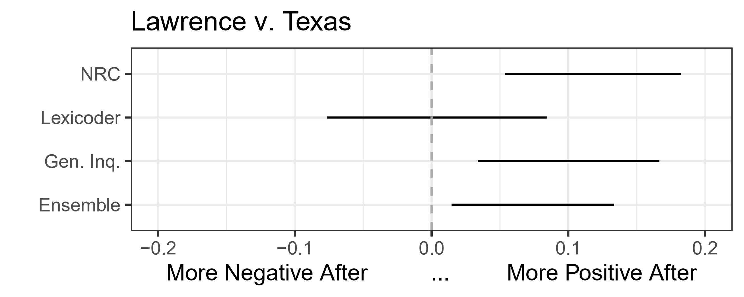
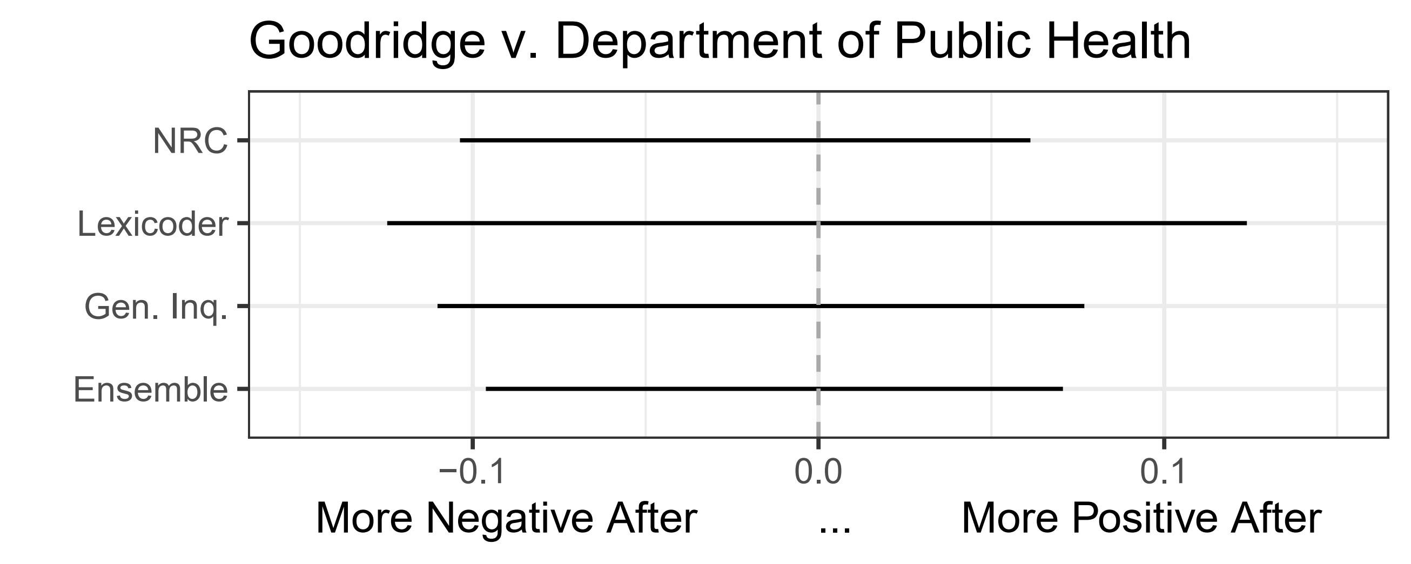
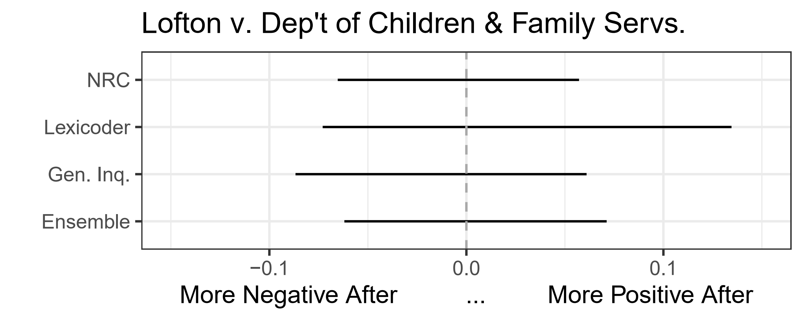
Figure A4: T-Test Analyses Across Sentiment Dictionaries.
A7. Alternative Model Specification: Randomization Tests
To further examine the robustness of the article tone results in the main text, we conduct a series of approximate randomization tests (e.g., Edgington and Onghena 2007; Lax and Rader 2010). The goal of these randomization tests is to relax the parametric assumptions associated with estimating the specific parameters in the model and, effectively, to ask whether or not the specific decisions had an effect. Through randomization, we construct a distribution of test values where we know there is no relationship between the decision and article tone; for each permutation, the units are randomly assigned a treatment. Then, we analyze our observed test statistic against this random distribution, based entirely on our drawn data rather than parametric statistical tables, to identify how unusual the observed effect is relative to the distribution of where there is no effect.
Our approach operates as follows. For each of the decisions (Lawrence, Goodridge, and Lofton), we estimate the proportion of articles before and after within our dataset. Then, we run twelve randomization tests in total, four (the number of dictionaries) for each of the three decisions. For each randomization test, we conduct 1,000 random permutations. In a single permutation, we randomize the assignment of the decision to before or after based on the observed proportion of articles appearing before and after that decision. We estimate an identical linear model to that reported in the main text and Table A2, store the t-value associated with the decision covariate based on that permutation.
To address the temporality of the decisions, we iterate through the randomizations as follows. Note that this has no substantive effect on the results; alternative approaches obtain similar results. For the Lawrence models, each of Lawrence, Goodridge, and Lofton are randomized, and we extract the test statistic associated with the Lawrence covariate. For the Goodridge models, Lawrence is not randomized, but each of Goodridge and Lofton are randomized. Finally, for the Lofton models, only the Lofton covariate is randomized. Though again the results are robust to alternatives, the underlying intuition for the approach we present here is relatively straightforward; if we are laying out a series of alternative timelines where we are certain the Goodridge decision has no effect, we must incorporate the causally prior decision in Lawrence, and likewise for Lofton.
We present the results in Figures A5 (Lawrence v. Texas), A6 (Goodridge v. Department of Public Health), and A7 (Lofton v. Department of Children and Family Services). In Figure A5, we plot the distribution of t-values (x-axis) across the 1,000 permutations for Lawrence v. Texas. The vertical black line indicates, based on the 1,000 random permutations, a 95% significance level; values greater than the indicated 95% significance level indicate that the decision had a positive effect on article tone. We indicate the observed t-value (that is, the t-value from the models reported in the main text and in Table A2) with a vertical dashed line.
As elsewhere, the results are consistent with those reported throughout. In the randomization tests, three of four analyses indicate that Lawrence v. Texas was associated with a positive change in the sentiment of articles, with only the model based on Lexicoder diverging. In contrast, we find no evidence for an effect from Goodridge or Lofton on article tone.

Ensemble | General Inquirer
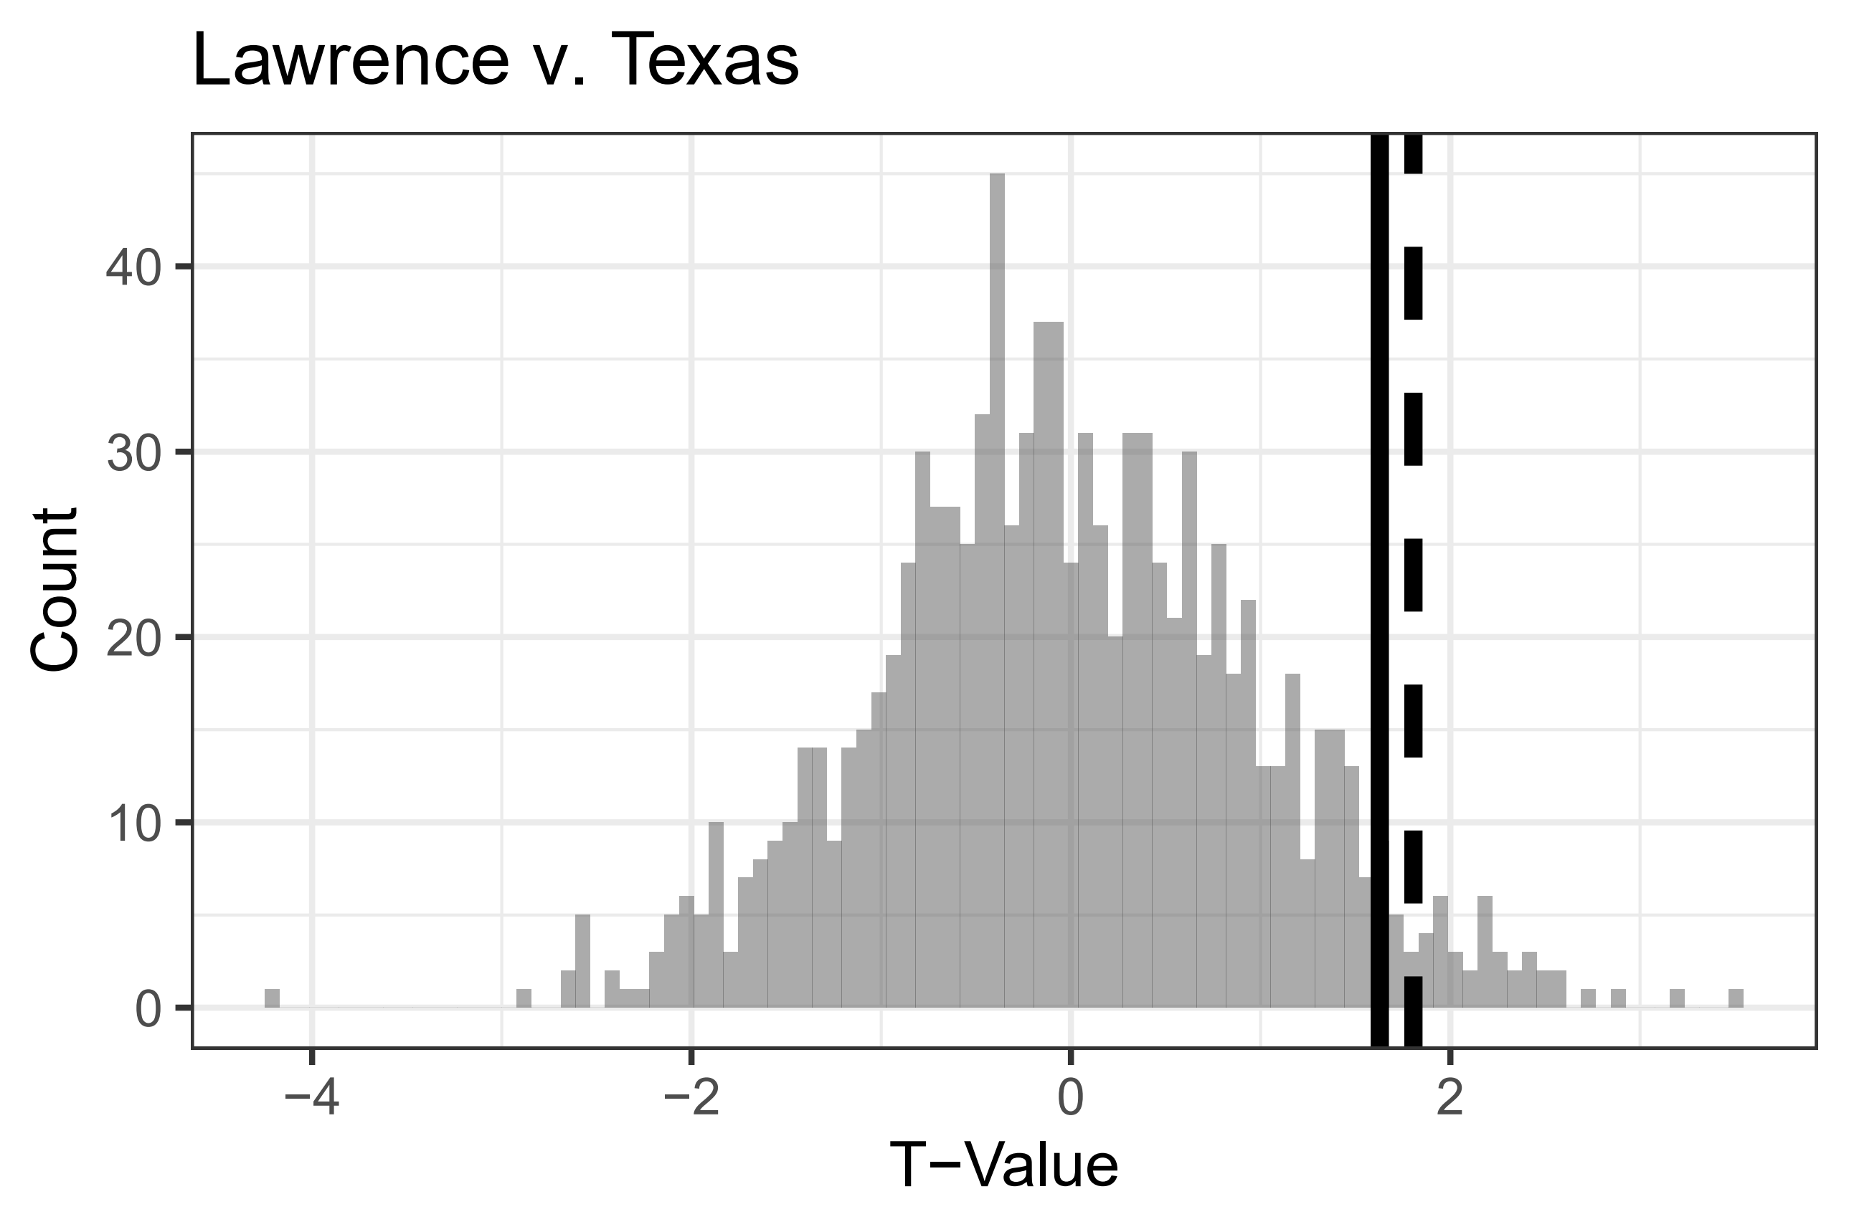 | 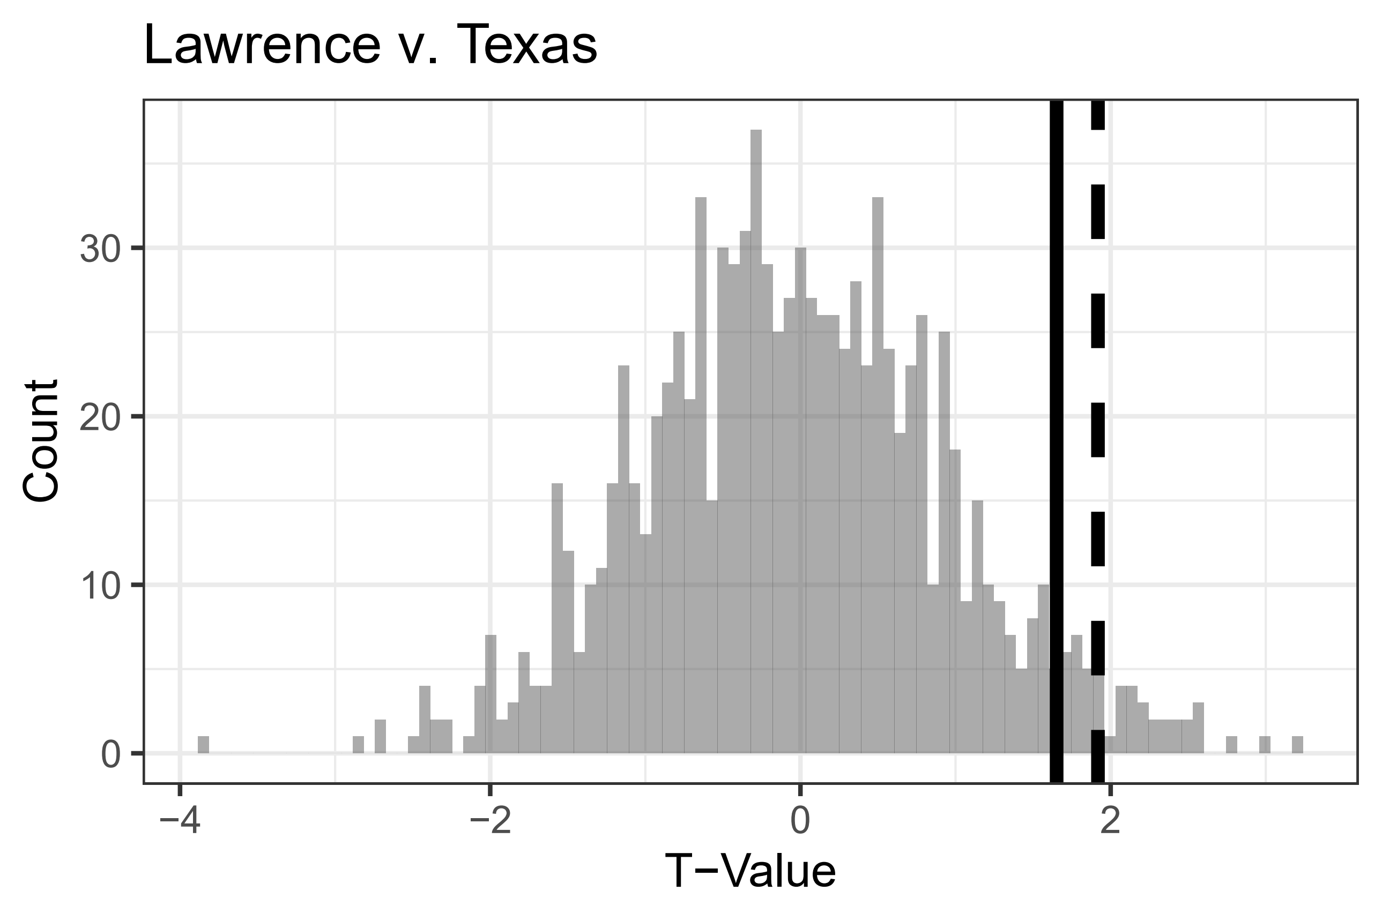
Lexicoder | NRC
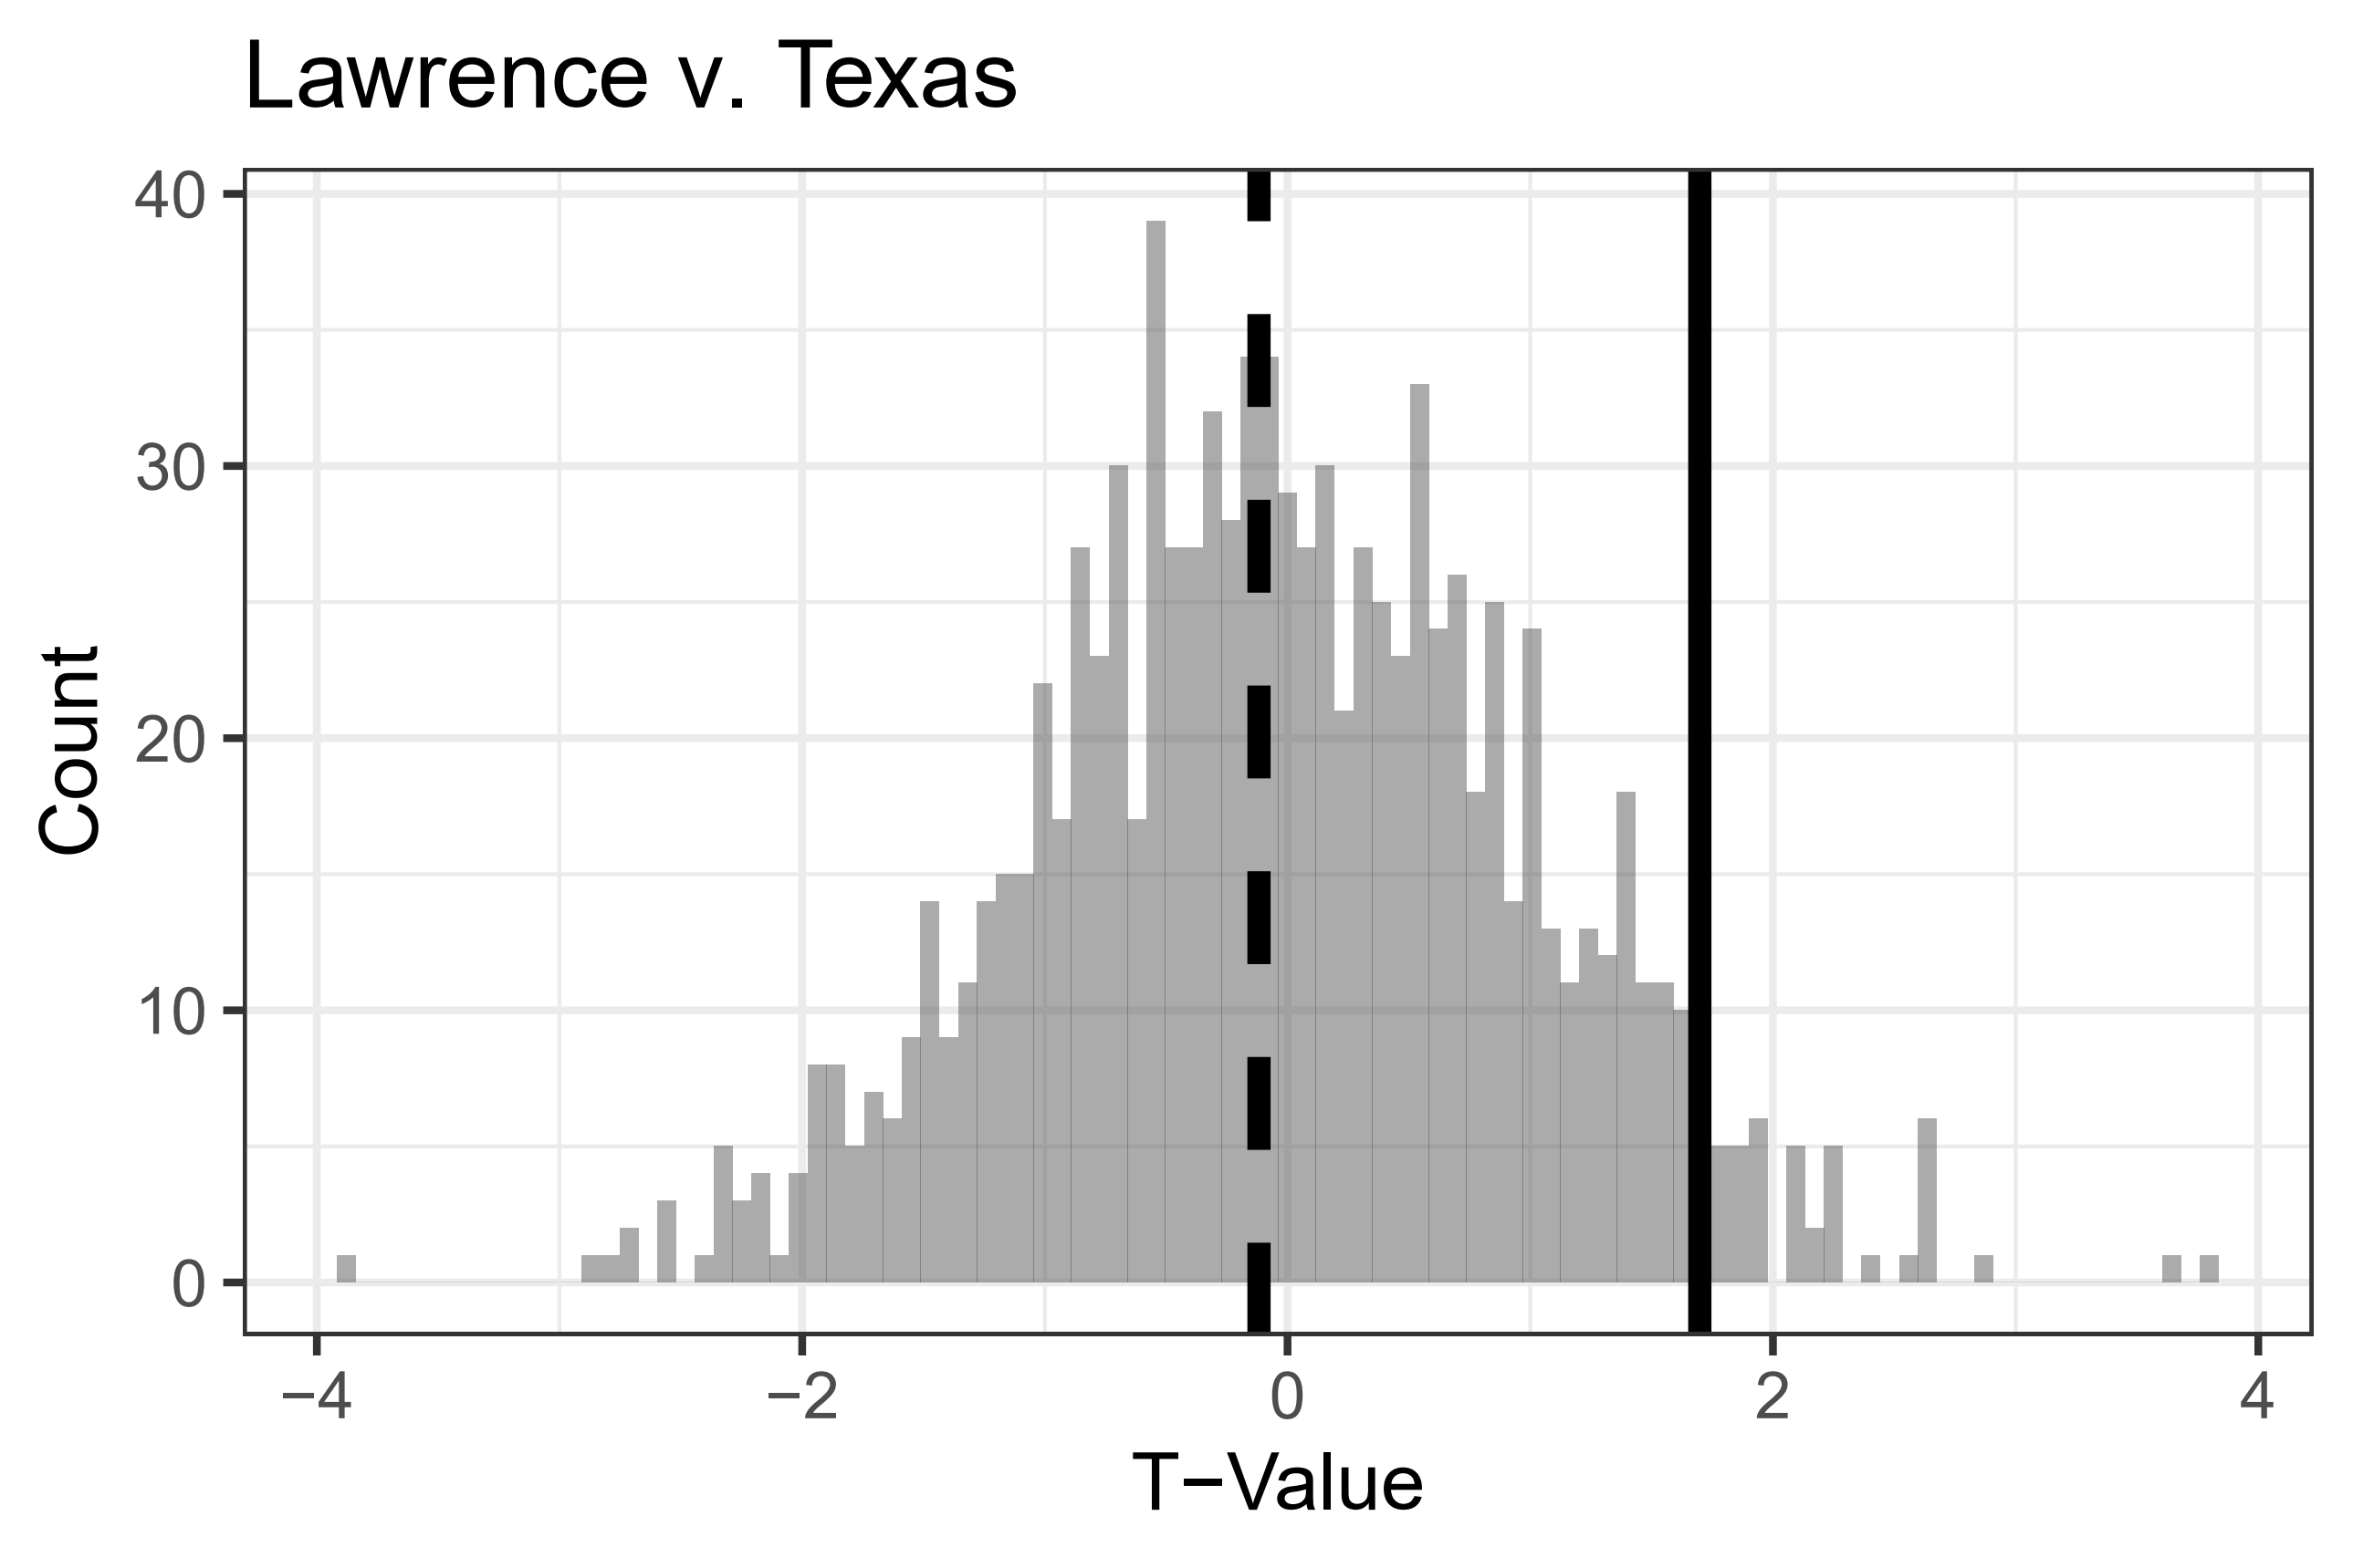 | 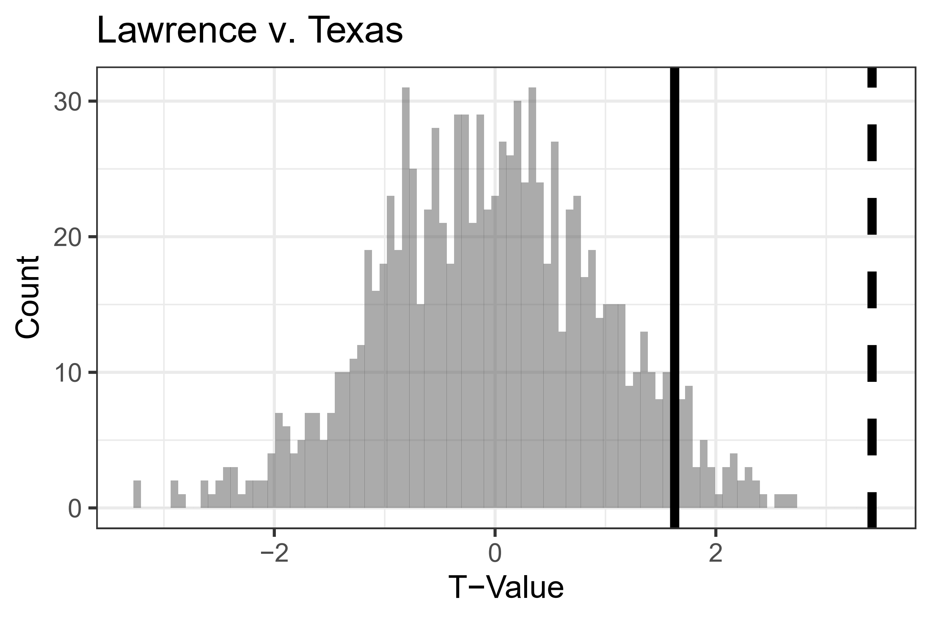
Figure A5: Results of Randomization Tests for Lawrence v. Texas.

Ensemble | General Inquirer
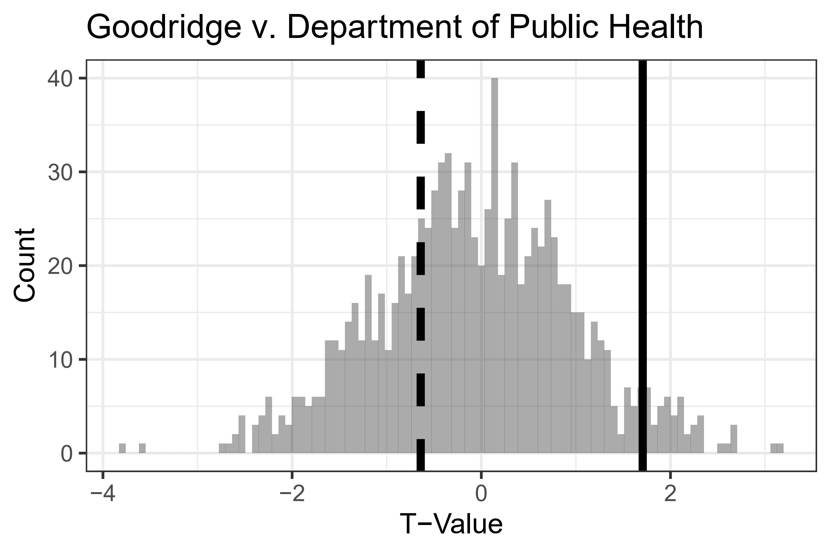 | 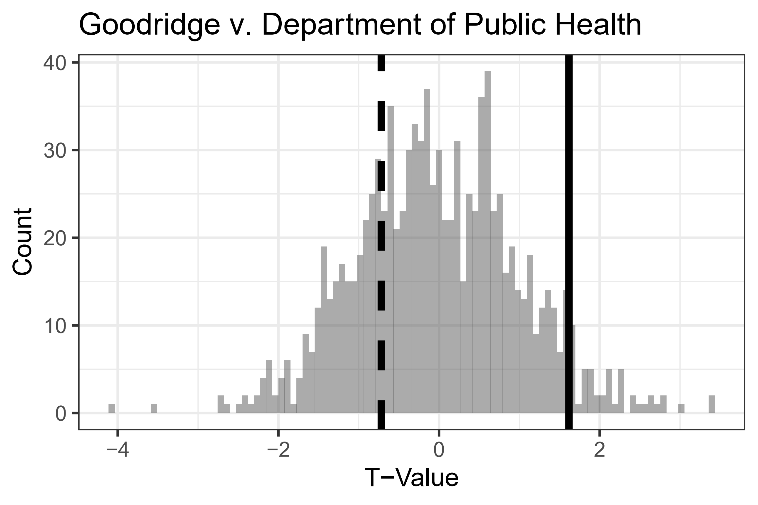
Lexicoder | NRC
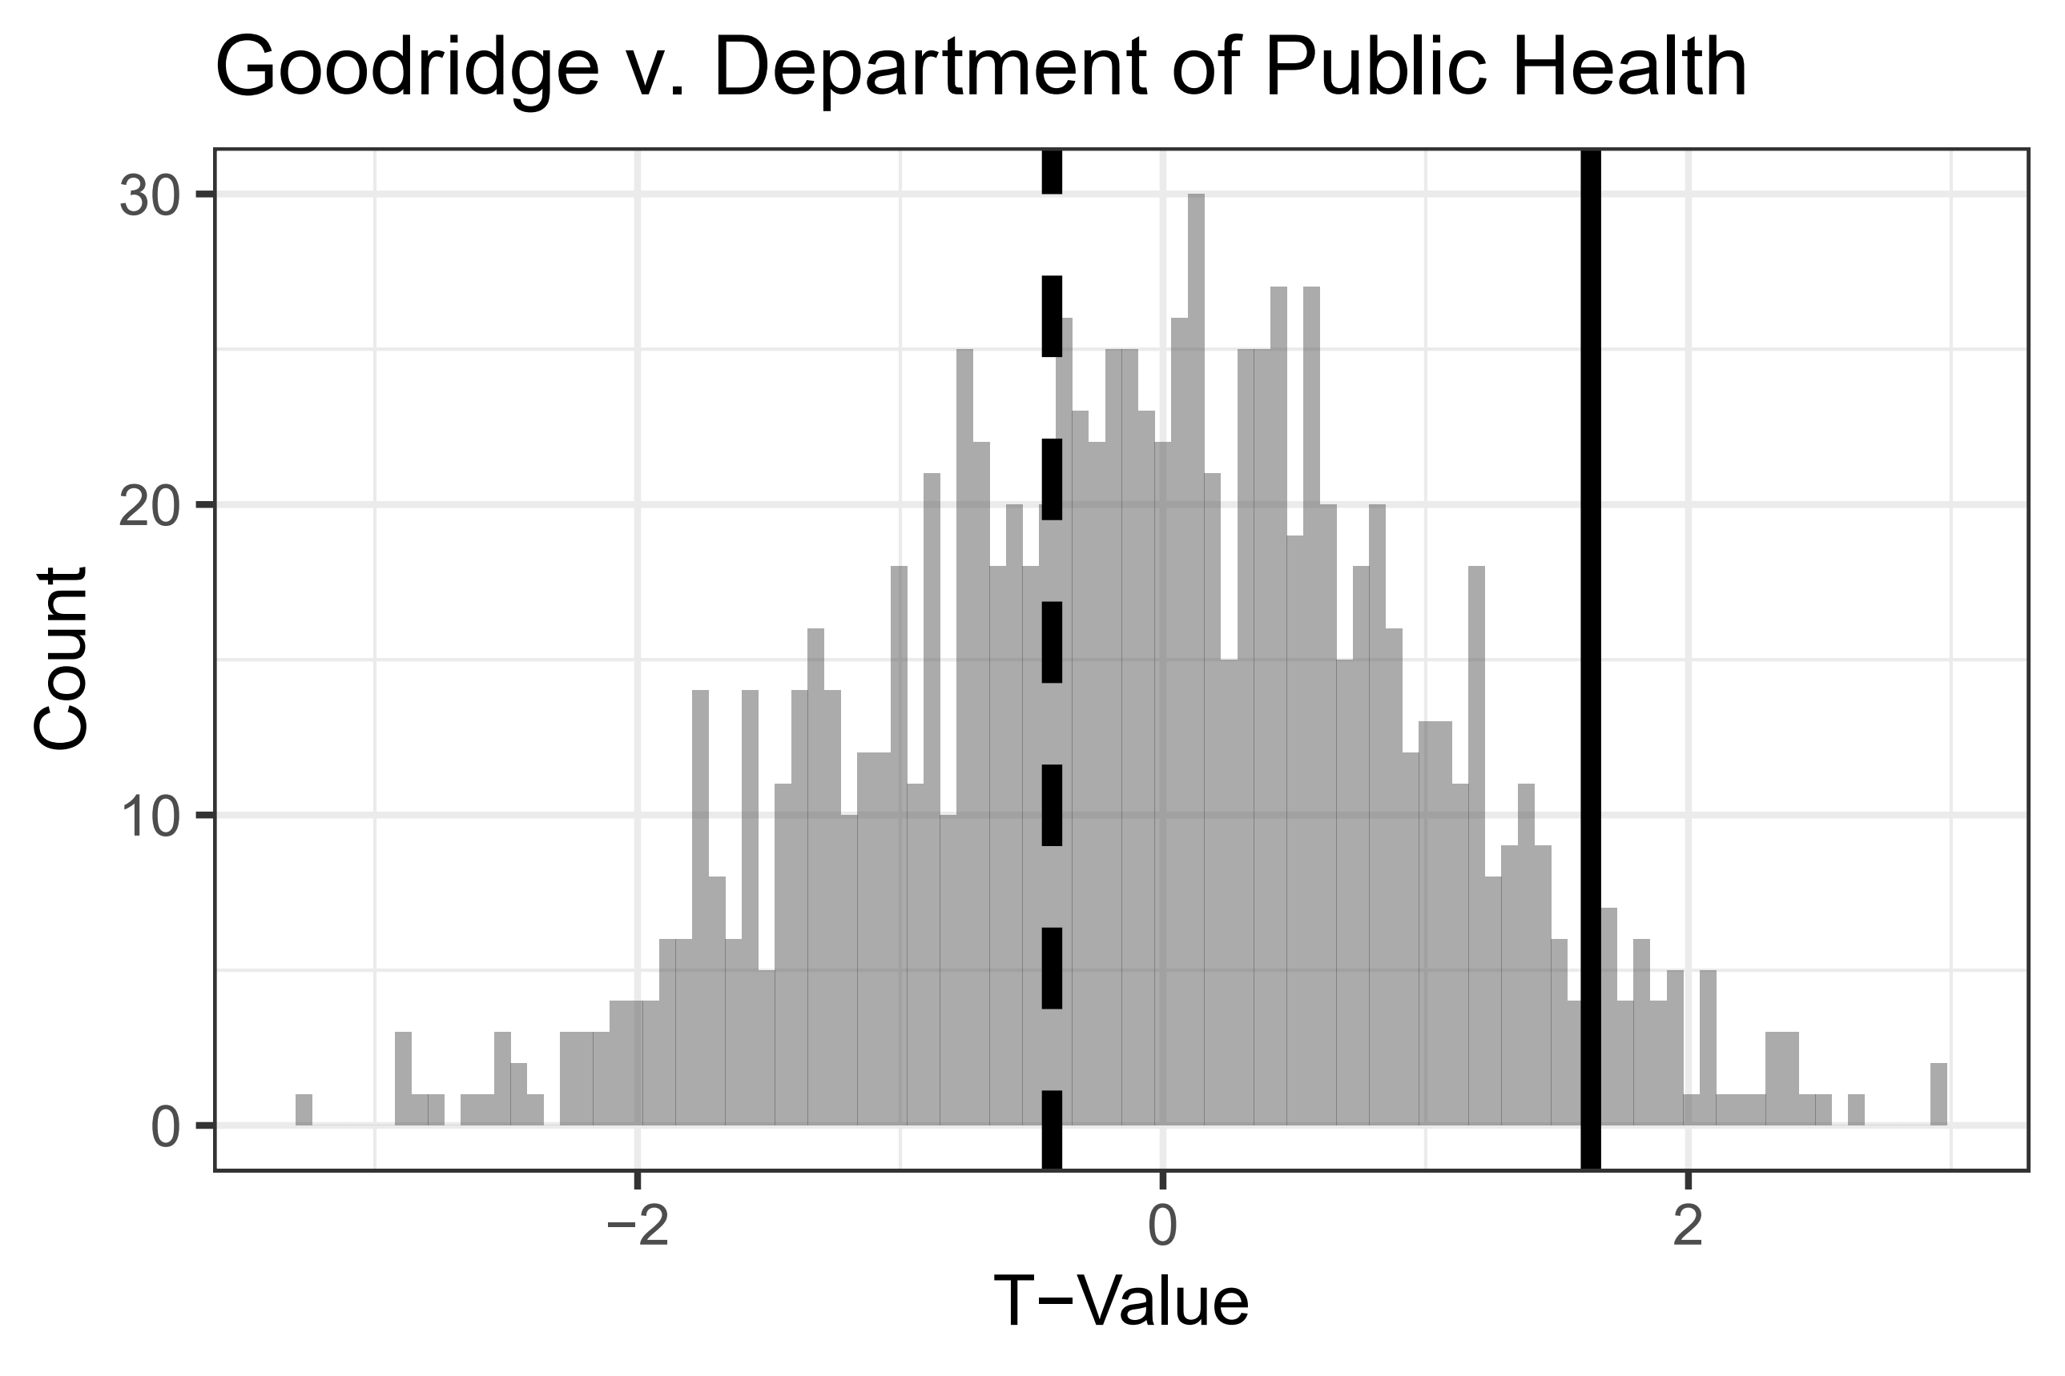 | 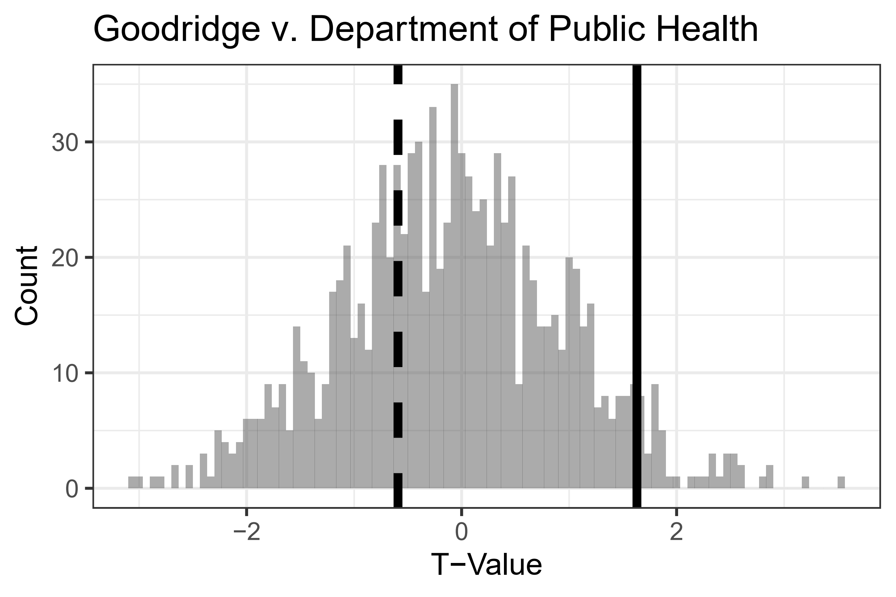
Figure A6: Results of Randomization Tests for Lawrence v. Texas.

Ensemble | General Inquirer
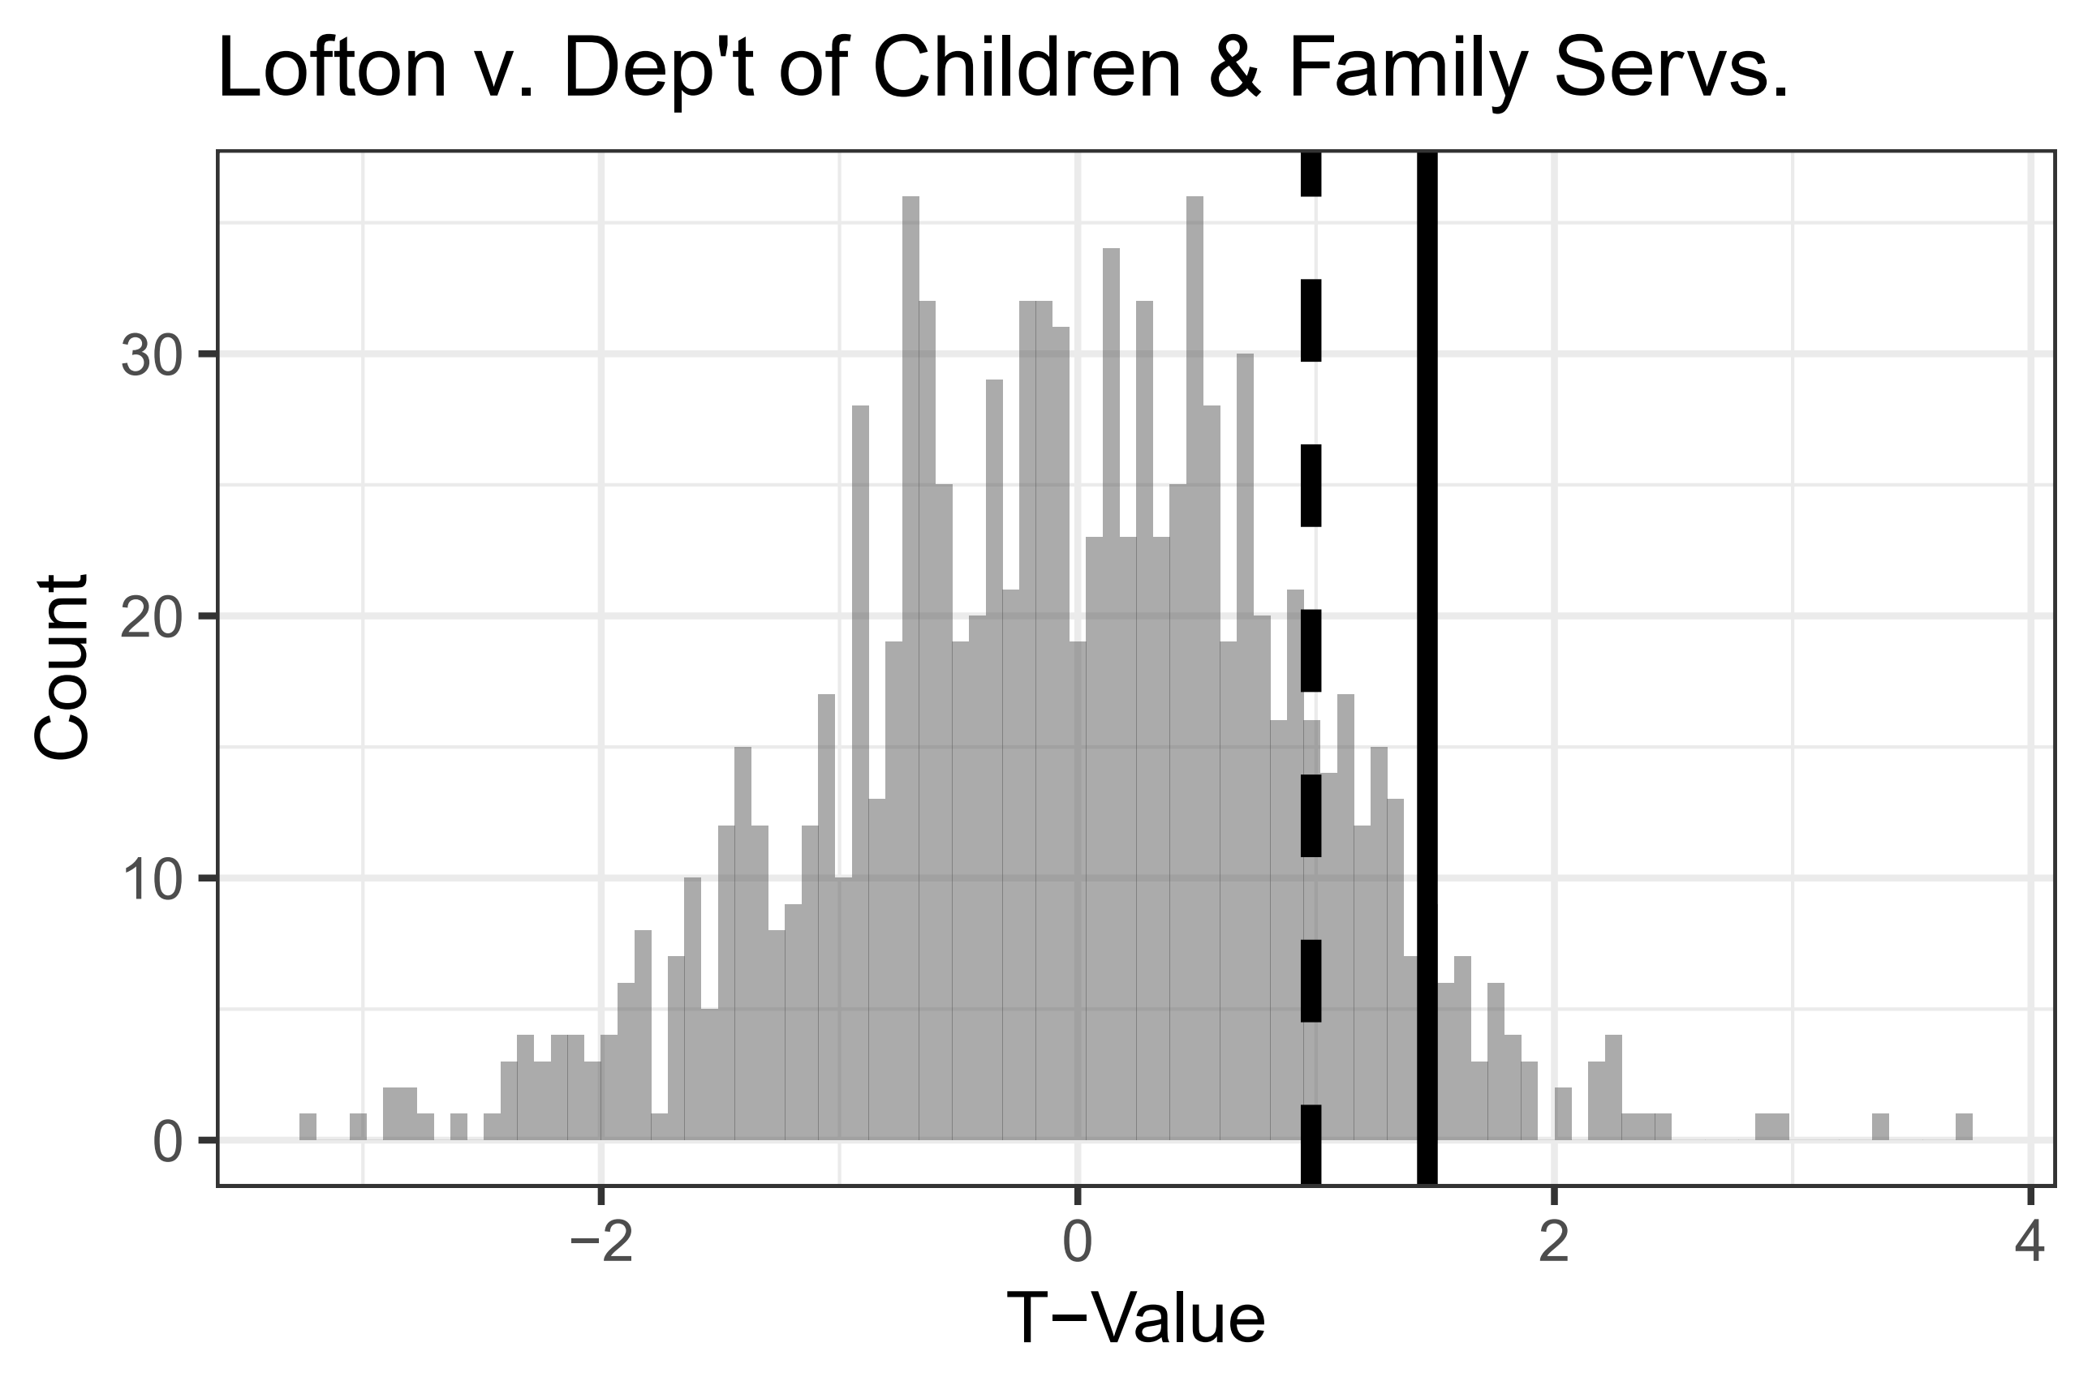 | 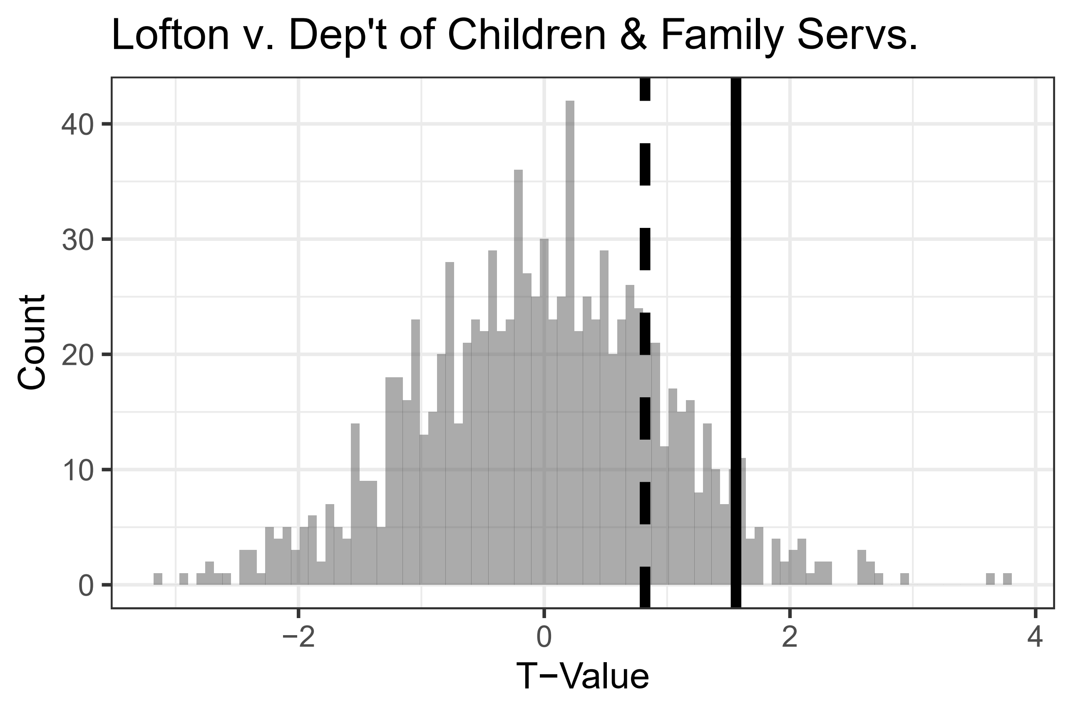
Lexicoder | NRC
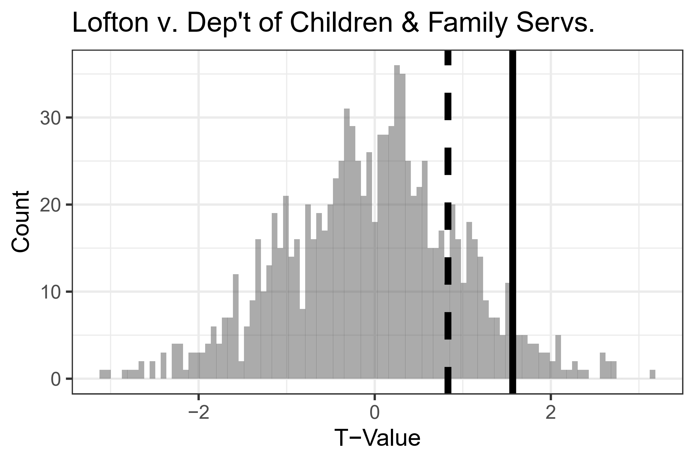 | 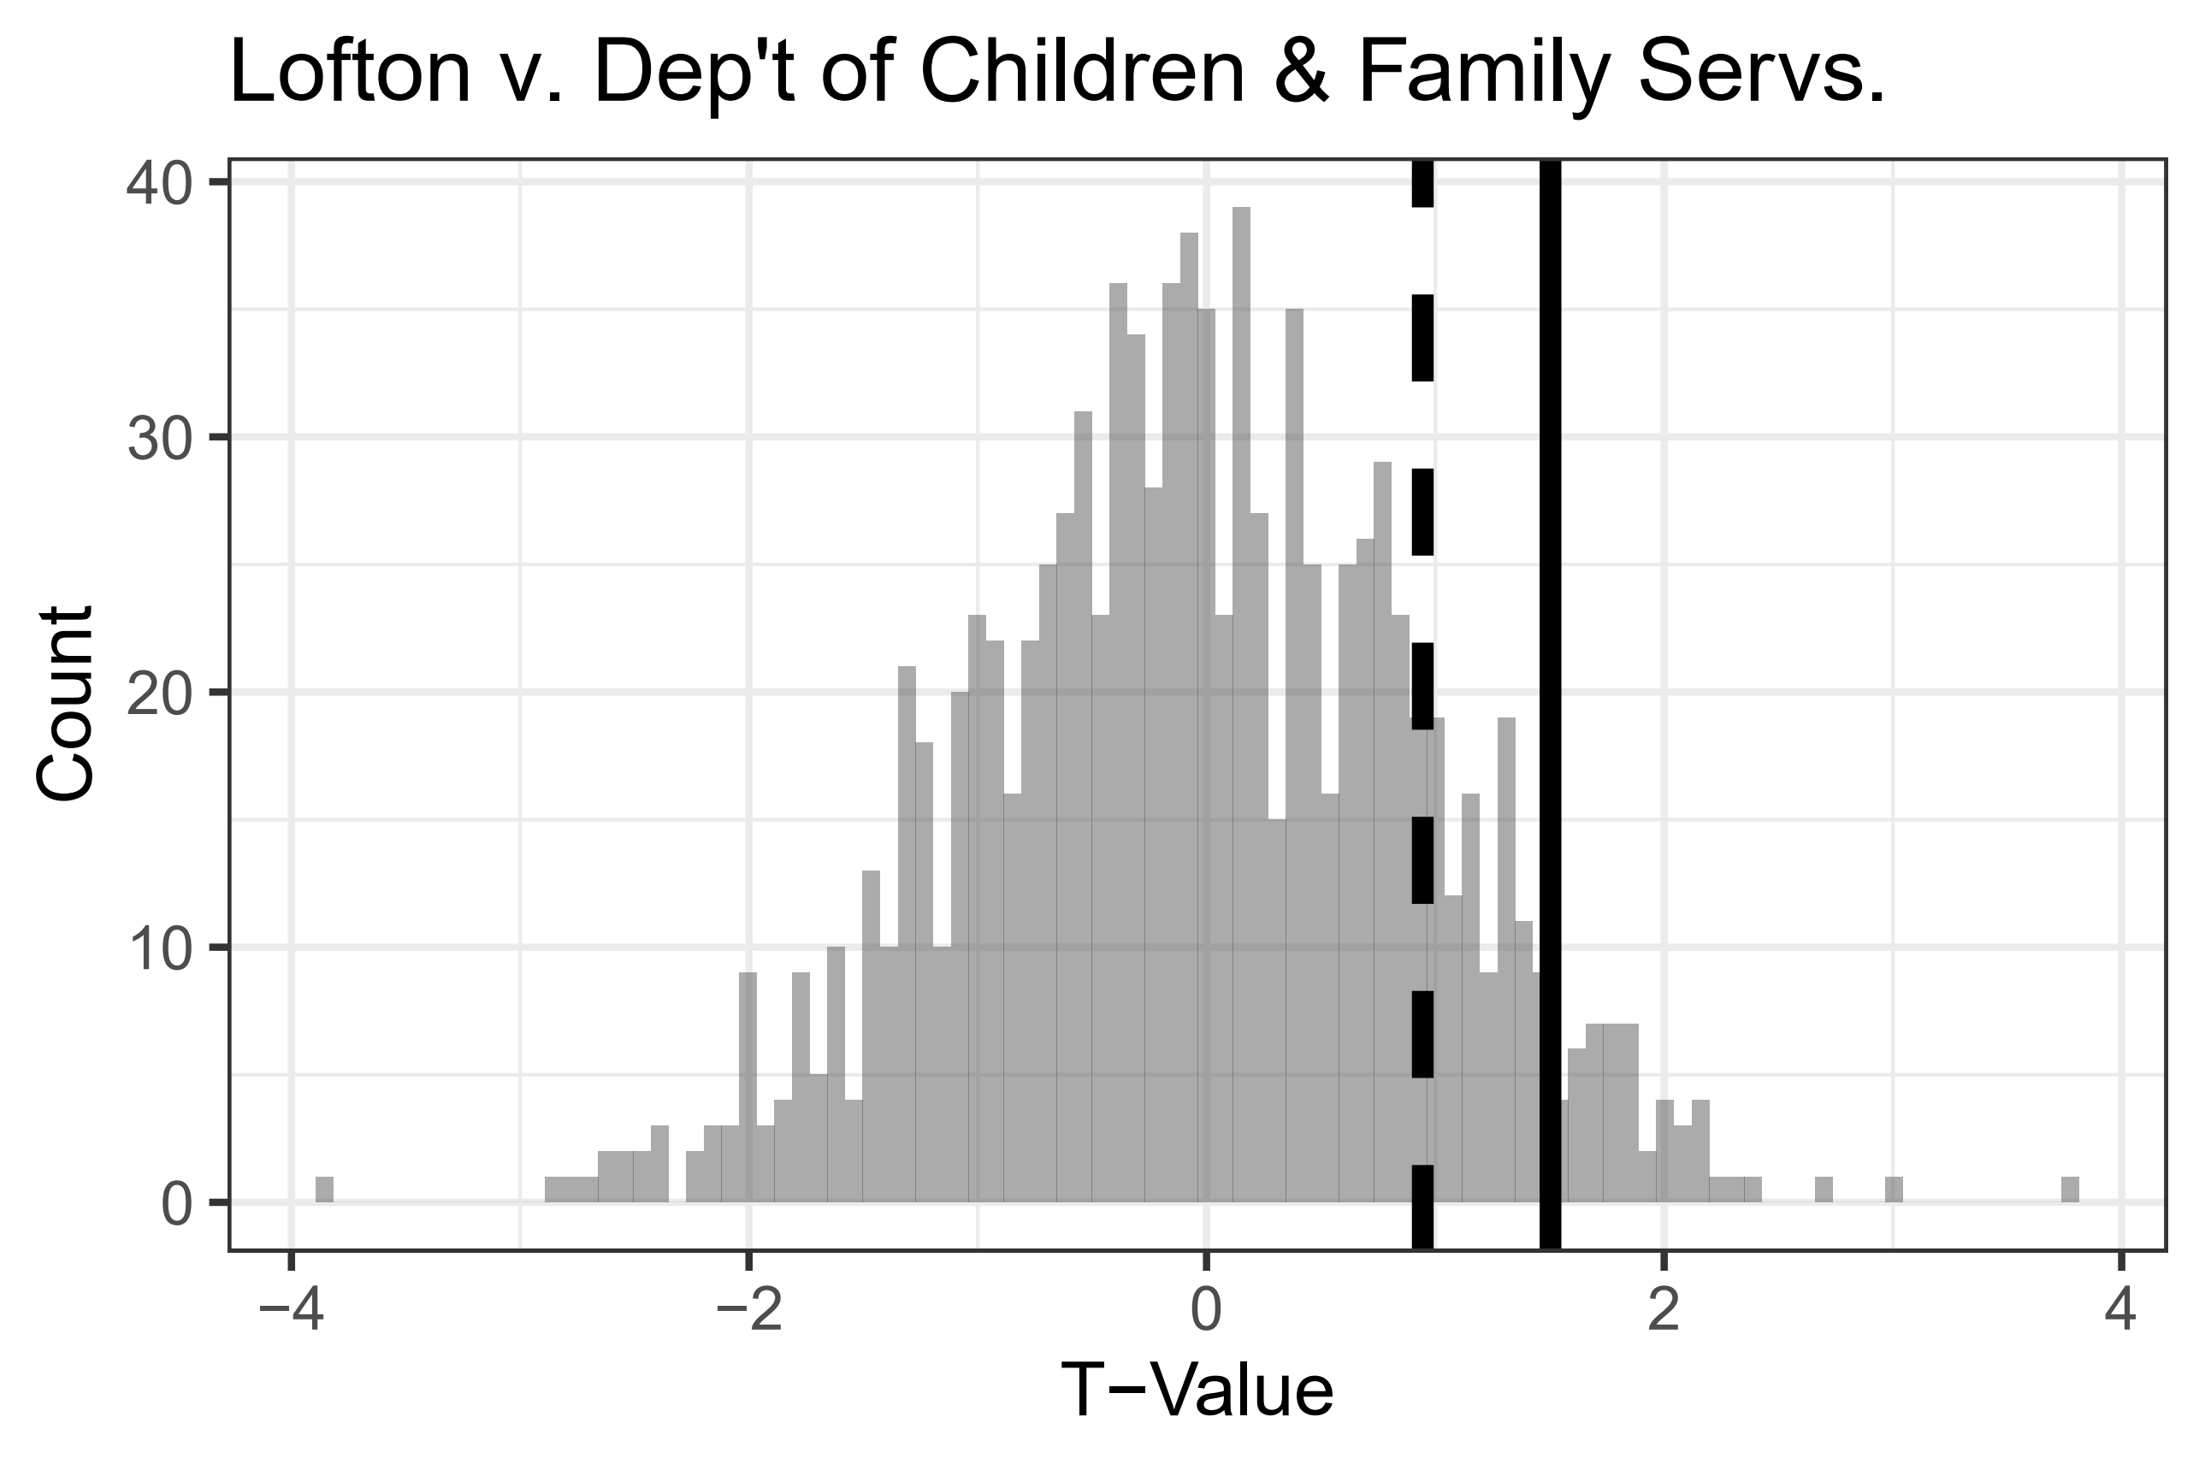
Figure A7: Results of Randomization Tests for Lofton v. Department of Children & Family Services.
A8. Sequential Model Specifications
Recognizing the potential sequential dependency (and the challenges to estimation) introduced by the time series, we estimate a series of alternative models that sequentially vary the inclusion of the indicators for each of our three decisions: Lawrence, Goodridge, and Lofton. The models are of the same form as those reported in the main text and Table A2, with the following change in approach. We include, for each, six different specifications: Lawrence only, Lawrence and Goodridge (excluding Lofton), all three decisions, Goodridge only (excluding Lawrence and Lofton), Goodridge and Lofton (excluding Lawrence), and Lofton only. The goal of this approach is to identify whether or not decisions, most specifically Goodridge and Lofton, might exert some effect that is missed with the inclusion of Lawrence. As before, we estimate separate models for each of the four tone score dependent variables and present the results from each. To ease interpretation, we present the coefficient estimates and associated confidence intervals from the models in coefficient plots below, one for each dictionary (ensemble in Figure A8, General Inquirer in Figure A9, Lexicoder in Figure A10, and NRC in Figure A11). Within each plot, each panel represents a different coefficient, dots present the coefficient estimates, and lines indicate the confidence intervals for that coefficient across the different model specifications. Volatile estimates would indicate that the models were failing to distinguish the effect of one decision from another, whereas more stable estimates indicate that the effect of each decision is more robust to the inclusion or exclusion of other decision covariates.
The results are consistent with those reported in the main text and Table A2. By way of interpretation, consider Figure A8; for Lawrence, the coefficient estimate is significant at the 95% level across each model specification (Lawrence only, Lawrence and Goodridge, or the full model). Goodridge and Lofton, on the other hand, are not significant across any model specifications.
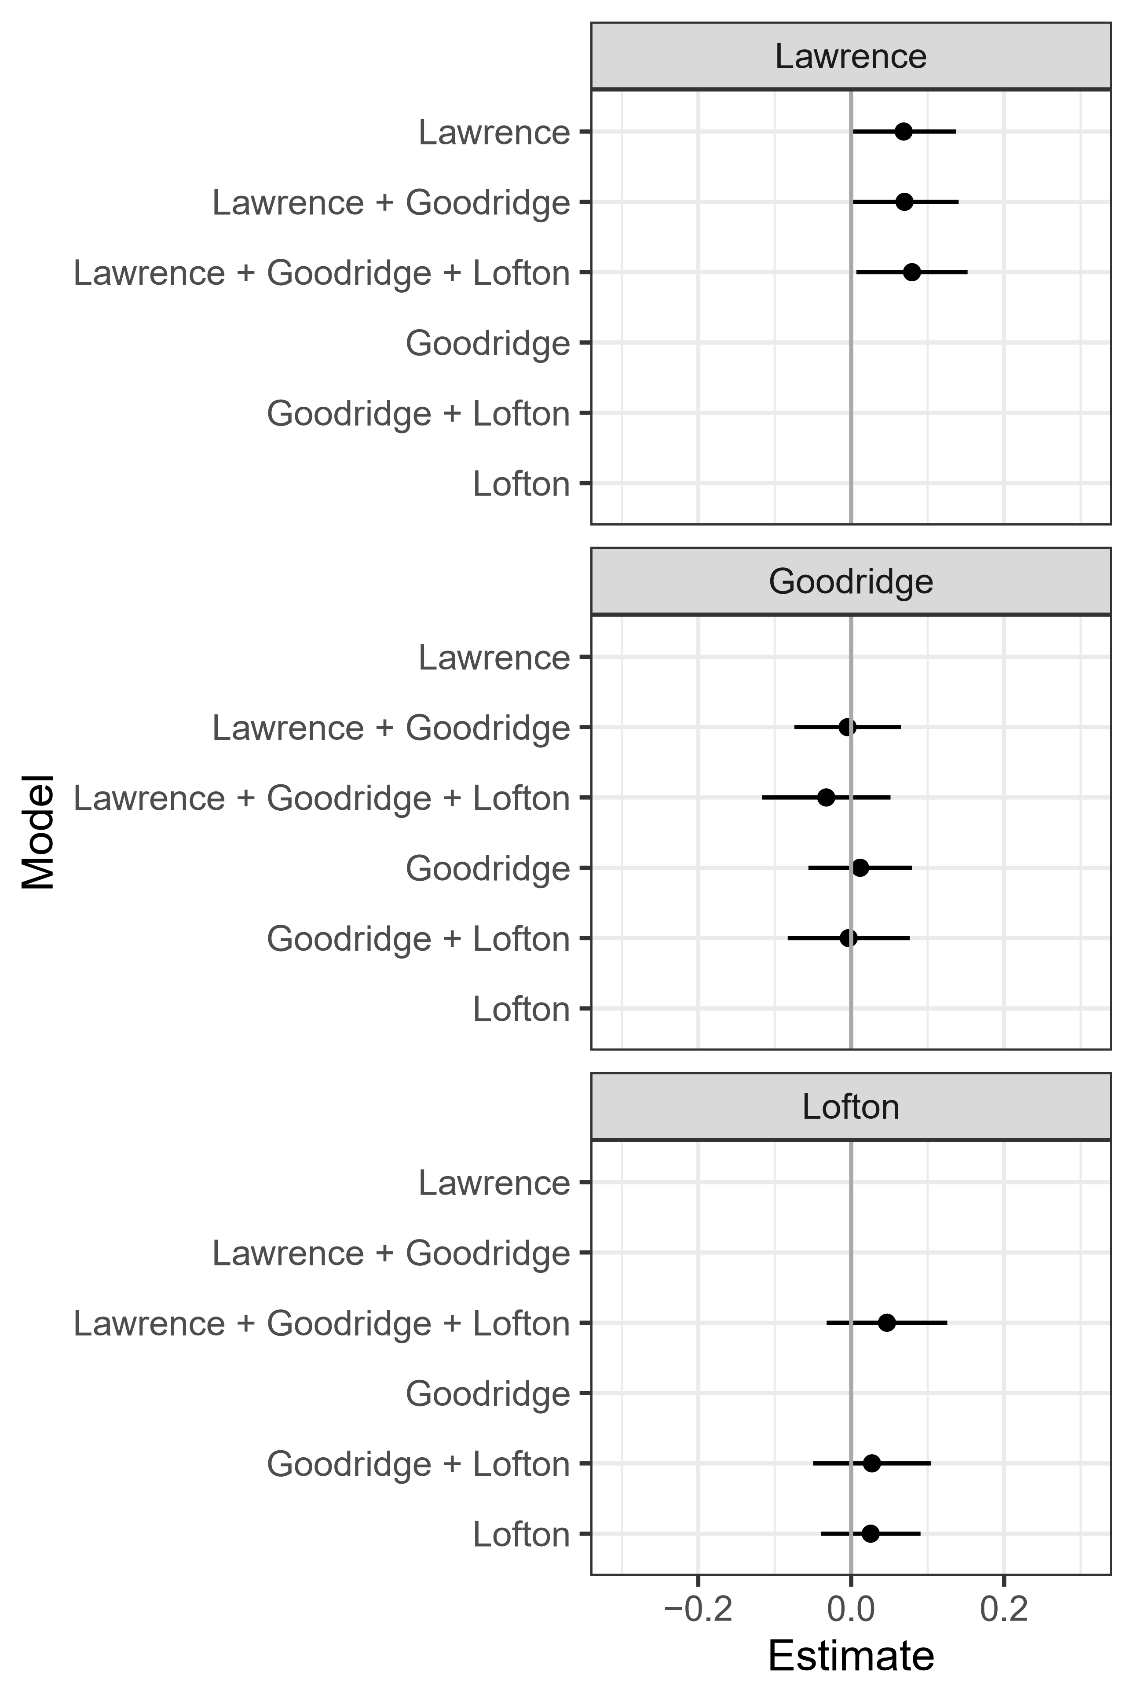
Figure A8: Sequential Model Results of Ensemble Tone
(see Table A3 for coefficient tables)

 | (1) | (2) | (3) | (4) | (5) | (6)
Lawrence | 0.069* | 0.070 | 0.080*
 | (0.042) | (0.043) | (0.044)
Goodridge |  | -0.002 | -0.031 | 0.014 | -0.002
 |  | (0.042) | (0.051) | (0.041) | (0.048)
Lofton |  |  | 0.049 |  | 0.029 | 0.028
 |  |  | (0.048) |  | (0.047) | (0.040)
Total Pages | 0.009* | 0.009* | 0.009* | 0.009* | 0.009* | 0.009*
 | (0.003) | (0.003) | (0.003) | (0.003) | (0.003) | (0.003)
Spline(Date) 1 | -0.006 | -0.005 | -0.024 | -0.002 | -0.013 | -0.014
 | (0.072) | (0.075) | (0.077) | (0.075) | (0.077) | (0.076)
Spline(Date) 2 | 0.009 | 0.008 | 0.031 | -0.014 | -0.002 | -0.001
 | (0.053) | (0.059) | (0.064) | (0.058) | (0.061) | (0.059)
Spline(Date) 3 | 0.007 | 0.010 | -0.045 | 0.110 | 0.086 | 0.084
 | (0.100) | (0.119) | (0.131) | (0.102) | (0.109) | (0.098)
Spline(Date) 4 | -0.134* | -0.132* | -0.155* | -0.113* | -0.125* | -0.125*
 | (0.065) | (0.068) | (0.072) | (0.067) | (0.070) | (0.069)
Spline(Date) 5 | 0.170 | 0.172 | 0.133 | 0.245* | 0.227* | 0.226*
 | (0.092) | (0.102) | (0.109) | (0.092) | (0.096) | (0.090)
Erie | 0.029 | 0.029 | 0.031 | 0.031 | 0.032 | 0.032
 | (0.021) | (0.021) | (0.021) | (0.021) | (0.021) | (0.021)
Just for Us | 0.210* | 0.210* | 0.217* | 0.210* | 0.214* | 0.214*
 | (0.060) | (0.060) | (0.060) | (0.060) | (0.060) | (0.060)
Rainbow Wedding | 0.199* | 0.199* | 0.200* | 0.197* | 0.198* | 0.198*
 | (0.058) | (0.058) | (0.058) | (0.058) | (0.058) | (0.058)
Tapestry | -0.006 | -0.006 | -0.004 | -0.004 | -0.003 | -0.003
 | (0.030) | (0.030) | (0.030) | (0.030) | (0.030) | (0.030)
Constant | 0.221* | 0.220* | 0.224* | 0.220* | 0.222* | 0.222*
 | (0.035) | (0.035) | (0.035) | (0.035) | (0.035) | (0.035)
R² | 0.058 | 0.058 | 0.059 | 0.056 | 0.056 | 0.056
Adj. R² | 0.050 | 0.049 | 0.049 | 0.047 | 0.047 | 0.048
Num. obs. | 1229 | 1229 | 1229 | 1229 | 1229 | 1229
*p < 0.05, one-tailed.

Table A3: Complete Sequential Model Results for Models of Ensemble Tone
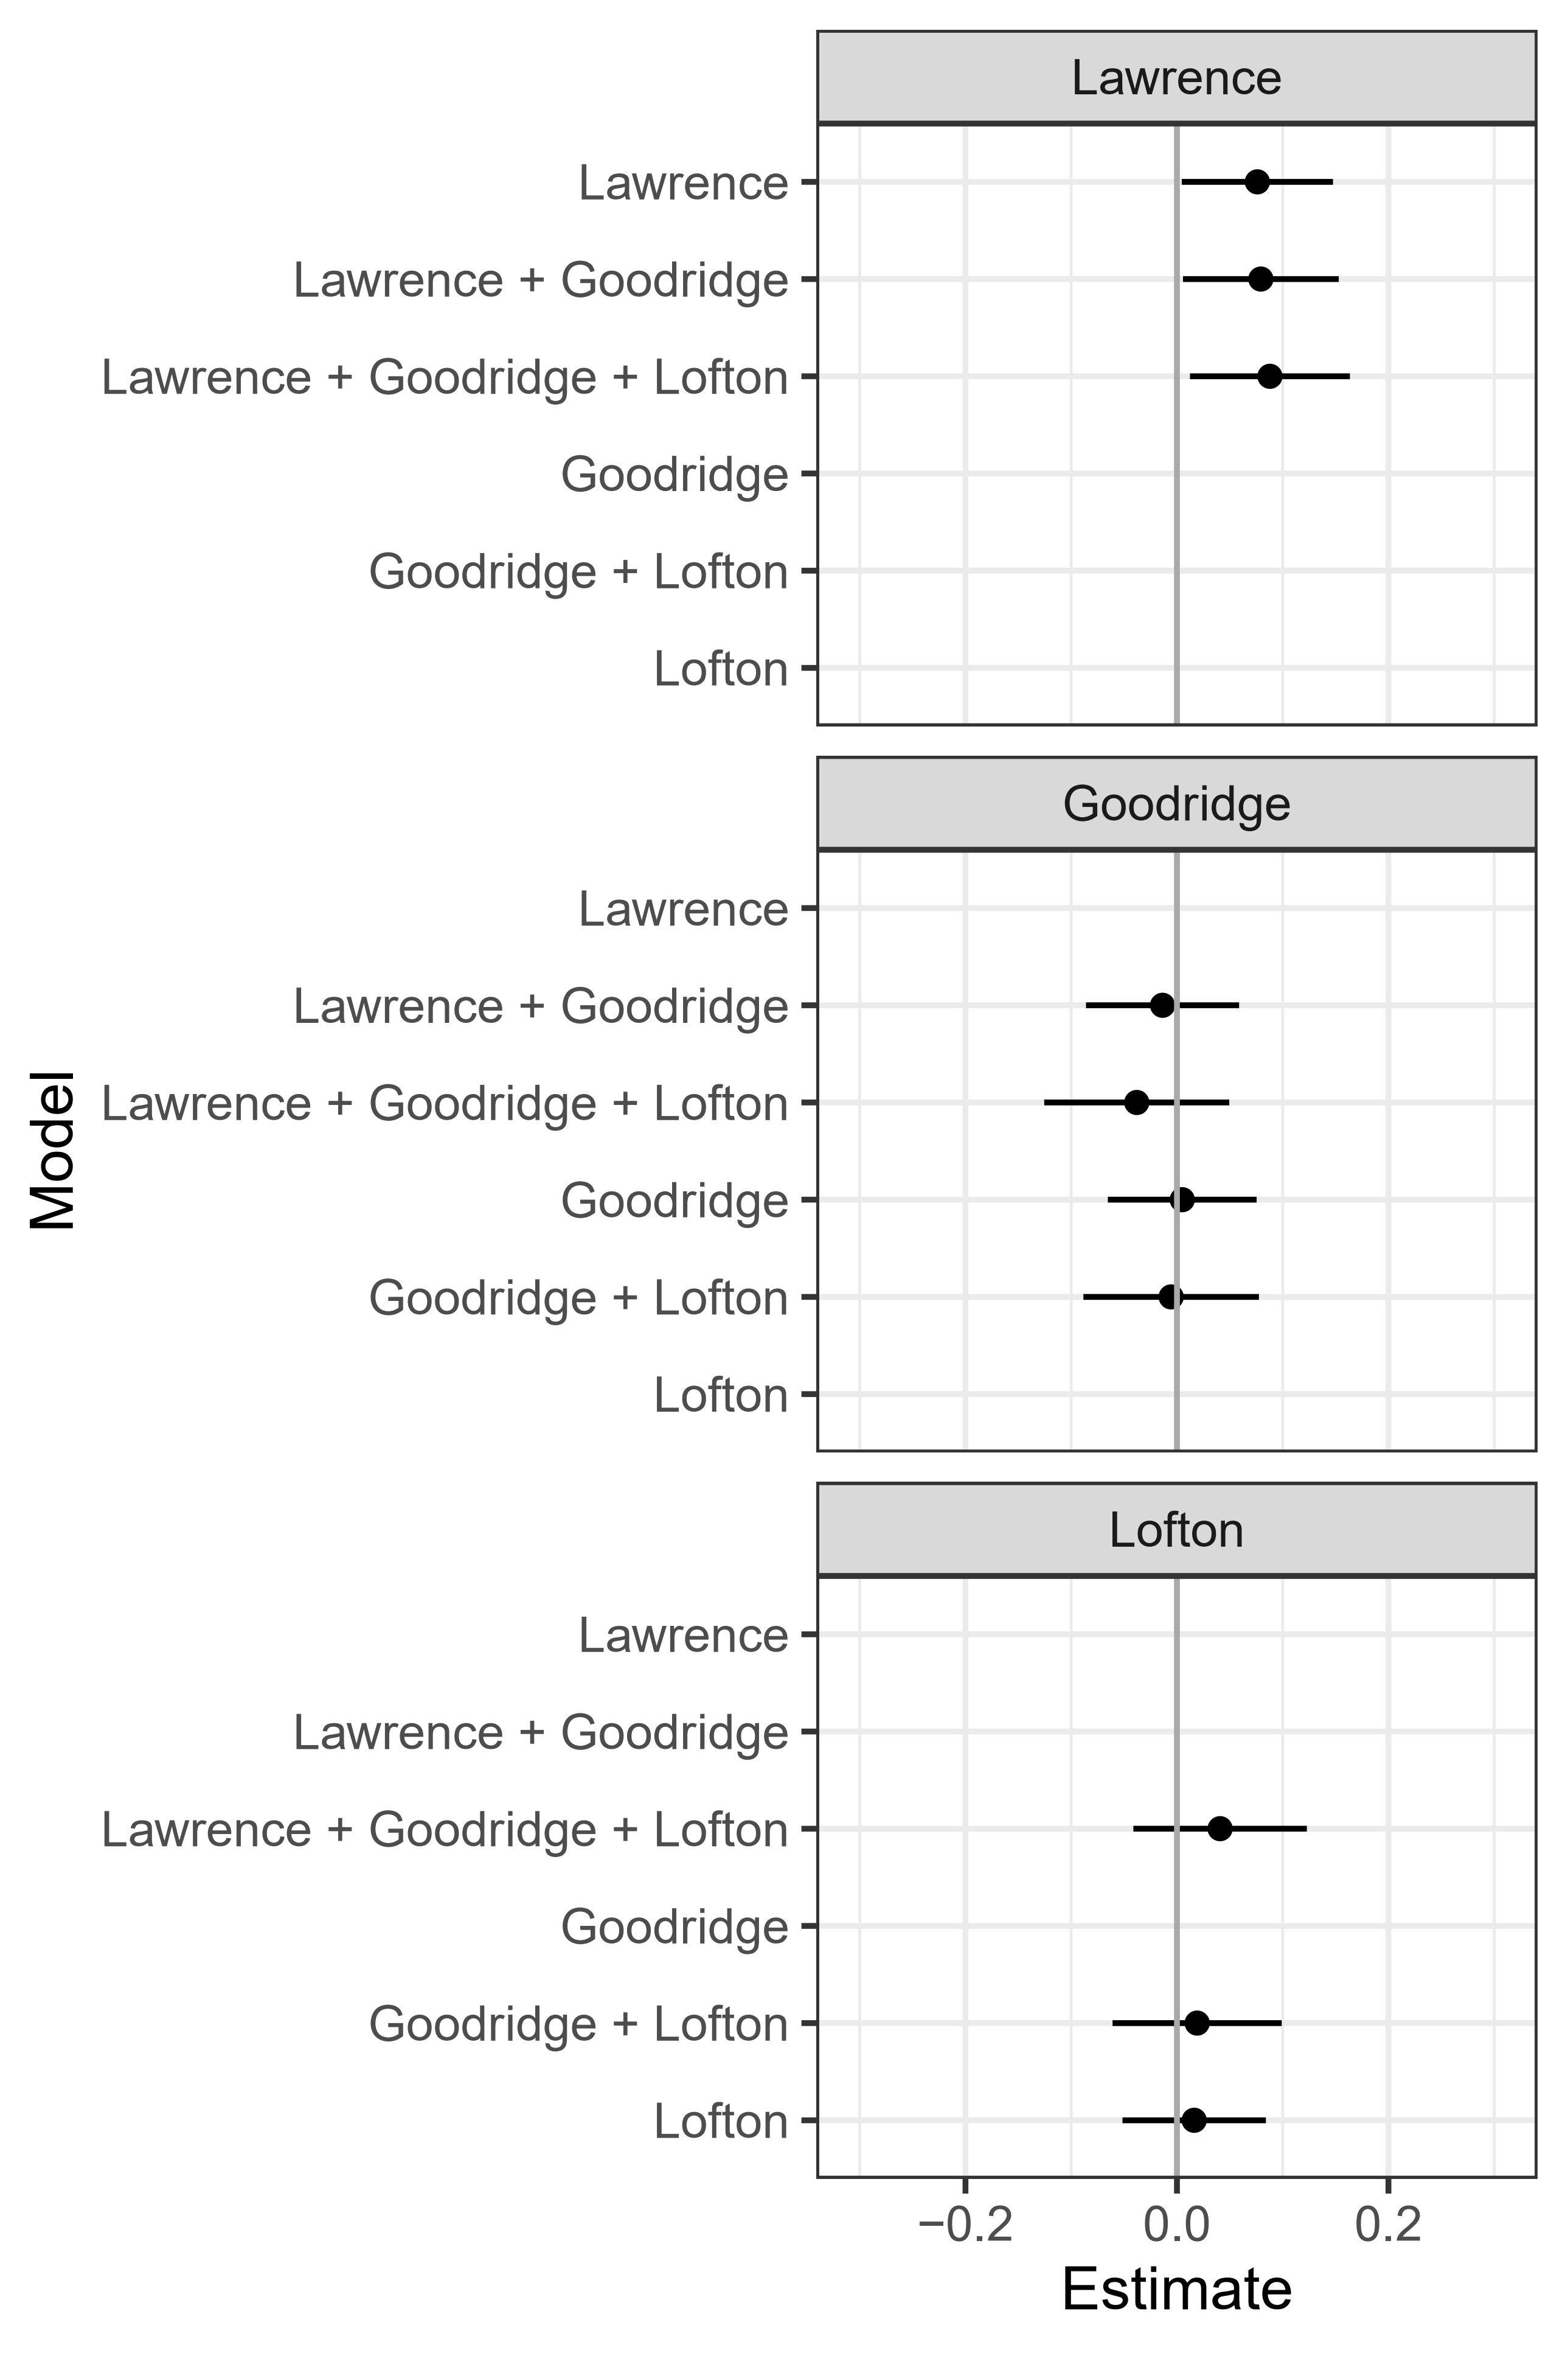
Figure A9: Sequential Model Results of General Inquirer Tone
(see Table A4 for coefficient tables)

 | (1) | (2) | (3) | (4) | (5) | (6)
Lawrence | 0.076* | 0.079* | 0.088*
 | (0.043) | (0.045) | (0.046)
Goodridge |  | -0.014 | -0.038 | 0.005 | -0.005
 |  | (0.044) | (0.053) | (0.043) | (0.050)
Lofton |  |  | 0.041 |  | 0.019 | 0.016
 |  |  | (0.050) |  | (0.048) | (0.041)
Total Pages | 0.003 | 0.003 | 0.003 | 0.004 | 0.004 | 0.004
 | (0.003) | (0.003) | (0.003) | (0.003) | (0.003) | (0.003)
Spline(Date) 1 | -0.067 | -0.061 | -0.077 | -0.057 | -0.065 | -0.066
 | (0.075) | (0.078) | (0.080) | (0.078) | (0.080) | (0.079)
Spline(Date) 2 | 0.019 | 0.010 | 0.030 | -0.014 | -0.006 | -0.004
 | (0.055) | (0.061) | (0.066) | (0.060) | (0.063) | (0.061)
Spline(Date) 3 | -0.055 | -0.035 | -0.081 | 0.079 | 0.063 | 0.057
 | (0.104) | (0.123) | (0.136) | (0.106) | (0.113) | (0.102)
Spline(Date) 4 | -0.168* | -0.161* | -0.180* | -0.139* | -0.147* | -0.148*
 | (0.067) | (0.071) | (0.074) | (0.069) | (0.072) | (0.071)
Spline(Date) 5 | 0.090 | 0.104 | 0.071 | 0.186* | 0.174* | 0.171*
 | (0.095) | (0.106) | (0.113) | (0.095) | (0.099) | (0.093)
Erie | 0.145* | 0.145* | 0.146* | 0.147* | 0.148* | 0.148*
 | (0.022) | (0.022) | (0.022) | (0.022) | (0.022) | (0.022)
Just for Us | 0.212* | 0.213* | 0.219* | 0.213* | 0.216* | 0.215*
 | (0.062) | (0.062) | (0.063) | (0.062) | (0.063) | (0.062)
Rainbow Wedding | 0.155* | 0.155* | 0.156* | 0.153* | 0.153* | 0.153*
 | (0.060) | (0.060) | (0.060) | (0.060) | (0.061) | (0.060)
Tapestry | -0.045 | -0.045 | -0.044 | -0.043 | -0.043 | -0.043
 | (0.031) | (0.031) | (0.031) | (0.031) | (0.031) | (0.031)
Constant | 0.329* | 0.328* | 0.331* | 0.327* | 0.328* | 0.328*
 | (0.036) | (0.036) | (0.036) | (0.036) | (0.036) | (0.036)
R² | 0.079 | 0.079 | 0.079 | 0.076 | 0.076 | 0.076
Adj. R² | 0.070 | 0.070 | 0.069 | 0.068 | 0.067 | 0.068
Num. obs. | 1229 | 1229 | 1229 | 1229 | 1229 | 1229
*p < 0.05, one-tailed.

Table A4: Complete Sequential Model Results for Models of General Inquirer Tone
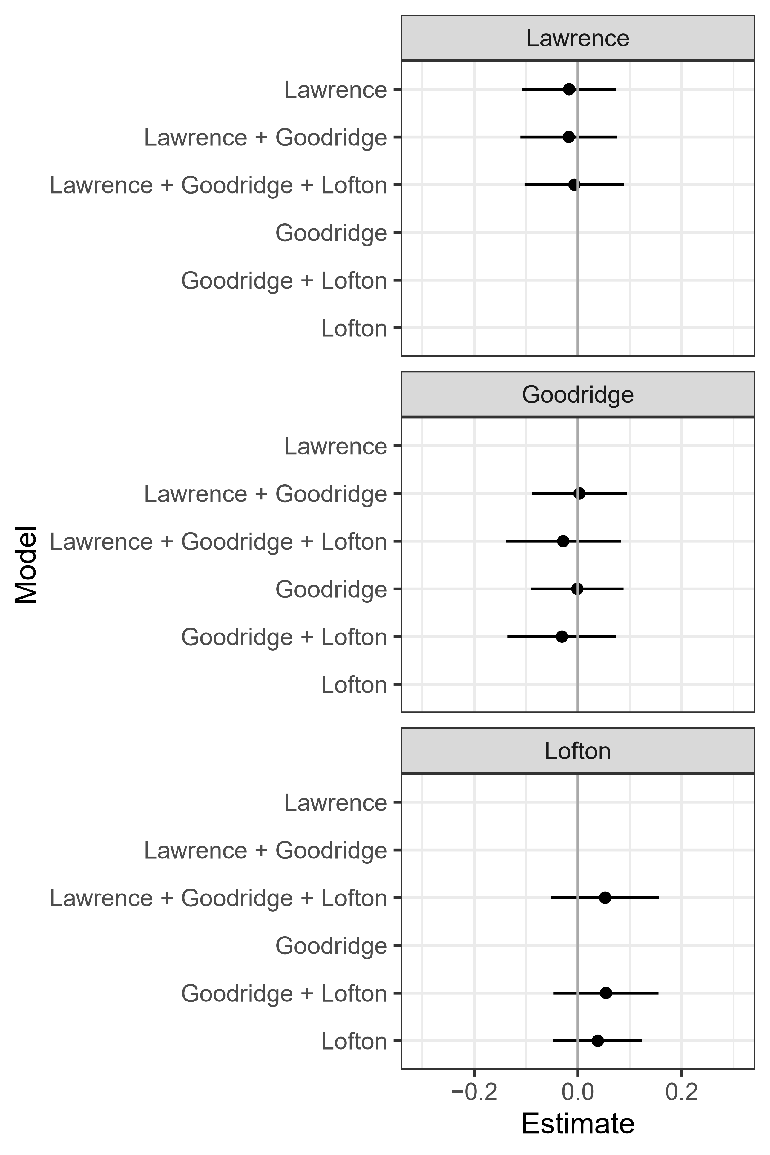
Figure A10: Sequential Model Results of Lexicoder Tone
(see Table A5 for coefficient tables)

 | (1) | (2) | (3) | (4) | (5) | (6)
Lawrence | -0.015 | -0.017 | -0.005
 | (0.055) | (0.057) | (0.058)
Goodridge |  | 0.010 | -0.025 | 0.006 | -0.027
 |  | (0.056) | (0.067) | (0.054) | (0.064)
Lofton |  |  | 0.058 |  | 0.059 | 0.046
 |  |  | (0.063) |  | (0.062) | (0.052)
Total Pages | 0.010* | 0.010* | 0.010* | 0.010* | 0.010* | 0.010*
 | (0.004) | (0.004) | (0.004) | (0.004) | (0.004) | (0.004)
Spline(Date) 1 | 0.097 | 0.092 | 0.069 | 0.091 | 0.069 | 0.063
 | (0.095) | (0.099) | (0.102) | (0.099) | (0.102) | (0.101)
Spline(Date) 2 | -0.012 | -0.006 | 0.021 | -0.001 | 0.023 | 0.032
 | (0.070) | (0.078) | (0.084) | (0.076) | (0.080) | (0.078)
Spline(Date) 3 | 0.203 | 0.188 | 0.122 | 0.164 | 0.114 | 0.088
 | (0.132) | (0.157) | (0.173) | (0.135) | (0.144) | (0.129)
Spline(Date) 4 | -0.092 | -0.097 | -0.124 | -0.102 | -0.126 | -0.131
 | (0.086) | (0.090) | (0.095) | (0.088) | (0.092) | (0.091)
Spline(Date) 5 | 0.333* | 0.323* | 0.276 | 0.305* | 0.270* | 0.252*
 | (0.122) | (0.135) | (0.144) | (0.121) | (0.126) | (0.119)
Erie | -0.114* | -0.114* | -0.113* | -0.114* | -0.113* | -0.113*
 | (0.028) | (0.028) | (0.028) | (0.028) | (0.028) | (0.028)
Just for Us | 0.272* | 0.271* | 0.279* | 0.271* | 0.280* | 0.276*
 | (0.079) | (0.079) | (0.080) | (0.079) | (0.080) | (0.079)
Rainbow Wedding | 0.245* | 0.245* | 0.247* | 0.245* | 0.247* | 0.247*
 | (0.077) | (0.077) | (0.077) | (0.077) | (0.077) | (0.077)
Tapestry | -0.051 | -0.050 | -0.048 | -0.051 | -0.048 | -0.049
 | (0.040) | (0.040) | (0.040) | (0.040) | (0.040) | (0.040)
Constant | 0.095* | 0.096* | 0.100* | 0.096* | 0.100* | 0.101*
 | (0.046) | (0.046) | (0.046) | (0.046) | (0.046) | (0.046)
R² | 0.056 | 0.056 | 0.056 | 0.056 | 0.056 | 0.056
Adj. R² | 0.047 | 0.046 | 0.046 | 0.047 | 0.047 | 0.048
Num. obs. | 1229 | 1229 | 1229 | 1229 | 1229 | 1229
*p < 0.05, one-tailed.

Table A5: Complete Sequential Model Results for Models of Lexicoder Tone
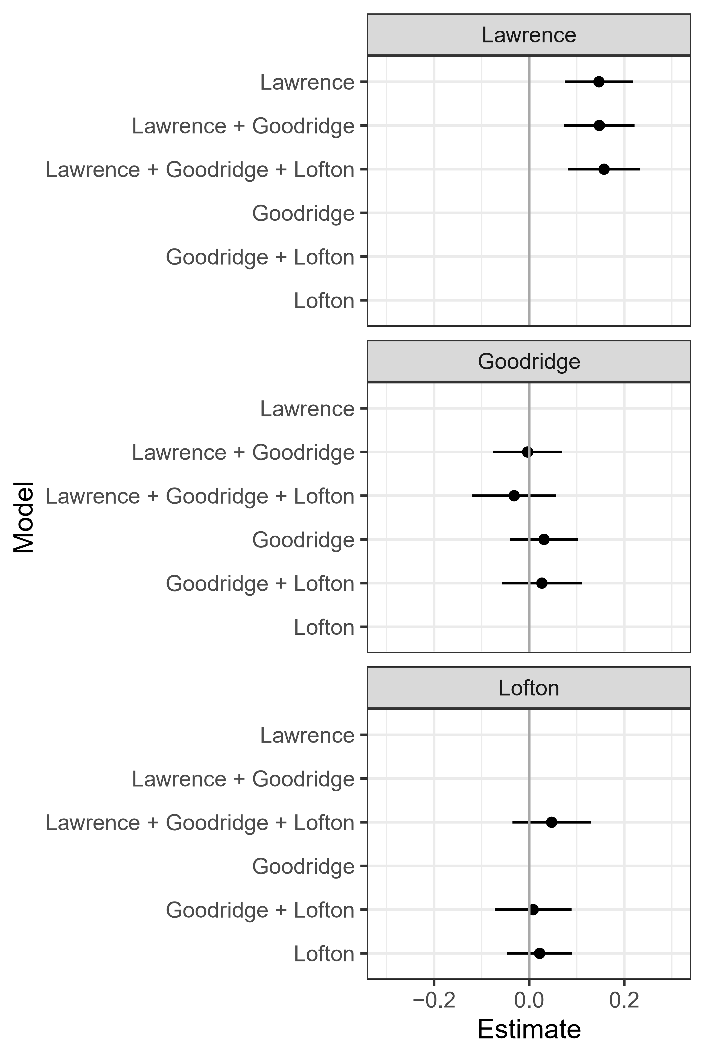
Figure A11: Sequential Model Results of NRC Tone
(see Table A6 for coefficient tables)

 | (1) | (2) | (3) | (4) | (5) | (6)
Lawrence | 0.147* | 0.148* | 0.157*
 | (0.044) | (0.045) | (0.046)
Goodridge |  | -0.003 | -0.032 | 0.031 | 0.027
 |  | (0.044) | (0.053) | (0.043) | (0.051)
Lofton |  |  | 0.047 |  | 0.008 | 0.022
 |  |  | (0.050) |  | (0.049) | (0.041)
Total Pages | 0.013* | 0.013* | 0.013* | 0.013* | 0.013* | 0.013*
 | (0.003) | (0.003) | (0.003) | (0.004) | (0.004) | (0.004)
Spline(Date) 1 | -0.048 | -0.047 | -0.065 | -0.040 | -0.044 | -0.039
 | (0.075) | (0.078) | (0.080) | (0.078) | (0.081) | (0.080)
Spline(Date) 2 | 0.021 | 0.018 | 0.041 | -0.026 | -0.023 | -0.032
 | (0.055) | (0.062) | (0.066) | (0.061) | (0.064) | (0.062)
Spline(Date) 3 | -0.127 | -0.122 | -0.176 | 0.089 | 0.082 | 0.108
 | (0.105) | (0.124) | (0.137) | (0.107) | (0.114) | (0.103)
Spline(Date) 4 | -0.141* | -0.139* | -0.161* | -0.098 | -0.101 | -0.096
 | (0.068) | (0.071) | (0.075) | (0.070) | (0.073) | (0.072)
Spline(Date) 5 | 0.087 | 0.090 | 0.052 | 0.243* | 0.238* | 0.256*
 | (0.096) | (0.106) | (0.114) | (0.096) | (0.100) | (0.094)
Erie | 0.057* | 0.057* | 0.058* | 0.061* | 0.061* | 0.061*
 | (0.022) | (0.022) | (0.022) | (0.022) | (0.022) | (0.022)
Just for Us | 0.146* | 0.146* | 0.153* | 0.145* | 0.146* | 0.150*
 | (0.063) | (0.063) | (0.063) | (0.063) | (0.063) | (0.063)
Rainbow Wedding | 0.197* | 0.197* | 0.199* | 0.194* | 0.194* | 0.194*
 | (0.061) | (0.061) | (0.061) | (0.061) | (0.061) | (0.061)
Tapestry | 0.078* | 0.078* | 0.080* | 0.082* | 0.082* | 0.083*
 | (0.031) | (0.031) | (0.031) | (0.031) | (0.032) | (0.031)
Constant | 0.238* | 0.237* | 0.241* | 0.236* | 0.236* | 0.235*
 | (0.036) | (0.036) | (0.037) | (0.037) | (0.037) | (0.037)
R² | 0.081 | 0.081 | 0.082 | 0.073 | 0.073 | 0.073
Adj. R² | 0.073 | 0.072 | 0.072 | 0.064 | 0.064 | 0.064
Num. obs. | 1229 | 1229 | 1229 | 1229 | 1229 | 1229
*p < 0.05, one-tailed.

Table A6: Complete Sequential Model Results for Models of NRC Tone

A9. Qualitative Content Analysis: Approach, Design, Methods
Qualitative content analysis is a method “for describing the meaning of qualitative material in a systematic way” given a particular set of research questions and objectives (Schreier 2012, 1). The objective of qualitative content analysis is to render complex texts tractable for the research purposes at hand by constraining (some of) their content within a limited number of relevant categories or codes. In qualitative content analysis, the analyst develops a frame of categories or codes for understanding parts of texts that are expected to be generally applicable (at least between the texts under investigation) given the research questions and objectives, and assigns successive parts of the texts to one or more categories (Saldana 2015, 5-6). Qualitative content analysis is most commonly employed in contexts where knowledge is still emergent, instances of categories are subject to debate, the meaning of material is potentially influenced by context, and describing material therefore requires more interpretation and judgment (e.g., Roller 2019; Saldana 2015; Schreier 2012, 16).
Qualitative content analysis is also distinctive in the ways it treats the relationship between category formation, coding of main texts, and evaluation of results. Qualitative content analysis typically begins with the inductive development of categories through immersion in a sample of texts, which are then used to help structure initial interpretation and tagging of content in the full group texts of interest (Elo and Kyngas 2008). Critically, qualitative content analysis coding categories and processes may evolve during the process of investigation in response both to unexpected content and to the analyst’s developing understanding of the material. These new insights can be used to reassess and/or enhance coding of previously-reviewed texts during subsequent passes through those texts. This iterative “updating” of understanding of the evidence based on newly encountered information is central to effective qualitative research (Bennett, Charman, and Fairfield 2021; Fairfield and Charman 2019; McKeown 1999).
In our qualitative content analysis, our objective was to grasp the ways in which LGBTQ+ media contribute to how people understand judicial decisions and their related legal concerns on the issue of same-sex marriage. We began by inductively developing several preliminary coding categories for this specific research purpose based on a review of numerous articles not included in the analysis reported in this manuscript. These categories served as the initial “analytic lens” through which we sought to interpret the 15 articles most associated with the same-sex marriage topic (Saldana 2015, 5-6). Next, we successively worked through the selected articles, reading each article and applying the preliminary codes, but also revising our categories, adding additional categories, and deleting or combining others as we learned more about our texts. This process yielded the final coding categories described in the left-hand panel of Figure A4, which we used for the remainder of the coding process. We will make the articles with our qualitative coding tags available in the Qualitative Data Repository.

Initial Coding Categories | Consolidated Categories for Report
- Discussion of Particular Cases:  Discussion of federal and/or state court decisions, including substance of decisions, implications, and responses by other actors  - Trends in Caselaw:  Discussion of trends in federal and/or state court decisions, including substance of decisions, implications, and responses by other actors  - Discussion of Specific State Laws and Regulations:  Discussion of particular state laws and/or regulations, including substance, politics surrounding enactment, and responses by other actors  - Trends in State Law and Regulations:  Discussion of trends in state laws and/or regulations, including substance, politics surrounding enactment, and responses by other actors  - International Comparisons:  Discussion of legal decisions, laws, or regulations relating to marriage equality outside the United States  - Human Interest Stories:  Discussion of the stories of individuals and couples who were adversely affected by lack of access to marriage, civil unions, and/or domestic partnerships  - Allies and Adversaries:  Descriptions of, and discussions of the positions and actions of, individuals and organizations that support and oppose same-sex marriage, civil unions, and/or domestic partnerships  - Partisan and Ideological Struggles:  Discussion of the ways in which struggles over marriage equality relate to broader partisan and ideological conflicts over role of government, partisan strategy in elections, and the like  - Explanation of Important Legal Concepts:  Explanation, typically in form of quotations from LGBTQ+ legal activists, attorneys, or academics, explaining how judicial decisions and/or laws and regulations relate to or illustrate general legal concepts; or explanation of how judicial decisions and/or laws and regulations likely impact the ongoing development of important legal rights, constraints, or relations | - Informing Readers about Relevant Legal Episodes and Trends  - Highlighting Sympathetic “Victims” of Exclusionary Marriage Laws  - Creating Understandable Stories Featuring “Heroes” and “Villains”  - Linking Coverage of Court Cases to Broader Legal and Political Struggles  - Explaining Important Legal Concepts

Figure A4: Coding Categories and Consolidated Categories for Report
After our first pass through all of the articles, we took stock of our categories and decisions, and made a second complete pass through all of the articles in order to incorporate the adjustments to the coding categories we made on the first pass and ensure we applied them consistently to all 15 articles. Following the second pass, we examined the content we had associated with each of the codes to confirm that the coding adjustments represented the data well, and reflect on the patterns we had observed so far.
Next, a third pass was undertaken to promote full confidence and remove any errors that may have emerged in the first two rounds. Finally, after the third complete pass through the articles, we examined the coding results with an eye to how best to report our findings, consolidating some similar categories to facilitate ease of presentation and renaming overarching categories to better represent the included instances (e.g., Creswell 2013, 184-185; Saldana 2015, 24). The major consolidation was of five categories that described patterns in judicial decisions and state lawmaking into a single category, “Informing Readers about Relevant Legal Episodes and Trends.” We represent how we consolidated categories in the right-hand panel of Figure A4.

A6. Annotations for Transparent Inquiry
Below, we report our annotations for transparent inquiry (ATI) corresponding to our qualitative data analysis and identified in the text of the manuscript. For more information on ATI see, for example, Qualitative Data Repository (2022) and Kapiszewski and Karcher. (2021).

[ATI 1]
The articles closely associated with the marriage topic extensively covered the Massachusetts Supreme Judicial Court’s 2003 ruling in Goodridge v. Department of Public Health ordering the state legislature to take steps to legally recognize same-sex relationships; as well as struggles among state officials about whether to respond to the decision by granting marriage equality, providing civil unions, or enacting a constitutional amendment banning same-sex marriages altogether; and the jubilation of Massachusetts gay and lesbian couples completing wedding vows following enactment of same-sex marriage legislation.

For example, Our Wedding Album 2004 provided a comprehensive timeline of major events surrounding the Goodridge decision.
“4.11.2001
In Boston seven same-sex couples sue to challenge Massachusetts’s ban on gay marriage after being denied marriage licenses.
5.8.2002
A superior court judge rules that the legality of same-sex marriage should be decided by the legislature and rules against granting marriage licenses to the seven couples.
3.4.2003
The Massachusetts supreme judicial court hears arguments in the case brought by the seven gay couples who wish to obtain marriage licenses.
11.18.2003
The supreme judicial court rules it is unconstitutional to bar gay couples from getting married, and it gives the legislature 180 days to come up with a solution to allow gay marriage.
12.11.2003
The Massachusetts senate votes to ask the supreme judicial court if Vermont-style civil unions would satisfy the court's order to permit same-sex marriage.
2.4.2004
The supreme judicial court clarifies its earlier ruling, saying that only full, equal marriage rights for gay couples not civil unions will satisfy constitutional requirements.
2.6.2004
Presumed Democratic presidential candidate John Kerry announces his opposition to gay marriage in Massachusetts. He endorses civil unions as an alternative.
2.11.2004
The Massachusetts legislature opens its constitutional convention with debate on a proposed constitutional ban on gay marriage.
2.12.2004
Lawmakers adjourn the convention amid debate after failing to pass three separate proposals to constitutionally ban same-sex marriage.
3.11.2004
Lawmakers recess the constitutional convention but come closer to passing a proposed constitutional amendment that would ban gay marriage and allow for civil unions.
3.29.2004
The state legislature approves a proposed constitutional amendment to ban gay marriage but legalize civil unions. If approved by the next legislative session, the amendment would go before voters on the November 2006 ballot.
4.15.2004
In an effort to get around his own attorney general, who favors allowing same-sex marriages, Gov. Mitt Romney files a legislative measure to permit him to appeal to the state’s high court directly. His effort fails.
4.29.2004
Romney invokes a 1913 state law in an attempt to bar out-of-state same-sex couples from marrying in Massachusetts.
5.14.2004
The U.S. Supreme Court refuses to block the country’s first state-sanctioned gay marriages from taking place starting May 17.
5.17.2004
Marriages of gay couples commence in Massachusetts.”

Meanwhile, Kuhr 2004 and Not Giving Up explained (ultimately futile) resistance from Massachusetts Governor Mitt Romney and conservative state legislators to marriage equality in the state in some detail.

Kuhr reported that “In Massachusetts Governor Mitt Romney continues to vow that he’ll derail the same-sex marriages scheduled to begin May 17. On April 15 he filed a request for emergency legislation to appoint special counsel to circumvent the state’s attorney general and petition the Massachusetts supreme judicial court for a stay of its decision granting same-sex couples marriage rights. Romney had sought Atty. Gen. Tom Reilly’s representation in front of the state’s high court, but Reilly urged Romney to accept defeat, calling same-sex marriage the law of the state.”

Not Giving Up noted that some state legislators sought to ban marriage equality. “In Massachusetts the legislature's marriage-ban proposal, which needs to be confirmed in a final vote March 29, would allow for civil unions. But it would take at least two years to implement and would not affect the state supreme judicial court’s ruling that same-sex marriages must be legal May 17.”

[ATI 2]
The articles in our dataset provided considerable coverage of a similar development in New Jersey, in which a 2006 State Supreme Court ruling that the denial of equal rights to same-sex couples violated the state’s constitution led the state legislature to enact civil unions legislation in 2004.

For example, Bob 2007 provided an overview of the politics surrounding enactment of the legislation, as well as an overview of its major features and the reactions of gay rights groups to its passage:

“The Governor of New Jersey has signed a new civil unions law giving the state’s gay couples all the rights and responsibilities of marriage. New Jersey becomes the third state to institute civil unions and the fifth to offer some version of marriage.

Gov Jon S. Corzine, a Democrat, signed the civil unions bill which takes effect Feb. 19, making New Jersey, Connecticut and Vermont the three states that allow civil unions for gay couples. Massachusetts allows gay couples to marry, while California has domestic partnerships.

Under the New Jersey law, gay couples are also granted adoption, inheritance, hospital visitation and medical decision-making rights and the right not to testify against a partner in state court.
The Legislature passed the civil unions bill in response to an October state Supreme Court order
that gay couples be granted the same rights as married couples. The court gave lawmakers six months to act but left it to them to decide whether to call the unions, marriage, or something else.
While activists welcome the law, some argue that not calling the relationship “marriage” creates a different, inferior institution. Even though the state law provides gays with the benefits of married couples, they won’t be entitled to the same federal benefits because of the 1996 federal law that defines marriage as being between a man and a woman. For example, surviving partners won’t be able to collect deceased partners Social Security benefits.

The gay rights group Garden State Equality has promised to push lawmakers to change the terminology to marriage. Others are considering lawsuits to force full recognition of gay marriage. The bill creates a commission that will regularly review the law and recommend possible changes.”

Dahir 2004 provides a similarly detailed discussion of the politics around enactment of New Jersey’s civil union legislation, while also providing quotations from state legislators and legal authorities to shed light on the bill’s features:

“Already in the news for an ongoing court battle that could legalize same-sex marriage in the state, New Jersey has now become only the fifth state in the nation to legally recognize gay and lesbian relationships. Signed into law by Gov. James McGreevey on January 12, the new law will give registered domestic partners hospital visitation rights, the ability to make medical decisions for their partners, an exemption from state inheritance taxes, and equal access to spousal benefits from insurance companies. The law covers not only same-sex couples but also unmarried heterosexual couples age 62 and older. Vermont, Hawaii, and California already have partnership laws, while Massachusetts’s highest court recently ordered that same-sex marriages be made legal before next summer.

“Influencing that case wasn’t the intention of passing the domestic partnership law,” said Loretta Weinberg, a state assemblywoman and lead sponsor of the bill. “For me, it is simply to recognize many people I know who don’t have as much equality under the law as they should have.”

Suzanne Goldberg, a law professor at Rutgers University in New Jersey, who helped draft an early version of the bill in 1999, said the new law still doesn’t give same-sex couples recognition as traditional families under many government programs. Strong opposition in tire state assembly [which barely passed the measure] caused the legislature to strip back the bill, she said. But the New Jersey law was never intended to be a substitute for marriage, she added. Though it doesn’t come close to comprehensive measures like Vermont’s civil unions or California’s sweeping domestic-partnership law, it’s a big step forward, she said, and an important nod to New Jersey’s gay population.”

[ATI 3]
The articles informed readers of developments in marriage-related lawmaking and court decisions in other nations, helping to provide context for understanding the (lack of) development of marriage equality throughout the United States prior to the Obergefell decision in 2015.

For example, Allen 2005 reported that:
“In the last two months the United Kingdom and New Zealand sanctioned civil unions for gay and lesbian couples, which will take effect this year. And full legal gay marriage is expected in Spain, South Africa, and Canada, perhaps by year’s end. The Canadian supreme court on December 9 gave approval to the introduction of legislation that would legalize same-sex marriage nationwide. Prime Minister Paul Martin and his justice minister, Irwin Cotier, have pledged to offer a same-sex marriage bill as soon as the parliament reconvenes January 31. After a period of debate, the first vote will likely occur within a couple of months.

Despite organized opposition from some well-funded religious groups and a call for a national referendum on same-sex marriage by conservative Canadian lawmakers, at this point it looks like it will pass, said Laurie Arron, director of advocacy for Egale Canada, a national gay rights group. Seven provinces and the Yukon Territory have declared same-sex marriage laws to be legal, and polls consistently show that a majority of Canadians approve.

In October, Spain’s ruling Socialist Party approved legislation to legalize same-sex marriage, and the bill is expected to pass the legislature later this year. And in a case brought by a lesbian couple in South Africa, that country’s highest court ruled on November 30 in favor of providing marriage rights to gay and lesbian couples.”

Hudson 2005 also provided extensive information about developments in policymaking relating to marriage and civil unions in other parts of the world:

“Spain is just one of a half dozen countries worldwide that have made crucial strides toward marriage rights - or at least civil union-like protections - during the past year.
In April, New Zealand’ s Civil Union Bill gave unmarried couples crucial rights in such areas as child custody, taxation, and welfare. Brazil has also extended rights to same-sex couples. In December same-sex couples in the United Kingdom will get the same tax and pension rights as straight couples under the Civil Partnership Bill.

What country will be next to offer protections to gay and lesbian couples? It seems that Sweden will be the next country after Spain to open up marriage. It’s difficult to say which country will follow after that, says Kees Waaldijk, law professor at Leiden University in the Netherlands.
Still, Spain continues to represent the most dramatic turn for gay equality. In March 2004, just days after the Madrid train bombings, voters tossed out the Popular Party for the Socialists, led by Prime Minister Jose Luis Rodriguez Zapatero. He immediately promised liberal reform.

“Spain is different from the first countries who led the way,” says Lee Badgett, economics professor at the University of Massachusetts Amherst and research director of the Institute for Gay and Lesbian Strategic Studies. “Because it is very religious, it’s more like the countries that have been slow to act. That’s why it’s interesting to see what is happening there.”

[ATI 4]
The articles closely associated with the marriage equality topic consistently took for granted that same-sex marriage should be a primary objective of the LGBTQ+ movement, and that marriage equality – and not mere civil unions – was the end goal of the movement.

A primary way in which the articles emphasized the primacy of marriage equality was by repeatedly citing and quoting Evan Wolfson of Freedom to Marry and Mary Bonauto of Gay and Lesbian Defenders – two of the staunchest proponents of marriage equality in the LGBTQ+ legal movement (Frank 2017) – in their coverage of legal and political developments relating to marriage.

[ATI 5]
In one striking example of the articles’ highlighting of the activities of pro-marriage actors, On the Towns 2004 approvingly profiled local registrars who granted marriage licenses to same-sex couples despite a lack of clear authorization from their states’ legislatures:

“Want to get married in your hometown? Urge your local officials to follow the path of these cities defiant leaders.

ASBURY PARK, N.J.
population: 16,930 Percentage in heterosexual marriages: 29.2
Marriage advocate: Deputy Mayor James Bruno, a divorced father of two, married his first same-sex couple on March 8.
Quote: “It felt like any other wedding I’ve done,” Bruno told The New York Times. “It was a very cool thing - the atmosphere, the friends. I have gay neighbors and gay friends. They’re like anybody else. They cut their grass. They walk the dog. They pay their taxes.”
Can same-sex couples get MARRIED THERE NOW? No. On March 9, New Jersey attorney general Peter C. Harvey ordered city officials to stop issuing marriage licenses to gay couples and ruled that any such licenses already issued were invalid.

BERNALILLO, N.M.
population: 6,611
PERCENTAGE IN HETEROSEXUAL marriages: 48.7
MARRIAGE ADVOCATE:
Sandoval County clerk Victoria Dunlap, who on February 20 issued marriage licenses to at least 26 same-sex couples after the county attorney said New Mexico marriage laws do not specify gender.
Quote: “This has nothing to do with politics or morals. If there are no legal grounds that say this should be prohibited, I can’t withhold it.”
Can same-sex couples get MARRIED THERE NOW? No. On February 20, New Mexico attorney general Patricia Madrid issued an opinion saying the licenses were invalid under state law. A crowd reacted with boos as a deputy clerk read Madrid's ruling, which ended Dunlap’s civil disobedience.

NEW PALTZ, N.Y.
Population: 6,034
Percentage in heterosexual marriages: 25.5
Marriage advocate: Mayor Jason West, 26, of the Green Party, earned multiple misdemeanor counts for marrying 25 same-sex couples on February 27; 40 licenses were issued before West was pressured to stop.
Quote: "I firmly believe that it would be both unfair and contrary to the New York constitution to deny the benefits and responsibilities afforded by marriage to same-sex couples.”
Can same-sex couples get married there now? No. but as of March 4. the same-sex marriage waiting list was 1,400 names deep.

NYACK, N.Y.
Population: 6,737
Percentage in heterosexual marriages: 40
Marriage advocate: Openly gay mayor John Shields on March 3 announced that Nyack would sue the New York State Department of Health to force it to allow the town to issue marriage licenses to same-sex couples including Shields and his partner.
Quote: “As time has gone on, I've realized more and more it’s time for me to fight for people such as ourselves.”
Can same-sex couples get MARRIED THERE NOW? No.

PORTLAND, ORE.
Population: 529,121
Percentage in heterosexual MARRIAGES: 44.1
Marriage advocates: The Multnomah County commissioners decided on March 3 that Oregon’s law compelled them to provide marriage licenses to same-sex couples. As many as 2.000 licenses were issued within two weeks.
Quote: “This decision really was an interpretation of what the law in Oregon really is. And that is, we cannot discriminate,” said county commissioner Lisa Naito.
Can same-sex couples get MARRIED THERE NOW? As Of press time, yes. On March 8 a judge denied a request for a preliminary injunction brought by a conservative group to stop the weddings. To find out the current status, call (503) 988-3027.

SAN FRANCISCO
Population: 776,733
Percentage in heterosexual marriages: 38.7
Marriage advocate: Newly elected mayor Gavin Newsom, 36, has overseen more than 4,000 same-sex marriages.
Quote: “I am reacting to President Bush's divisiveness on this issue, and I am responding to my oath of office. I felt what we are doing is consistent with the [California] constitution, and from a legal perspective we think we are on a firm basis.” [Find the full interview with Newsom at www.advocate.com]
Can same-sex couples get MARRIED THERE NOW? No. After 4,161 weddings, on March 11 the California supreme court ordered a halt to the issuing of marriage licenses to same-sex couples.”

[ATI 6]
In addition to the legal discussions cited in the text, Dahir 2003 provided a detailed overview of the debate between legal analysts over the meaning of the Massachusetts Supreme Judicial Court’s ruling in Goodridge, noting the variation in analysts’ interpretation of the language of the decision:

“There’s only one way to read this, from my perspective,” says Mary Bonauto the day after the Massachusetts Supreme Judicial Court ruled that it was unconstitutional to exclude gay couples from marriage. “We won the right to marry.” Bonauto, an attorney at the Boston organization Gay and Lesbian Advocates and Defenders, was lead counsel in the case, so she could be excused for having a biased perspective. But most advocates for same-sex marriage say no excuse is necessary.

“There’s no wiggle room here,” says David Buckel, director of Lambda Legal Defense and Education Fund’s Marriage Project and the lead attorney on a similar marriage case in New Jersey. “There’s no ambiguity: Marriage is the remedy.” And Evan Wolfson, executive director of New York City-based Freedom to Marry, declares, “This is it, it’s done, it’s marriage!”

Marriage opponents, however, find less clarity in the November 18 decision. The sticking point, they say, is the 180 days justices gave the legislature to respond to the ruling. They say the six-month stay is the court’s way of providing lawmakers enough leeway to pass nonmarriage legislation such as civil unions or domestic-partnership packages and still meet its mandate.

Republican governor Mitt Romney immediately declared his opposition to the court’s ruling. “Marriage is an institution between a man and a woman,” he said in a prepared statement. “I will support an amendment to the Massachusetts constitution to make that expressly clear. Of course, we must provide basic civil rights and appropriate benefits to nontraditional couples, but marriage is a special institution that should be reserved for a man and a woman.”

Romney has strong allies in the legislature, including the powerful speaker of the house, Democrat Tom Finneran, who also favors a constitutional amendment banning gay marriage. A Finneran spokesman tells The Advocate, We don’t know what the legislative response will be at this time. I don’t think anyone does.

Unlike in Alaska and Hawaii where court rulings in favor of gay marriage were nullified by legislative action amending those states constitutions it would take at least three years for such an amendment to take effect in Massachusetts. It first must be approved during two legislative sessions (one in 2004 and another in 2005), and it then would have to go before voters in November 2006 at the earliest. A joint session of the legislature, called a constitutional convention, has been scheduled for February 11 to take up the proposed amendment.

Even some legal scholars supportive of same-sex marriage say the ruling could be interpreted to allow a solution that falls short of full marriage equality. “The court said that those in same-sex unions have to be ensured the same privileges and responsibilities" as married heterosexuals, says Nathaniel Persily, a constitutional law professor at the University of Pennsylvania. “It does not say it has to grant gay marriages per se.”

Adds Shari Levitan of the Boston-based law firm Holland and Knight: “I personally don’t read civil unions as passing muster under this court ruling. But who’s to say the legislature won’t purposely thumb its nose at the court and pass something like a civil unions bill just to force a showdown?"

That’s exactly what Greg Johnson, associate professor at Vermont Law School and cocounsel on the Alaska marriage case, worries opponents might try in order to drag out the legal battles until the constitutional amendment can pass. “This whole tiling could be tied up in the courts for years and we won’t see civil marriage or civil union or anything come out of it,” he says.

Emphasizing that the Massachusetts ruling is a bold, courageous opinion that represents the strongest American court statement on gay marriage, Johnson points to Hawaii, Alaska, and even Vermont in cautioning, “There is always a difference between legal intent and political reality. I don’t think any of us knows what will happen in 180 days.”

But Bonauto is sure of one thing that will happen on May 16. “If gay and lesbian people can’t walk through the doors and get marriage licenses,” she says, “we’ll be back in court.”

References

Abelson, Reed. 2000. “Out Magazine Acquired by The Advocate, A Key Rival.” New York Times, February 21.
Allen, Dan. 2005. “Global Marriage Boom.” The Advocate, February 1.
Adams, Ira. 2007. “Your America: Focus on New Jersey.” Rainbow Wedding Network Magazine 2(1): 17-19.
Bennett, Andrew, Andrew E. Charman, and Tasha Fairfield. 2022. “Understanding Bayesianism: Fundamentals for Process Tracers.” Political Analysis 30(2): 298-305.
Bob. 2007. “Civil Unions Legal in New Jersey.” Erie Gay News, February.
Caldwell, John. 2004. “New England Nuptials?” The Advocate, March 16.
Clark, Tom S. 2009. “The Separation of Powers, Court Curbing, and Judicial Legitimacy.” American Journal of Political Science 53(4): 971-989.
COLAGE. 2023. “Our Story.” https://colage.org/our-story/ (June 22).
Creswell, John W. 2013. Qualitative Inquiry and Research Design: Choosing Among Five Approaches. 3rd Edition. New York: Sage.
Dahir, Mubarak. 2003. “Waiting at the Alter,” The Advocate, December 23.
Dahir, Mubarak. 2004. “Garden State of Bliss.” The Advocate, February 17.
Edgington, Eugene, and Patrick Onghena. 2007. Randomization Tests. Boca Raton, FL: Chapman & Hall/CRC Press.
Elo, Satu, and Helvi Kyngas. 2008. “The Qualitative Content Analysis Process.” Advanced Nursing 62(1): 107-115.
Erie Gay News. 2023. “About Erie Gay News.” https://www.eriegaynews.com/news/article.php?recordid=aboutegn.html (June 22).
Fairfield, Tasha, and Andrew Charman. 2019. “A Dialogue with the Data: The Bayesian Foundations of Iterative Research in Qualitative Social Science.” Perspectives on Politics 17(1): 154-167.
Gadd, Christianne Anastasia. 2012. “The Advocate and The Making of a Gay Model Minority.” Ph.D. Dissertation. Lehigh University.
Hudson, Mike. “You and Me Against the World.” The Advocate, June 21.
International Foundation for Gender Education. 2023. “Transgender Tapestry.” http://www.ifge.org/tgmag/tgmagtop.htm (June 22).
Kuhr, Fred. 2004. “Gay Marriages in Limbo,” The Advocate, May 25.
Lax, Jeffrey R., and Kelly T. Rader. 2010. “Legal Constraints on Supreme Court Decision Making: Do Jurisprudential Regimes Exist?” Journal of Politics 72(2): 273-284.
Lisotta, Christopher. 2004. “Can Mass. Dodge Marriage?” The Advocate, February 3.
Kapiszewski, Diana, and Sebastian Karcher. 2021. “Empowering Transparency: Annotation for Transparent Inquiry (ATI).” PS: Political Science & Politics 54(3): 473-478.
Kuhr, Fred. 2004. “Gay Marriages in Limbo.” The Advocate, May 25.
McKeown, Timothy J. 1999. “Case Studies and the Statistical Worldview: Review of King, Keohane, and Verba's Designing Social Inquiry: Scientific Inference in Qualitative Research.” International Organization 53(1): 161-190.
“Not Giving Up.” 2004. The Advocate. April 13.
“On the Towns.” 2004. The Advocate, April 13.
“Our Wedding Album”. 2004. The Advocate, June 22.
Qualitative Data Repository. 2022. “Annotation for Transparent Inquiry (ATI) at a Glance.” https://qdr.syr.edu/ati (September 1).
RainbowWeddingNetwork. 2023. “Advertise.” https://www.rainbowweddingnetwork.com/advertise (June 22).
Roller, Margaret R. 2019. “A Quality Approach to Qualitative Content Analysis: Similarities and Differences Compared to Other Qualitative Methods.” Forum: Qualitative Social Research 20(3): DOI:10.17169/fqs-20.3.3385.
Ryan, Benjamin. 2004. “Bordering on Equality.” The Advocate, June 8.
Saldana, Johnny. 2015. The Coding Manual for Qualitative Researchers. London, UK: Sage.
Schreier, Margrit. 2012. Qualitative Content Analysis in Practice. London, UK: Sage.
Simmons, Todd. 2005. “Civil Compromise.” The Advocate, May 24.
Vining Jr, Richard L., and Teena Wilhelm. 2011. “Measuring Case Salience in State Courts of Last Resort.” Political Research Quarterly 64(3): 559-572.

We do not claim to exhaustively code all of the content of each article, but rather only the content that is relevant to our research purposes.
In our qualitative content analysis, we assigned codes while reading the full text of each article. Because the unit of analysis was the article, codes could be assigned to blocks of text of different length. In this project, the minimum acceptable length was one sentence, but the more common length of a coded segment was several sentences (i.e., a paragraph).
The categories are not mutually exclusive – a unit of text could be assigned to more than one category.

