Appendix

Part 1: Selected Tables and Figures

Part 2: Issues of Design and Recruitment
Please note: Further Supplementary Materials for the Causal Mediation Analyses Can Be Found in the APSR Dataverse

Part 1

Table A.1: Appendix Tables for Table 1 in Main Paper: Panels A and B
A.1 Panel A: Mean Policy-Based Scores (PBS) By Issue Area Across Time, Participant Group

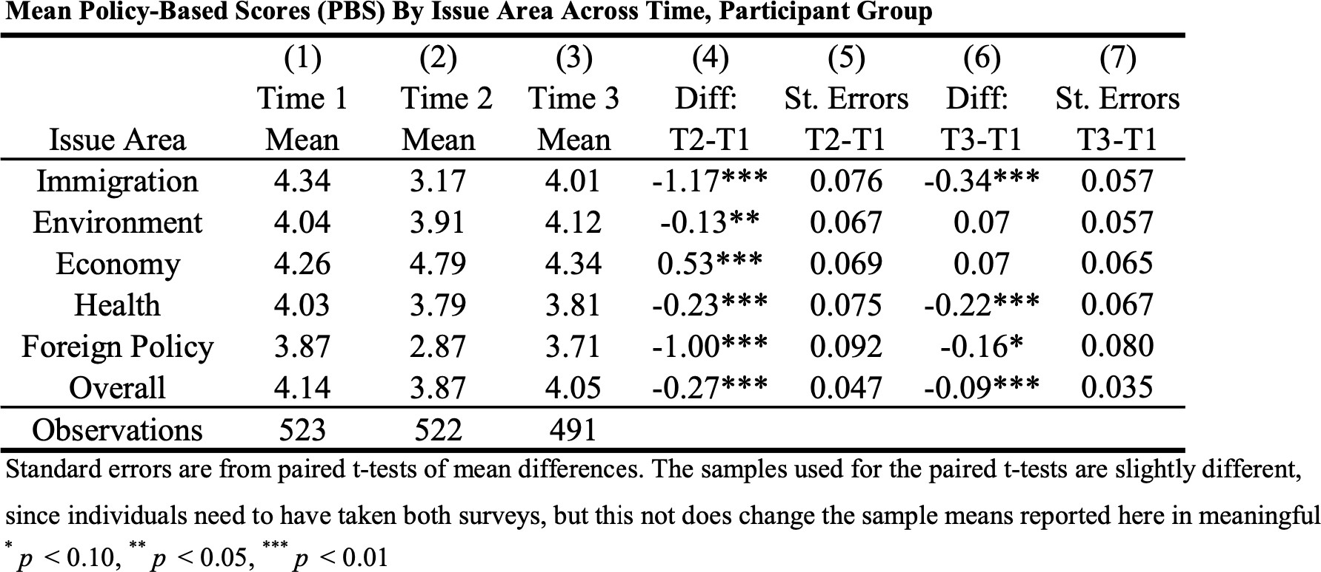

A.1 Panel B: Mean Policy-Based Scores (PBS) By Issue Area Across Time, Control
Group

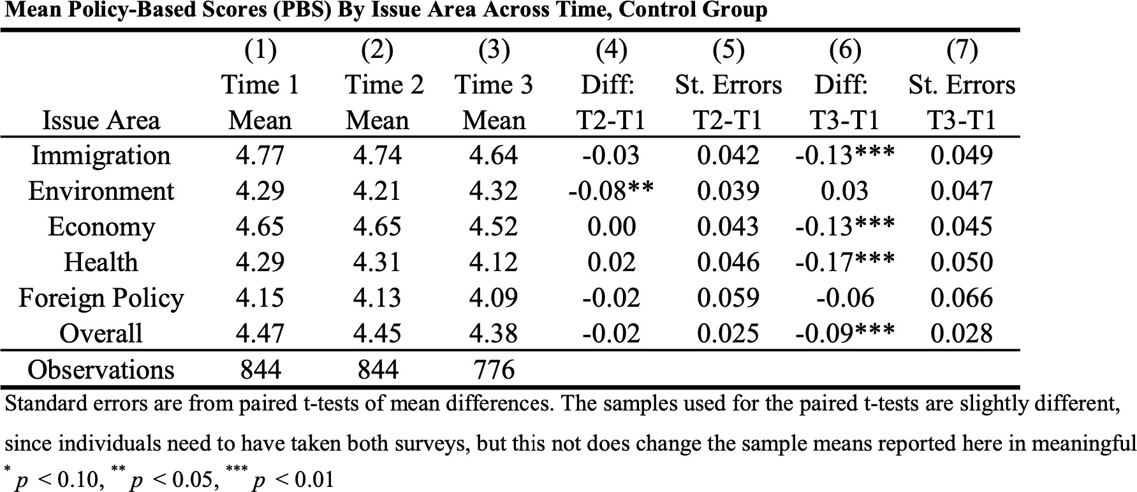

Table A.2: Differences By Issue Area¹

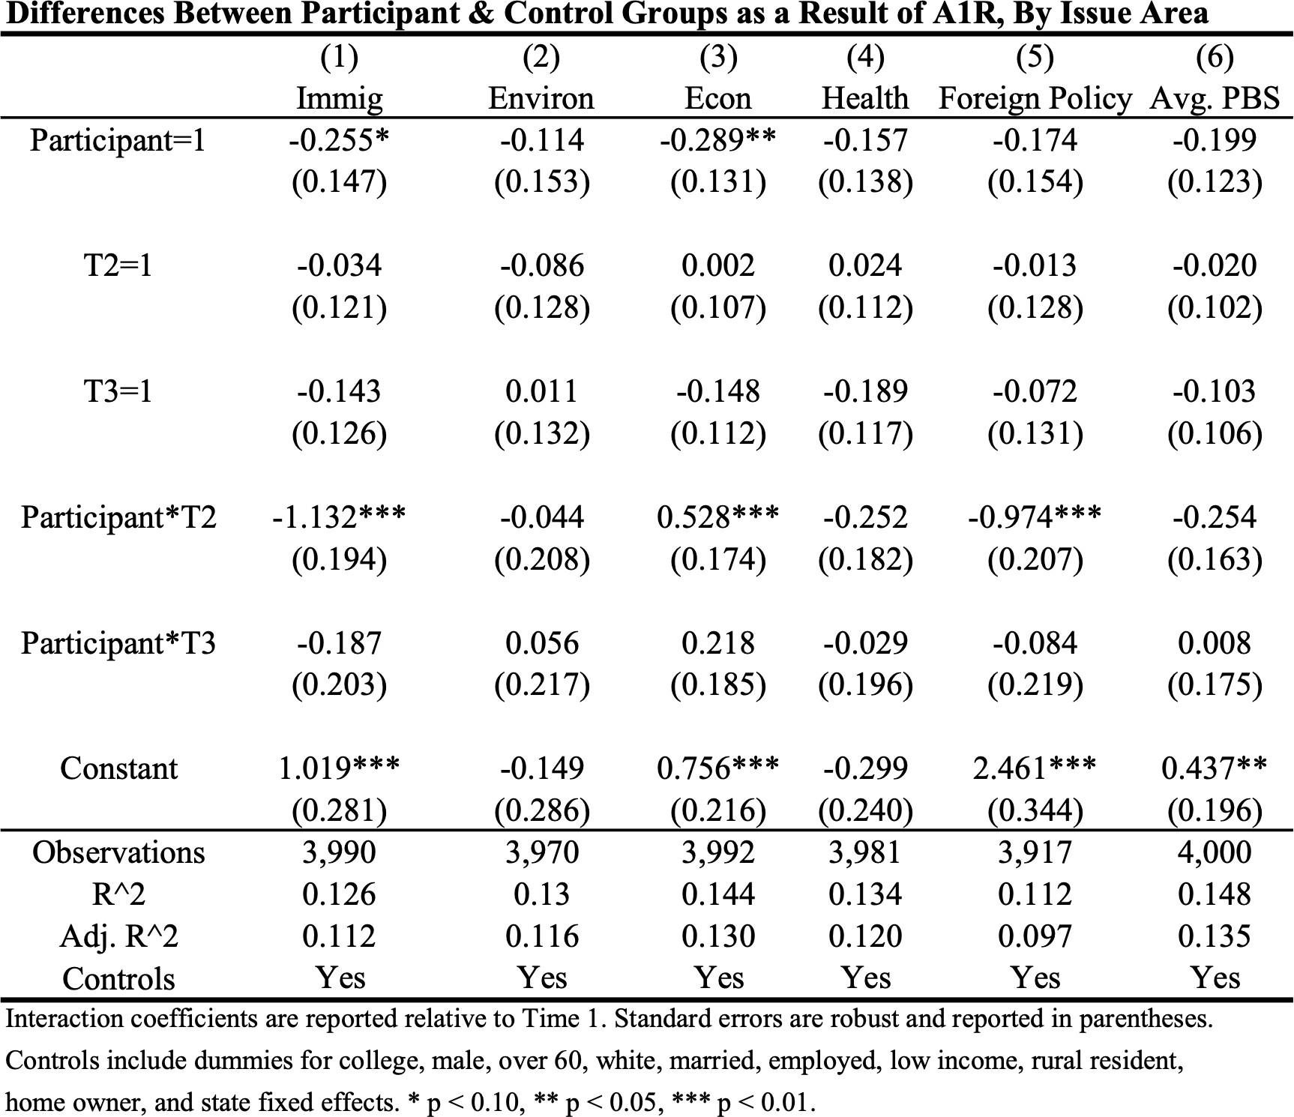

¹ Please see “appendix_table_A2.log” in the Dataverse for complete model results.

Table A.3: Balance Table, Time 1 Sample

 | (1)  Participant Group  Mean | (2)  Control Group  Mean | (3)  Difference (2)-(1) | (4)  T-Stat | (5)  Num Observations Participants/Contro l
Less Than HS/HS | 0.10 | 0.20 | 0.11*** | 5.27 | 523/844
Some College | 0.39 | 0.35 | -0.04 | -1.60 | 523/844
BA or Higher | 0.51 | 0.45 | -0.06** | -2.33 | 523/844
Male | 0.48 | 0.52 | 0.03 | 1.14 | 523/844
Over 60 | 0.34 | 0.36 | 0.02 | 0.69 | 523/844
White | 0.64 | 0.72 | 0.08*** | 3.09 | 523/844
Married | 0.49 | 0.55 | 0.06** | 2.21 | 523/844
Employed | 0.64 | 0.64 | 0.01 | 0.29 | 523/844
HH Inc. <$60,000 | 0.40 | 0.42 | 0.02 | 0.76 | 523/844
Homeowner | 0.69 | 0.78 | 0.09*** | 3.79 | 523/844
From Non-Metro | 0.12 | 0.12 | -0.00 | -0.08 | 523/844
Share Democrats | 0.41 | 0.38 | -0.03 | -1.03 | 474/770
Share Republicans | 0.27 | 0.32 | 0.05* | 1.83 | 474/770
Share Independents | 0.32 | 0.30 | -0.02 | -0.74 | 474/770
Policy-Based Score, T1 | 4.14 | 4.47 | 0.33** | 2.55 | 523/844
Before election, said will vote | 0.89 | 0.86 | -0.03 | -1.40 | 463/710
After election, said voted | 0.95 | 0.93 | -0.02 | -1.32 | 424/726
After election, confirmed voted in registration files | 0.88 | 0.85 | -0.03 | -1.11 | 462/739
Before election, said will vote for Biden | 0.62 | 0.52 | -0.10*** | -3.22 | 415/628
After election, said voted for Biden | 0.58 | 0.51 | -0.08** | -2.45 | 400/667
* p < 0.10, ** p < 0.05, *** p < 0.01

Table A.4: Balance Table, Time 3 Sample

 | (1)  Participan t Group Mean | (2)  Control Group Mean | (3)  Differenc e (2)-(1) | (4)  T-Stat | (5)  Num Observations Participants/Control
Less Than HS/HS | 0.09 | 0.20 | 0.11*** | 5.41 | 491/776
Some College | 0.38 | 0.34 | -0.04 | -1.57 | 491/776
BA or Higher | 0.53 | 0.46 | -0.07** | -2.41 | 491/776
Male | 0.48 | 0.52 | 0.04 | 1.32 | 491/776
Over 60 | 0.34 | 0.37 | 0.02 | 0.86 | 491/776
White | 0.64 | 0.73 | 0.08*** | 3.19 | 491/776
Married | 0.50 | 0.55 | 0.05* | 1.83 | 491/776
Employed | 0.63 | 0.64 | 0.01 | 0.39 | 491/776
HH Inc. <$60,000 | 0.40 | 0.43 | 0.03 | 1.03 | 491/776
Homeowner | 0.70 | 0.78 | 0.08*** | 3.07 | 491/776
From Non-Metro | 0.12 | 0.12 | 0.01 | 0.27 | 491/776
Share Democrats | 0.41 | 0.38 | -0.03 | -1.14 | 444/708
Share Republicans | 0.28 | 0.33 | 0.04 | 1.60 | 444/708
Share Independents | 0.31 | 0.30 | -0.01 | -0.40 | 444/708
Policy-Based Score, T1 | 4.14 | 4.48 | 0.34** | 2.54 | 491/776
Before election, said will vote | 0.89 | 0.86 | -0.03 | -1.35 | 457/689
After election, said voted | 0.95 | 0.92 | -0.03 | -1.64 | 415/698
After election, confirmed voted in registration files | 0.88 | 0.86 | -0.02 | -1.00 | 437/680
Before election, said will vote for Biden | 0.62 | 0.52 | -0.10*** | -3.06 | 410/609
After election, said voted for Biden | 0.59 | 0.50 | -0.09*** | -2.67 | 393/640
* p < 0.10, ** p < 0.05, *** p < 0.01

Table A.5: Balance Table, Time 4 Sample

 | (1)  Participan t Group Mean | (2)  Control Group Mean | (3)  Difference (2)-(1) | (4)  T-Stat | (5)  Num Observations Participants/Control
Less Than HS/HS | 0.09 | 0.20 | 0.12*** | 5.36 | 463/710
Some College | 0.39 | 0.34 | -0.05* | -1.80 | 463/710
BA or Higher | 0.52 | 0.46 | -0.06** | -2.16 | 463/710
Male | 0.47 | 0.53 | 0.06* | 1.94 | 463/710
Over 60 | 0.36 | 0.37 | 0.02 | 0.56 | 463/710
White | 0.66 | 0.73 | 0.07*** | 2.63 | 463/710
Married | 0.50 | 0.56 | 0.06** | 2.05 | 463/710
Employed | 0.62 | 0.64 | 0.02 | 0.55 | 463/710
HH Inc. <$60,000 | 0.40 | 0.42 | 0.02 | 0.54 | 463/710
Homeowner | 0.71 | 0.79 | 0.07*** | 2.84 | 463/710
From Non-Metro | 0.12 | 0.12 | -0.00 | -0.06 | 463/710
Share Democrats | 0.40 | 0.38 | -0.03 | -0.89 | 421/648
Share Republicans | 0.28 | 0.33 | 0.05 | 1.57 | 421/648
Share Independents | 0.32 | 0.30 | -0.02 | -0.63 | 421/648
Policy-Based Score, T1 | 4.12 | 4.48 | 0.36*** | 2.59 | 463/710
Before election, said will vote | 0.89 | 0.86 | -0.03 | -1.40 | 463/710
After election, said voted | 0.95 | 0.93 | -0.02 | -1.58 | 399/668
After election, confirmed voted in registration files | 0.89 | 0.87 | -0.02 | -0.71 | 415/622
Before election, said will vote for Biden | 0.62 | 0.52 | -0.10*** | -3.22 | 415/628
After election, said voted for Biden | 0.58 | 0.50 | -0.09*** | -2.70 | 378/614
* p < 0.10, ** p < 0.05, *** p < 0.01

Table A.6: Balance Table, Time 5 Sample

 | (1)  Participan t Group  Mean | (2)  Control Group  Mean | (3)  Difference (2)-(1) | (4)  T-Stat | (5)  Num Observations Participants/Contro l
Less Than HS/HS | 0.08 | 0.20 | 0.12*** | 5.69 | 424/726
Some College | 0.40 | 0.35 | -0.05 | -1.56 | 424/726
BA or Higher | 0.52 | 0.44 | -0.08*** | -2.58 | 424/726
Male | 0.48 | 0.53 | 0.05 | 1.49 | 424/726
Over 60 | 0.39 | 0.37 | -0.02 | -0.83 | 424/726
White | 0.72 | 0.75 | 0.03 | 1.06 | 424/726
Married | 0.54 | 0.57 | 0.02 | 0.70 | 424/726
Employed | 0.62 | 0.64 | 0.02 | 0.61 | 424/726
HH Inc. <$60,000 | 0.39 | 0.40 | 0.02 | 0.53 | 424/726
Homeowner | 0.72 | 0.79 | 0.07*** | 2.73 | 424/726
From Non-Metro | 0.13 | 0.13 | -0.01 | -0.26 | 424/726
Share Democrats | 0.40 | 0.37 | -0.02 | -0.80 | 388/664
Share Republicans | 0.28 | 0.33 | 0.04 | 1.46 | 388/664
Share Independents | 0.32 | 0.30 | -0.02 | -0.62 | 388/664
Policy-Based Score, T1 | 4.23 | 4.50 | 0.27* | 1.93 | 424/726
Before election, said will vote | 0.90 | 0.86 | -0.04* | -1.86 | 399/668
After election, said voted | 0.95 | 0.93 | -0.02 | -1.32 | 424/726
After election, confirmed voted in registration files | 0.90 | 0.87 | -0.03 | -1.55 | 377/642
Before election, said will vote for Biden | 0.60 | 0.51 | -0.09*** | -2.69 | 362/590
After election, said voted for Biden | 0.58 | 0.51 | -0.08** | -2.45 | 400/667
* p < 0.10, ** p < 0.05, *** p < 0.01

Table A.7: Voting Recollection for Participants and Control Group, Time 5

Participants Control

Trump/Pence | 151 | 35.61% | 304 | 41.87%
Biden/Harris Didn't vote Someone else  DK/SKIPPED ON WEB/REFUSED  Total | 233 | 54.95% | 337 | 46.42%
 | 23 | 5.42% | 54 | 7.44%
 | 16 | 3.77% | 26 | 3.58%
 | 1 | 0.24% | 5 | 0.69%
 | 424 | 100% | 726 | 100%

Table A8 Panels A, B and C

Knowledge for Participants and Control for T1, T2 and T3

Panel A: Share Answering Each Knowledge Question Correctly at Time 1
 | (1) | (2) | (3)
 | Participant | Control | Difference
 | Group | Group | (2)-(1)
 | mean | Mean
Trade | 0.41 | 0.38 | -0.03
Taxation | 0.25 | 0.24 | -0.01
Healthcare | 0.58 | 0.50 | -0.08***
Climate | 0.32 | 0.32 | 0.00
Immigration | 0.21 | 0.18 | -0.03
House Majority | 0.72 | 0.69 | -0.03
Senate Majority | 0.75 | 0.67 | -0.08***
Observations | 521 | 840 | 1361
* p < 0.10, ** p < 0.05, *** p < 0.01

Panel B: Share Answering Each Knowledge Question Correctly at Time 2
 | (1) | (2) | (3)
 | Participant | Control | Difference
 | Group | Group | (2)-(1)
 | mean | Mean
Trade | 0.50 | 0.40 | -0.10***
Taxation | 0.47 | 0.27 | -0.20***
Healthcare | 0.63 | 0.57 | -0.07**
Climate | 0.50 | 0.33 | -0.17***
Immigration | 0.75 | 0.16 | -0.59***
House Majority | 0.70 | 0.66 | -0.04
Senate Majority | 0.73 | 0.68 | -0.05**
Observations | 520 | 837 | 1357
* p < 0.10, ** p < 0.05, *** p < 0.01

Panel C: Share Answering Each Knowledge Question Correctly at Time 3
 | (1) | (2) | (3)
 | Participant | Control | Difference
 | Group | Group | (2)-(1)
 | mean | Mean
Trade | 0.54 | 0.45 | -0.09***
Taxation | 0.40 | 0.29 | -0.12***
Healthcare | 0.69 | 0.60 | -0.09***
Climate | 0.39 | 0.30 | -0.09***
Immigration | 0.26 | 0.17 | -0.09***
House Majority | 0.81 | 0.71 | -0.09***
Senate Majority | 0.85 | 0.75 | -0.11***
Observations | 491 | 776 | 1267
* p < 0.10, ** p < 0.05, *** p < 0.01

Table A 10
Regressions, Figures 8-10
(1) (2) (3) (4) (5) (6)

Follow Campaig n
Follow Campaig n
Worth Listenin g
Worth Listening
Knowledg e
Knowledge

Participant=1 | 0.720*** | 0.712*** | 0.613**  * | 0.505*** | 0.058*** | 0.050**
 | (0.134) | (0.134) | (0.138) | (0.137) | (0.022) | (0.021)
T2=1 |  |  | 0.090 | 0.090 | -0.012 | -0.012
 |  |  | (0.125) | (0.122) | (0.021) | (0.019)
T3=1 |  |  | 0.237* | 0.226* | -0.004 | -0.004
 |  |  | (0.127) | (0.125) | (0.021) | (0.019)

Participant*T2 | 0.699** |  |  | 0.699*** | -0.008 | -0.008
 |  |  | *
 |  |  | (0.185) | (0.183) | (0.033) | (0.030)
Participant*T3 |  |  | 0.166 | 0.178 | 0.049 | 0.049*
 |  |  | (0.189) | (0.185) | (0.032) | (0.030)
Constant | 7.050*** | 6.150*** | 7.004**  * | 6.963*** | 0.671*** | 0.809***

 | (0.089) | (0.330) | (0.091) | (0.639) | (0.014) | (0.033)
Observations | 1,171 | 1,171 | 3,408 | 3,408 | 4,101 | 4,101
R^2 | 0.023 | 0.155 | 0.048 | 0.098 | 0.009 | 0.165
Controls | No | Yes | No | Yes | No | Yes
Interaction coefficients are reported relative to Time 1. Standard errors are robust and reported in parentheses.
Controls include dummies for college, male, over 60, white, married, employed, low income, rural resident,homeowner, and state fixed effects. * p < 0.10, ** p < 0.05, *** p
< 0.01.

The table above reports linear regression results with the objective of providing additional context for Figures 8-10. Figure 8, which captures differences between participant and control groups in following the campaign at Time 4, is addressed in columns (1) and (2). In column (1), we report results for a regression that, like Figure 8, is unconditional on any controls. The participant group is 0.72 points more likely to follow the campaign than the control group. With the mean control group campaign following level of 7.05, the participant group is about 10 percent more likely to follow the campaign at Time 4 than the control group. Conditioning on a range of demographic controls (education, gender, age, race, marital status, employment status, income level, rural/urban residence, home ownership status, and state of residence), as we do in column (2), does not do much to change this result. Figure 9, which captures differences in belief that my political opinions are worth listening to between participant and control groups, is addressed in columns (3) and (4). The interactions of participant dummy variables with Time 2 and Time 3 dummies show what happens to differences between participant and control groups over time. The large and statistically significant difference at Time 2 wanes in magnitude and loses statistical significance by Time 3, but the magnitude remains positive and substantial even at Time 3. The inclusion of demographic controls does not change the results in meaningful ways. Figure 10, which captures differences in the political knowledge index between participant and control groups, is addressed in columns (5) and (6). As in columns (3) and (4), the interactions show what happens to differences between participant and control groups over time. With or without controls, the regressions show that there is effectively no difference between participant and control groups at Time 2 in the knowledge index. By Time 3, however, the difference grows, with the participant group gaining political knowledge on its own, months after the experiment took place. This difference is weakly statistically significant. See log table in the Dataverse for complete model results.

Appendix A 11 Components of the Policy Based Score (PBS)

No. | Question
 | Immigration
Q2A | [Reduce the number of refuges allowed to resettle in the US.]
Q2C | [Provide aid to reduce poverty and violence in Central America.]
Q2E | [Increase the number of visas for low-skilled workers to move to the US for industries that need them, like agriculture and service.]
Q2H | [Continue DACA, the Deferred Action for Childhood Arrivals program, which protects people who were brought to the US as children when their parents entered the country illegally.]
Q2I | [Undocumented immigrants should be forced to return to their home countries before applying to legally come to the US to live and work permanently.]
 | Environment
Q3A | [The US should commit to the 2014 Paris Agreement to combat climate change.]
Q3B | [The US should go beyond the Paris Agreement and aim for more significant cutbacks on greenhouse gas emissions.]
Q3C | [The US should use taxes or other market incentives to achieve emissions reductions.]
Q3D | [A Green New Deal to commit to major investments in infrastructure and renewable energy.]
Q3E | [The US should expand oil and gas production.]
Q3H | [The US should mandate zero carbon emissions for cars, trucks, and buses.]
 | Economy and Taxes
Q4A | [Capital gains -- income earned when an investment that has increased in value is sold -- should be taxed the same as ordinary wage income.]
Q4B | [The US should impose a wealth tax on the richest taxpayers, requiring them to pay a small portion of their wealth on an annual basis.]
Q4C | [The US should repeal the estate tax, which currently taxes deceased individuals worth at least $11 million and deceased couples worth at least $22 million.]
Q4F | [Lower the corporate tax rate from 21% to 15%.]
Q4G | [Increase federal minimum wage from $7.25/hr. to $15/hr.]
Q4H | [The government should cover the cost of college tuition at public universities for all students who could not otherwise afford it.]
Q4I | [The government should fund a bond for each child born that will accumulate in value until the child turns 18 to then become usable for higher education or other essentials for a start in life.]
 | Healthcare
Q5A | [The Affordable Care Act should be repealed.]
Q5B | [Repeal the Affordable Care Act and replace with grants to state Governments to create their own systems.]
Q5C | [The federal subsidies in the Affordable Care Act that help the poor should be increased.]
Q5D | [The federal subsidies in the Affordable Care Act that help the middle class should be expanded to include more people.]
Q5H | [People should be automatically enrolled in a more generous version of Medicare.]

 | Foreign Policy
Q6A | [The US should rejoin the Trans-Pacific Partnership, a trading agreement between 12 countries excluding China.]
Q6F | [The US should recommit to the Iran Nuclear Agreement.]
Q6G | [Presidents should be required to obtain explicit congressional approval for sending US troops into combat situations.]

Figure A.1 Thermometer Ratings by Party for Treatment and Control, T1, T2 and T3 (Panels A, B, C and D)

Figure A.2 Attitudes at T1 toward Those With Whom You “Disagree Strongly”, Treatment and Control Samples Panels A, B, C and D
Figure A.2: Panel A: “Not Thinking Clearly” Time 1 Sample

Figure A.2: Panel B: “Good Reasons” Time 1 Sample

Panel C: “Not Thinking Clearly” Time 4 Sample

Figure A.2: Panel D: “Good Reasons” Time 4 Sample

Table A12: Average Causal Mediated Effect (ACME) of Participation (95% CI) Verified Vote

Dependent Variable
 | Did Vote at All | Did Vote for Biden
 | (t5) | (t5)
Follows Campaign | 0.0225*** | 0.00851**
(t3) | (0.01, 0.04) | (-0.000704, 0.02)
Worth Listening To? | 0.00645* | 0.002769*
Mediator (t3) | (-0.001, 0.02) | (-0.003703,0.01)
Knowledge Index | 0.010891*** | -0.00102
(t3) | (0.004674, 0.02) | (-0.00628, 0.002)
PBS_{T1} - PBS_{T2} | -0.00529 | 0.0242***
 | (-0.01534, 0.001) | (0.0142, 0.04)
Observations | 927 | 985
*p < .1; **p < .05; ***p < .01
Note: Each model is fit using a generalized linear mixed effects model for both the mediators and the dependent variables—linear models for each of the mediators and logistic regression models for the dependent variables. Random intercepts were fit at the state level. We include a set of respondent demographic controls (age, gender, race, education, employment status, and party ID) in each model, as well as respondent PBS. Observations include participants and control groups members. Models are fit using the ‘mediation’ package in R with 95% CI included in the parenthesis. Complete model results in the Appendix Tables for A12 below.
Note: Further Supplementary Materials for Causal Mediation and Other Analyses Can be Found in the APSR Dataverse

Part 2: Issues of Design and Recruitment
This project employs an experimental design using treatment and control groups. The treatment in the project involved being invited to and then participating in the deliberations as a “delegate.” The control group, also a representative sample of registered voters, was not invited to participate in the deliberations and therefore did not receive the treatment. The respondents in the treatment and control groups were selected using stratified random sampling from NORC’s probability-based AmeriSpeak® Panel panel. The project selected a nationally representative sample of registered voters from the panel, and then randomly assigned the registered voters to the treatment and control groups. The AmeriSpeak Panel panel is an address based sample of approximately 35,000. The members of the panel were recruited by mail, telephone and personal visits and are paid a small honorarium for participating in surveys. They are promised confidentiality of their responses. The research protocol is approved by the IRB responsible for NORC. In addition, all of the travel and living expenses for the delegates were paid by the project, plus a modest honorarium.
Using the panel as the probability sample source, we identified the delegates and controls in separate and independent processes to meet their respective requirements for targeted sample size. The control sample was selected first under a systematic stratified random
sample design to ensure a balanced sample with respect to age, gender, race/ethnicity, educational attainment, political party identification, geography, and other dimensions. After the control sample was selected, the delegate sample was identified from the rest of the sample frame using the same sample stratification procedure. The independent samples were drawn to create representative treatment and control samples that correspond to U.S registered voter population benchmarks derived from the November 2018 Current Population Survey or the 2018 General Social Survey.
The treatment and control group samples were administered the same pre-event survey. All control group pre-event survey completions were retained for the
post-event follow-up survey. All treatment group pre-event survey completions were potentially eligible for selection to the event. NORC sub-sampled treatment group completions for selection to receive an invitation to participate in the event. The “final delegate” sample was selected from the pool of treatment pre-event survey completions who stated a willingness to be part of the event or were initially reluctant to participate but later changed their minds. To ensure that the final delegates who participate fully represent the diversity of the registered voting population, we set a sample size quota for key subpopulations defined by age, gender, race/ethnicity, geography, educational attainment, party identification, and LGBT status. NORC employed a “concierge” method, assigning a specific researcher to assist them with any travel or logistical issues related to their participation in the event. Additional funds were available to help respondents with special needs (compensation for
child-care at home, companions who might assist those who lacked mobility, etc). The participants were informed that they were participating in a social science investigation of their opinions collected in confidential questionnaires.

The two surveys are designed to measure opinion and knowledge shifts that could occur in the time period elapsing between the administrations of the two surveys. The pre-event survey was administered to the treatment (n=2,741 completions) and control (1,101 completions) groups between July 9, 2019 and August 5, 2019 in English and Spanish. 1,566 participants in the treatment group were randomly selected within the relevant sub-populations to receive an invitation. 605 accepted and registered for the event. 560 booked travel (at the expense of the project) and 526 made the trip with 523 completing the final survey. The post-event survey was administered to the control group (n=844, 76.7% follow-up rate) between September 10 and September 20, 2019. The delegates completed the post-event survey on September 22, 2019 at the event itself using a self-administered paper survey. Of the 526 delegates attending event, 523 completed the post-event survey (99.4% completion rate).
NORC then administered essentially the same questionnaire to the treatment and control groups at T3, ten months later in July 2020 and a shortened version at T4, October 20202. A final wave at T5 (November-December 2020) was administered by NORC after the election for self-report of actual voting by the treatment and control groups.
Participants’ individual privacy rights are maintained in all published and written data resulting from the study. Participant’s confidentiality is maintained through confidential questionnaires and recordings producing anonymized transcripts. All data collected is for research purposes only, anonymized, and stored on an encrypted and password protected device.

