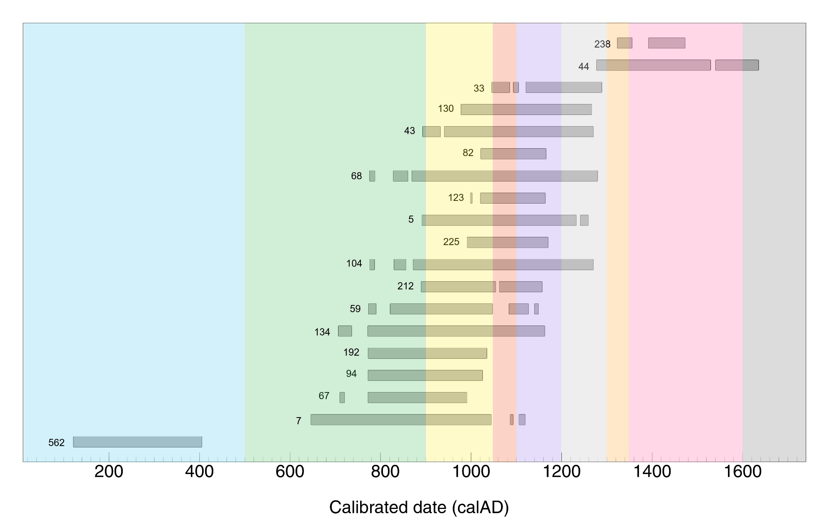
Supplemental Figure 22. Calibrated age ranges at 95.4% probability for Picture Cave pictographs. This is another graphical representation of the data presented in Table 1 and Figure 1, from oldest to youngest (with glyph 212 represented as a weighted average). Glyph identification numbers label each calibrated age range. Accepted chronological horizons for the region are shown in colored bands based on Pauketat 2025:204. Blue = Middle Woodland (150 BC-AD 500); Green = Late Woodland (AD 500-900); Yellow = Terminal Late Woodland (AD 900-1050); Coral = Lohmann phase (AD 1050-1100); Purple = Sterling phase AD (1100-1200); Light Gray = Moorehead phase (AD 1200-1300); Orange = Sand Prairie phase (AD 1300-1350); Pink = Late Mississippian (AD 1350-1600); Dark Grey = Protohistoric/Contact (after AD 1600)

