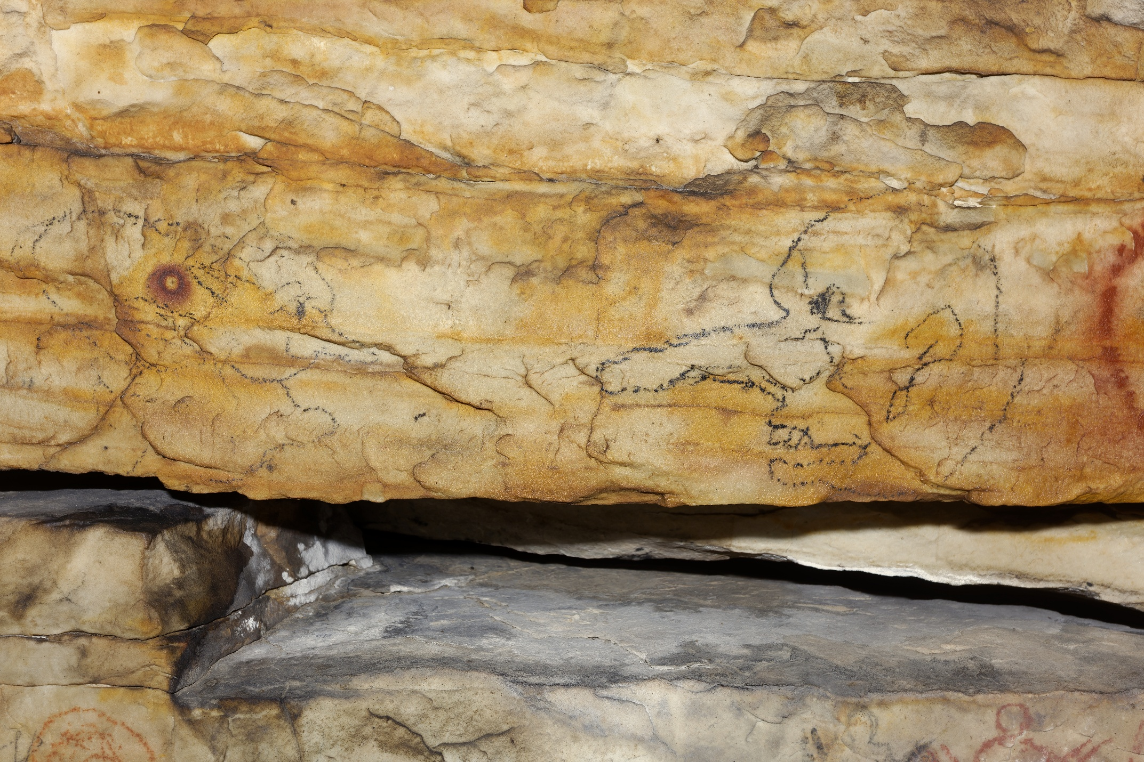Supplemental Figure 20. On panel 2 of Picture Cave 1, glyph 235 is approximately 14 cm tall. We obtained a radiocarbon date of 13,320±130 RCYBP (CAMS 193466, 9.6 mg, 70 μg C, 16350-15590 cal BC, 95.4%) from the figure on the right. This unrealistic age suggests that coal-based pigment was used to make historic period graffiti. Photo credit: Mike Chervinko.

