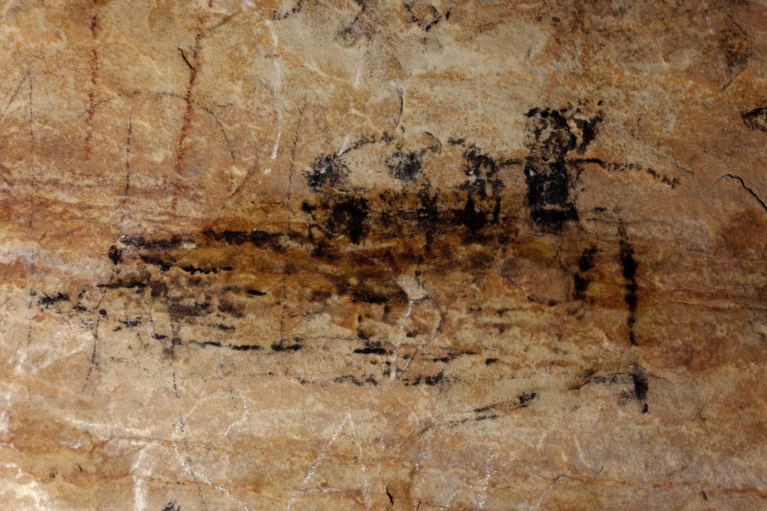Supplemental Figure 19. On panel 4 of Picture Cave 1, glyph 238 is approximately 14 cm tall and has been interpreted as four figures in a canoe. We obtained a radiocarbon date of 495±45 RCYBP (CAMS 193470, cal AD 1320-1475, 95.4%) for this black pictograph. Photo credit: Mike Chervinko.

