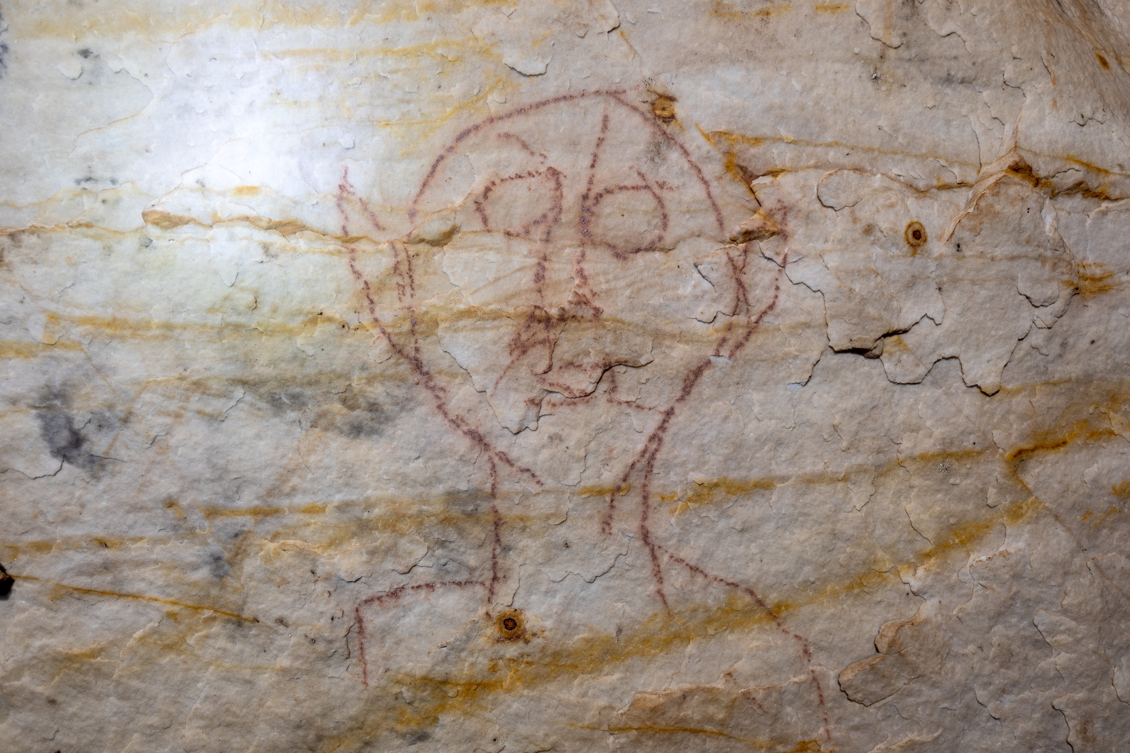Supplemental Figure 18. On panel 3 of Picture Cave 1, glyph 44 was previously thought to be historic graffiti. This fine-lined, red drawing of a face with large eyes and ears is approximately 50 cm tall. We obtained a radiocarbon date of 520±110 RCYBP (CAMS 193472, cal AD 1275-1635, 95.4%) for this red pictograph. Photo credit: Mike Chervinko

