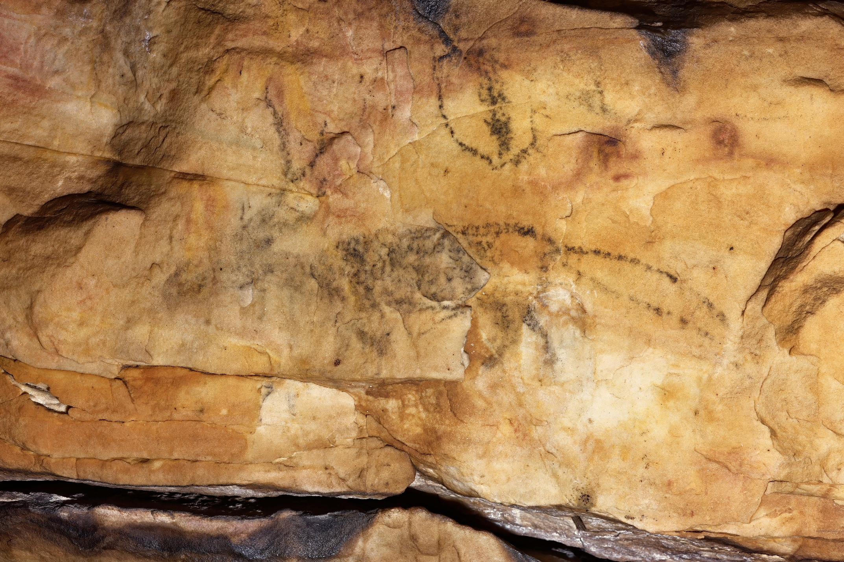Supplemental Figure 17. On panel 2 of Picture Cave 1, glyph 33 is approximately 18 cm tall and is an antlered zoomorph on the right side of the panel above the rock shelf. We obtained a radiocarbon date of 820±60 RCYBP (CAMS 193467, cal AD 1045-1290, 95.4%) for this black pictograph. Photo credit: Mike Chervinko.

