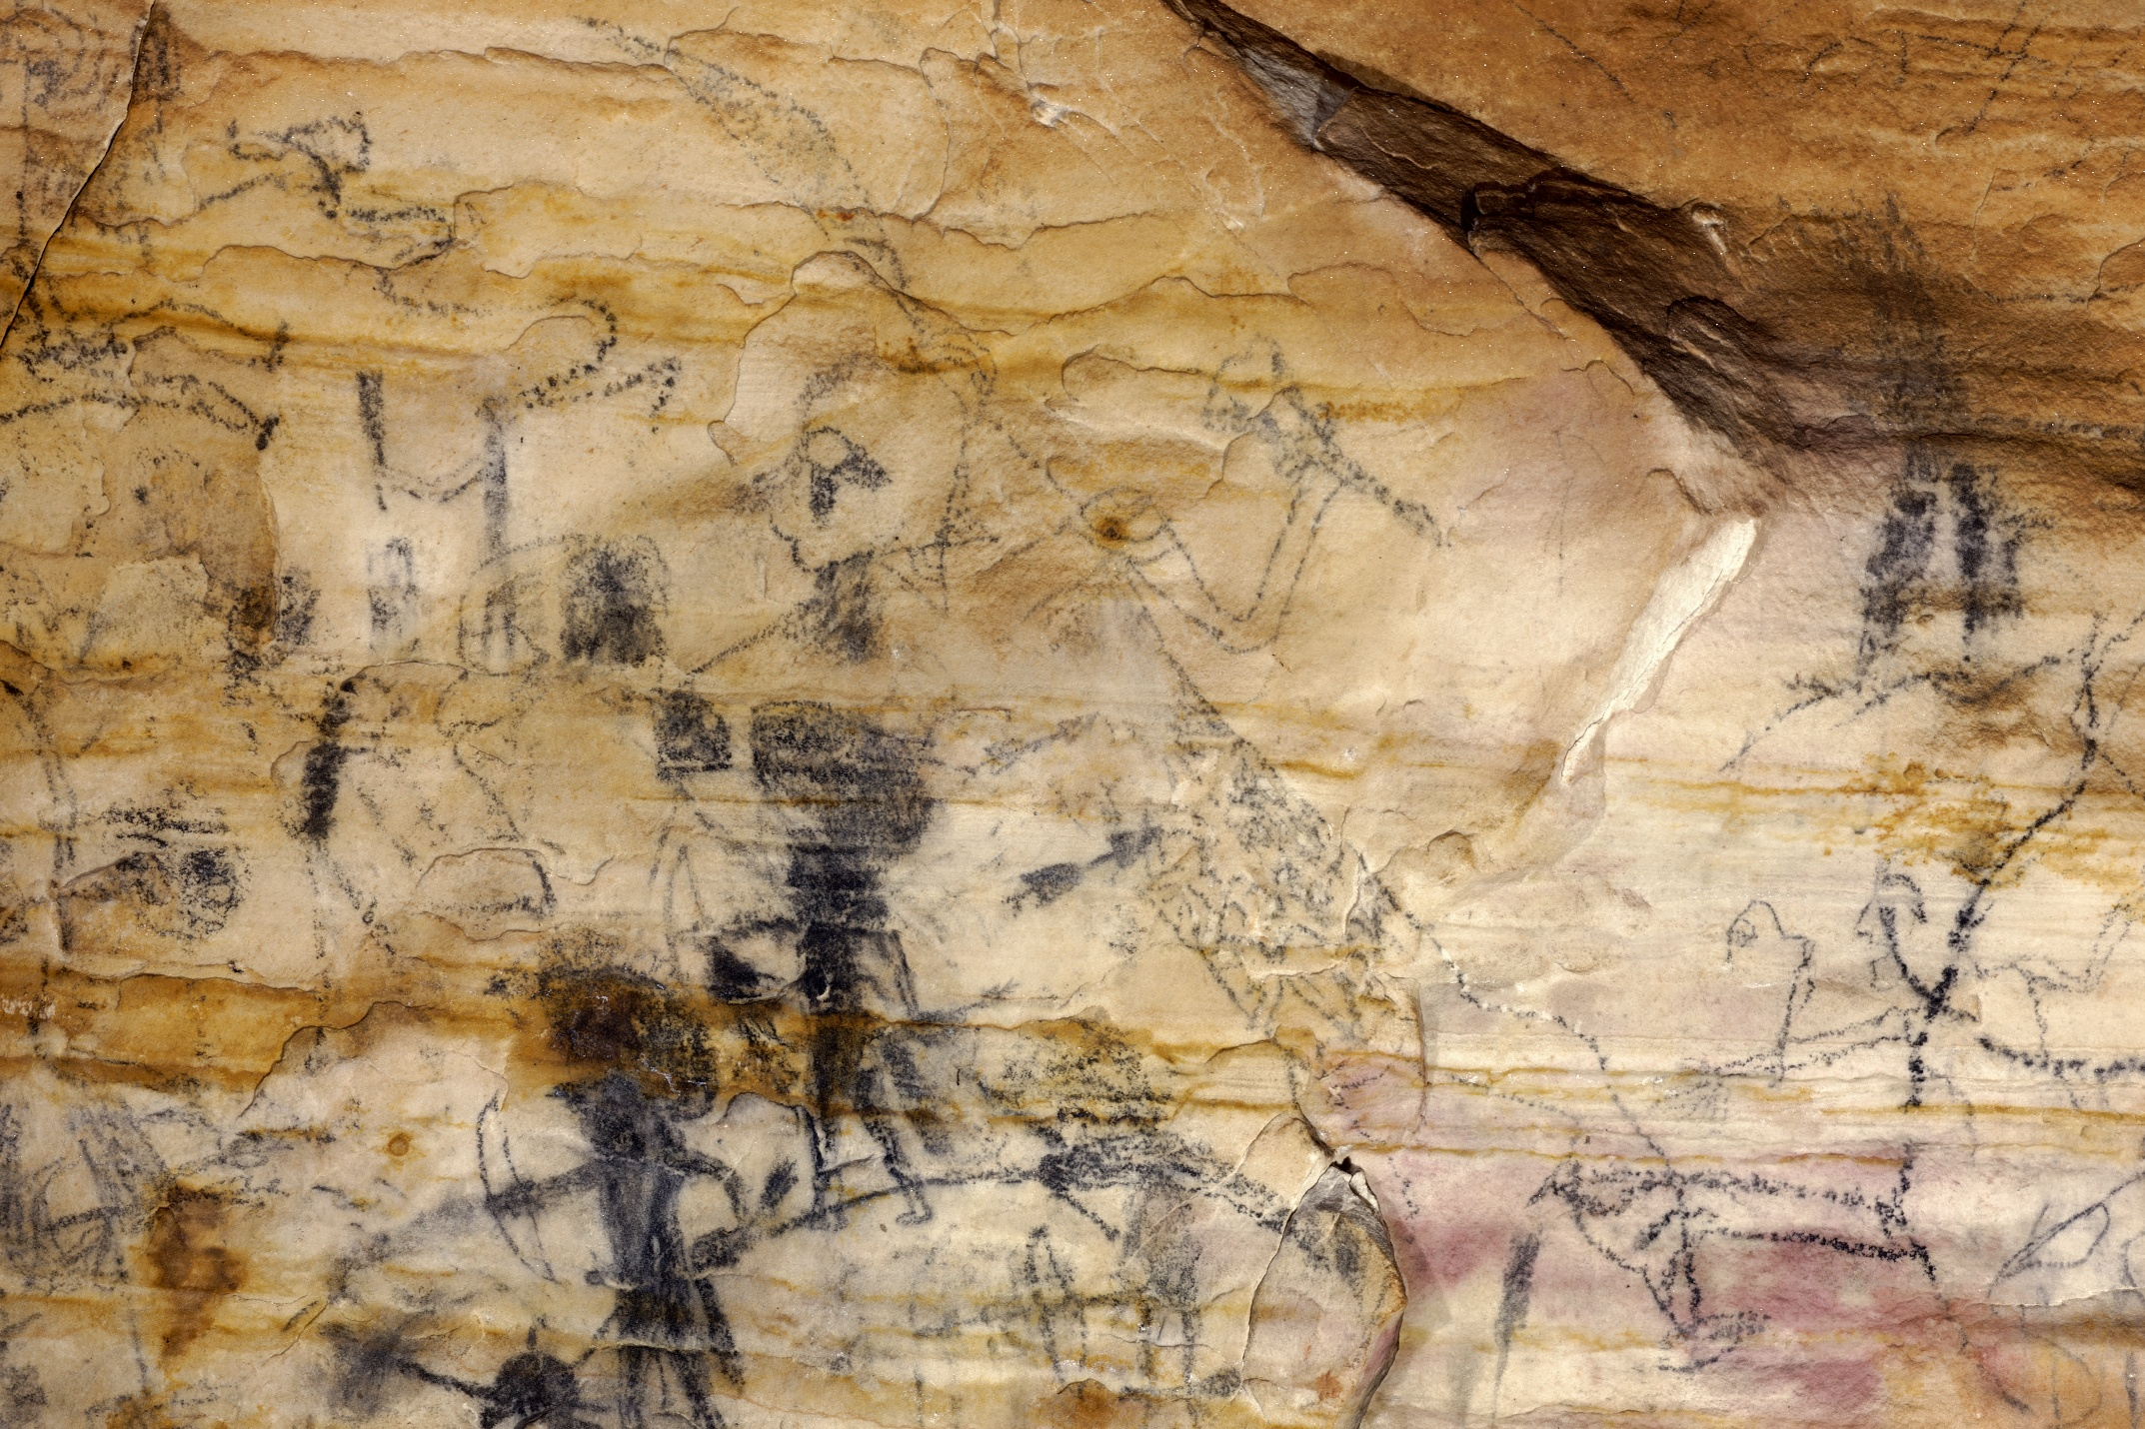Supplemental Figure 16. On panel 1 of Picture Cave 1, glyph 130 is an approximately 72 cm tall human figure with a falcon eye, holding a mace, and wearing a patterned wrap over the torso. Rowe obtained a radiocarbon date of 940±80 RCYBP (CAMS 41464, cal AD 975-1270, 95.4%) for this black pictograph (Diaz-Granados et al. 2001; Duncan et al. 2015). Photo credit: Mike Chervinko.

