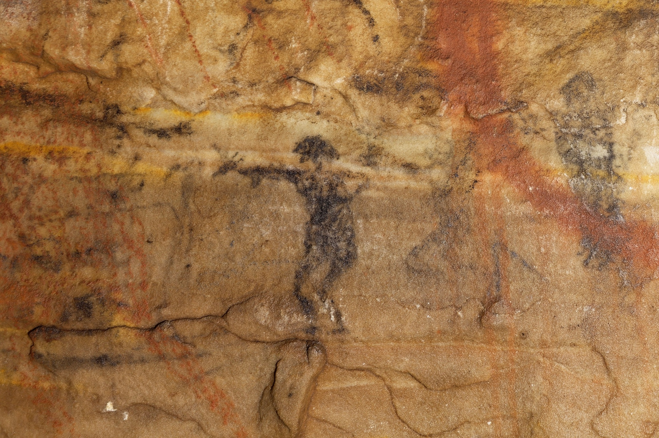Supplemental Figure 11. On panel 2 of Picture Cave 1, glyph 5 is approximately 8 cm tall and is a human figure with an animal head hand. We obtained a radiocarbon date of 970±90 RCYBP (CAMS 193457, cal AD 890-1260, 95.4%) for this black pictograph. Photo credit: Mike Chervinko.

