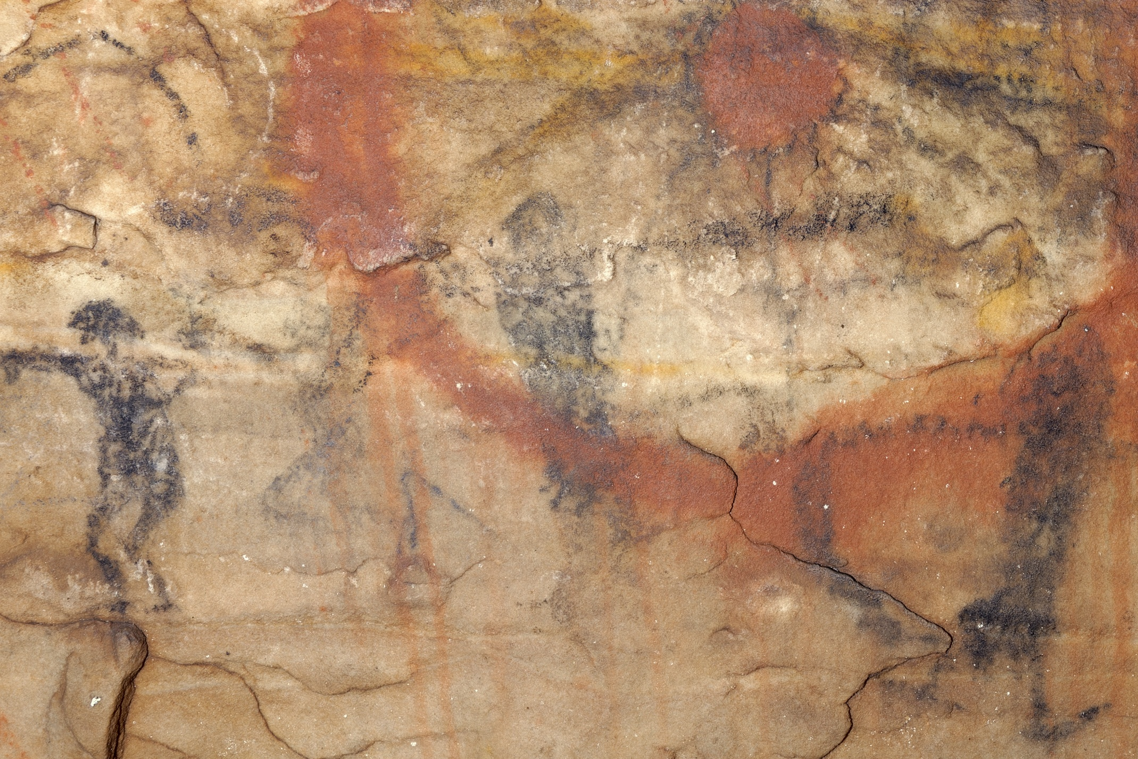Supplemental Figure 10. On panel 2 of Picture Cave 1, glyph 225 is approximately 10 cm tall and is in superimposition with a red dot and circle motif (glyph 7). We obtained a radiocarbon date of 980±45 RCYBP (CAMS 193458, cal AD 990-1170, 95.4%) for this black pictograph. Photo credit: Mike Chervinko.

