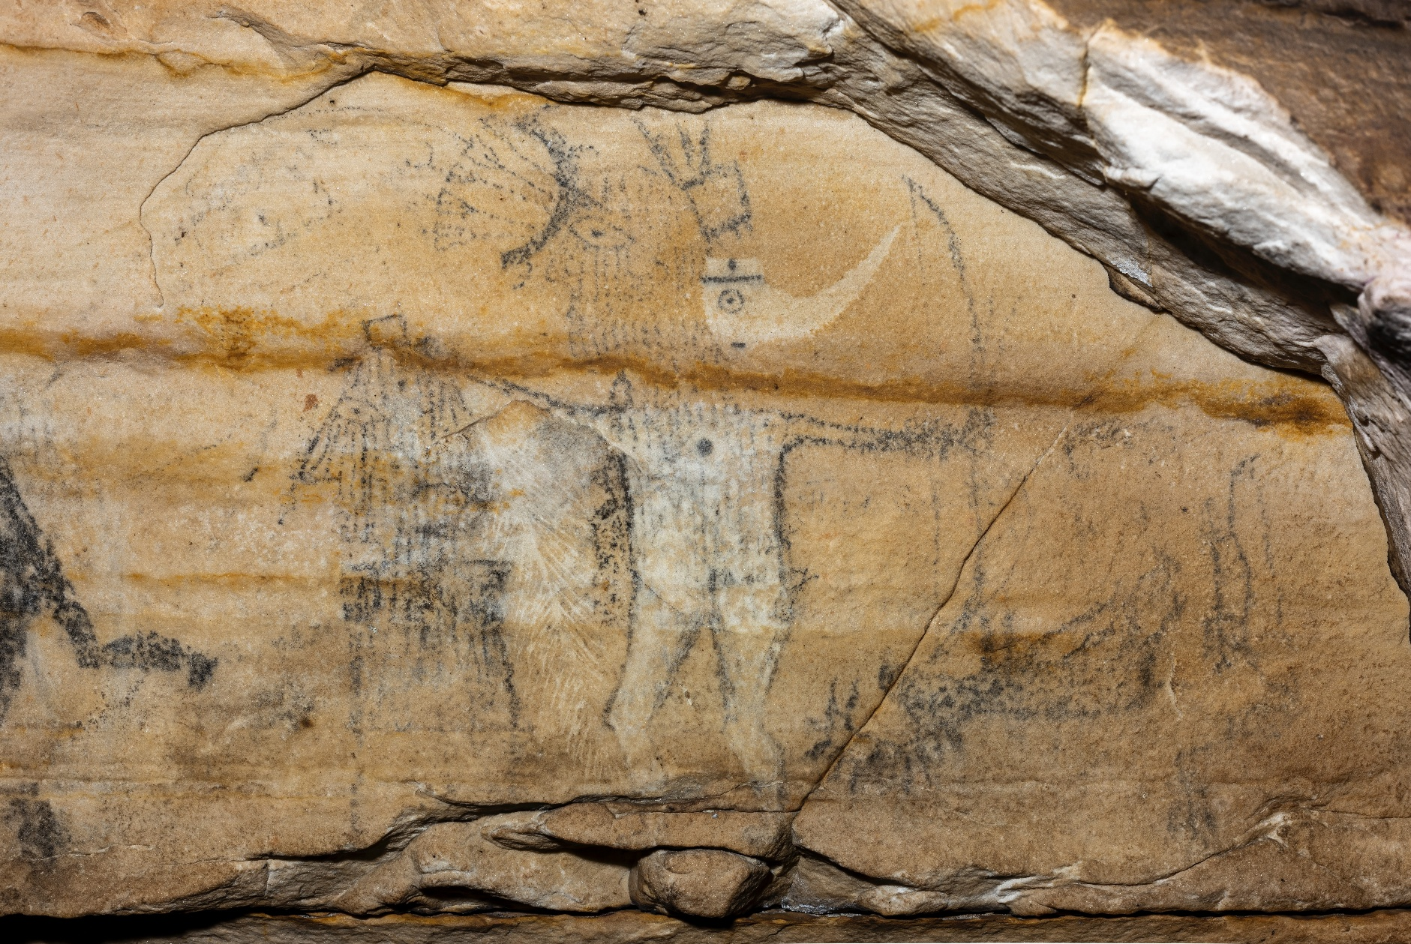

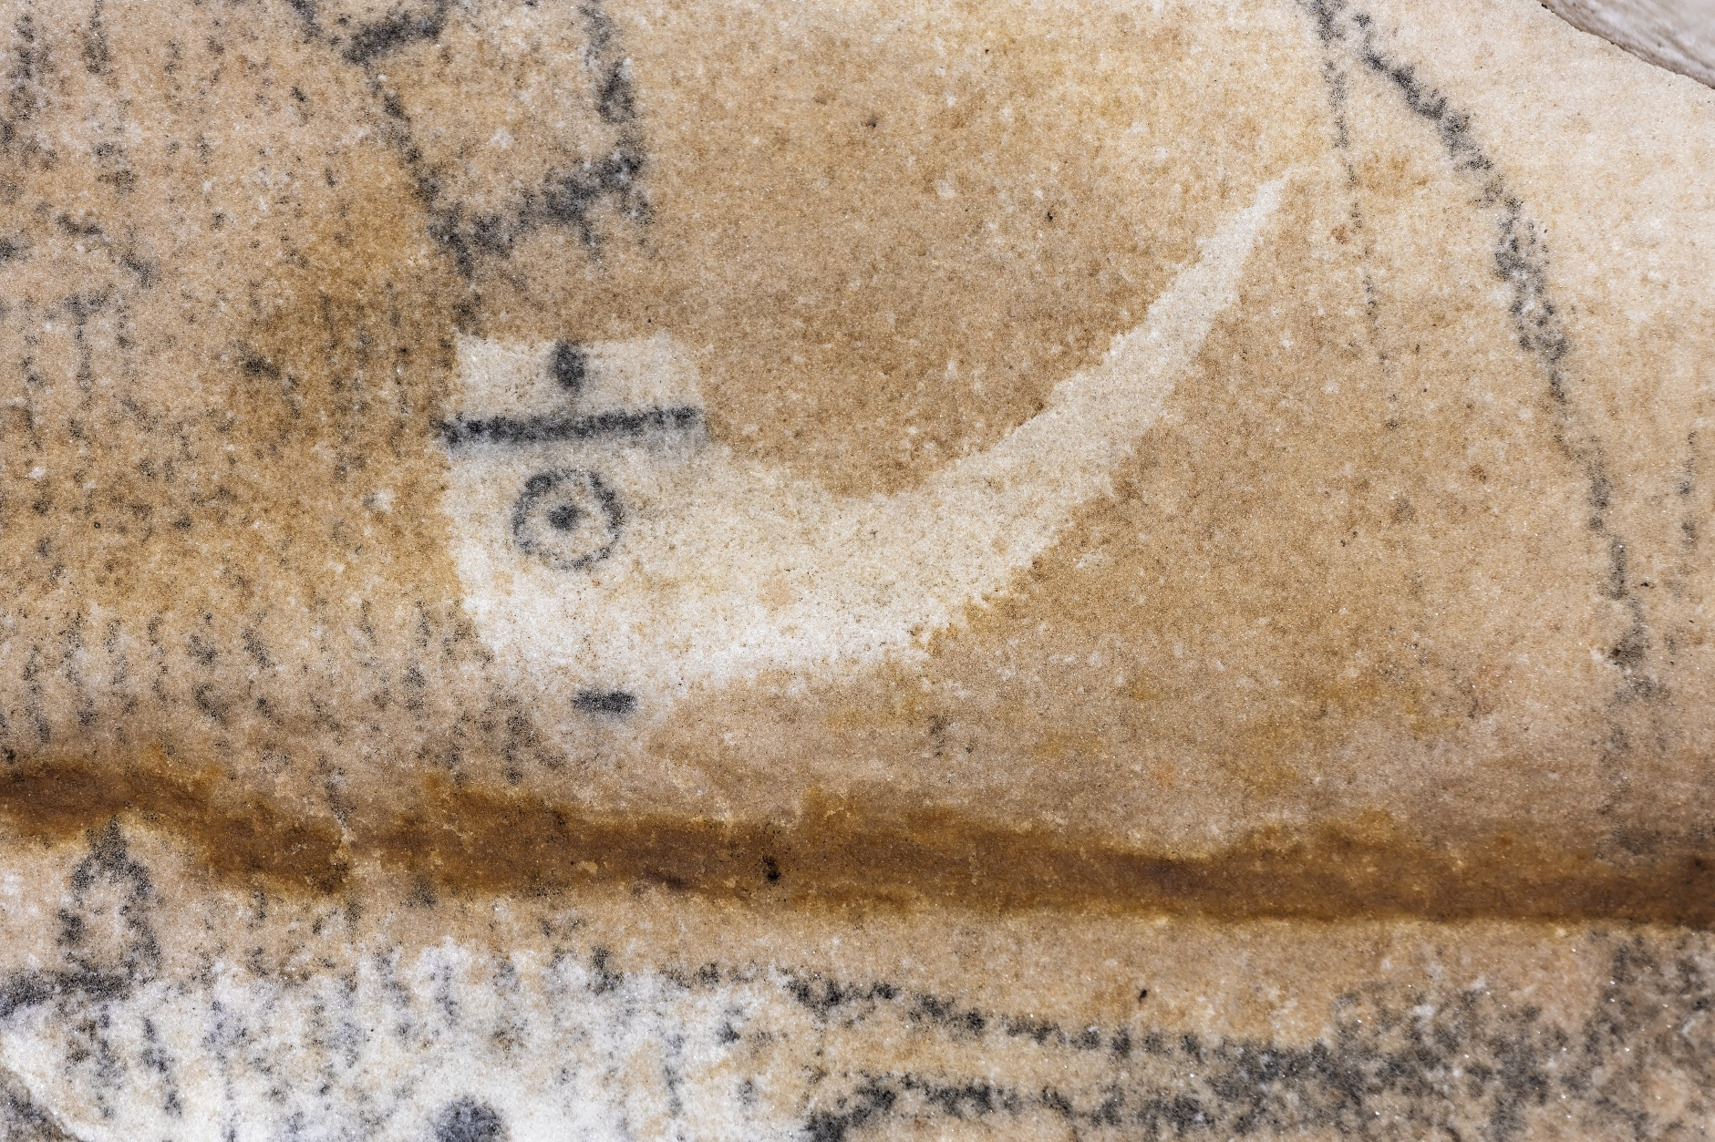

Supplemental Figure 9. (top) On panel 1 of Picture Cave 1, glyph 104 is approximately 30 cm tall. This well-known pictograph is thought to represent Red Horn/Morning Star. (bottom) Detail of long-nose earring. We obtained a radiocarbon date of 980±110 RCYBP (CAMS 193465, cal AD 775-1270, 95.4%) for black charcoal pigment from this pictograph. Photo credit: Mike Chervinko.

