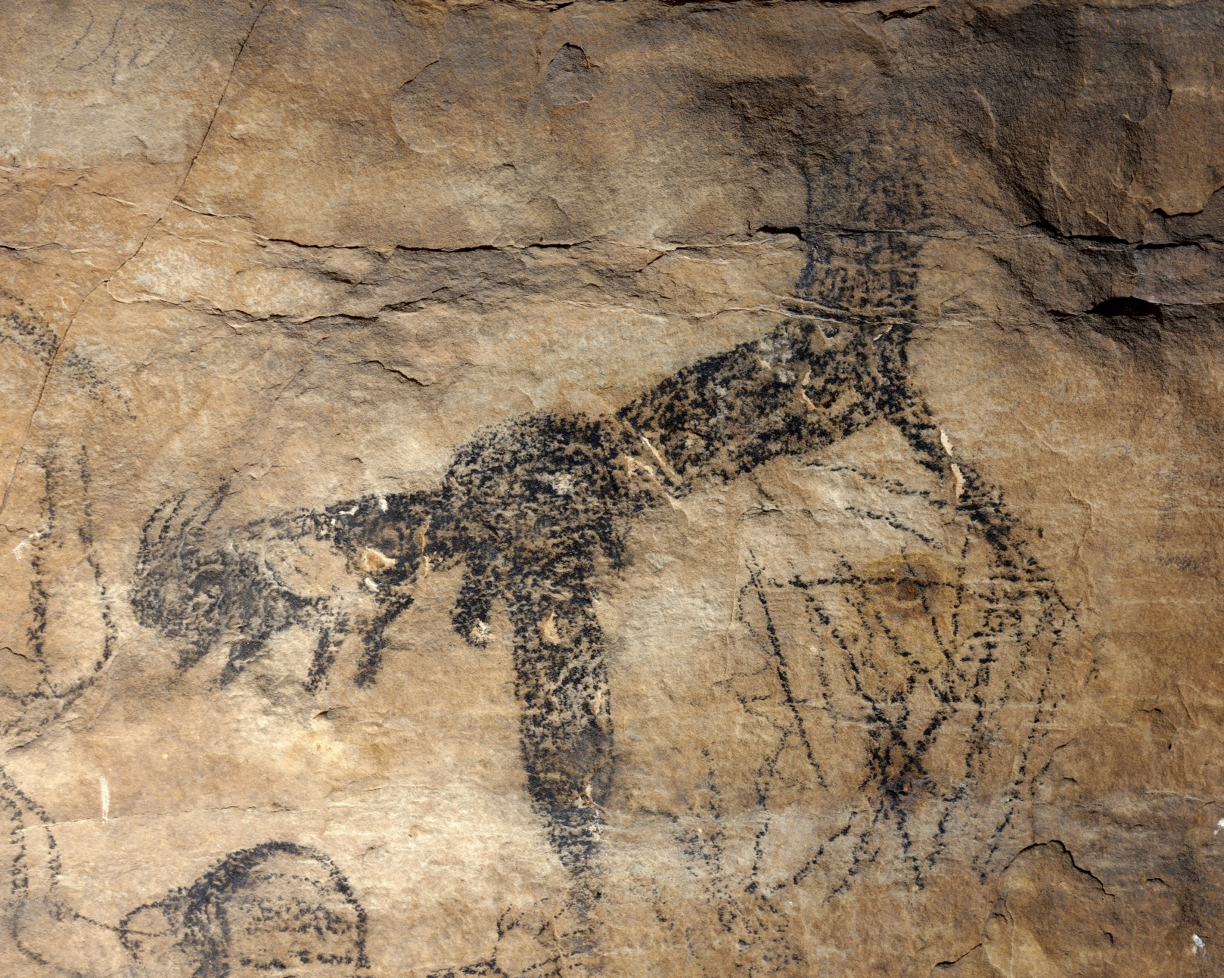

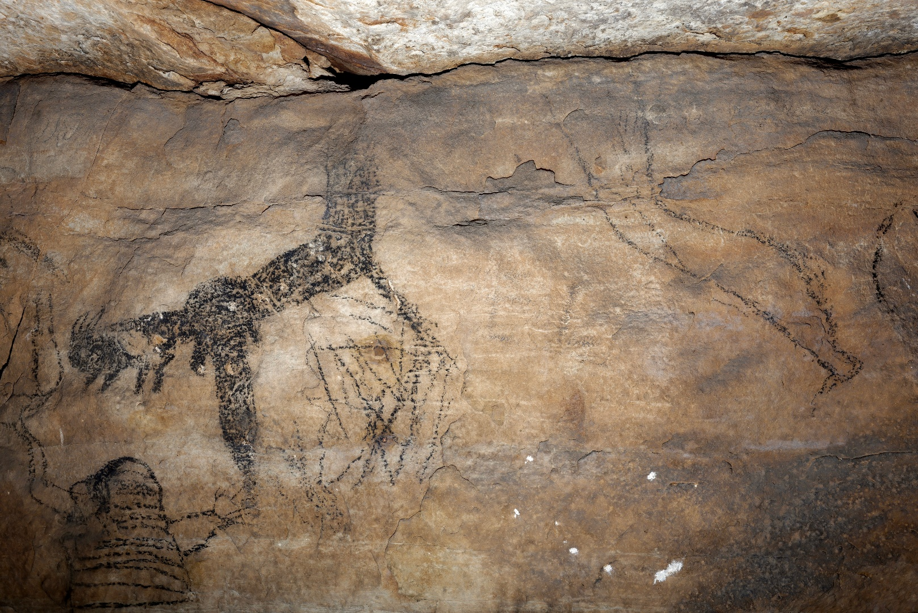

Supplemental Figure 8. On panel 5 of Picture Cave 1, glyph 212 is approximately 55 cm tall and depicts an in-filled bent arm reaching out from a crack in the cave wall. (top) The arm has a pelt hanging off the wrist area and an animal hand. (bottom) This in-filled arm is associated with an outlined leg also coming out of the crack in the cave wall. Rowe obtained two radiocarbon dates 1000±70 (CAMS 38458) and 1090±110 (CAMS 41466) RCYBP, reporting a weighted average of 1035±55 RCYBP (cal AD 880-1160, 95.4%) for this black pictograph (Diaz-Granados et al. 2001 and Duncan et al. 2015). Photo credit: Mike Chervinko.

