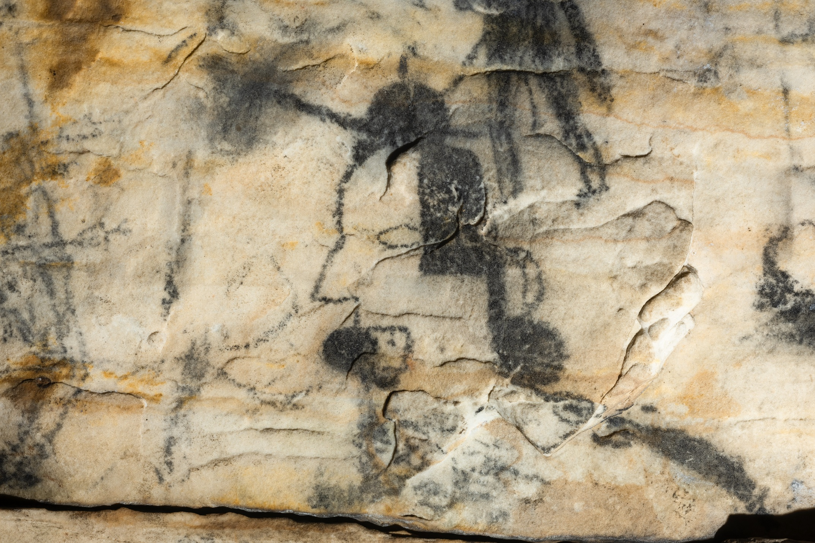Supplemental Figure 6. On panel 1 of Picture Cave 1, glyph 134 is approximately 20 cm tall and depicts a profile human head with hair and a filled-in circle in the mouth. We obtained a radiocarbon date of 1080±90 RCYBP (CAMS 193471, cal AD 705-1165, 95.4%) for this black pictograph. Photo credit: Mike Chervinko.

