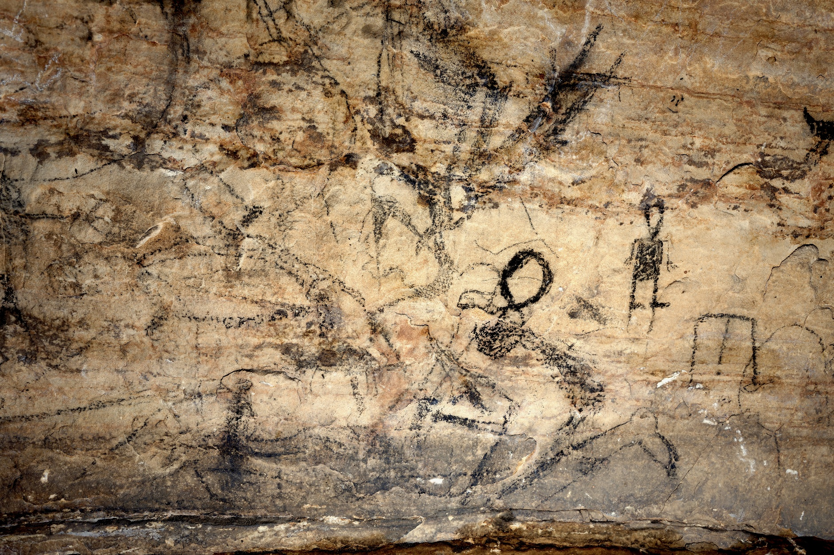

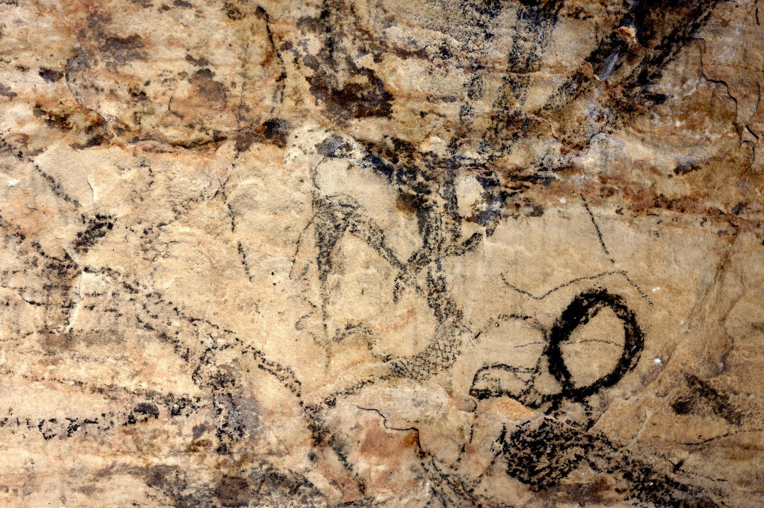

Supplemental Figure 5. On panel 4 of Picture Cave 1, glyph 192 is approximately 72 cm tall. (top) This elaborate kneeling figure with a falcon eye, snake skin pattern on the neck, and an erect phallus has been identified as Snake Hide (Great Serpent). (bottom) Detail of head and upper torso. We obtained a radiocarbon date of 1100±60 RCYBP (cal AD 770-1035, 95.4%) for this black pictograph. Photo credit: Mike Chervinko.

