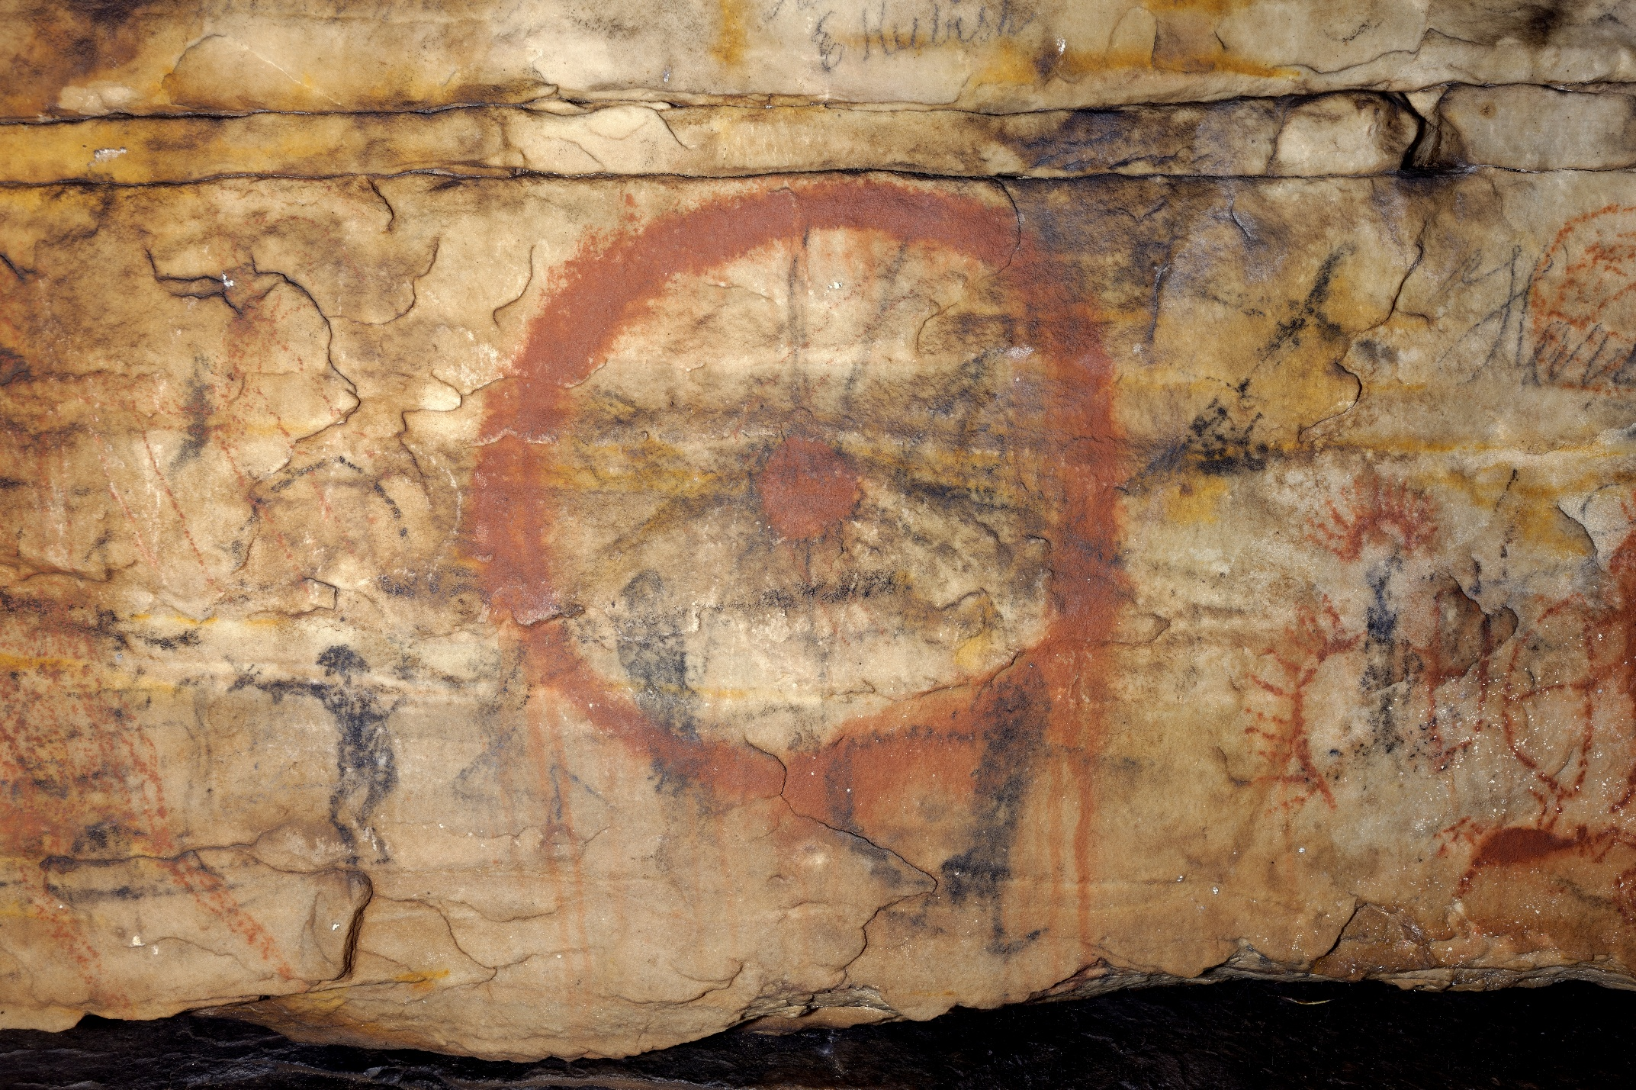
Supplemental Figure 2. On panel 2 of Picture Cave 1, glyph 7 is a dot and circle motif with a radius of approximately 25 cm. We obtained a radiocarbon date of 1180±110 RCYBP (CAMS 193456, cal AD 645-1120, 95.4%) for this red pictograph. Photo credit: Mike Chervinko.

