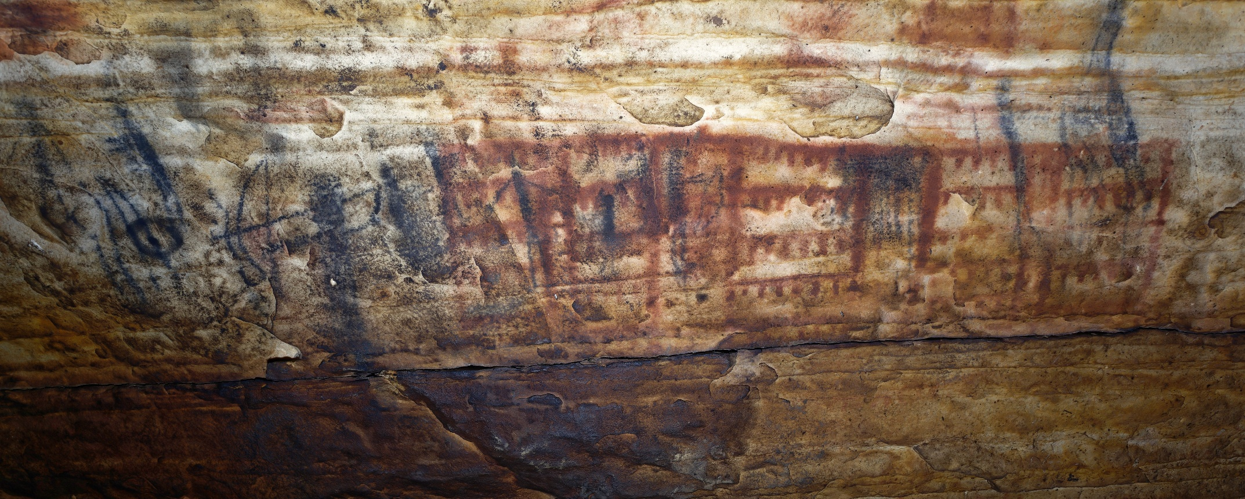Supplemental Figure 1. On panel 6 of Picture Cave 2, glyph 562 is approximately 22 cm tall and has been interpreted as a meat drying rack. We obtained a radiocarbon date of 1800±60 RCYBP (CAMS 193468, cal AD 120-405, 95.4% probability) for this red pictograph. Photo credit: Mike Chervinko.

