Luminescence dating of stone structures in the Northeastern United States—Supplementary Material

James Feathers
University of Washington
jimf@uw.edu

Shannon Mahan
United States Geological Survey
smahan@usgs.gov

Supplementary Material. Supplemental material for this article consists of four parts: (1) figures and tables relevant to the main text, (2) principles of luminescence, (3) technical data for UW samples not included in Feathers et al. 2022 and Feathers and Muller 2020, and (4) technical data for USGS samples not included in Mahan et al. 2015 and Mahan 2021. These parts are referenced as Supplemental Text 1-4 in the main paper.

SUPPLEMENTAL
Text 1: Figures and Tables Relevant to the Main Text
Table S1-1. List of samples collected by UW. 23 were from sediment and 20 from rocks.
UW Lab # | Site | State | Structure type*
Sediments
UW4076 | Madison Lithic | CT | Wall (Hammonassett Line)
UW4077 | Madison Lithic | CT | Small platform
UW4079 | Gungywamp | CT | circular arrangement (Mill race)
UW4081 | Gungywamp | CT | Chamber (Chi-rho)
UW4083 | Hunt’s Brook Souterrain | CT | chamber
UW4087 | Manitou Hassannash | RI | Wall (E-W)
UW4088 | Manitou Hassannash | RI | Wall (E-W)
UW4089 | Manitou Hassannash | RI | Cairn (#24)
UW4092 | Lewis Hollow | NY | Cairn (#4)
UW4094 | Lewis Hollow | NY | Cairn (#1 near Altar)
UW4095 | Rocky Hill Road | RI | Wall (niche)
UW4096 | Rocky Hill Road | RI | Wall (Snakehead Wall)
UW4097 | Rocky Hill Road | RI | Cairn (#1 within Serpentine Wall)
UW4098 | America’s Stonehenge | NH | Chamber (Oracle, above)
UW4101 | America’s Stonehenge | NH | Wall (Watch House)
UW4102 | Crown Farm | RI | Wall (Manitou)
UW4103 | Crown Farm | RI | Rock arrangement (Dragonfly)
UW4120 | Calendar II | VT | chamber
UW4169 | Richard’s | VT | chamber
UW4175 | Goshen Tunnel | MA | Chamber (south of well)
UW4176 | Twin Column | MA | chamber
UW4178 | Smith Mt. Gap | PA | cairn
UW4179 | West Berlin | PA | wall
Rocks
UW3808 | Oley Hills | PA | Rock pile (Terrace)
UW4078 | Gungywamp | CT | Chamber (#1)
UW4080 | Gungywamp | CT | Wall (IC Ball)
UW4084 | Hunt’s Brook Souterrain | CT | tunnel
UW4091 | Ed Wood Estate | RI | Cairn (big)
UW4099 | America’s Stonehenge | NH | Chamber (Closet G)
UW4100 | America’s Stonehenge | NH | Chamber (Oracle)
UW4106 | Milford | NH | Foundation, known age from historic records
UW4107 | Deerfield | NH | Rock pile surrounded by wall
UW4108 | Milford | NH | Foundation, known age from historic records
UW4109 | Deerfield | NH | Rock pile surrounded by wall
UW4168 | Oley Hills | PA | Platform (B)
UW4170 | Alpenglow | PA | wall
UW4171 | Bear’s Den | MA | chamber
UW4172 | Council Rocks | PA | Boulder (Cat Stone)
UW4173 | Council Rocks | PA | Boulder (Whale Stone)
UW4174 | Council Rocks | PA | Boulder (Snake Head stone)
UW4177 | Walker Quartz | VT | cairn
UW4179 | West Berlin | PA | wall
UW4181 | Hexenkopf Rocks | PA | Wall (N-S)
* In parenthesis after the structure type is a description of where on the site the sample was taken, usually just a common name or designation for the structure. The name does not imply any particular function for the structure.

Figure S1-1. Figure adapted from Feathers et al, 2022 to include sites of USGS samples. Counties in the
northeastern states of the US are shown in red where sites are located. Detailed locations are not
emphasized as many are on private property and contain structures that can be vandalized.
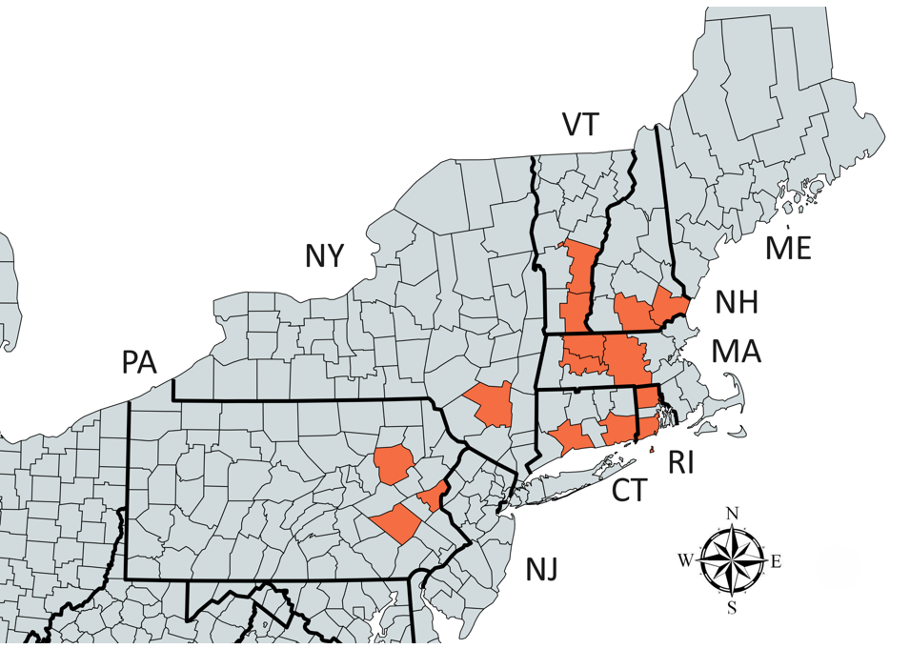

Table S1-2. List of samples collected by U.S.Geological Survey. All were sediment samples.
USGS Lab # | Site | State | Structure type*
Upton #2 | Upton | MA | chamber
Upton #4 | Upton | MA | chamber
Upton #5 | Upton | MA | chamber
Upton #10 | Upton | MA | chamber
PR-1a | Pratt Hill | MA | Rock pile
PR-1b | Pratt Hill | MA | Rock pile
Tolba-1 | Tolba | MA | effigy
Tolba-2 | Tolba | MA | effigy
Tolba-3 | Tolba | MA | effigy
Tolba 4a | Tolba | MA | Colonial house
MH-1 | Hopkinton | RI | Wall
Neara #28 | Milford | NH | Foundation, known age
Neara #87 | Milford | NH | Foundation, known age
Neara #66 | Deerfield | NH | Rock Pile with wall
Neara #72 | Deerfield | NH | Rock Pile with wall

Table S1-3. Total D_{r} (Gy/ka) for all UW calculated samples
UW Lab # | Quartz (OSL) |  | K-feldspar (IRSL)
 | lab | field | lab | field
Sediments
UW4076 | 0.89±0.05 | 1.49±0.28 | 1.48±0.18 | 2.07±0.33
UW4077 | 1.25±0.06 | 1.95±0.45 | 1.82±0.17 | 2.06±0.36
UW4079 |  |  | 3.87±0.27 | 4.12±0.59
UW4081 | 2.78±0.12 | 3.13±0.27 | 3.48±0.23 | 3.82±0.34
UW4083 | 3.35±0.13 | 3.26±0.19 | 4.02±0.24 | 3.94±0.28
UW4087 | 3.03±0.11 | 3.21±0.24 | 3.65±0.21 | 3.81±0.30
UW4088 | 3.59±0.14 |  | 4.28±0.25
UW4089 | 3.08±0.12 | 4.33±0.33 | 3.72±0.22 | 3.72±0.22
UW4092 | 2.55±0.13 | 3.76±0.36 | 3.00±0.46 | 4.50±0.56
UW4094 | 2.68±0.12 | 2.75±0.52 | 4.26±0.47 | 4.32±0.69
UW4095 | 2.94±0.19 | 3.83±0.60 | 3.50±0.28 | 4.36±0.64
UW4096 | 2.73±0.13 | 4.21±0.46 | 4.28±0.48 | 5.76±0.65
UW4097 | 2.64±0.11 | 3.12±2.11 | 4.17±0.46 | 4.65±2.16
UW4098 | 2.10±0.15 | 2.80±0.30 | 2.70±0.26 | 3.40±0.36
UW4101 | 2.41±0.10 | 2.72±0.26 | 3.04±0.21 | 3.36±0.32
UW4102 | 2.345±0.16 | 7.02±0.26 | 2.91±0.26 | 7.59±0.33
UW4103 | 2.39±0.14 | 2.31±0.13 | 3.85±0.50 | 3.77±0.49
UW4120 | 2.09±0.08 | 1.87±0.17 | 3.57±0.45 | 3.35±0.47
UW4169 |  |  | 4.05±0.46 | 3.72±0.45
UW4175 |  |  | 4.79±0.48 | 3.97±0.51
UW4176 |  |  | 6.83±0.66 | 7.00±0.64
UW4178 | 2.83±0.13 | 2.43±0.16 | 4.04±0.47 | 3.64±0.47
UW4179 | 1.23±0.07 | 0.80±0.06 | 2.43±0.44 | 2.02±0.44
Rocks
UW Lab # | OSL |  | IRSL
 | lab | field | lab | field
UW3808 | 4.10±0.50 |  | 4.59±0.23
UW4078 | 0.80±0.64 | 2.11±0.32 | 2.21±0.44 | 3.51±0.54
UW4084 |  | 1.49±0.17 |  | 2.03±0.25
UW4091 | 5.75±0.65 |  | 6.33±0.57
UW4106 |  | 2.41±0.13 |  | 3.79±0.45
UW4109 |  | 6.79±0.39 |  | 8.13±0.63
UW4168 | 2.77±0.11 | 2.24±0.15 | 4.18±0.46 | 3.66±0.47
UW4170 | 2.22±0.09 | 1.68±0.12 | 2.81±0.21 | 2.27±0.22
UW4171 | 0.87±0.05 | 1.60±0.09 | 1.45±0.47 | 2.17±0.48
UW4172 | 1.79±0.08 | 1.89±0.04 | 2.32±0.19 | 2.43±0.19
UW4173 | 1.59±0.09 | 1.05±0.08 | 2.13±0.21 | 1.59±0.21
UW4174 | 2.61±0.10 | 1.88±0.09 | 3.17±0.17 | 2.48±0.18
UW4177 | 0.55±0.05 | 0.45±0.03 | 1.10±0.18 | 0.99±0.18
UW4179 | 1.36±0.07 | 0.99±0.07 | 2.43±0.44 | 2.02±0.44
UW4181 | 1.40±0.07 |  | 1.97±0.19
*Empty boxes obtain where field dosimeter measurements were not made or where either quartz or feldspar were not analyzed for D_{e}. Samples missing from the table are those where D_{r} was not calculated because D_{e} was so high that a Holocene age would not have been obtained. The D_{r} for K-feldspar (IRSL) is more than that for quartz (OSL) because of internal K concentration. For the rocks, quartz and K-feldspar grains were not isolated.

Table S1-4. Total dose rates (Gy/ka) for USGS samples
USGS lab # | Quartz dose rate | Feldspar dose rate
Upton #2 | 2.76 ± 0.19
Upton #4 | 1.77 ± 0.17
Upton #5 | 3.43 ± 0.16
Upton #10 | 2.98 ± 0.20
PR-1a* | 1.74 ± 0.05 | 2.34 ± 0.07
PR-1b* | 1.74 ± 0.05 | 2.34 ± 0.07
Tolba-1 | 1.33 ± 0.11
Tolba-2 | 1.38 ± 0.11
Tolba-3 | 1.47 ± 0.11
Tolba 4a | 1.73 ± 0.13
MH-1 | 1.93 ± 0.07
Neara #28 | 1.61 ± 0.06
Neara #87 | 1.10 ± 0.06
Neara #66 | 0.71 ± 0.06
Neara #72 | 0.60 ± 0.07
* These samples were taken from the same place

Table S1-5. Acceptance rates for quartz and feldspars for all single grain sediment samples. N=number of grains measured.
UW Lab # | State | Quartz (OSL) |  | K-feldspar (IRSL)
 |  | N | % accepted | N | % accepted
UW4076 | CT | 487 | 13.6 | 795 | 39.8
UW4077 | CT | 394 | 22.6 | 397 | 46.1
UW4079 | CT | 0 |  | 880 | 16.5
UW4081 | CT | 588 | 13.3 | 491 | 50.9
UW4083 | CT | 1575 | 3.1 | 784 | 23.2
UW4087 | RI | 1278 | 8.5 | 297 | 42.4
UW4088 | RI | 786 | 5.5 | 496 | 43.8
UW4089 | RI | 586 | 11.6 | 291 | 60.8
UW4092 | NY | 977 | 10.2 | 293 | 53.2
UW4094 | NY | 492 | 15.9 | 888 | 9.9
UW4095 | RI | 587 | 15.5 | 689 | 24.2
UW4096 | RI | 393 | 16.8 | 493 | 16.0
UW4097 | RI | 0 |  | 989 | 7.9
UW4098 | NH | 787 | 9.1 | 1479 | 15.8
UW4101 | NH | 1181 | 13.2 | 394 | 26.9
UW4102 | RI | 889 | 7.1 | 393 | 62.6
UW4103 | RI | 196 | 7.7 | 494 | 15.2
UW4120 | VT | 296 | 27.0 | 1672 | 7.2
UW4169 | VT | 591 | 1.0 | 1075 | 9.6
UW4175 | MA | 495 | 1.2 | 987 | 7.6
UW4176 | MA | 394 | 2.3 | 296 | 38.9
UW4178 | PA | 396 | 19.2 | 692 | 1.6
UW4179 | PA | 1389 | 8.6 | 1085 | 0.5
Upton #2 | MA | 2400 | 6.8
Upton #4 | MA | 2400 | 6.8
Upton #5 | MA | 2400 | 5.8
Upton #10 | MA | 2400 | 5.5
total |  | 24357 | 8.2 | 14391 | 22.6

Table S1-6. D_{e}, age and other data for quartz samples. CAM = central age model; MAM = minimum age model
Lab # | # accepted  Grains* | D_{e} (Gy)  CAM** | Over-dispersion  (%) | D_{e} (Gy)  MAM** | Age (ka)  MAM** | Calendar age  (years AD, except where BC indicated)
UW4076 | 66 | 2.40±0.24 | 68.2 | 0.98±0.16 | 0.66±0.16 | 1360±160
UW4077 | 89 | 1.53±0.20 | 116.1 | 0.44±0.07 | 0.35±0.06 | 1670±60
UW4081 | 78 | 5.25±0.76 | 120.1 | 0.80±0.08 | 0.29±0.03 | 1730±30
UW4083 | 49 | 4.40±0.81 | 116.4 | 1.20±0.34 | 0.36±0.10 | 1660±100
UW4087 | 108 | 1.46±0.18 | 114.9 | 0.64±0.04 | 0.21±0.02 | 1810±20
UW4088 | 43 | 0.88±0.13 | 86.0 | 0.61±0.05 | 0.17±0.02 | 1850±20
UW4089 | 68 | 4.07±0.52 | 96.7 | 0.75±0.08 | 0.17±0.02 | 1850±20
UW4092 | 100 | 1.54±0.18 | 103.7 | 0.53±0.09 | 0.14±0.03 | 1880±30
UW4094 | 78 | 6.38±1.07 | 142.0 | 0.65±0.07 | 0.24±0.03 | 1780±30
UW4095 | 91 | 2.08±0.26 | 109.6 | 0.90±0.05 | 0.31±0.03 | 1720±30
UW4096 | 66 | 2.08±0.23 | 81.5 | 0.72±0.16 | 0.17±0.04 | 1850±40
UW4098 | 72 | 2.35±0.35 | 113.9 | 0.79±0.15 | 0.28±0.06 | 1740±60
UW4101 | 156 | 3.23±0.25 | 89.6 | 0.89±0.09 | 0.37±0.04 | 1650±40
UW4102 | 63 | 2.09±0.32 | 117.2 | 0.47±0.10 | 0.20±0.04 | 1820±40
UW4103 | 15 | 2.76±0.52 | 63.1 | 1.18±0.25 | 0.49±0.11 | 1530±110
UW4120 | 80 | 0.87±0.08 | 60.6 | 0.52±0.04 | 0.25±0.02 | 1770±20
UW4178 | 76 | 1.35±0.22 | 135.0 | 0.16±0.03 | 0.25±0.03 | 1780±30
UW4179 | 119 | 3.23±0.38 | 119.0 | 0.39±0.07 | 0.49±0.10 | 1530±100
Upton #2 | 162 | 3.85±0.28 | 82.3 | 1.48±0.21 | 0.54±0.08 | 1480±80
Upton #4 | 164 | 2.22±0.23 | 172.0 | 1.02±0.13 | 0.58±1.08 | 1440±80
Upton #5 | 138 | 2.57±0.34 | 113.0 | 1.56±0.23 | 0.46±0.07 | 1560±70
Upton #10 | 131 | 5.93±0.44 | 142.0 | 2.28±0.34 | 0.76±0.12 | 1250±115
PR-1a | 30* | 2.89 ± 0.26 | 48.0 | 1.02±0.03 | 0.60±0.05 | 1420±40
PR-1b | 36* | 10.5 ± 0.76 | 43.0 | 6.24±0.14 | 3.60±0.26 | 1575±260 BC
Tolba-1 | 45* | 1.58 ± 0.19 | 80.0 | 0.57±0.03 | 0.43±0.08 | 1590±80
Tolba-2 | 48* | 1.50 ± 0.14 | 65.0 | 0.51±0.04 | 0.37±0.08 | 1650±80
Tolba-3 | 35* | 2.96 ± 0.37 | 74.0 | 1.03±0.03 | 0.70±0.10 | 1320±100
Tolba 4a | 36* | 6.71 ± 0.94 | 89.0 | 1.16±0.06 | 0.67±0.12 | 1350±120
MH-1 | 47* | 1.81 ± 0.10 | 37.0 | 1.81±0.10 | 0.49±0.04 | 1530±40
Neara #28 | 47* | 4.96±0.59 | 80.0 | 1.48±0.04 | 0.92±0.04 | 1100±40
Neara #87 | 19* | 235±25 | 46.0 | 111±4.3 | 101.1±6.6 | 99080±6660 BC
Neara #66 | 43* | 77.9±5.4 | 44.0 | 27.4±0.71 | 38.7±3.66 | 36720±3660 BC
Neara #72 | 28* | 29.6±4.6 | 75.0 | 7.94±0.30 | 13.3±1.69 | 11320±1690 BC
*For the last 11 samples, the value is number of small aliquots, not grains
**For the Upton samples, the D_{e} values are for the mean rather than CAM and for the FMM youngest component instead of MAM.

Table S1-7. D_{e}, age and other data for K-feldspar samples. CAM=central age model; MAM = minimum age model. Fading correction is done on age.
UW lab# | # accepted  Grains* | D_{e} (Gy)  CAM | Over-dispersion  (%) | Fading  Rate**  (%/decade) | Age (ka)  CAM | Age (ka)  MAM | Calendar age  (years AD, except where BC indicated)
UW4076 | 316 | 1.84±0.11 | 102.2 | 3.62±11.2 | 1.08±0.08 | 0.51±0.07 | 1510±70
UW4077 | 183 | 2.90±0.29 | 124.1 | 2.99±0.53 | 1.89±0.21 | 0.40±0.06 | 1620±60
UW4079 | 145 | 4.68±0.50 | 124.0 | 9.32 | 2.00±0.28 | 0.38±0.08 | 1640±80
UW4081 | 250 | 7.18±0.55 | 118.2 | 4.09±0.40 | 2.74±0.23 | 0.53±0.07 | 1490±70
UW4083 | 182 | 10.05±0.90 | 111.3 | 5.59±0.58 | 3.36±0.37 | 0.60±0.11 | 1420±110
UW4087 | 126 | 2.44±0.31 | 127.2 | 8.69±0.96 | 0.90±0.14 | 0.60±0.12 | 1420±120
UW4088 | 217 | 3.13±0.28 | 119.0 | 6.04±0.52 | 0.84±0.09 | 0.23±0.05 | 1790±50
UW4089 | 177 | 3.86±0.28 | 86.4 | 6.19±0.48 | 1.08±0.10 | 0.44±0.08 | 1580±80
UW4092 | 155 | 2.86±0.32 | 133.2 | 8.61±0.66 | 1.14±0.16 | 0.47±0.05 | 1550±50
UW4094 | 88 | 8.13±1.14 | 128.0 | 4.56 | 2.66±0.40 | 0.35±0.06 | 1670±60
UW4095 | 166 | 3.72±0.38 | 121.4 | 3.45±0.60 | 1.12±0.12 | 0.40±0.04 | 1620±40
UW4096 | 79 | 2.53±0.41 | 129.0 | 2.82 | 0.45±0.07 | 0.25±0.06 | 1770±60
UW4097 | 78 | 3.39±0.53 | 127.0 | 2.84 | 0.967±0.17 | 0.24±0.07 | 1780±70
UW4098 | 234 | 4.92±0.38 | 110.5 | 2.92±2.78 | 1.70±0.16 | 0.38±0.08 | 1640±80
UW4101 | 106 | 6.46±0.70 | 103.1 | 1.64±5.45 | 2.28±0.27 | 0.62±0.12 | 1400±120
UW4102 | 246 | 3.36±0.24 | 110.2 | 5.72±0.43 | 1.63±0.14 | 0.52±0.09 | 1500±90
UW4103 | 75 | 2.14±0.36 | 136.0 | 7.05 | 0.63±0.13 | 0.14±0.04 | 1880±40
UW4120 | 116 | 5.66±045 | 110.0 | 2.54 | 1.83±0.24 | 0.40±0.08 | 1620±80
UW4169 | 103 | 30.0±3.33 | 109.0 | 2.06 | 8.35±1.26 | 1.31±0.31 | 710±310
UW4175 | 75 | 10.1±1.82 | 152.0 | 3.12 | 2.14±0.49 | 0.39±0.11 | 1550±130
UW4176 | 95 | 15.3±1.29 | 80.9 | 1.15 | 2.54±0.23 | 0.93±0.15 | 1090±150
PR-1a | 9 | 8.77 ± 0.16 | 50.0 | 4.5 ± 0.5 | 3.75 ± 0.13 | 0.58±0.05 | 1440±50
PR-1b | 9 | 10.4 ± 0.16 | 29.0 | 4.5 ± 0.5 | 4.25 ± 0.15 | 4.42±0.30 | 2400±300 BC
*For Pratt Hill samples, the value is for a number of small aliquots, not grains
**Fading rate is weighted average g-value, standardized to two days. Decade refers to a power of 10.

Table S1-8. Age as a function of depth from various cores from rocks. “SAT” means the signal is saturated. NA means the D_{e} could not be determined for some reason.
Sample | Rock type | Core | Age (ka)
 |  |  | Slice 1 | Slice 2 | Slice 3 | Slice 4 | Slice 5
OSL
UW4078 | Granitic gneiss | 1 | NA | 1.28±0.26 | NA | NA | NA
UW4091 | granodiorite | 2 | 0.38±0.20 | 0.87±0.06 | 3.04±0.31 | 3.84±0.49 | 4.31±0.61
UW4106 | granite | 3 | 0.94±0.19 | 1.32±0.22 | SAT | SAT | SAT
 |  | 4 | 1.64±0.22 | 2.77±0.28 | 5.79±0.85 | SAT | 15.7±1.40
UW4109 | granite | 1 | 0.38±0.03 | 0.60±0.04 | 1.77±0.12 | SAT | SAT
 |  | 7 | 1.50±0.15 | 1.45±0.38 | 2.89±0.24 | SAT | SAT
 |  | 8 | 0.81±0.16 | 1.85±0.16 | 3.25±0.38 | SAT | SAT
UW4168 | granite | 3 | 4.07±0.97 | 9.06±1.04 | 12.3±0.90 | 15.6±1.23 | 21.3±1.40
UW4171 | quartzite | 1 | 3.67±0.42 | 4.35±1.78 | 8.31±2.86 | 10.2±21.1 | 18.5±19.0
 |  | 3 | 2.94±0.43 | 5.16±1.32 | 11.0±34.9 | NA | 33.0±33.8
UW4172 | quartzite | 3 | 2.06±0.20 | SAT | SAT | SAT | SAT
UW4173 | quartzite | 1 | 2.29±0.45 | 4.50±4.72 | 9.27±8.38 | NA | SAT
 |  | 2 | NA | 1.38±0.37 | SAT | 16.9±6.61 | SAT
UW4174 | quartzite | 2 | 0.46±0.12 | 7.02±1.17 | 25.1±7.55 | 9.38±1.72 | SAT
 |  | 4 | 4.48±0.79 | 5.28±0.80 | SAT | 14.2±7.88 | 7.08±1.31
 |  | 5 | 1.03±0.11 | 6.95±1.31 | 8.29±1.80 | 7.58±0.94 | 9.16±1.25
UW4179 | quartzite | 1 | 3.70±0.84 | NA | NA | NA | NA
 |  | 3 | 4.44±0.80 | NA | NA | NA | NA
IRSL
UW3808 | gneiss | 1 | 2.64±0.28 | 1.65±0.017 | 4.97±0.28 | 16.5±1.06 | 70.2±33.7
 |  | 3 | 2.46±0.26 | 1.53±0.16 | 2.57±0.15 | 4.60±0.27 | 4.03±0.23
UW4078 | Granitic gneiss | 1 | NA | 0.27±0.06 | NA | NA | NA
UW4084 | Granitic gneiss | 2 | 1.03±0.29 | NA | 18.8±4.62 | 40.9±13.5 | SAT
 |  | 4 | 2.85±2.63 | NA | 28.8±22.8 | SAT | SAT
UW4091 | granodiorite | 2 | 0.77±0.57 | NA | 0.47±0.19 | 0.54±0.14 | 0.68±0.18
 |  | 3 | 0.40±0.06 | 0.36±0.05 | 0.51±0.07 | 1.7±0.03 | SAT
UW4106 | granite | 3 | 0.18±0.03 | 0.26±0.04 | 1.64±0.20 | 2.94±0.36 | 4.54±0.55
 |  | 4 | 0.49±0.06 | 0.74±0.10 | 0.69±0.08 | 0.97±0.12 | 1.80±0.22
UW4109 | granite | 1 | 0.29±0.03 | 0.36±0.05 | 0.55±0.05 | 2.05±0.19 | SAT
 |  | 7 | 0.31±0.03 | 0.33±0.04 | 0.58±0.05 | SAT | SAT
 |  | 8 | 0.23±0.02 | 0.40±0.05 | 0.56±0.05 | 0.62±0.06 | 4.62±0.43
UW4168 | granite | 3 | 1.46±1.32 | 0.44±0.15 | NA | NA | NA
UW4170 | quartzite | 1 | 0.94±0.23 | 1.13±0.25 | SAT | SAT | SAT
UW4171 | quartzite | 3 | 2.80±2.54 | SAT | SAT | SAT | SAT
UW4172 | quartzite | 1 | 2.17±0.77 | NA | NA | SAT | SAT

Table S1-9. Rock ages. Weighted averages where N is the number of measurements averaged, from the top one or two slices.
Sample | Location | OSL |  | IRSL
 |  | N | Age (ka) | N | Age (ka)
UW3808 | Oley Hills, PA |  |  | 7 | 2.59 ± 0.33
UW4078 | Gungywamp, CT | 1 | 0.42 ± 0.10* | 1 | 0.27 ± 0.06*
UW4084 | Hunt’s Brook Souterrain, CT |  |  | 1 | 1.03 ± 0.29*
UW4091 | Ed Woods Estate, RI | 1 | 0.38 ± 0.20* | 6 | 0.54 ± 0.08
UW4106 | Milford, NH | 4 | 1.31 ± 0.14* | 3 | 0.29 ± 0.05**
UW4109 | Deerfield, NH | 2 | 0.43 ± 0.03* | 5 | 0.28 ± 0.02
UW4168 | Oley Hills, PA | 3 | 4.09 ± 0.46* | 4 | 0.78 ± 0.29
UW4170 | Alpenglow, PA | 2 | 1.04 ± 0.17* | 3 | 2.03 ± 1.18
UW4171 | Bear’s Den Chamber, MA | 3 | 3.41 ± 0.30* | 1 | 2.80 ± 2.54*
UW4172 | Council Rocks (Cat Stone), PA | 1 | 2.06 ± 0.20* | 1 | 2.17 ± 0.77*
UW4173 | Council Rocks (Whale Stone), PA | 2 | 1.90 ± 0.31
UW4174 | Council Rocks (Snake Head), PA | 5 | 1.02 ± 0.16*
UW4179 | West Berlin Wall, PA | 4 | 4.31 ± 0.54*
*Indicates samples where the age may be an over-estimate because it is taken only from the top slice in a profile that had no plateau. (The N may represent more than one core or more measurements from the same slice.)
**Because of poor fading data, the age for this sample was estimated using three different assumptions for the fading rate. All three ages were within error terms and this is the middle one.

Text 2: Luminescence Dating Principles
When minerals such as quartz and feldspar are exposed to sufficient radiation (see below for common natural sources) electrons are removed from the parent atom and raised to higher energy levels where they are free to move about the crystal lattice. When the radiation ceases, most electrons return to the ground state, but some get attracted to defects in the lattice where there is a localized charge deficiency. The deficiency may be either positive or negative. The negatively charged electrons are attracted to only negative deficiencies but the vacancies left behind in the parent atoms, called holes, are also attracted to defects, but ones with a positive deficiency. An example of a defect is the substitution of Ca for Na in table salt (NaCl). Calcium has a +2 valence, while Na only has a +1 valence; the extra electron creates a positive deficiency. For the crystal lattice to remain electrically neutral, somewhere else there must exist another defect with a negative deficiency. When an electron (or hole) becomes attached to one of these charge deficient defects, it is said to be “trapped”. Dating based on these principles is called “trapped charge dating” and includes luminescence and electron spin resonance.
Electrons (or holes) in the traps, representing the absorbed radiation dose, are released from the traps by imparting additional energy (e.g., light and/or heat). When the charge is released, electrons and holes are brought together at recombination centers in an energized state. Upon return to the ground state, this energy is released, in part, as light called luminescence.
The intensity of the luminescence signal is thus proportional to the amount of original trapped charge which in turn is proportional to the amount of absorbed dose accumulated since the traps were last emptied. If the traps are deep enough, in the sense that charge will not be released at ambient temperature, and if there is no exposure to light, then charge will continue to accumulate in the traps through time. If the natural radiation is absorbed at a constant rate, then the intensity of the luminescence relates to the time since the traps were last emptied by exposure to heat or light. That heating event, for example when a ceramic is fired, or that light exposure event, for example when sediment is exposed to sun during deposition, is often exactly what archaeologists want to know.
To calculate an age, two quantities must be estimated: the average dose rate (D_{r}) through time and the equivalent dose (D_{e}). The average D_{r} is estimated from the current D_{r} on the assumption of a constant rate. This is normally the case because of the long half-lives of the principal sources of natural radiation: ²³⁸U, ²³²Th, and ⁴⁰K, all with half-lives on the order of 10⁹ years, or somewhat greater than the age of the universe. Sometimes the D_{r} can change because of geological processes, where radionuclides are removed, for example by leaching, or added, for example by burial.
The D_{e} is an estimate of the total accumulated absorbed dose, sometimes called the paleodose. It is the amount of radiation necessary to account for the observed luminescence signal. It is called “equivalent” because it is determined by calibrating the signal against radiation applied in the laboratory. The D_{e} is the laboratory dose that is equivalent to the natural radiation absorbed by the sample since the traps were last emptied.
The age equation is a simple quotient where Gy stands for Gray, the international unit of absorbed dose, and t is a unit of time:
Age (t) = D_{e} (Gy) / D_{r} (Gy/t)

A distinction is made among thermoluminescence (TL), optically stimulated luminescence (OSL) and infrared stimulated luminescence (IRSL). These are versions of the same dating method, distinguished by how the luminescence is stimulated in the laboratory, regardless of how traps were emptied in nature. For TL the stimulation is by heat, for OSL the stimulation is by light in the visible range, for IRSL the stimulation is by infrared light. OSL and IRSL are commonly used for both heated materials and sediments, mainly because of better precision and, for sediments, because the signal is more likely to be completely zeroed in nature. If all traps have not been emptied by the depositional event of interest, the signal is said to be partially bleached. The TL signal has an unbleachable residual, making it less useful for sediment dating.
D_{e} is commonly determined by some variant of the single-aliquot regeneration (SAR) protocol, originally proposed for quartz (Murray and Wintle 2000), but later adapted for feldspar (Auclair et al. 2003). The natural luminescence signal is calibrated by a series of signals from laboratory doses of different magnitude on a single aliquot (or sub sample), which “regenerate” the signal. All stimulations are preceded by a preheat to remove unstable signals. Between each main dose is a small test dose. always of the same magnitude, the signal from which is used to correct for any sensitivity change that may occur during the series of irradiations, preheats and stimulations. Sensitivity refers to the amount of luminescence per unit radiation dose. Table S2-1 shows the general protocol that was used in this study. D_{e} is determined by interpolating the natural luminescence signal normalized by the test dose (L_{N}/T_{N}) into a luminescence growth curve defined by the regeneration doses (L_{x}/T_{x}).

Table S2-1. Generalized single aliquot regeneration protocol for IRSL and OSL (Wintle and Murray, 2006, Auclair et al 2003). Specific parameters are given in the technical discussions.
Sequence
- Natural dose
- Preheat
- Stimulation (Green or IR lasers or blue diodes)
- Test dose beta irradiation
- Preheat
- Stimulation (Green or IR lasers or blue diodes)
- Beta irradiation for regeneration dose
- Preheat
- Stimulation (Green or IR lasers or blue diodes)
- Test does beta irradiation
- Preheat
- Stimulation (Green or IR lasers or blue diodes)
- High temperature OSL or IRSL wash
- Repeat steps 7-13 with additional regeneration doses

In recent years D_{e} has been determined on very small aliquots or on single grains. The estimated D_{e} might not be the same for every small aliquot or grain for various reasons. Some have to do with uncertainties in measurement, variations in luminescence properties from grain to grain, and variation in D_{r} at a single-grain scale. Differences in D_{e} that are of most interest in dating result from differences in age. This includes partial bleaching where not all grains are completely zeroed at the same time and post-depositional movement caused by turbation agents which move grains up and down a stratigraphic column without exposure to light. Single-grain analysis will thus result in a distribution of D_{e} values. The task in dating is to evaluate that distribution in terms of these various causes.
Grain-to-grain differences in D_{r} reflect differences in penetrating power of the three forms of terrestrial radiation: alpha, beta and gamma radiation. Alphas only penetrate microns of sediment or rocks, while gammas can travel up to 30 cm. Betas are intermediary with a 1-3 mm range. Single-grain analysis is usually done on fine sand grains of quartz or feldspar. These minerals have little internal sources of alpha radiation, which therefore has negligible impact on the luminescence particularly if outer surfaces are etched away. Long-ranged gammas affect all grains within a sample evenly. The problem is with beta radiation. If the sources of beta radiation are heterogeneously distributed within a sample, grains close to the sources will have a larger D_{e} than grains further away, even if the same age. D_{r}, by current methods, is determined on bulk samples, not individual grains.
Luminescence protocols provide various internal tests to evaluate the integrity of the derived age. One is called dose recovery where grains are zeroed by exposing them to light and then given a known irradiation dose. D_{e} is then determined to see if the known dose can be derived. This serves as a test of protocols but also provides an estimate of the spread typical of a sample for reasons other than differential D_{r} or differential age.
A good introduction to luminescence dating for archaeologists is provided by Duller (2008). A more recent introduction, written for geologists, is Mahan et al. (2022). Those wanting to delve into the physics might try Yukihara and McKeever (2011).

References cited:
Duller, Geoffrey A. T.
2008 Luminescence Dating: Guidelines on Using Luminescence Dating in Archaeology. English Heritage.
Mahan, Shannon A., Tammy M. Rittenour, Michelle S. Nelson, Nina Ataee, Nathan Brown, Regina DeWitt, Julie Durcan, Mary Evans, James Feathers, Marine Frouin, Guillaume Guérin, Maryam Heyidari, Sebastien Huot, Mayank Jain, Amanda Keen-Zebert, Bo Li, Gloria I. López, Christina Neudorf, Naomi Porat, Kathleen Rodriques, Andre O. Sawakuchi, Joel Q. G. Spencer, and Kristina Thomsen
2022 Guide for Interpreting and Reporting Luminescence Dating Results. Geological Survey of America Bulletin, https://doi.org/10.1130/B36404.1
Murray, Andrew. S., and Ann G. Wintle
2000 Luminescence Dating of Quartz Using an Improved Single-Aliquot Regenerative-Dose Protocol. Radiation Measurements 32(1): 57-73.
Yukihara, Eduardo G., and Stephen W. S. McKeever
2011 Optically Stimulated Luminescence: Fundamentals and Applications. Wiley and Sons, Chichester, United Kingdom.
Text 3: LUMINESCENCE ANALYSIS OF ROCK STRUCTURES IN THE NORTHEASTERN US, NOT PREVIOUOSLY REPORTED
University of Washington

This supplement presents results of luminescence analysis of 11 sediment samples and 10 rock samples collected from various rock structures in northeastern United States. The sediments were collected from underneath rocks in the structures. Assuming that prior to placement of the rock various turbation processes brought sufficient sediment grains to the surface where their luminescence signal was removed, the sediments should date the placement of the rock. The rocks, as part of the structure, provide a more direct measurement of the rock placement, on the assumption that a buried surface of the rock was exposed to sufficient sunlight prior to placement. Samples with laboratory numbers UW4103 or less were collected by the author. Others were collected by members of NEARA. Table S3-1 lists the samples and other information. Laboratory procedures are detailed in Feathers et al. (2022).

Table S3-1. Samples collected from various rock structures in northeastern US
UW Lab # | site | State | Structure type | Other information
Sediments
UW4079 | Gungywamp | CT | circular arrangement | Mill race
UW4094 | Lewis Hollow | NY | cairn | Cairn 1 near Altar
UW4096 | Rocky Hill Road | RI | wall | East-West Snakehead Wall
UW4097 | Rocky Hill Road | RI | cairn | #1 within Serpentine Wall
UW4103 | Crown Farm | RI | arrangement | Dragonfly
UW4120 | Calendar II | VT | chamber
UW4169 | Richard’s | VT | chamber
UW4175 | Goshen Tunnel | MA | chamber | 24-feet south of well
UW4176 | Twin Column | MA | chamber
UW4178 | Smith Mt. Gap | PA | cairn
UW4179 | West Berlin | PA | wall | 29 m south of northern terminus
Rocks
UW4078 | Gungywamp | CT | chamber | Chamber 1
UW4168 | Oley Hills | PA | platform | Platform B
UW4170 | Alpenglow | PA | wall
UW4171 | Bear’s Den | MA | chamber
UW4172 | Council Rocks | PA | boulder | Cat Stone
UW4173 | Council Rocks | PA | boulder | Whale Stone
UW4174 | Council Rocks | PA | boulder | Snake Head Stone
UW4177 | Walker Quartz | VT | cairn
UW4179 | West Berlin | PA | wall | 29 m south of northern terminus
UW4181 | Hexenkopf Rocks | PA | wall | North-South wall

Dose Rate
Radioactivity was measured on each sample and any associated rocks or sediments. Relevant concentrations are given in Table S3-2. Radioactivity on the samples was mainly determined using alpha counting and flame photometry. The beta dose rate calculated from these measurements was compared with the beta dose rate measured directly by beta counting (Table S3-2). These differed at one-sigma for seven samples (values in italics) but were different at two-sigma for only three samples. Given the relatively low U and Th content, these discrepancies probably reflect problems with the K measurement. Attempts to adjust the U and Th contents to match the beta counting values resulted in negative contents. Therefore, the K content for these samples was adjusted to match the beta counting. Beta counting was considered a more accurate measure of beta dose rate because it is a more direct measure. The one exception to the K content being adjusted was UW4176, which had very high U and Th contents. The pairs method in alpha counting is less reliable when U and Th contents are high. For this sample the U and Th contents were adjusted to match the beta counting.
The dose rates for potassium feldspar samples require an estimation of internal K from individual grains. This was not measured. Smedley et al. (2012) estimated an internal K content of 10 ± 2 % for most samples. This estimation was used for most samples in this study, although the error was increased to 3 % to cover more variability. The estimate for UW4178 and UW4179 was reduced to 8 ± 3 % on account that these samples had very low sensitivity when stimulated by infrared light. Only about 1% of grains measured on these samples had a usable signal. Some studies suggest a correlation between low IRSL sensitivity and low internal K (Feathers 2012).
Sediment was collected in the field to measure moisture contents for adjusting the dose rates. The rocks had negligible moisture. Cosmic dose rate was calculated after Prescott and Hutton (1994), taking into account the thickness of the walls. Cosmic radiation hitting the samples through the sides of the wall was considered negligible.
The sample locations are a complicated juxtaposition of rocks, sediment, and air. This makes estimating the gamma dose rate challenging. Two approaches were applied. First, samples of rocks or sediment within 20 cm of the sample were collected and measured for their radioactivity. The geometry of a 30-cm sphere about the sample was then constructed roughly, and the proportion of the gamma dose rate contributed by rocks, sediment and air was then approximated using the gamma gradients of Aiken (1985, appendix H). This procedure suffered from the approximation of the approach, the fact that the geometry behind the sample was not known, and the inadequate collection of relevant samples for some locations. As an alternative, CaSO₄ dosimeters were placed at each sample location during collection and left for one year. While the dosimeter was placed in the hole left by the sample removal, the dose rate recorded by the dosimeter is only an approximation of the actual exposure. Table S3-3 compares the gamma dose rate determined in the laboratory by the procedure just noted (and including the cosmic dose rate) with the gamma plus cosmic dose rate measured from the dosimeter. The laboratory and field measurements agree at one-sigma for only six samples. While a couple of others are within two-sigma, many are quite different. The effect of the difference in these measurements on the total dose rate is less critical if the latter is dominated by the beta dose rate. This will be taken up later.
The beta dose rate comes generally from within the sample, so it is not difficult to measure, but for the dated rocks some of the beta radiation originates from outside the sample. There was another rock directly adjacent to the surface being dated for all samples. At the interface between the two rocks, the beta dose rate will be 50% of the beta dose rate from the dated rock and 50% of the beta dose rate from the adjacent rock. With depth, the contribution to the beta dose rate of the dated rock increases and that of the adjacent rock diminishes. Beyond the 2-3 millimeters range of beta radiation, all the beta dose rate originates from the dated rock.
Table S3-4 gives the total dose rate for each sample, including values based just on laboratory measurements and those for which the external dose rate is provided by the dosimeter (replacing the gamma and cosmic dose rates with the values listed in the last column of Table S3-3). The dose rates for both quartz and feldspar, using both laboratory and field measurements, are given. Because of higher beta than gamma dose rates, more laboratory and field measurements are in agreement at one-sigma than in Table S3-3, especially among the K-feldspar samples which have higher error terms due to uncertainty in the internal K content. For the rock samples, grains sizes of about 200 µm were assumed (and roughly verified on rock slices by a binocular microscope).

Table S3-2. Radionuclide concentrations for samples collected from various rock structures in
northeastern US
Sample | ²³⁸U  (ppm) | ²³³Th  (ppm) | K  (%) | Beta dose rate (Gy/ka)
 |  |  |  | ß-counting | α-counting/flame photometry
UW4078 | 1.01±0.09 | 3.09±0.62 | 6.78±0.26 | 5.72±0.77 | 5.79±0.72
UW4079 | 1.68±0.14 | 5.16±0.90 | 2.03±0.12 | 2.64±0.40 | 2.06±0.10
rock | 0.61±0.05 | 1.04±0.35 | 1.06±0.03
UW4094 | 2.29±0.20 | 11.29±1.29 | 1.38±0.08
rock | 2.67±0.19 | 6.92±1.00 | 2.34±0.21
UW4096 | 2.05±0.17 | 9.38±1.15 | 2.17±0.13 | 1.62±0.20 | 2.34±0.11
rock | 2.44±0.20 | 9.87±1.30 | 3.28±0.27
UW4097 | 2.78±0.19 | 6.94±1.06 | 1.43±0.04 | 1.78±0.22 | 1.66±0.05
rock | 0.65±0.12 | 10.47±1.30 | 1.16±0.07
UW4103 | 1.79±0.12 | 1.66±0.05 | 1.75±0.15 | 1.63±0.19 | 1.74±0.13
rock | 0.66±0.07 | 3.09±0.61 | 1.51±0.11
UW4120 | 1.50±0.12 | 4.36±0.77 | 1.04±0.03 | 1.16±0.14 | 1.19±0.04
rock | 2.72±0.21 | 9.49±1.29 | 2.04±0.07
UW4168 | 0.92±0.08 | 1.41±0.46 | 2.12±0.08 | 1.95±0.23 | 1.91±0.07
rock | 1.11±0.09 | 1.63±0.50 | 2.29±0.06
UW4169 | 1.10±0.15 | 10.43±1.36 | 1.57±0.06 | 1.54±0.18 | 1.74±0.07
UW4170 | 1.26±0.12 | 5.88±0.87 | 0.62±0.02 | 2.17±0.27 | 2.32±0.06
sediment | 2.61±0.18 | 6.27±1.03 | 2.15±0.06
rock 1 | 0.88±0.07 | 0.86±0.35 | 0.13±0.01
rock 2 | 1.12±0.09 | 3.07±0.63 | 0.34±0.03
UW4171 | 0.56±0.07 | 2.70±0.62 | 0.45±0.02 | 0.46±0.07 | 0.53±0.03
sediment | 1.55±0.16 | 4.65±0.46 | 0.20±0.01
UW4172 | 1.98±0.12 | 0.53±0.32 | 0.20±0.01 | 0.49±0.06 | 0.47±0.02
rock | 1.77±0.15 | 7.24±1.06 | 1.92±0.05
UW4173 | 1.38±0.10 | 2.66±0.59 | 0.83±0.03 | 0.79±0.10 | 0.95±0.03
rock | 0.97±0.09 | 3.88±0.71 | 1.16±0.05
UW4174A | 1.20±0.09 | 1.81±0.48 | 1.53±0.05 | 1.36±0.17 | 1.48±0.05
UW4174B | 1.83±0.13 | 4.45±0.79 | 1.51±0.05 | 1.67±0.22 | 1.62±0.05
rock | 0.15±0.06 | 2.05±0.50 | 2.83±0.09
UW4175 | 3.92±0.25 | 7.34±1.17 | 2.66±0.12 | 2.89±0.36 | 2.95±0.11
rock | 2.41±0.27 | 20.6±2.00 | 2.26±0.07
UW4176 | 29.17±0.14 | 1.86±2.68 | 2.05±0.04 | 4.28±0.52 | 5.98±0.09
rock | 12.57±0.64 | 3.81±1.26 | 1.02±0.03
UW4177 | 0.27±0.03 | 0.01±0.01 | 0.40±0.01 | 0.22±0.03 | 0.37±0.01
rock | 0.26±0.05 | 1.86±0.47 | 0.20±0.01
UW4178 | 2.99±0.20 | 5.90±1.01 | 2.41±0.06 | 2.56±0.31 | 2.58±0.07
UW4179-sed | 3.10±0.20 | 5.81±0.92 | 0.42±0.02 | 0.77±0.10 | 0.96±0.04
UW4179-rock | 0.69±0.08 | 2.95±0.65 | 0.71±0.02
rock | 0.20±0.06 | 3.13±0.52 | 0.30±0.01
UW4181 | 0.63±0.05 | 0.78±0.31 | 0.88±0.02 | 0.73±0.09 | 0.84±0.02
rock | 1.08±0.08 | 1.96±0.49 | 1.04±0.04

Table S3-3. Gamma and cosmic dose rates determined in laboratory and in the field using a dosimeter.
Sample | Lab dose rate (Gy/ka) | Dosimeter dose rate (Gy/ka)
UW4078 | 0.41±0.05 | 1.71±0.32
UW4079 | 1.03±0.07 | 1.28±0.53
UW4094 | 1.21±0.09 | 1.28±0.51
UW4096 | 1.35±0.09 | 2.83±0.45
UW4097 | 1.10±0.08 | 1.57±2.11
UW4103 | 0.85±0.07 | 0.77±0.04
UW4120 | 1.05±0.07 | 0.83±0.16
UW4168 | 0.93±0.06 | 0.40±0.11
UW4169 | 1.14±0.07 | 0.80±0.06
UW4170 | 0.77±0.06 | 0.23±0.09
UW4171 | 0.44±0.04 | 1.16±0.09
UW4172 | 0.61±0.04 | 0.71±0.01
UW4173 | 0.62±0.04 | 0.09±0.01
UW4174 | 0.96±0.05 | 0.12±0.06
UW4175 | 1.31±0.09 | 0.49±0.18
UW4176 | 1.99±0.15 | 2.15±0.13
UW4177 | 0.35±0.05 | 0.22±0.03
UW4178 | 1.03±0.08 | 0.63±0.13
UW4179 | 0.60±0.05 | 0.18±0.04
UW4181 | 0.61±0.05 | lost

Table S3-4. Dose rates (Gy/ka) for samples discussed in this section*
Sample | alpha | beta | gamma | cosmic | Total (laboratory) | Total (dosimeter)
Quartz
UW4078 | 0.01±0.01 | 0.32±0.02 | 0.24±0.03 | 0.17±0.03 | 0.75±0.05 | 2.05±0.32
UW4094 | 0.001±0.01 | 1.46±0.08 | 1.04±0.09 | 0.17±0.03 | 2.68±0.12 | 2.75±0.52
UW4096 | 0.01±0.01 | 1.37±0.10 | 1.18±0.08 | 0.17±0.03 | 2.73±0.13 | 4.21±0.46
UW4097 | 0.03±0.02 | 1.51±0.07 | 0.91±0.07 | 0.19±0.04 | 2.64±0.11 | 3.12±2.11
UW4103 | 0.01±0.01 | 1.53±0.13 | 0.62±0.005 | 0.22±0.05 | 2.39±0.14 | 2.31±0.13
UW4120 | 0.02±0.01 | 1.02±0.05 | 0.92±0.06 | 0.13±0.03 | 2.09±0.08 | 1.87±0.17
UW4168 | 0.01±0.01 | 1.78±0.10 | 0.71±0.03 | 0.23±0.05 | 2.75±0.10 | 2.22±0.14
UW4170 | 0.01±0.01 | 1.39±0.06 | 0.60±0.05 | 0.16±0.03 | 2.17±0.08 | 1.63±0.11
UW4171 | 0.01±0.01 | 0.41±0.03 | 0.31±0.02 | 0.12±0.03 | 0.85±0.05 | 1.57±0.09
UW4172 | 0.01±0.01 | 1.10±0.05 | 0.46±0.02 | 0.15±0.03 | 1.71±0.06 | 1.82±0.12
UW4173 | 0.02±0.01 | 0.89±0.07 | 0.46±0.03 | 0.16±0.03 | 1.52±0.08 | 0.99±0.07
UW4174A | 0.01±0.01 | 1.77±0.08 | 0.63±0.03 | 0.18±0.04 | 2.78±0.09 | 1.95±0.10
UW4174B | 0.02±0.02 | 1.79±0.10 | 0.78±0.04 | 0.18±0.04 | 2.78±0.09 | 1.95±0.10
UW4177 | 0.01±0.01 | 0.21±0.02 | 0.13±0.01 | 0.22±0.04 | 0.54±0.05 | 0.44±0.03
UW4178 | 0.02±0.02 | 1.78±0.10 | 0.83±0.07 | 0.20±0.04 | 2.83±0.13 | 2.43±0.16
UW4179
sediment | 0.02±0.02 | 0.59±0.04 | 0.46±0.04 | 0.16±0.03 | 1.23±0.07 | 0.80±0.06
rock | 0.01±0.01 | 0.60±0.04 | 0.51±0.05 | 0.15±0.03 | 1.30±0.06 | 0.93±0.06
UW4181 | 0.01±0.01 | 0.79±0.05 | 0.37±0.02 | 0.232±0.05 | 1.37±0.06 | NA
K-feldspar
UW4078 | 0.06±0.03 | 1.74±0.44 | 0.24±0.03 | 0.17±0.03 | 2.21±0.44 | 3.51±0.54
UW4079 | 0.09±0.05 | 2.75±0.25 | 0.83±0.06 | 0.20±0.04 | 3.87±0.27 | 4.12±0.59
UW4094 | 0.16±0.10 | 2.88±0.46 | 1.04±0.09 | 0.17±0.03 | 4.26±0.47 | 4.32±0.69
UW4096 | 0.13±0.080 | 2.80±0.46 | 1.18±0.08 | 0.17±0.03 | 4.28±0.48 | 5.76±0.65
UW4097 | 0.14±0.08 | 2.93±0.45 | 0.91±0.07 | 0.19±0.04 | 4.17±0.46 | 4.65±2.16
UW4103 | 0.06±0.04 | 2.94±0.49 | 0.62±0.05 | 0.22±0.05 | 3.85±0.50 | 3.77±0.49
UW4120 | 0.08±0.05 | 2.44±0.44 | 0.92±0.06 | 0.13±0.03 | 3.57±0.45 | 3.35±0.47
UW4168 | 0.04±0.02 | 3.18±0.47 | 0.71±0.03 | 0.23±0.05 | 4.18±0.46 | 3.66±0.47
UW4169 | 0.12±0.06 | 2.80±0.45 | 1.01±0.07 | 0.12±0.02 | 4.05±0.46 | 3.72±0.45
UW4170 | 0.09±0.05 | 1.95±0.19 | 0.60±0.05 | 0.17±0.03 | 2.81±0.21 | 2.27±0.22
UW4171 | 0.04±0.02 | 0.97±0.47 | 0.31±0.04 | 0.12±0.03 | 1.45±0.47 | 2.17±0.48
UW4172 | 0.06±0.04 | 1.66±0.19 | 0.46±0.02 | 0.15±0.03 | 2.32±0.19 | 2.43±0.19
UW4173 | 0.06±0.04 | 1.44±0.21 | 0.46±0.03 | 0.16±0.03 | 2.13±0.21 | 1.59±0.21
UW4174A | 0.05±0.03 | 2.28±0.22 | 0.68±0.03 | 0.18±0.04 | 3.17±0.17 | 2.48±0.18
UW4174B | 0.05±0.03 | 2.33±0.22 | 0.78±0.04 | 0.18±0.04 | 3.37±0.21 | 2.54±0.22
UW4175 | 0.13±0.08 | 3.35±0.47 | 1.19±0.09 | 0.12±0.02 | 4.79±0.48 | 3.97±0.51
UW4176 | 0.63±0.39 | 4.21±0.51 | 1.94±0.15 | 0.04±0.01 | 6.83±0.66 | 7.00±0.64
UW4177 | 0.01±0.01 | 0.76±0.18 | 0.13±0.01 | 0.22±0.04 | 1.10±0.18 | 0.99±0.18
UW4178 | 0.10±0.06 | 2.91±0.45 | 0.83±0.07 | 0.20±0.04 | 4.04±0.47 | 3.64±0.47
UW4179
sediment | 0.10±0.06 | 1.73±0.44 | 0.46±0.04 | 0.14±0.03 | 2.43±0.44 | 2.02±0.44
rock | 0.03±0.02 | 1.16±0.19 | 0.51±0.05 | 0.15±0.03 | 1.90±0.19 | 1.53±0.19
UW4181 | 0.02±0.01 | 1.34±0.19 | 0.37±0.02 | 0.23±0.05 | 1.97±0.19 | NA
* The beta dose rate is lower than that given in Table 2 due to moisture correction.

Equivalent Dose – sediments

For12 samples, equivalent dose was measured on quartz single grains using OSL and on K-feldspar single grains using IRSL, using the 180-212 µm grain-size fraction. Quartz was not measured on UW4079 and UW4097, because other co-located samples had weak quartz signals. Tables S3-5 and S3-6 give the number of grains measured for each sample, the number rejected by various criteria (explained in the caption), the number accepted, and the rate of acceptance. Both minerals had similar acceptance rates (9.4-9.8%) with some samples with much higher acceptance rates than others. Those with very low number of grains accepted – UW4169, UW4175 and UW4176 for quartz ad UW4178 and UW4179 for feldspar – were not analyzed further.
Table S3-5. Acceptance rates for quartz, including the number of grains measured for each sample, the number rejected by various criteria*, the number accepted, and the rate of acceptance.
Sample |  | N | No signal | Failed Recycle | Too high | Feldspar | Recuperation/  Zero dose | Accepted | Rate (%)
UW4094 |  | 492 | 376 | 12 | 13 | 3 | 10 | 78 | 15.9
UW4096 |  | 393 | 312 | 6 | 1 | 5 | 3 | 66 | 16.8
UW4103 |  | 196 | 140 | 16 | 0 | 23 | 2 | 15 | 7.7
UW4120 |  | 296 | 173 | 7 | 2 | 10 | 24 | 80 | 27.0
UW4169 |  | 591 | 568 | 8 | 1 | 4 | 4 | 6 | 1.0
UW4175 |  | 495 | 438 | 40 | 9 | 0 | 2 | 6 | 1.2
UW4176 |  | 394 | 55 | 84 | 112 | 126 | 8 | 9 | 2.3
UW4178 |  | 396 | 277 | 18 | 6 | 13 | 6 | 76 | 19.2
UW4179 |  | 1389 | 1149 | 85 | 22 | 5 | 9 | 119 | 8.6
total |  | 4642 | 3488 | 276 | 166 | 189 | 68 | 455 | 9.8

Table S3-6. Acceptance rates for k-feldspar including the number of grains measured for each sample, the number rejected by various criteria*, the number accepted, and the rate of acceptance.
Sample | N | No signal | Failed Recycle | Too high | Recuperation/  Zero dose | Accepted | Rate (%)
UW4079 | 880 | 679 | 30 | 23 | 3 | 145 | 16.5
UW4094 | 888 | 730 | 42 | 14 | 14 | 88 | 9.9
UW4096 | 493 | 386 | 19 | 3 | 6 | 79 | 16.0
UW4097 | 989 | 881 | 22 | 1 | 7 | 78 | 7.9
UW4103 | 494 | 388 | 30 | 0 | 1 | 75 | 15.2
UW4120 | 1672 | 1471 | 45 | 23 | 13 | 120 | 7.2
UW4169 | 1075 | 460 | 146 | 358 | 8 | 103 | 9.6
UW4175 | 987 | 743 | 82 | 82 | 5 | 75 | 7.6
UW4176 | 296 | 112 | 29 | 40 | 0 | 115 | 38.9
UW4178 | 692 | 669 | 10 | 0 | 2 | 11 | 1.6
UW4179 | 1085 | 1073 | 7 | 0 | 0 | 5 | 0.5
total | 9551 | 7592 | 462 | 544 | 51 | 894 | 9.4
* “No signal” refers to grains that lacked a measurable signal, as judged by an error greater than 30% on the test dose or a natural signal that was not at least three standard deviations above background. The other criteria for rejection were for those grains where the designated criterion was the only problem. “Failed recycle” refers to grains where the recycle ratio of the corrected signal between two measurements using the same dose did not fall between 0.8 and 1.2. “Recuperation” refers to grains where the signal from a zero dose was more than 10% of the natural signal and the decay curve showed an unambiguous downward slope. “Too high” refers to grains where the natural signal was larger than the signal from the highest regeneration dose and thus did not intersect the growth curve. “Zero dose” refers to grains where the derived equivalent dose was significantly negative. “Feldspar” refers to those grains in the quartz analysis that were deemed to be feldspars due to loss of signal from an IR stimulation at two of the regeneration points. All grains falling under these criteria were rejected for analysis.

A dose recovery test was performed to validate the measurement protocol (single-aliquot regenerative protocol [SAR]) for equivalent dose. In this test a set of grains are zeroed by exposure to light and then given a known dose. The SAR procedure (see Feathers et al. 2022 for details on the exact procedure used) is then applied to see if the correct dose can be obtained. The test was performed on 600 quartz grains from UW4094, UW4120 and UW4178, of which 153 passed all the acceptance criteria. The ratio of derived to administered dose, using the central age model, was 0.99 ± 0.02, which is near perfect. Over-dispersion was 9.7 ± 1.7%. The same test was performed on 400 K-feldspar grains from UW4103, UW4120, UW4169, and UW4176, of which 131 passed the acceptance criteria. The derived to administered dose ratio was 1.01 ± 0.09, which again is near perfect, but the over dispersion was 98 ± 6%. The reason for the much higher scatter in the K-feldspar than in the quartz results is uncertain, but it could be related to the difficulty often encountered in fully zeroing a feldspar signal. The quartz grains were zeroed by exposure to 1s of the green laser, while the feldspar grains were zeroed by exposure to 200s of IR diodes and 1s of the IR laser. Many grains causing the high over-dispersion gave equivalent dose values of twice the given dose, suggesting poor resetting.
Equivalent dose was determined on single grains for both quartz and feldspar, resulting in an equivalent dose distribution for both for each sample. Various age or dose models are employed in describing distributions (Galbraith and Roberts 2012). For K-feldspars the analysis of the distribution is conducted after fading corrected ages are determined for each grain. The models are then called age models. For quartz, where no fading correction is required, the analysis is conducted on the equivalent dose distributions, thus they are dose models, although the terms are often used interchangeably. The central age (or dose) model gives an estimate of the central tendency. It also provides an estimate of over-dispersion, which is the spread of values beyond what can be accounted for by differential precision. The minimum age (or dose) model provides an estimate of the statistically smallest equivalent dose value and therefore the youngest age. The finite mixture model provides an overall structure of the distribution, by dividing it into components, each of which contain grains that are statistically consistent with a single value.
Given the idea that these samples were only partially bleached prior to placement of the rock over them, emphasis is on the minimum age model. In employing this model (as well with the finite mixture model), the over-dispersion typical of a single-aged sample must be specified. This will not be zero due to heterogeneity in the dose rate to individual grains, measurement uncertainty in the instrument, and other factors. The over-dispersion obtained in dose recovery, which by design is a single-aged sample, can provide a minimum value of typical over-dispersion for single-aged samples. This was about 10% for quartz. The high value for feldspar is not considered reliable because of, probably, insufficient zeroing. Given that dose recovery does not provide potential variability in the dose rate (all grains were given the same dose), 10% is considered an under-estimate for natural samples. I use both 15% and 30% over-dispersion in applying the models. For quartz, variable dose rates are mainly a consequence of uneven distribution of beta emitters, principally from the potassium of K-feldspars. Variable dose rates from heterogenous distribution of K-feldspar in quartz matrices have been modelled by Mayya et al. (2006) and Chauhan et al. (2021). Applying these models to these samples allows assessment of whether high over-dispersions can be attributed to such heterogeneity. Comparing ages of the first two components of the finite mixture model, following these dose rate adjustments and using 15% over-dispersion, shows that the difference between the components cannot be attributed to variable beta dose rate. This suggests that 15% is a good estimation of the typical over-dispersion of a single-aged sample for these samples. The 30% over-dispersion is also applied to see how much difference it makes. For K-feldspar most of the variable dose rate problem stems from variation in the amount of internal K. The 10 ± 3% internal K probably covers most possibilities, so 15% is probably a good estimate here as well.
Quartz -- Quartz results will be discussed first. Table S3-7 gives the number of grains with acceptable signals, the value of the central dose model and the values of the minimum dose model using both 15 and 30% over-dispersion. The minimum dose model could not be fit to the UW4120 data, so the lowest (i.e., youngest) component of the finite mixture model was used instead. Few quartz grains from UW4103 had an acceptable signal.

Table S3-7. Equivalent dose (Gy) of quartz*
Sample | # grains | Central dose model | Over-dispersion (%) | Minimum dose model  (15% over-dispersion) | Minimum dose model  (30% over-dispersion_
UW4094 | 78 | 6.38±1.07 | 142±12.2 | 0.65±0.07 | 0.70±0.10
UW4096 | 66 | 2.08±0.23 | 81.5±8.56 | 0.72±0.16 | 0.99±0.15
UW4103 | 15 | 2.76±0.52 | 63.1±14.6 | 1.18±0.25 | 1.30±0.40
UW4120 | 80 | 0.87±0.08 | 60.6±7.48 | 0.52±0.04 | 0.72±0.05
UW4178 | 76 | 1.35±0.22 | 135±12.1 | 0.16±0.03 | 0.18±0.04
UW4179 | 119 | 3.23±0.38 | 119±8.79 | 0.39±0.07 | 0.47±0.09
* The minimum dose model can be run with either 3 or 4 unknown parameters. The values given reflect four unknowns unless that resulted in a poor fit to the data.

Note that the over-dispersion is quite high for these samples, much higher than it was in dose recovery. This suggests the samples are mixed age, which is consistent with partial bleaching. Also note that the difference in the minimum dose values using 15 or 30% over-dispersion is not significant for any sample except UW4120. This suggests that the values from the minimum dose model are not highly influenced by the choice of typical over-dispersion.
To visualize the distribution, Figure 1 plots the equivalent dose distributions as radial graphs. This graph plots precision (the reciprocal of relative error) on the x-axis and equivalent dose on the y-axis. Equivalent dose is standardized by the number of standard errors each point is away from some reference. Two references, represented by the straight lines, are plotted. The red line is the equivalent dose from the central age model. The line through the shaded area is the equivalent dose from the minimum age model. The shaded area encompasses all points within two standard errors of that reference. A line drawn from the origin through any point intersects the right axis at the derived equivalent dose value.
The radial graphs show that the minimum dose model captures most of the smallest equivalent dose values. The graphs appear somewhat bimodal with a variable amount of smaller (younger) values and a large number of high values. Few grains are consistent with the central dose model in most cases. The larger values may reflect the original age of the deposit (glacially derived?), while the smaller values reflect exposure to the sun after the sediment was deposited, consistent with the idea that the smallest (youngest) grains represent the age of rock placement.

Figure S3-1. Radial graphs for quartz equivalent dose (Gy)

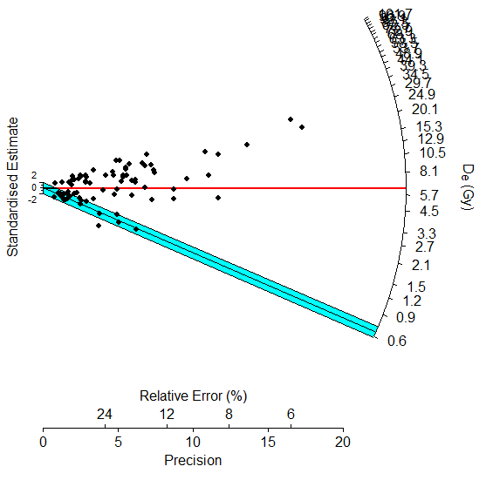UW4094

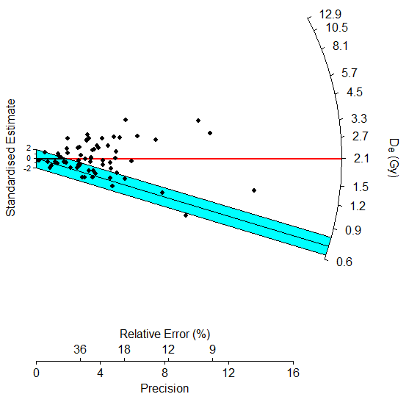UW4096

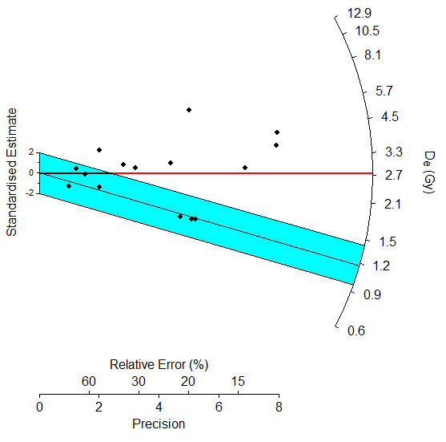UW4103

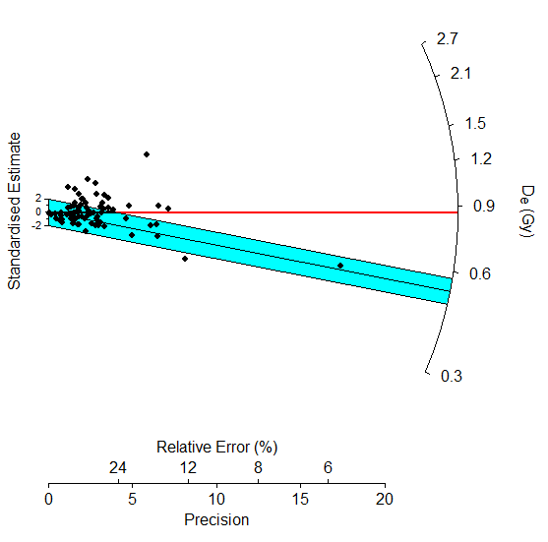UW4120

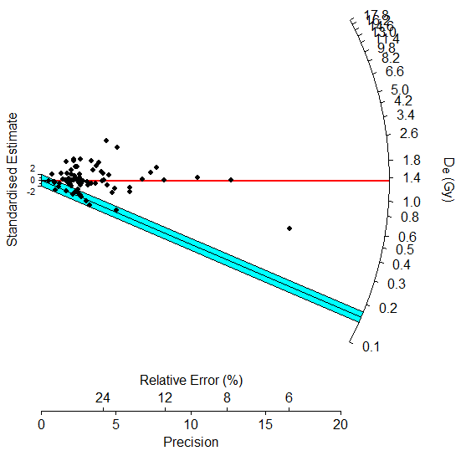UW4178

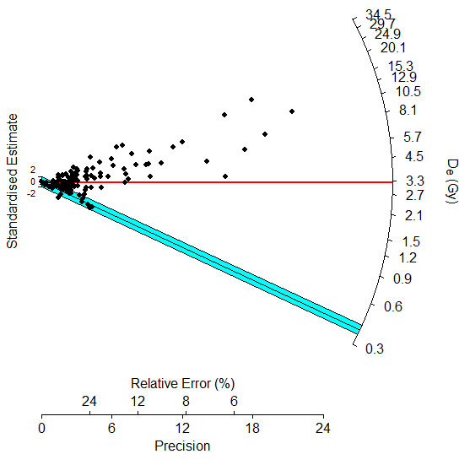UW4179

K-feldspar – Table S3-8 gives the number of acceptable grains, the equivalent dose from the central dose model, and the weighted average and median of the g-value, which is the fading rate. Fading refers to anomalous fading, an athermal loss of signal that can lead to age under-estimation. The age was corrected for fading using the Huntley-Lamothe (2001) method. Because the spread in equivalent dose values is partly a function of differential fading, various age models are applied after the correction is made and will be discussed in the next section. The high over-dispersion should be reduced when fading is taken into account.
Figure S3-2 plots equivalent dose against fading rate for grains from all samples. Although scatter is high, a regression analysis shows that equivalent dose decreases with increasing g-value, which is what is expected. There are a large number of negative g-values, which are thought to be statistical artifacts. Very high g-values result in an infinite age correction. These are tabulated in Table S3-8 but removed from further analysis.

Table S3-8. Equivalent dose (Gy) from central age model and fading data for K-feldspar
Sample | # grains | Equivalent dose  (Gy) | Over-dispersion  (%) | g-value  weighted ave. | g-value  median | Infinite  corrections
UW4079 | 145 | 4.68±0.50 | 124±7.78 | 9.32 | 9.03 | 50
UW4094 | 88 | 8.13±1.14 | 128±10.1 | 4.56 | 4.08 | 7
UW4096 | 79 | 2.53±0.41 | 129±12.5 | 2.82 | 2.82 | 11
UW4097 | 78 | 3.39±0.53 | 127±11.7 | 2.84 | 1.91 | 5
UW4103 | 75 | 2.14±0.36 | 136±12.2 | 7.05 | 6.62 | 15
UW4120 | 212/116* | 5.66±0.45 | 110±5.93 | 2.54 | 1.36 | 12
UW4169 | 103 | 30.0±3.33 | 109±8.05 | 2.06 | 3.84 | 11
UW4175 | 75 | 10.1±1.82 | 152±13.1 | 3.12 | 4.50 | 11
UW4176 | 95 | 15.3±1.29 | 80.9±6.04 | 1.15 | 1.35 | 2
* For UW4120, 212 grains were accepted for equivalent dose, but the fading data were poor for 96 of them, so only 116, less 12 infinite corrections, were used in analysis.

Figure S3-2. Equivalent dose as a function of fading rate. The dotted line is a linear regression.

Ages – sediments

Quartz—Table S3-9 gives ages derived in different ways. For UW4178 ages are calculated not only for the minimum dose but also for the 2nd component of the finite mixture model. This is because the minimum dose model resulted in a modern age, suggesting some recent contamination. There is no significant difference in age between dose rates determined only from lab measurements and dose rates determined in part by the field dosimeter, except for UW4179. The dosimeter age is preferred for this sample. There is no significant difference in age between an assumption of 15% for single-aged over-dispersion and an assumption of 30% for any sample except for UW4120 and the FMM age for UW4178. The latter differs because using 30% over-dispersion resulted in fewer components than using 15% over-dispersion. The 2nd and 3rd components using 15% were combined into one component using 30%. The ages will be evaluated further when comparing to the feldspar ages.

Table S3-9. Ages of quartz sediments*
Sample | Basis for age | Dose rate from lab |  |  | Dose rate from dosimeter
 |  | Age (ka) | % error | Calendar age  (years AD) | Age (ka) | % error | Calendar age  (years AD)
15% overdispersion for typical single-aged sample
UW4094 | MDM | 0.24±0.03 | 12.1 | 1780±30 | 0.24±0.05 | 21.9 | 1790±50
UW4096 | MDM | 0.26±0.06 | 22.9 | 1760±60 | 0.17±0.04 | 24.9 | 1850±40
UW4103 | MDM | 0.49±0.11 | 22.2 | 1530±110 | 0.51±0.11 | 22.2 | 1510±110
UW4120 | FMM 1st | 0.25±0.02 | 9.4 | 1770±20 | 0.28±0.04 | 12.5 | 1740±40
UW4178 | MAM | 0.06±0.01 | 19.5 | 1970±10 | 0.07±0.01 | 20.1 | 1960±10
 | FMM 2nd | 0.25±0.03 | 10.9 | 1780±30 | 0.29±0.03 | 11.9 | 1730±30
UW4179 | MAM | 0.32±0.06 | 19.0 | 1710±60 | 0.49±0.10 | 19.5 | 1530±100
30% overdispersion for typical single-aged sample
UW4094 | MDM | 0.26±0.04 | 15.3 | 1760±40 | 0.25±0.06 | 23.9 | 1770±60
UW4096 | MDM | 0.36±0.06 | 16.1 | 1660±60 | 0.24±0.04 | 18.9 | 1790±40
UW4103 | MDM | 0.54±0.17 | 31.5 | 1480±170 | 0.56±0.18 | 31.5 | 1460±180
UW4120 | FMM 1st | 0.34±0.03 | 8.9 | 1680±30 | 0.38±0.05 | 12.1 | 1640±50
UW4178 | MAM | 0.06±0.01 | 22.9 | 1960±10 | 0.07±0.02 | 23.4 | 1950±20
 | FMM 2nd | 0.43±0.04 | 8.9 | 1590±40 | 0.51±0.05 | 10.1 | 1520±50
UW4179 | MAM | 0.38±0.08 | 20.1 | 1640±80 | 0.59±0.12 | 20.6 | 1430±120
* MDM = minimum dose model; FMM = finite mixture model with component designated. 1st is the youngest component, 2nd is the second youngest. The base year for ka is 2022.

K-feldspar -- Corrected ages using the central age model and over-dispersion values are given in Table S3-10. The over-dispersion was lower than that from Table S3-8 for all samples but one, indicating that some of the over-dispersion from Table S3-8 is due to differential fading. The decrease is not much, however. This suggests differential age is a main cause of over-dispersion. There is no significant difference in age when using the dosimeter data. Table S3-11 gives the ages from the minimum age model, using both 15 and 30% over-dispersion as typical for a single-aged sample. There are no significant differences except for UW4169. Figure 3 provides the radial graphs for the age distributions, using the same format as for quartz.

Table S3-10. K-feldspar ages from the central age model.
Sample | N | Dose rate from lab |  | Dose rate from dosimeter
 |  | Age (ka) | Over-dispersion (%) | Age (ka) | Over-dispersion (%)
UW4079 | 95 | 2.00±0.28 | 108±11.2 | 1.87±0.26 | 107±11.2
UW4094 | 81 | 2.66±0.40 | 116±11.6 | 2.65±0.40 | 115±11.6
UW4096 | 68 | 0.60±0.09 | 84.3±13.0 | 0.45±0.07 | 85.1±13.0
UW4097 | 73 | 0.97±0.17 | 120±14.2 | 0.91±0.16 | 116±15.4
UW4103 | 60 | 0.63±0.13 | 133±15.8 | 0.65±0.13 | 133±15.9
UW4120 | 108 | 1.83±0.24 | 114±10.2 | 1.95±0.26 | 114±10.3
UW4169 | 92 | 8.35±1.26 | 113±11.8 | 9.12±1.38 | 113±11.8
UW4175 | 64 | 2.14±0.49 | 152±17.3 | 2.60±0.60 | 152±17.4
UW4176 | 93 | 2.54±0.23 | 78.2±7.0 | 2.47±0.23 | 78.1±7.0

Table S3-11. Ages of K-feldspar sediments from the minimum age model
Sample | Dose rate from lab |  |  | Dose rate from dosimeter
 | Age (ka) | % error | Calendar age  (years AD) | Age (ka) | % error | Calendar age  (years AD)
15% overdispersion for typical single-aged sample
UW4079 | 0.28±0.04 | 14.3 | 1740±40 | 0.29±0.05 | 17.2 | 1730±50
UW4094 | 0.33±0.05 | 15.2 | 1690±50 | 0.33±0.05 | 15.2 | 1690±50
UW4096 | 0.32±0.07 | 21.9 | 1700±70 | 0.23±0.05 | 21.7 | 1790±50
UW4097 | 0.18±0.07 | 38.9 | 1840±70 | 0.29±0.09 | 31.0 | 1730±90
UW4103 | 0.13±0.03 | 23.1 | 1890±30 | 0.14±0.03 | 21.4 | 1880±30
UW4120 | 0.35±0.06 | 17.1 | 1670±60 | 0.37±0.07 | 18.9 | 1650±70
UW4169 | 0.78±0.16 | 20.5 | 1240±160 | 0.85±0.18 | 21.2 | 1170±180
UW4175 | 0.33±0.08 | 24.2 | 1690±80 | 0.40±0.10 | 25.0 | 1620±100
UW4176 | 0.78±0.10 | 12.8 | 1240±100 | 0.76±0.10 | 13.2 | 1260±100
30% overdispersion for typical single-aged sample
UW4079 | 0.38±0.08 | 21.0 | 1640±80 | 0.38±0.08 | 21.0 | 1640±80
UW4094 | 0.35±0.06 | 17.2 | 1670±60 | 0.35±0.06 | 17.2 | 1670±60
UW4096 | 0.34±0.08 | 23.5 | 1680±80 | 0.25±0.06 | 24.0 | 1770±60
UW4097 | 0.24±0.07 | 29.2 | 1780±70 | 0.31±0.10 | 32.3 | 1710±100
UW4103 | 0.14±0.04 | 28.6 | 1880±40 | 0.14±0.04 | 28.6 | 1880±40
UW4120 | 0.40±0.08 | 20.2 | 1620±80 | 0.43±0.08 | 18.6 | 1590±80
UW4169 | 1.31±0.31 | 23.7 | 710±310 | 1.43±0.34 | 23.8 | 590±340
UW4175 | 0.39±0.11 | 28.2 | 1630±110 | 0.47±0.13 | 27.7 | 1550±130
UW4176 | 0.93±0.15 | 16.1 | 1090±150 | 0.90±0.14 | 15.6 | 1120±140

Figure S3-3. Radial graphs of K-feldspar age distributions.
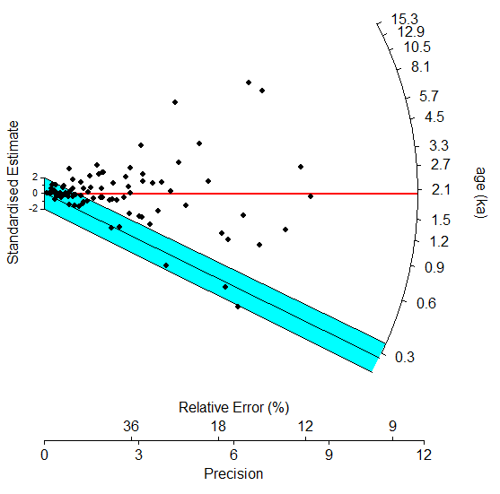 UW4079
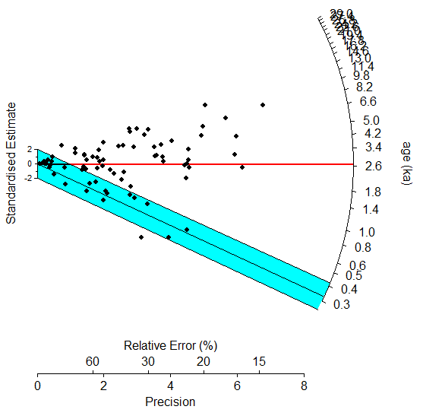UW4094

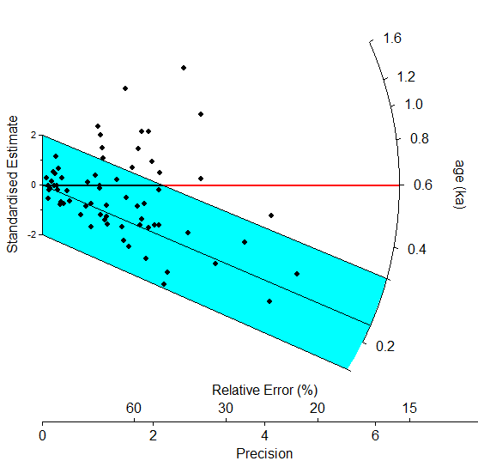UW0496

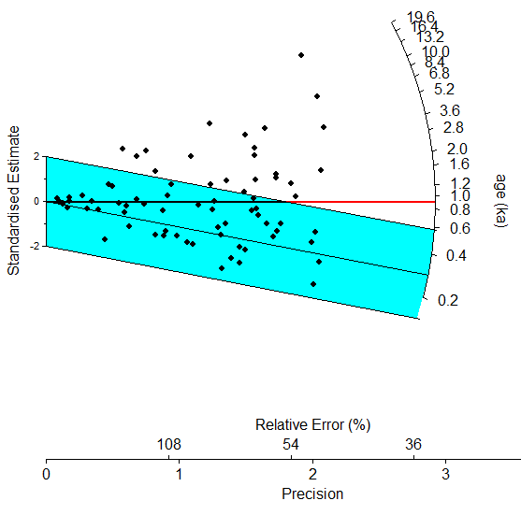UW4097

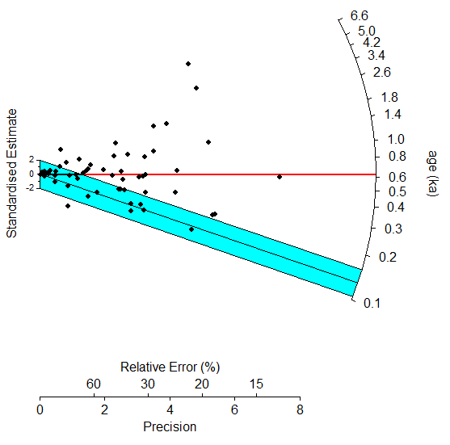UW4103

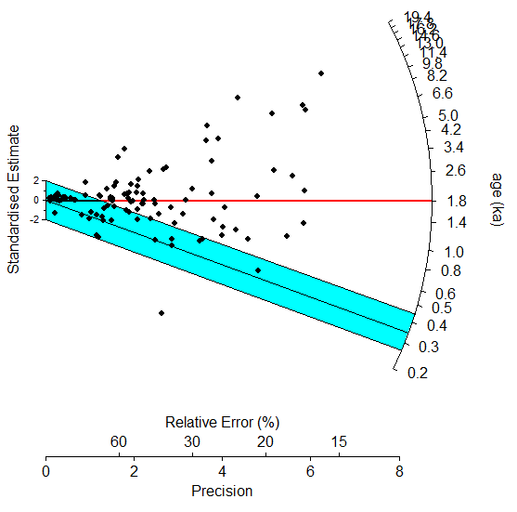UW4120

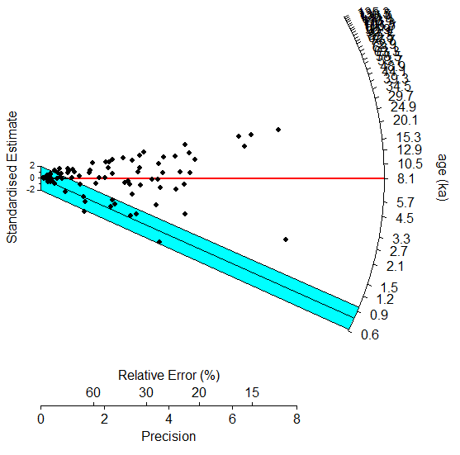UW4169

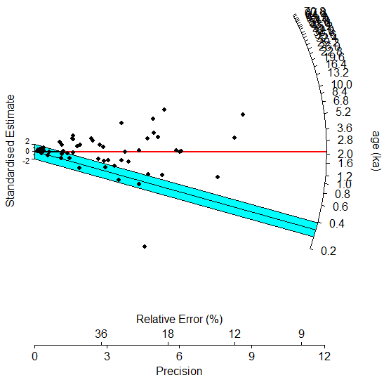UW4075

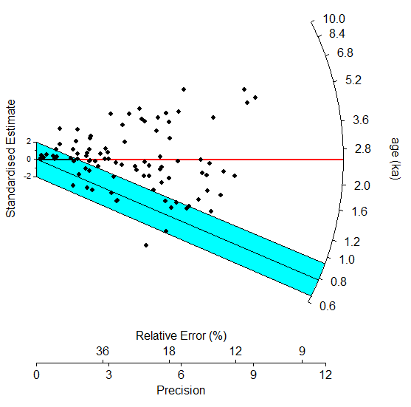UW4176

Table S3-12 gives the final ages for both quartz and K-feldspar. Where the ages differ according to whether the field dosimeters are used or not, the field measurements are used for dose rate. Otherwise, the age with the best precision is used. In all cases, the minimum age or finite mixture model are used for the age and 15% over-dispersion is assumed for typical single-aged samples. On the four samples where both a quartz and feldspar age were obtained, one, UW4096, shows agreement, two, UW4094 and UW4120, shows the K-feldspar age older than the quartz age, and one, UW4103, shows the quartz age older. It was argued in Feathers et al. 2022, that the quartz age for many New England samples appears to be underestimated, making the K-feldspar age the better estimate. The Crown Farm sample, UW4103, is anomalous in this regard. The K-feldspar age was considered the best estimate for the other sample from this site, but the K-feldspar age for UW4103 is very young, suggesting possible contamination. On the other hand, the quartz age is based on only 15 grains, but it does agree with the K-feldspar age from the other sample.
Figure S4 is a radial graph of the sediment ages from both Feathers et al. 2022 and this report. This report produced seven ages that are colonial, whereas the work in Feathers et al. (2022) produced only one. That one is from Rocky Hill Road. Two samples from this site in this report also gave colonial ages. This report also produced two ages much older than those from Feathers et al. (2022), from Richard’s Chamber and from Twin Column Chamber. Using the central age model, all ages from this report and Feathers et al. (2022), provide a central tendency of AD 1590 ± 30.

Table S3-12. Best estimates for sediment ages.
Sample | site | Quartz age (ka) | K-feldspar age (ka
UW4079 | Gungywamp |  | 0.28±0.04
UW4094 | Lewis Hollow | 0.24±0.03 | 0.33±0.05
UW4096 | Rocky Hill Road | 0.26±0.06 | 0.23±0.05
UW4097 | Rocky Hill Road |  | 0.29±0.09
UW4103 | Crown Farm | 0.51±0.11 | 0.13±0.03
UW4120 | Calendar II chamber | 0.25±0.02 | 0.35±0.06
UW4169 | Richard’s Chamber |  | 0.78±0.16
UW4175 | Goshen Tunnel |  | 0.33±0.08
UW4176 | Twin Column chamber |  | 0.78±0.10
UW4178 | Smith Mountain Gap | 0.25±0.03
UW4179 | West Berlin Wall | 0.49±0.10

Figure S3-4. Radial graph of all ages from this report and Feathers et al. 2022. The reference of 0.4 corresponds to AD 1620, the year the Pilgrims landed.

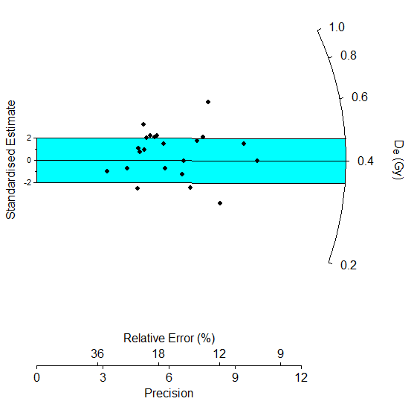

Dating of Rock Samples

Ten rock samples were dated as described in Table S1-1. Rock samples were collected directly from a portion of the structure under an opaque tarp. The rocks had at least one unexposed surface. Presumably the rocks were exposed to light during construction so that dating a surface not exposed at present within the structure should date the construction.
Dose rate -- For the dated rocks, some of the beta dose also comes from outside the sample. There was another rock directly adjacent to the surface being dated for all samples. At the interface between the two rocks, the beta dose rate will be 50% of the beta dose rate from the top rock and 50% of the beta dose rate from the bottom rock. With depth into the rock, the contribution to the beta dose rate of the dated rock increases until after a couple of millimeters, beyond the range of betas that could come from the other rock, all of it does. For these samples the difference in dose rate between the surface and second slice was never more than 0.15 Gy and within error terms for all samples. Radioactivity of the dated rock and the adjacent rock are given in Table S3-2. A field dosimeter was placed for each sample, but the one for UW4181 was not retrieved due to disturbance of the sampling location. The differences in gamma and cosmic dose rate between lab and field measurements are given in Table S3-3. They are mostly quite different and agree at two-sigma for only two samples (UW4172 and UW4177). For rocks, it is more difficult for the dosimeter to experience radiation exactly as the rock did, because the rock and the adjacent rock have been removed. Table S4 computes the total dose rate for both lab and field measurements for the surface slice, but the lab measurements, where the radioactivity of the rock and adjacent rock could be measured, may be more accurate.
Depth profiles – Several ~1 cm cores were drilled into the surface being dated for each rock using a drill press with a diamond tipped bit in red light conditions. The core was then cut into ~ 1 mm slices using a diamond tipped blade of 0.4 mm diameter. Luminescence from portions of each slice were then measured for equivalent dose. Because the whole slice was not measured at any given time, multiple measurements could be made on each slice.
All rocks were coarse-grains, with average grain size about 200 µm as judged by a binocular microscope. UW4170, UW4171, UW4172, UW4173, UW4174, and UW4179 were quartzites or quartz-rich sandstones. UW4078 and UW4181 were granitic schists, UW4168 was granite or granodiorite and UW4177 was a metamorphic amphibolite. Photos of the rocks are displayed at the end of the report. D_{e} was determined by the double SAR method (Banerjee et al. 2001), where an infrared stimulation proceeded a blue stimulation, both using diodes and for 100 s at each step. Emission was through a UV340 filter. A preheat of 240°C for 10s followed regeneration doses while a cut heat of 200°C followed the test doses, which were about 2 Gy. A fading test (after Auclair et al. 2003) was performed on all slices to correct the feldspar ages (following Huntley and Lamothe 2001). The double SAR method was used because it was not known initially if the best signal would come from feldspar or quartz. A justification for this procedure is given in Feathers et al. (2022).
A dose recovery test was performed on four slices with OSL and four with IRSL. The derived to administered dose ratio was 2.0 ± 0.5, which is within 2-sigma of 1, for IRSL and 1.78 ± 0.26, more than 2-sigma above 1 for OSL. This is not very satisfactory and suggests equivalent dose values may be over-estimated. The samples were bleached by 100 s exposure to blue diodes, which perhaps was not sufficient to fully bleach some samples. This requires further study.
Table S3-13 gives the equivalent dose from OSL and IRSL for the top four slices from each core measured. Where more than one measurement was made on a slice (done only on slices 1 and 2), the lowest equivalent dose value is given. If the equivalent dose could not be determined because the natural signal did not intersect a saturating growth curve, the cell is labeled SAT. NA means equivalent dose could not be determined for other reasons such as lack of measurable signal, recycling errors or recuperation. Not all cores produced a usable signal either because the equivalent dose was so high that Pleistocene ages would be obtained (suggesting poor bleaching) or because of lack of measurable signal. Only cores with usable data are reported. According to the bleaching model for rock surfaces, the lowest equivalent dose should be obtained on the first, or surface slice, with higher equivalent doses obtained with depth. This model was not met for several samples. For example, slice 2 often produced a lower equivalent dose than slice 1. This is counter-intuitive but can be explained by understanding that the light path into the rock is not necessarily linear but may move diagonally around opaque grains. Some samples, such as UW4177, had only high equivalent dose values, suggesting poor bleaching. Others, such as UW4172, showed bleaching only at the surface. It cannot be shown that such samples were fully bleached, because even the lower equivalent dose at the surface may represent partial bleaching. Samples where both the 1st and 2nd slices have reduced, and similar equivalent dose values were probably well bleached at the time of rock placement and should provide an age.

Table S3-13. Equivalent dose for rock slices
Sample | Core | Equivalent dose (Gy)
 |  | Slice 1 | Slice 2 | Slice 3 | Slice 4
OSL
UW4078 | 1 | 10.2±0.67 | 0.36±.0.03 | NA | NA
UW4168 | 1 | 9.05±1.78 | 21.1±2.51 | 40.2±4.22 | NA
 | 3 | 5.46±0.65 | 24.9±2.67 | 33.2±2.67 | 42.0±3.00
 | 4 | 19.7±4.64 | NA | 48.0±4.88 | NA
UW4170 | 1 | 1.88±0.45 | 17.8±5.61 | SAT | SAT
 | 2 | NA | 5.65±2.67 | NA | 17.8±5.61
UW4171 | 1 | 5.85±0.51 | 7.02±2.48 | SAT | 16.3±2.65
 | 2 | 7.19±0.59 | 11.1±3.09 | 23.2±4.87 | 23.0±6.37
 | 3 | 4.55±0.49 | 6.59±0.85 | 17.6±3.59 | NA
 | 4 | 11.4±1.33 | 9.64±1.53 | NA | NA
UW4172 | 1 | 114±10.7 | SAT | SAT | SAT
 | 3 | 3.68±0.30 | SAT | SAT | SAT
UW4173 | 1 | 3.52±0.66 | 5.60±4.17 | 8.60±3.35 | NA
 | 2 | 4.82±1.19 | 1.46±0.20 | SAT | SAT
UW4174 | 2 | 1.30±0.32 | 18.9±3.06 | 61.6±18.4 | 23.0±4.16
 | 4 | 11.7±2.00 | 13.0±1.89 | SAT | 30.8±17.1
 | 5 | 2.70±0.27 | 17.1±3.22 | 18.0±3.88 | 16.5±1.97
UW4177 | 3 | 15.4±3.63 | SAT | SAT | SAT
UW4179 | 1 | 4.68±0.62 | NA | NA | NA
 | 3 | 5.96±0.86 | NA | NA | NA
UW4181 | 1 | NA | 17.4±2.23 | SAT | SAT
 | 2 | 6.94±1.05 | 25.1±7.97 | SAT | SAT
IRSL
UW4078 | 1 | NA | 0.28±0.02 | NA | NA
UW4168 | 1 | 12.2±0.74 | 16.7±0.78 | NA | NA
 | 3 | 0.66±0.04 | 0.41±0.03 | 10.1±0.38 | 24.3±0.77
 | 4 | 7.75±0.31 | 34.2±2.74 | SAT | NA
UW4170 | 1 | 3.25±1.08 | 0.92±0.65 | 2.58±0.37 | 3.56±1.04
 | 2 | 1.63±0.23 | 0.87±0.95 | NA | 1.55±0.51
UW4171 | 1 | 59.8±11.0 | 5.30±1.05 | NA | NA
 | 2 | 74.1±6.50 | NA | 24.2±6.70 | SAT
 | 3 | 6.06±1.87 | SAT | SAT | SAT
UW4172 | 1 | 5.05±1.69 | 30.9±21.0 | 0.43±0.21 | SAT
 | 3 | 1.34±0.82 | 131±49.0 | SAT | SAT
UW4173 | 1 | 7.02±1.23 | SAT | NA | SAT
 | 2 | 43.9±13.9 | 12.4±3.00 | SAT | SAT
UW4174 | 2 | 14.1±2.94 | 6.17±1.25 | NA | NA
 | 4 | NA | 4.37±1.03 | NA | SAT
 | 5 | NA | 16.7±4.85 | SAT | SAT
UW4177 | 1 | 33.3±7.71 | 12.4±1.39 | 48.3±10.2 | SAT
 | 2 | 14.5±2.78 | SAT | 22.4±2.10 | SAT
 | 3 | 119±33.8 | 48.8±4.30 | SAT | SAT
UW4179 | 1 | 12.6±7.14 | NA | NA | NA
 | 3 | 6.68±2.94 | NA | NA | NA
UW4181 | 1 | NA | 5.22±0.99 | SAT | SAT
 | 2 | 20.5±7.66 | 13.8±3.12 | SAT | 36.2±11.6

To convert these equivalent dose values to ages requires correction for fading, using the Huntley-Lamothe (2001) procedure. The weighted average g-value (fading rate) for 64 IRSL determinations was 13.7 ± 1.1 %/decade. This is quite high and reflects some high values from some of the samples. The median was 9.4 %. The weighted average g-value for 32 OSL determinations was 0.4 +/- 1.0 %, indicating that the OSL signal in these measurements generally was not affected by fading.
Table S3-14 gives the lowest value ages drawn from the first two slices from each sample using the laboratory dose rates. The only exception was for UW4171, where the adjacent rock was not available for laboratory measurements, so these ages reflect the dosimeter reading. Two rocks were measured for UW4174, and their results are combined here. Also, no good IRSL data were available for this sample. For most samples only the 1st slice provided low-value ages.

Table S3-14. Rock ages for OSL and IRSL
Sample | OSL |  | IRSL
 | N | Age (ka) | N | Age (ka)
UW4078 | 1 | 1.28±0.26 | 1 | 0.27±0.06
UW4168 | 3 | 4.09±0.46 | 4 | 0.78±0.29
UW4170 | 2 | 1.04±0.17 | 3 | 2.03±1.18
UW4171 | 3 | 3.41±0.30 | 1 | 3.92±2.27
UW4172 | 1 | 2.06±0.20 | 1 | 2.17±0.77
UW4173 | 2 | 1.90±0.31 | 1 | 5.73±2.42
UW4174 | 5 | 1.02±0.16
UW4177 | 1 | 6.43±0.20 | 1 | 48.8±12.4
UW4179 | 4 | 4.31±0.54 | 1 | 44.4±81.4
UW4181 | 1 | 15.2±3.66 | 1 | 5.94±6.59

The only depth profiles that suggest sufficient bleaching are UW4078, UW4171 and UW4173 for OSL and UW4078, UW4168, UW4170 and maybe UW4171 for IRSL. For UW4078 from Gungywamp, the IRSL age is nearly the same as the sediment age, suggesting an 18th century age for that part of the site. Dating at another part of the site supports an earlier age (Feathers et al. 2022). The IRSL age for UW4168, from Oley Hills, is younger than an earlier age reported in (Feathers and Muller 2020), by 1800 years. This suggests the site was built, or at least maintained, over a long period of time.
UW4170 from Alpenglow was collected from a wall that is adjacent to a prehistoric site in and around a rock shelter. The site yielded mainly lithics, including an Archaic-styled projectile point. Because of a reduced equivalent dose at a depth of at least the second slice, the IRSL signal appears to have been sufficiently bleached at the time of placement. The OSL depth profile does not show any beaching deeper than the first slice, so it cannot be known from that profile that the first slice was adequately bleached. However, the OSL age from the top slice is in agreement with the IRSL age. This suggests a Woodland age for the wall construction, which is more recent than the projectile point. This age is in rough agreement with the ages obtained from the nearby Council Rocks. Of these rocks only the OSL depth profile from UW4173 gives evidence of any bleaching past the first slice, but the other two, UW4172 and UW4174, show evidence of at least some bleaching in the first slice. This means the bottoms of these rocks were exposed to light sometime around the time of occupation at Alpenglow. Placement of these large rocks then was not by glacial processes, but attributing their movement to humans still requires elimination of any other possible geological process.
The OSL signal from UW4171, from Bear’s Den Chamber, appears to have been adequately bleached but at a fairly early age, BC 1640. This is quite a bit earlier than ages obtained from other chambers samples in this study, which are about AD 1200. The rocks from Walker Quartz Cairn, West Berlin Wall and Hexenkopf Rocks all appear to be poorly bleached.

References

Banerjee, D., Murray, A. S., Bøtter-Jensen, L., and Lang, A., 2001, Equivalent dose estimation using a single aliquot of polymineral fine grains. Radiation Measurements 33(1):73-93.

Feathers, J.K., Frouin, M. and Bench, T., 2022, Luminescence dating of enigmatic rock structures in New England, USA. Quaternary Geochronology Vol 23. https://doi-org.offcampus.lib.washington.edu/10.1016/j.quageo.2022.101402

Feathers, J. K., and Muller, N., 2020, OSL dating of a probable native American cairn and wall site in eastern Pennsylvania. North American Archaeologist 41(1):33-50 https://doi.org/10.1177%2F0197693120920492
Galbraith, R. F., and Roberts, R. G., 2012, Statistical aspects of equivalent dose and error calculation and display in OSL dating: an overview and some recommendations. Quaternary Geochronology 11(1):1-27.

Huntley, D. J., and Lamothe, M., 2001, Ubiquity of anomalous fading in K-feldspars, and measurement and correction for it in optical dating. Canadian Journal of Earth Sciences 38:1093-1106.

Murray, A. S., and Wintle, A. G., 2000, Luminescence dating of quartz using an improved single-aliquot regenerative-dose protocol. Radiation Measurements 32(1):57-73.

Prescott, J. R., and Hutton, J. T., 1994, Cosmic ray contributions to dose rates for luminescence and ESR dating: large depths and longtime durations. Radiation Measurements 23(2-3):497-500.

Smedley, R. K., Duller, G. A. T., Pearce, J. G., and Roberts, H. M. (2012). Determining the K-content of single-grains of feldspar for luminescence dating. Radiation Measurements 47(9):790-796.

Figure 3-5. Photos of rocks after being cored for luminescence dating.

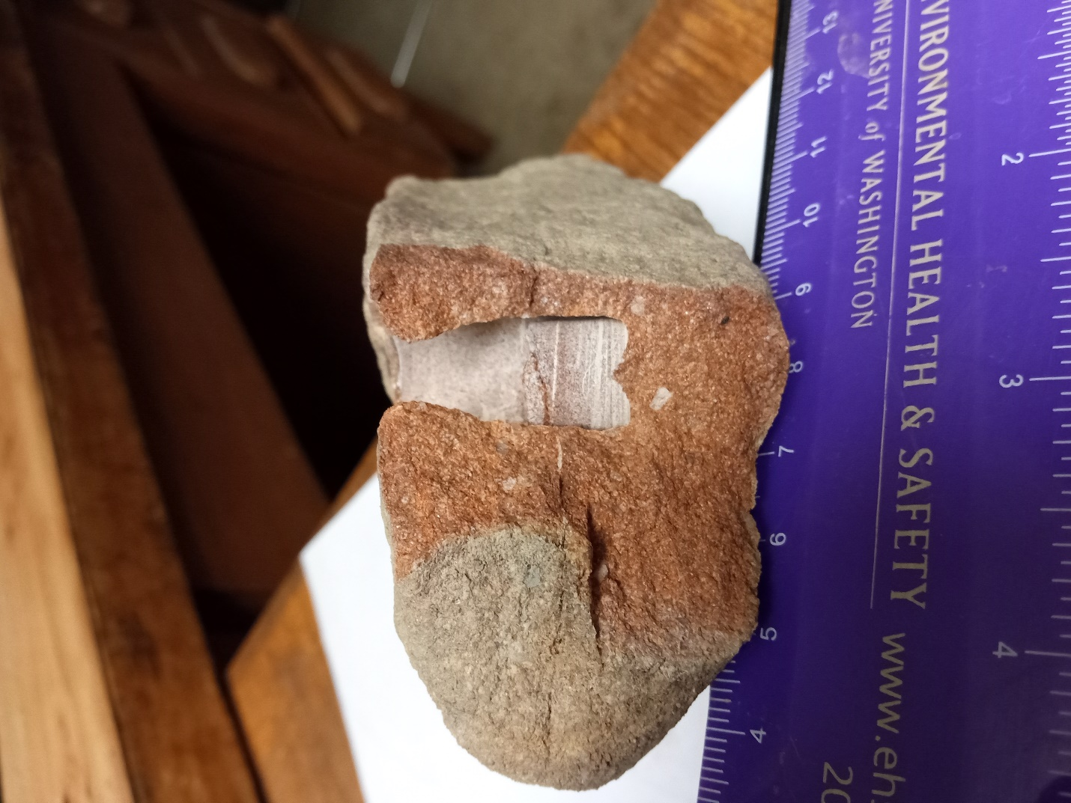
UW4179
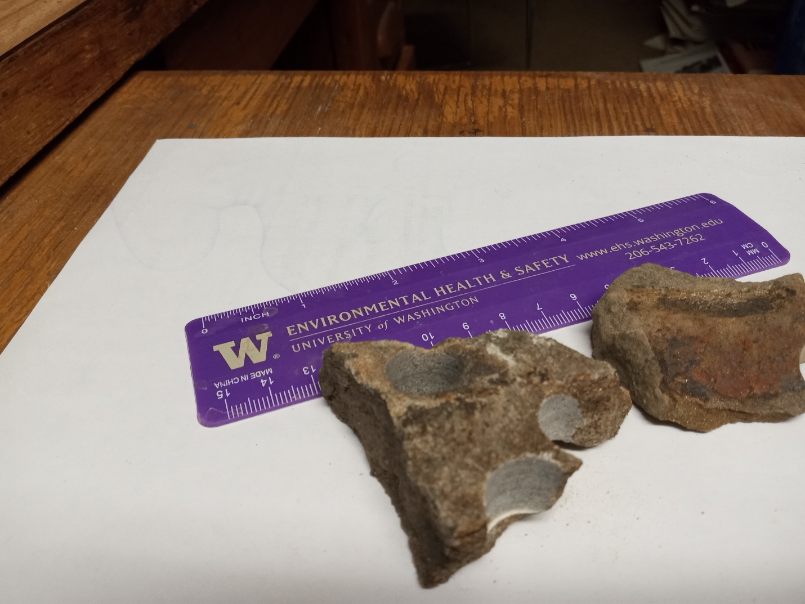
UW4181

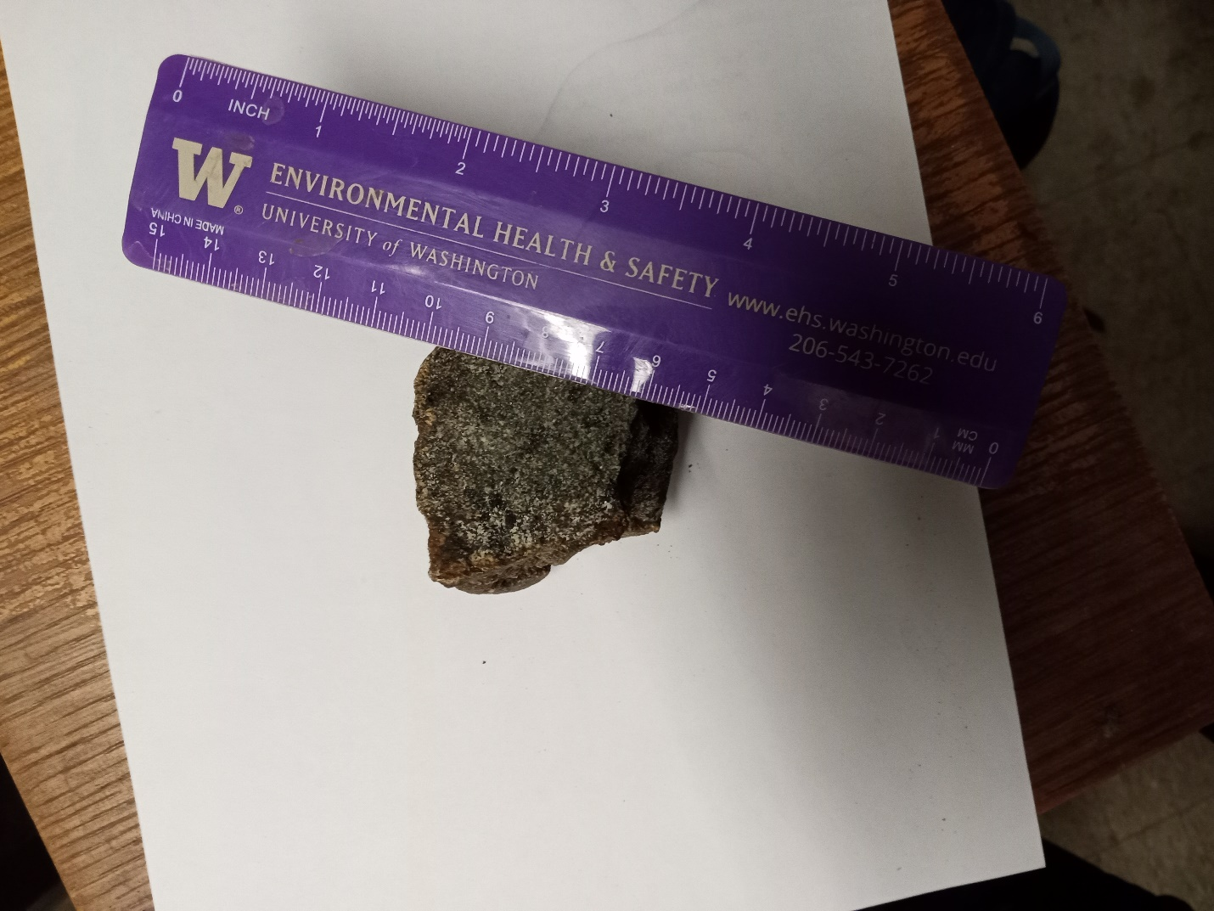

UW 4078

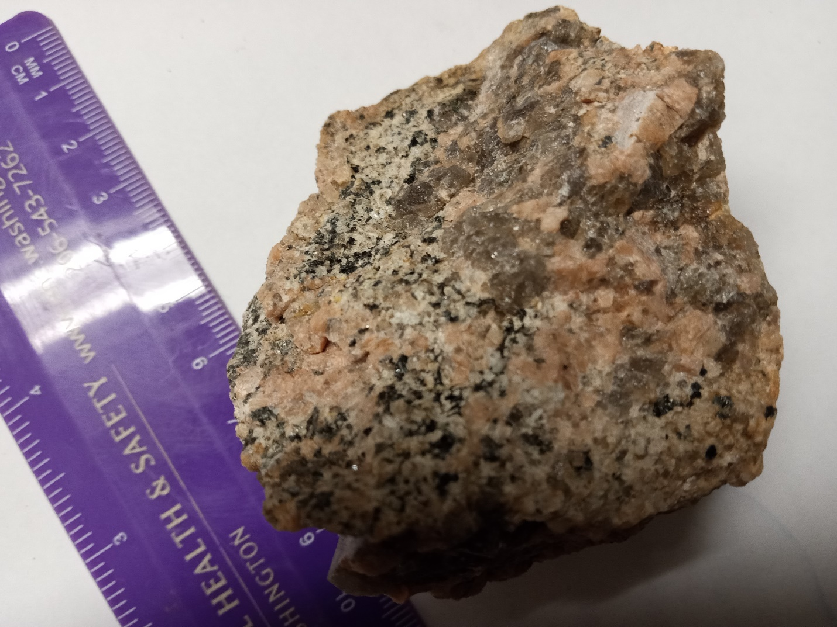

UW4170
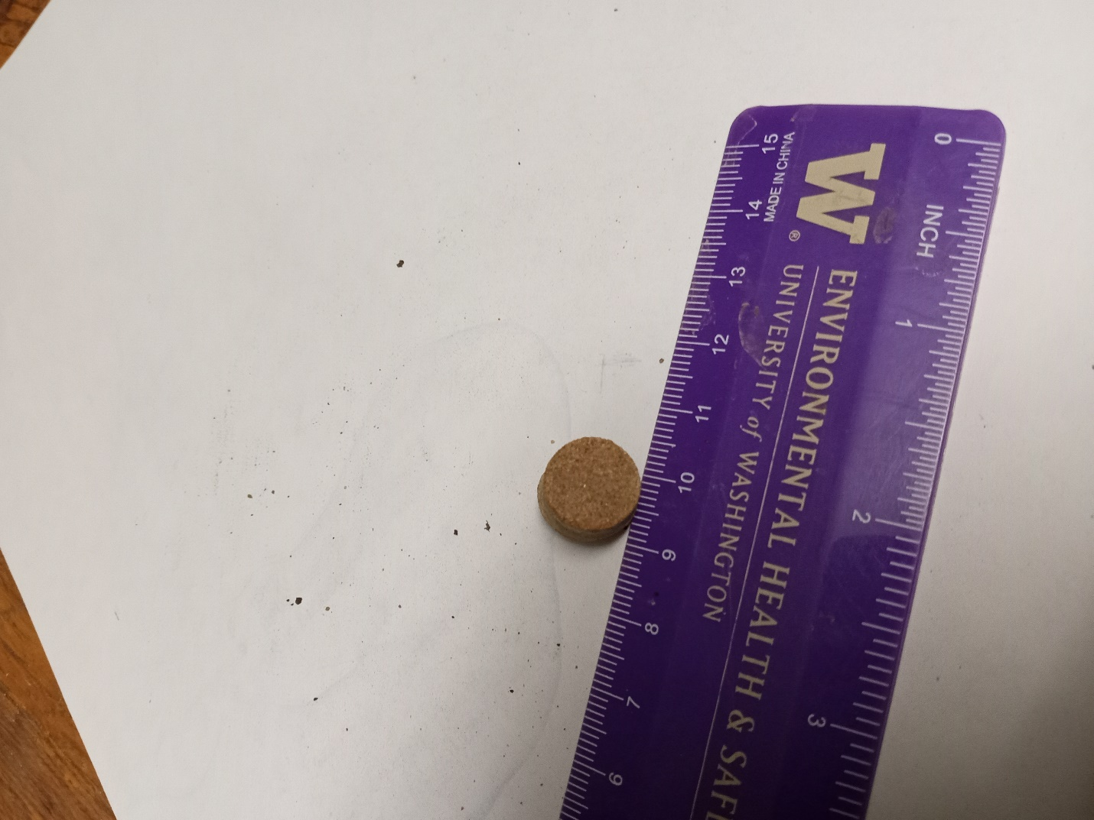
UW4174

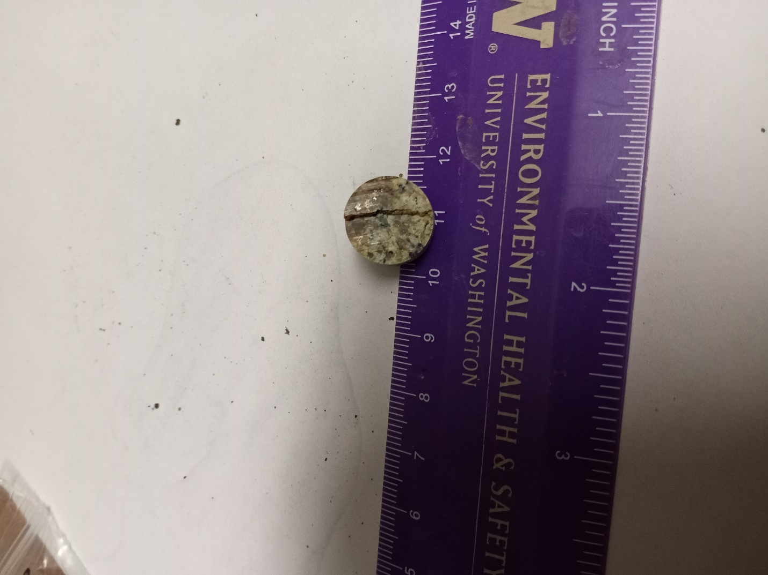
UW4168

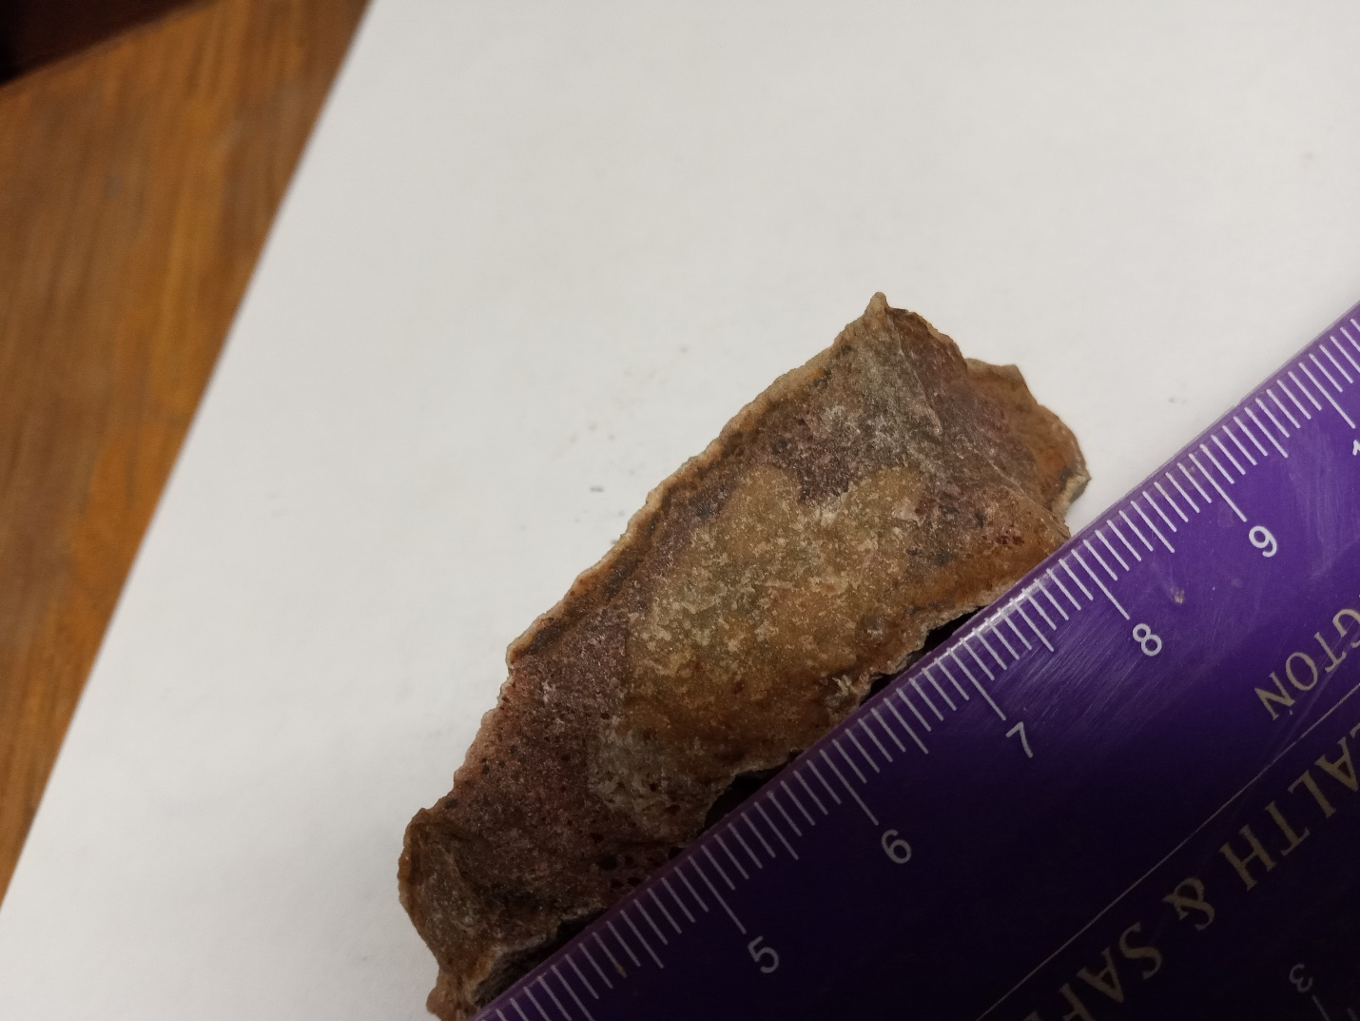

UW4171

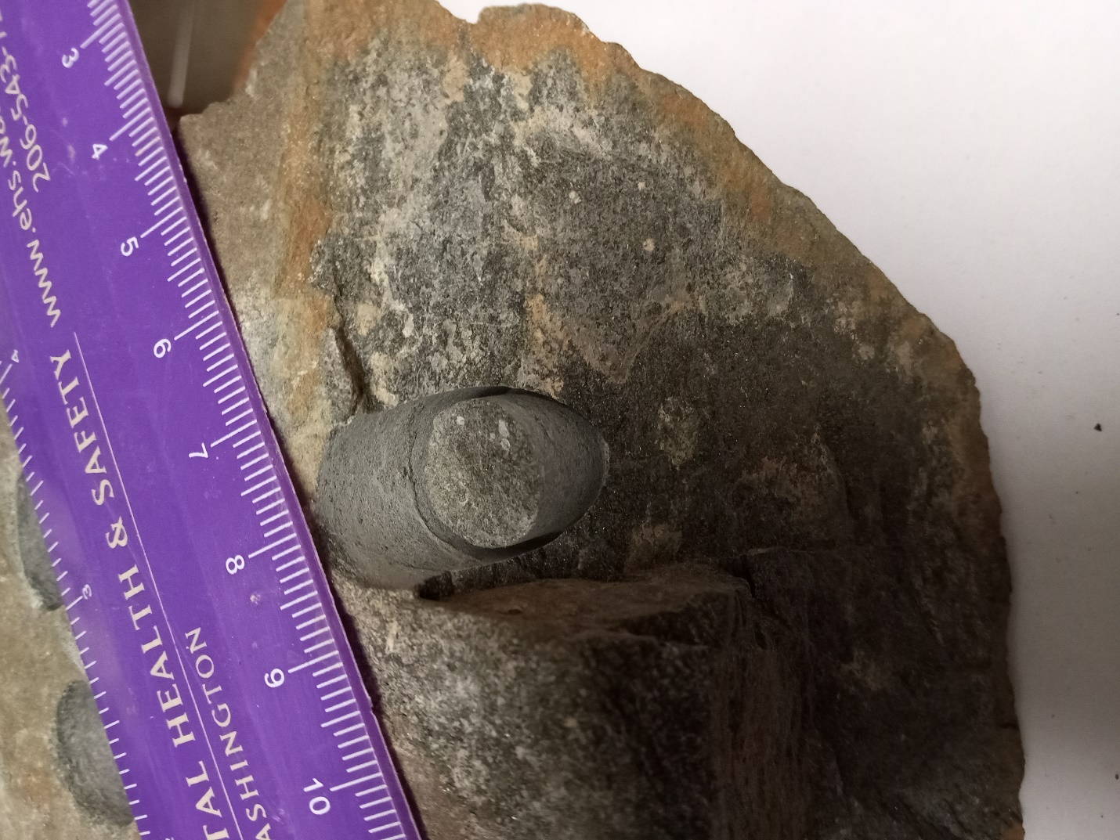

UW4177

TExt 4: Technical data on USGS analysis of sediment samples collected at Milford and Deerfield, NH

Table S4-1. Quartz OSL data and ages for New Hampshire state granitic rock structures
Sample | % waterª | K(%)^{b} | U(ppm)^{b} | Th(ppm)^{b} | Total dose rate  (Gy/ka)c | Equivalent  Dose (Gy) | N^{d} | Scatter (%)^{e} | Age (years)^{f}
Milford site
NEARA #28 | 16 (61) | 1.20±0.02 | 1.84±0.13 | 5.81±0.34 | 1.61±0.06 | 1.48±0.04 | 5(47) | 80 | 920±40
NEARA #87 | 12 (51) | 0.68±0.04 | 0.78±0.12 | 5.27±0.37 | 1.10±0.06 | 111±4.3 | 2(19) | 46 | 101,100  ±6660
Deerfield site
NEARA #66 | 40 (96) | 0.38±0.04 | 1.20±0.11 | 2.60±0.40 | 0.71±0.06 | 27.4±0.71 | 2(43) | 44 | 38,740  ±3660
NEARA #72 | 25 (70) | 0.32±0.04 | 0.77±0.15 | 1.01±0.25 | 0.60±0.07 | 7.94±0.30 | 1(28) | 75 | 13,340  ±1690
ªField moisture, with figures in parentheses indicating the complete sample saturation (%). Dose rates calculated using 60% of saturated moisture (i.e.,16 (61) = 61 * 0.6 =37)
^{b}Analysis obtained using high-resolution gamma spectrometry (high purity Ge detector)
^{c}Includes cosmic dose and attenuation with depth calculated using the methods of Prescott and Hutton (1994). Cosmic doses were between 0.15 and 0.20 Gy/ka
^{d}Number of replicated equivalent dose (D_{e}) estimates used to calculate the total D_{e}. Figures in parentheses indicate total number of measurements included in calculating the represented D_{e} and age using the minimum age model (MAM) dependent on scatter. Analyzed by single aliquot regeneration on quartz grains. Fit to growth curves by exponential plus linear function.
^{e}Defined as “over-dispersion” of the D_{e} values. Values >30% are considered to be poorly bleached or mixed sediments
^{f}Age for 180-250 micron sized quartz; errors at one-sigma

Sample characteristics:

Sediment sample #28
Milford, NH, 42.48 N, 71.62 W
Structure composed almost exclusively of granite rocks
Depth below ground surface: 65 cm
Depth below rock structure: 187 cm
Sample relative to rock: directly beneath
Sample horizontal depth behind profile: 2-10 cm

Sediment sample #87
Milford, NH, 42.48 N, 71.62 W
Structure composed almost exclusively of granite rocks
Depth below ground surface: 150 cm
Depth below rock structure: 60 cm
Sample relative to rock: directly beneath
Sample horizontal depth behind profile: 2-8 cm

Sediment sample #66
Deerfield, NH, 43.10 N, 71.33 W
Structure composed almost exclusively of granite rocks
Depth below ground surface: 40 cm
Depth below rock structure: 63 cm
Sample relative to rock: directly beneath
Sample horizontal depth behind profile: 2-10 cm

Sediment sample #72
Deerfield, NH, 43.10 N, 71.33 W
Structure composed almost exclusively of granite rocks
Depth below ground surface: 12 cm
Depth below rock structure: 35 cm
Sample relative to rock: directly beneath
Sample horizontal depth behind profile: 2-11 cm

