Supplemental Text 2: Low-quality Data for Fourteen Jamestown Canids

Supplemental materials for:

The Dogs of Tsenacomoco: Ancient DNA Reveals Presence of Local Dogs at Jamestown Colony in Early Seventeenth Century

Authors
Ariane Thomas*
Matthew E. Hill, Jr.
Leah Stricker
Michael Lavin
David Givens
Alida de Flamingh
Kelsey E. Witt
Ripan S. Malhi
Andrew Kitchen

*Corresponding author, ariane-thomas@uiowa.edu
§These authors co-supervised this work.

Contents

Description of Methods
Supplemental Figure 1: Majority rule maximum likelihood tree of ancient and modern canids and low-quality Jamestown sequences to estimate species ancestry of the mitogenomes (n = 905). Vulpes vulpes was used as an outgroup and is marked in blue. Ancient and modern wolves are colored black, modern coyotes are green, dingoes are dark yellow, ancient dogs from Asia and Europe are purple, ancient dogs from the Americas are tan, and modern dogs are gray. The tree was constructed using the same specifications as the ML tree (Figure 4 in the main manuscript) except this ML tree was run with 100 bootstraps.

Supplemental Figure 2: Magnification of the ancient North American clade in the maximum likelihood tree with low-quality Jamestown sequences to estimate species ancestry of the mitogenome. Jamestown samples are in red, Mesoamerican dogs are in a blue collapsed clade, and Siberian dogs are in a green collapsed clade.

Supplemental Figure 3: Magnification of clade containing #135138, #23799, and #74222, in red, in the maximum likelihood tree to estimate species ancestry of the mitogenome.

Supplemental Figure 4: Magnification of clade containing #22647, in red, in the maximum likelihood tree to estimate species ancestry of the mitogenome.

Supplemental Figure 5: Magnification of clade containing #135786 and #135144, in red, in the maximum likelihood tree to estimate species ancestry of the mitogenome.

Supplemental Figure 6: Magnification of clade containing #114709, in red, in the maximum likelihood tree to estimate species ancestry of the mitogenome.

Supplemental Table 1: Species Estimation of Low-Quality Jamestown Genomes.

Description of Methods

To estimate the species of low-quality samples from Jamestown, we used the same program, PALEOMIX v1.3.7 to map the reads to reference. ANGSD parameters were adjusted to increase the number of bases. The mapping quality score equal to or greater than 25 (-minMapQ 25) and minimum depth at 2 (-setMinDepth 2).
We input each consensus sequence into NCBI Basic Local Alignment Search Tool (BLAST) and recorded the frequency of the top 100 hits to Canis lupus, Canis lupus familiaris, dingoes, and Canis latrans, shown in Supplemental Table 1. The frequency range for wolf ancestry was 0-76% with the majority of sequence hits to wolf below 7%. Only three samples #23799, #135143, and #135777 had higher hits to wolf (76%, 73%, 22%, respectively). Three had 100% of the hits to dog, #135138, #74222, and #118236. There was only one hit to dingo, #118232, and one hit to coyote, #135140.
BLAST has a variety of useful functions, but it also has limitations. BLAST can be used to identify species, generate a phylogenetic tree of results, and can map DNA to its location within the genome. In this study, we used it for species identification of the entire mitochondrial genome. However, BLAST uses a heuristic to find short matches between two sequences which it uses to start a local alignment. This means that BLAST does not always find the optimal alignment among the tens of thousands of canid sequences available in its database. For this reason, we aligned the fourteen low quality Jamestown sequences to the large sample of ancient and modern dogs, wolves, coyotes, dingoes, and foxes, shown in Supplemental Figure 1. We also magnified the clades of each of the Jamestown canid to view their closest relatives (Supplemental Figures 2-6). All of the canid samples grouped with modern or ancient dogs, seven of which grouped in the ancient North American dog clade.

Supplemental Figure 1: Majority rule maximum likelihood tree of ancient and modern canids and low-quality Jamestown sequences to estimate species ancestry of the mitogenomes (n = 905). Vulpes vulpes was used as an outgroup and is marked in blue. Ancient and modern wolves are colored black, modern coyotes are green, dingoes are dark yellow, ancient dogs from Asia and Europe are purple, ancient dogs from the Americas are tan, and modern dogs are gray. The tree was constructed using the same specifications as the ML tree (Figure 4 in the main manuscript) except this ML tree was run with 100 bootstraps.

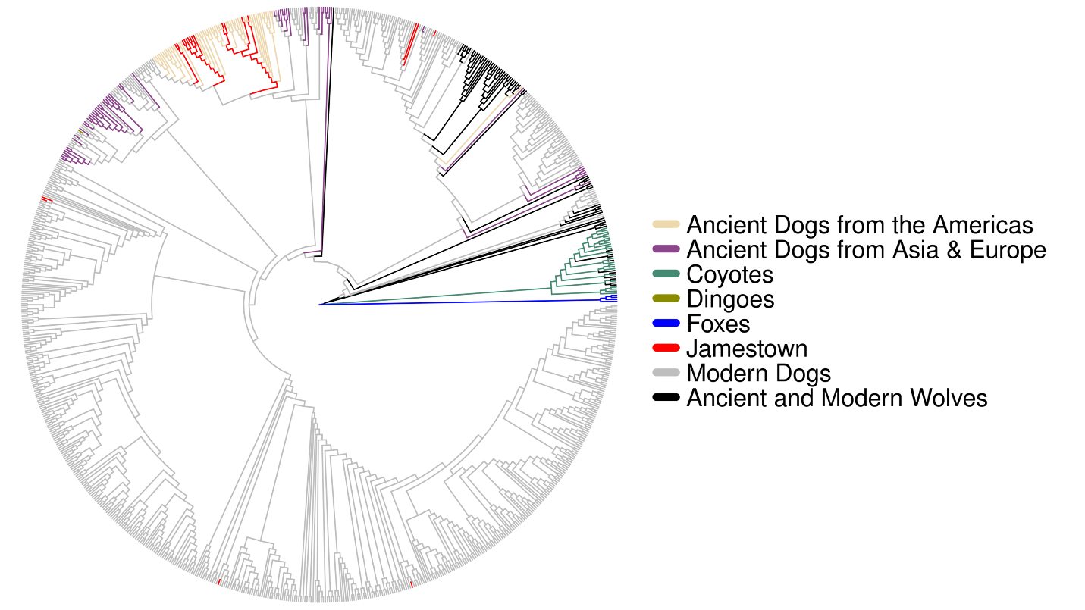

Supplemental Figure 2: Magnification of the ancient North American clade in the maximum likelihood tree with low-quality Jamestown sequences to estimate species ancestry of the mitogenome. Jamestown samples are in red, Mesoamerican dogs are in a blue collapsed clade, and Siberian dogs are in a green collapsed clade.

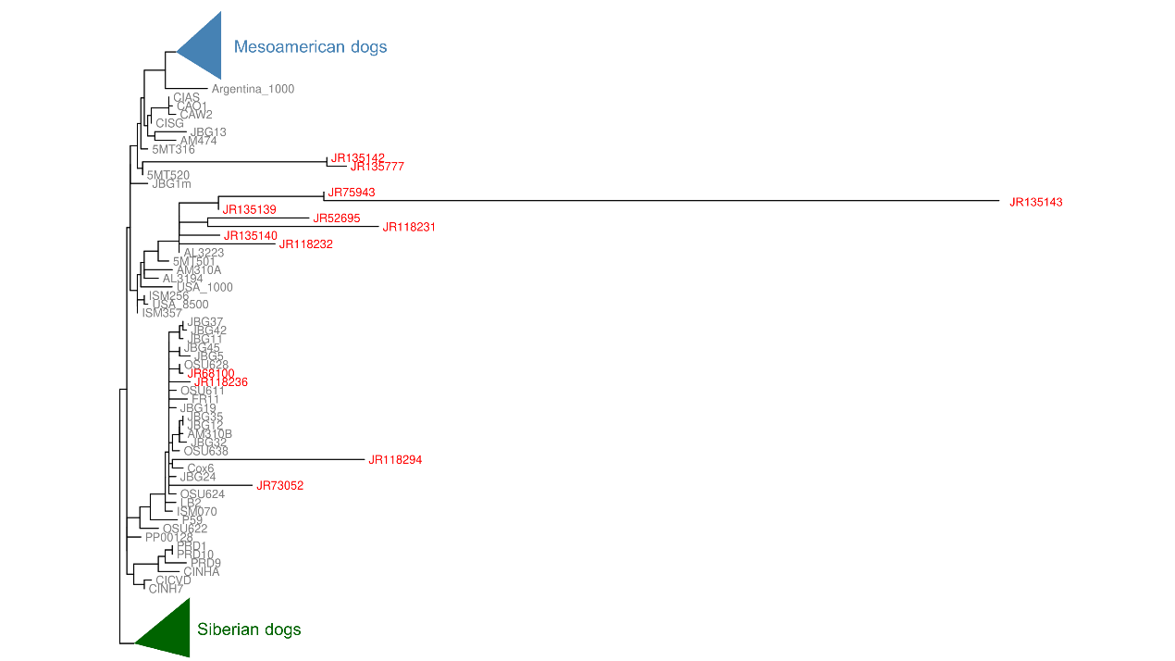

Supplemental Figure 3: Magnification of clade containing #135138, #23799, and #74222, in red, in the maximum likelihood tree to estimate species ancestry of the mitogenome.

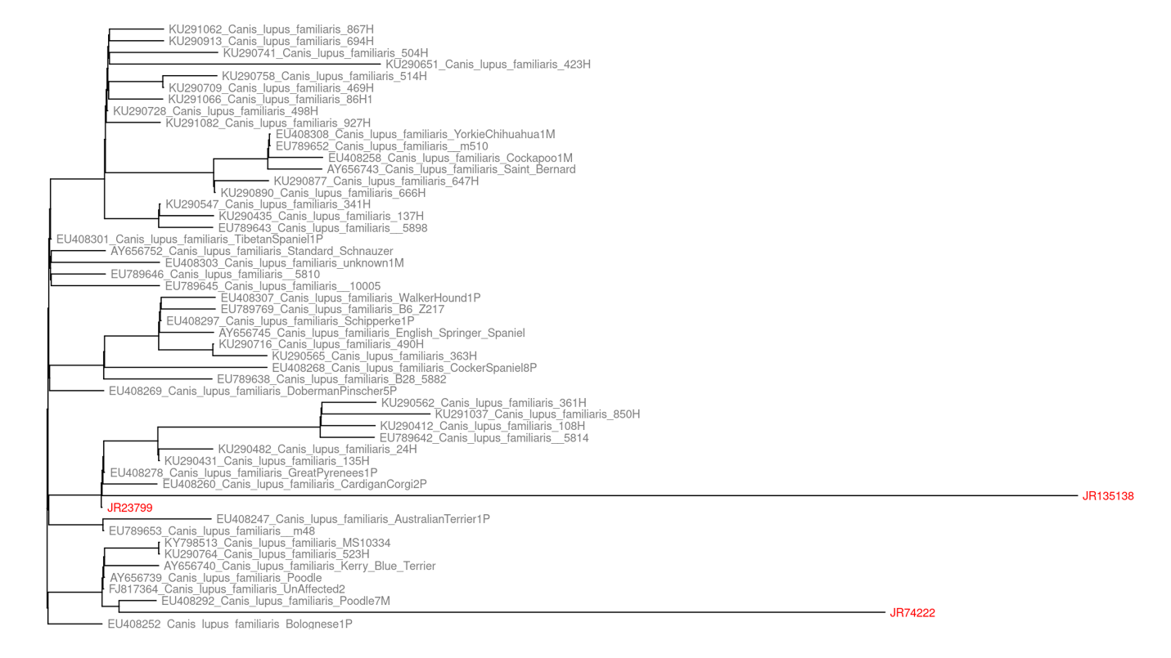
Supplemental Figure 4: Magnification of clade containing #22647, in red, in the maximum likelihood tree to estimate species ancestry of the mitogenome.
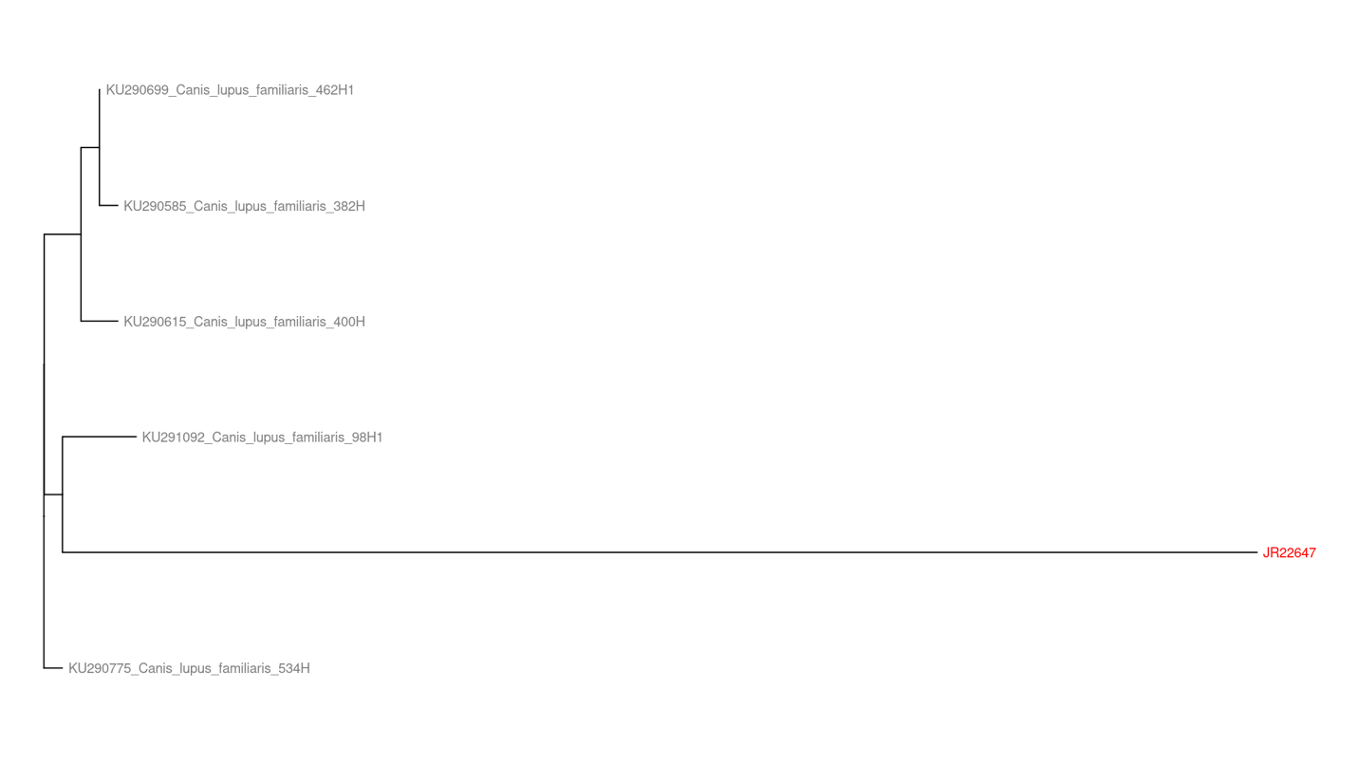

Supplemental Figure 5: Magnification of clade containing #135786 and #135144, in red, in the maximum likelihood tree to estimate species ancestry of the mitogenome.

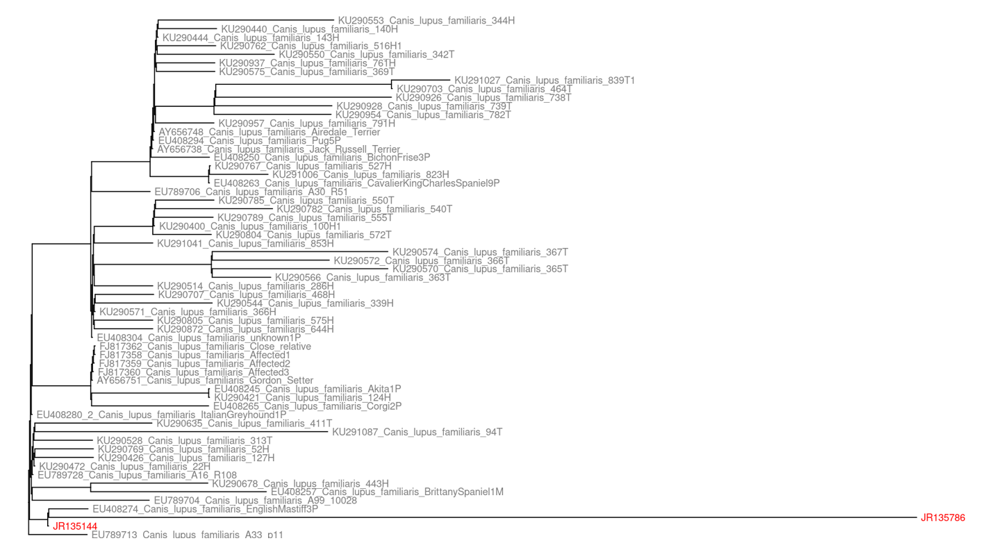

Supplemental Figure 6: Magnification of clade containing #114709, in red, in the maximum likelihood tree to estimate species ancestry of the mitogenome.

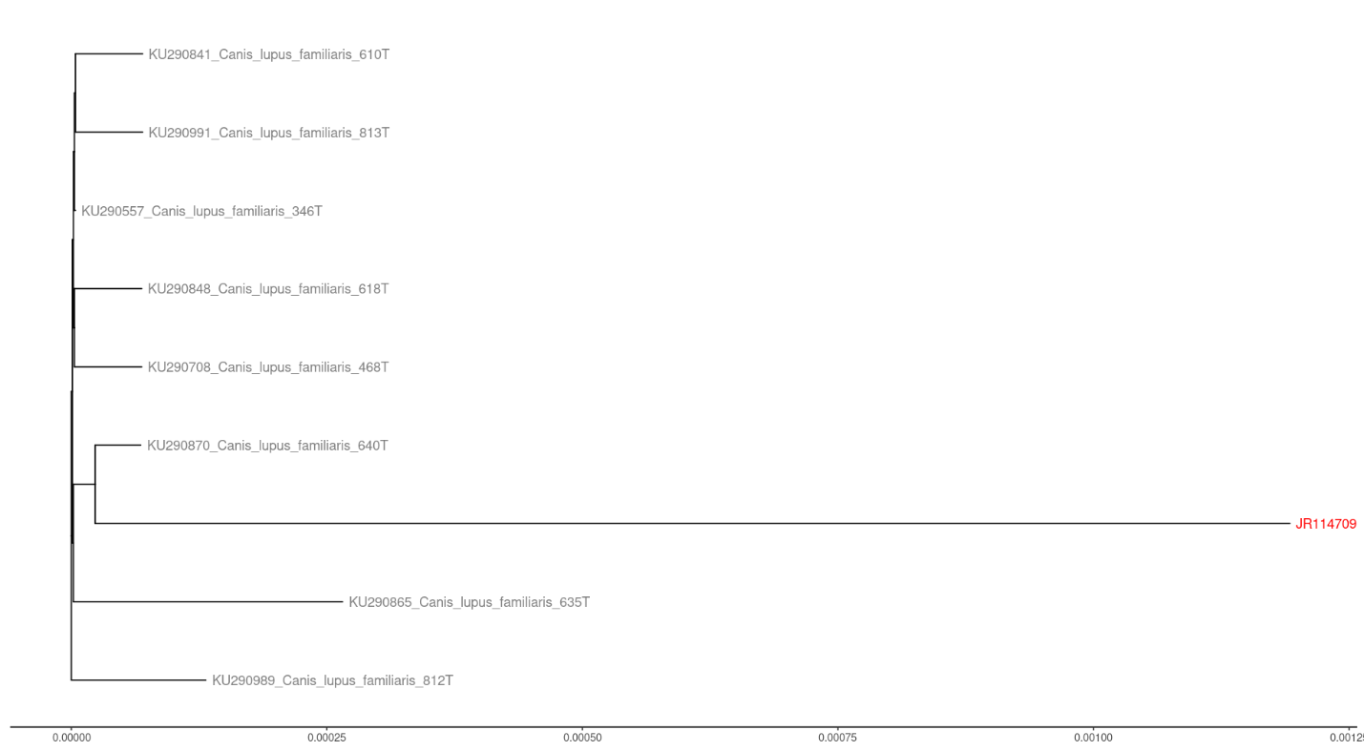

Supplemental Table 1: Species Estimation of Low-Quality Jamestown Genomes.
Sample ID | mtDNA Coverage | BLAST Top 100 Hits | Genetic Affiliation of Nearest Sample in ML Tree
JR_23799 | 0.185986728 | 76/100 wolf, 24/100 dog | Modern dog
JR_114709 | 0.273808812 | 2/100 wolf, 98/100 dog | Modern dog
JR_135143 | 0.427273271 | 73/100 wolf, 27/100 dog | ancient North American dog
JR_135142 | 0.668260896 | 3/100 wolf, 97/100 dog | ancient North American dog
JR_57981_135777 | 0.679081724 | 22/100 wolf, 78/100 dog | ancient North American dog
JR_135140 | 0.78011598 | 1/100 wolf, 1/100 coyote, 98/100 dog | ancient North American dog
JR_135138 | 0.965445089 | 100/100 dog | Modern dog
JR_22647 | 1.040593053 | 3/100 wolf, 97/100 dog | Modern dog
JR_135144 | 1.157768877 | 5/100 wolf, 95/100 dog | Modern dog
JR_52695 | 1.185568243 | 4/100, 96/100 dog | ancient North American dog
JR_118231 | 1.342201232 | 3/100 wolf, 97/100 dog | ancient North American dog
JR_135786 | 1.539427273 | 5/100 wolf, 95/100 dog | Modern dog
JR_74222 | 2.590721588 | 100/100 dog | Modern dog
JR_118294 | 4.140730555 | 4/100 wolf, 96/100 dog | ancient North American dog
JR_118232 | 5.318287798 | 4/100 wolf, 1/100 dingo, 95/100 dog | ancient North American dog
JR_135139 | 9.146589347 | 3/100 wolf, 97/100 dog | ancient North American dog
JR_73052 | 9.56973755 | 5/100 wolf, 95/100 dog | ancient North American dog
JR_75943 | 10.54331321 | 7/100 wolf, 93/100 dog | ancient North American dog
JR_68100 | 25.38088121 | 3/100 wolf, 97/100 dog | ancient North American dog
JR_118236 | 66.78507802 | 100/100 dog | ancient North American dog

