High-rate lithium ion energy storage to facilitate increased penetration of photovoltaic systems in electricity grids
Alison Lennon¹, Yu Jiang¹, Charles Hall¹, Derwin Lau¹, Ning Song¹, Patrick Burr², Clare P. Grey³, and Kent J. Griffith^{3,4}
¹School of Photovoltaic and Renewable Energy Engineering, UNSW Sydney, NSW 2052, Australia.
²School of Mechanical and Manufacturing Engineering, UNSW Sydney, NSW 2052, Australia.
³Department of Chemistry, University of Cambridge, Cambridge CB2 1EW, UK
⁴Department of Materials Science and Engineering, Northwestern University, Evanston, IL 60208, USA.

Supporting Information
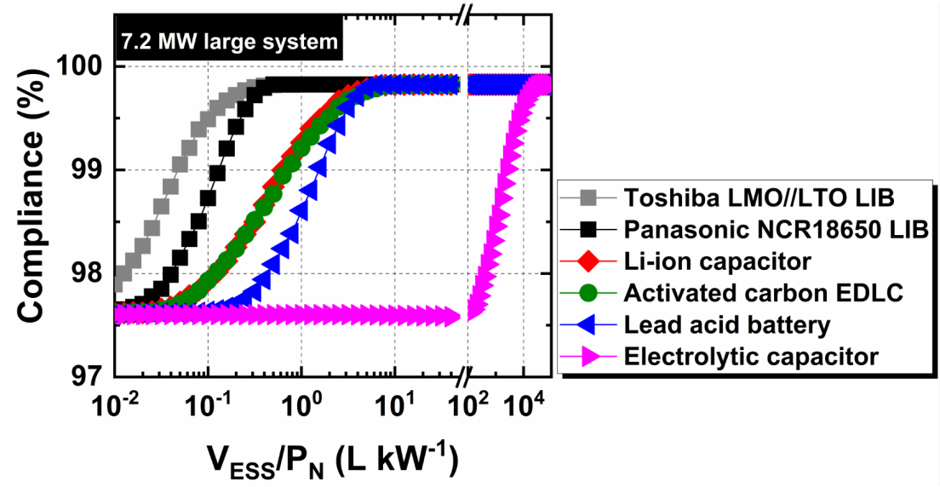
Figure S1. Ramp rate compliance of a PV array for different energy storage technologies. Compliance (%) of an energy storage system (ESS) of volume, V_{ESS}, to limit the ramp rate of the generated power to ≤ 10% per min from a 7.2 MW PV array (P_{N} = 7.2 MW) for a period of 46 summer days (using 1 s irradiance data) in Sydney, Australia (adapted from Jiang et al.¹). Note the compliance (%) was calculated as the percentage of power ramps over the total time (including day and night) where the power ramping was limited to within the 10% min⁻¹ target.
Table S1. Theoretical gravimetric and volumetric capacity of different anode materials.
Anode Material | Densityª  (g cm^{–3}) | n^{b} | Theoretical Capacity
 |  |  | Gravimetric (mAh g^{–1}) | Volumetric (mAh cm^{–3})
Graphite (C₆) | 2.27 | 1 | 372 | 843
Li₄Ti₅O₁₂ | 3.42 | 3 | 175 | 611
TiO₂ (Rutile) | 4.13 | 1 | 335 | 1384
TiO₂ (Brookite) | 3.99 | 1 | 335 | 1337
TiO₂ (Anatase) | 3.79 | 1 | 335 | 1270
TiO₂ (Bronze) | 3.64 | 1 | 335 | 1219
TiNb₂O₇ | 4.29 | 3/5 | 233/388^{b} | 998/1663 ^{b}
Ti₂Nb₁₀O₂₉ | 4.43 | 12/22 | 216/396 ^{b} | 957/1755^{b}
TiNb₂₄O₆₂ | 4.54 | 25/49 | 205/402^{b} | 930/1824^{b}

ªSingle crystal densities are listed for each material. Practical electrode densities are a function of particle size/morphology and electrode preparation.
^{b}Where two values are given, the value on the left is calculated for the one electron reduction of Ti⁴⁺/Ti³⁺ and Nb⁵⁺/Nb⁴⁺; the value on the right corresponds to the one electron reduction of Ti⁴⁺ to Ti³⁺ and the two electron reduction of Nb⁵⁺ to Nb³⁺ as is increasingly common in the literature.

References
1. Jiang, Y., Fletcher, J., Burr, P., Hall, C., Zheng, B., Wang, D.-W., Ouyang, Z. and Lennon, A.: Suitability of representative electrochemical energy storage technologies for ramp-rate control of photovoltaic power. J. Power Sources 384, 396-407 (2018).

