Supporting Information

Brush-structured Sulfur-Polyaniline-Graphene composite as Cathodes for Lithium Sulfur Batteries

Heguang Liuª, Ruixuan Jingª, Caiyin Youª, Qifeng Zhong*^{b}

ªSchool of Materials Science and Engineering, Xi’an University of Technology, Xi’an, 710048, China
^{b}Department of Pharmaceutical Equipment and Electronic Instruments, School of Engineering, China Pharmaceutical University, Nanjing 210009, China

Table S1. The EIS simulation parameters of S-PANI-G before and after 100 cycles discharge charge treatment.
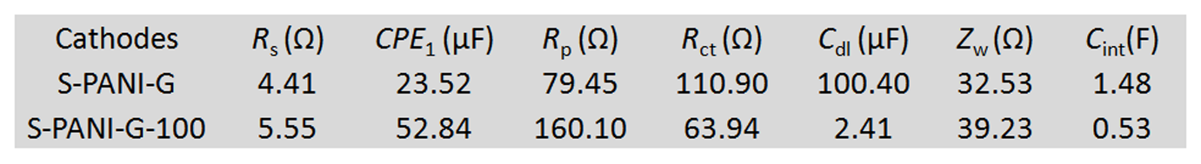

Figure S1. The equivalent circuit that was used to fit the experimental data.

