Hydrothermal Synthesis of Mg-substituted Tricalcium Phosphate Nanocrystals
Wei Cui†,§, Shaogang Wang†,§, Rui Yang†,§,, Xing Zhang†,§,*
† Institute of Metal Research, Chinese Academy of Sciences, Shenyang, Liaoning 110016, China
§School of Materials Sciences and Engineering, University of Science and Technology of China, Hefei, Anhui, 230026, China

Supplementary Materials

Fig. S1. XRD patterns of seashell, SU spine, SU shell and SF horn samples before (a) and after (b) hydrothermal reactions at 200ºC for 24 hours. (C: calcite, T: β-TCP, H: HA).

Fig. S2. XRD patterns of the products before (a) and after (b) hydrothermal reactions of Mg-calcite with different Mg content (9.6 mol.%, 11.7 mol.% and 21.4 mol.%) at 200ºC for 24 hours. (C: calcite, T: β-TCP).

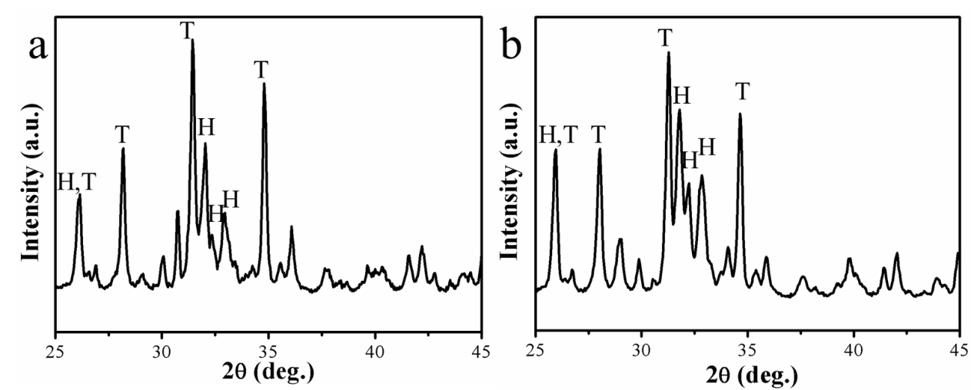
Fig. S3. XRD results for products of ball milling powders (< 45 μm) of SU spine (a) and synthetic Mg‒calcite powders (11.7 mol.% Mg) (b) after hydrothermal reactions at 200ºC for 24 hours. (T: β-TCP, H: HA).

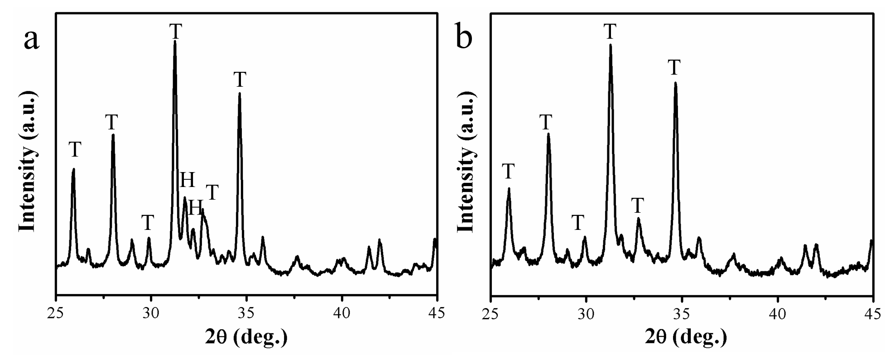
Fig. S4. XRD results for products of synthetic Mg‒calcite powders with 9.6 mol.% (a) and 11.7 mol.% Mg (b) after hydrothermal reactions at 200ºC for 24 hours. (T: β-TCP, H: HA).

Fig. S5. Ca-O bond information for two types of Ca²⁺ ions (Ca(1) and Ca(2)) in the HA crystal lattice.

Fig. S6. Ca-O bond information for five types of Ca²⁺ ions (Ca(1), Ca(2), Ca(3), Ca(4) and Ca(5)) in the β-TCP crystal lattice.

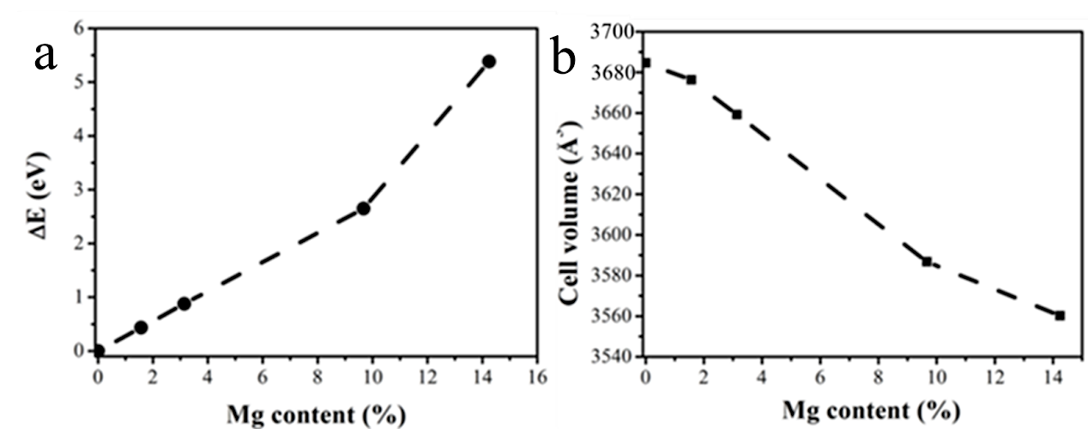
Fig. S7. The relationship of the formation energy (a) and cell volume (b) with the Mg content in the Mg-TCP crystal lattice based on the first-principle calculation.

Table S1. ICP results of Mg contents (Mg/(Mg+Ca) mol%) from SU spine, SU shell and SF horn samples before and after the hydrothermal reactions at 200ºC for 24 hours.
Mg content  (Mg/(Mg+Ca)) | Before Hydrothermal Reaction (mol%) | After Hydrothermal Reaction (mol%)
SU spine | 11.5±0.7 | 10.3±0.3
SU shell | 15.3±0.5 | 14.9±0.3
SF horn | 17.6±0.1 | 16.4±0.1

Table S2. ICP results of Mg contents (Mg/(Mg+Ca) mol%) of Mg-calcite transformed from Mg-ACC with different Ca/Mg molar ratios.
Ca/Mg molar ratio in the solution | Mg content (mol%)
1:1 | 21.4±0.4
2:1 | 11.7±0.2
5:2 | 9.6±0.2

Table S3. Ca-O bond information for five types of Ca²⁺ ions in the β-TCP crystal lattice before and after Mg²⁺ ion substitution.
Type of Ca | Atomic Percentage (%) | Coordination number | Initial average bond length (Å) | Bond length (Å) after Ca(5) substitution | Bond length (Å) after Ca(4) substitution
Ca(5) | 9.52 | 6 | 2.285 | / | /
Ca(4) | 4.76 | 3 | 2.371 | 2.329 | /
Ca(3) | 28.57 | 8 | 2.577 | 2.545 | 2.541
Ca(2) | 28.57 | 6 (8) | 2.457 | 2.462 | 2.488
Ca(1) | 28.57 | 7 | 2.486 | 2.513 | 2.505

