Supplementary Information for:

3D printing of PVDF/Photopolymer Resin Blends for Piezoelectric Pressure Sensing Application using Stereolithography Technique
Hoejin Kim¹, Luis Carlos Delfin Manriquez¹, Md Tariqul Islam², Luis A. Chavez¹, Jaime E. Regis¹, Md Ariful Ahsan², Juan C. Noveron², Tzu-Liang B. Tseng³, Yirong Lin¹

¹Department of Mechanical Engineering, University of Texas at El Paso, El Paso 79968, United States
²Department of Chemistry, University of Texas at El Paso, El Paso 79968, United States
³Department of Industrial, Manufacturing, and Systems Engineering, University of Texas at El Paso, El Paso 79968, United States

Correspondence to Hoejin Kim (E-mail: hkim4@miners.utep.edu)

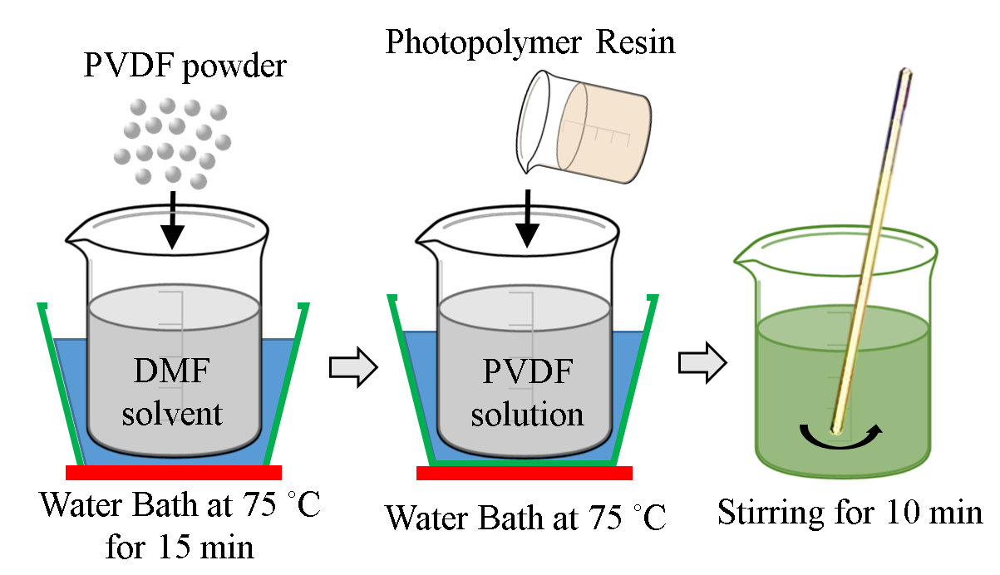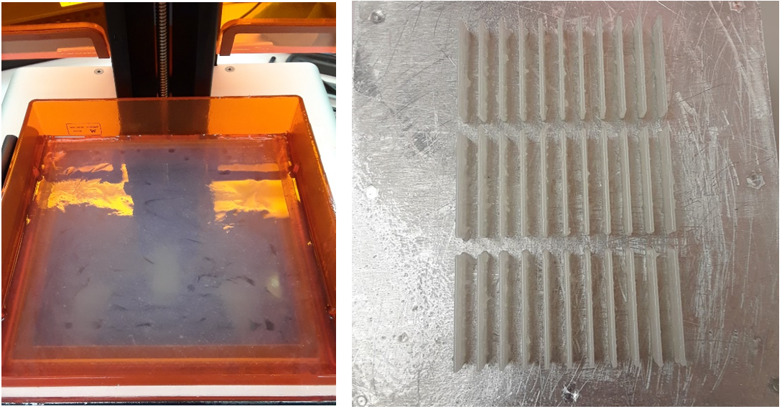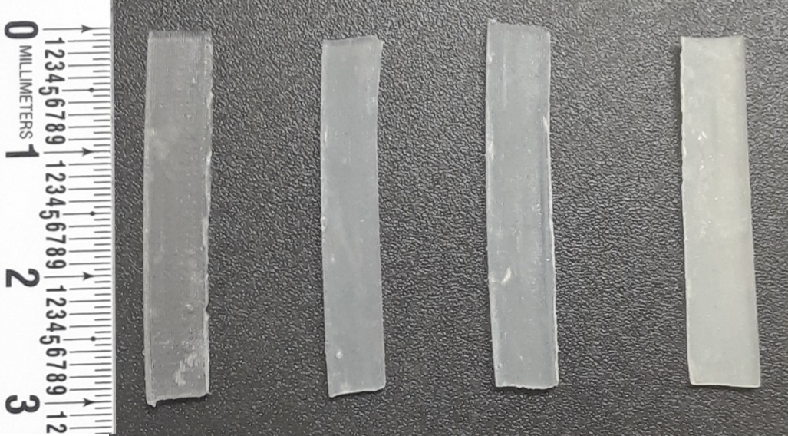
(b)
(c)
(a)
Figure S1. (a) Schematic illustration of the synthesis process for PVDF/PR composites, (b) composites resin placed in resin tank of the top-down projection-based SLA 3D printer and 3D printed composites samples on the to-down building platform, and (c) prepared samples for analyses (from left, pure PR, 1, 2.5, and 5wt.%-PVDF/PR).

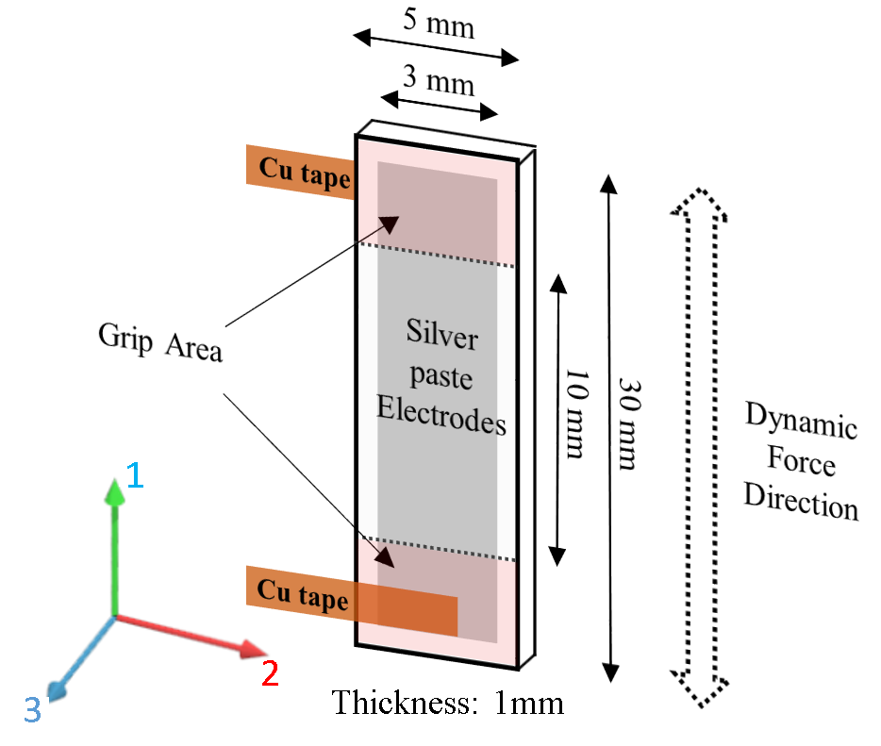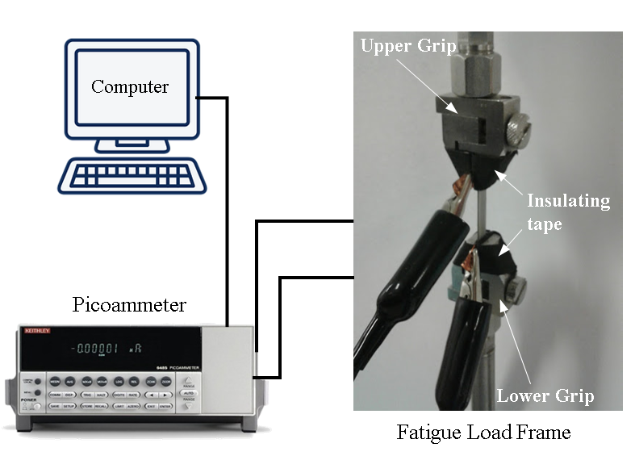
(b)
(a)
Figure S2. Schematic illustration of (a) sample and electrode design and (b) the experimental setup for piezoelectric output measurement.

(b)
(a)
Figure S3. (a) XRD patterns and (b) FTIR spectra for pure PR, 1, 2, 4, and 5wt.%-PVDF/PR composites after electrical poling.

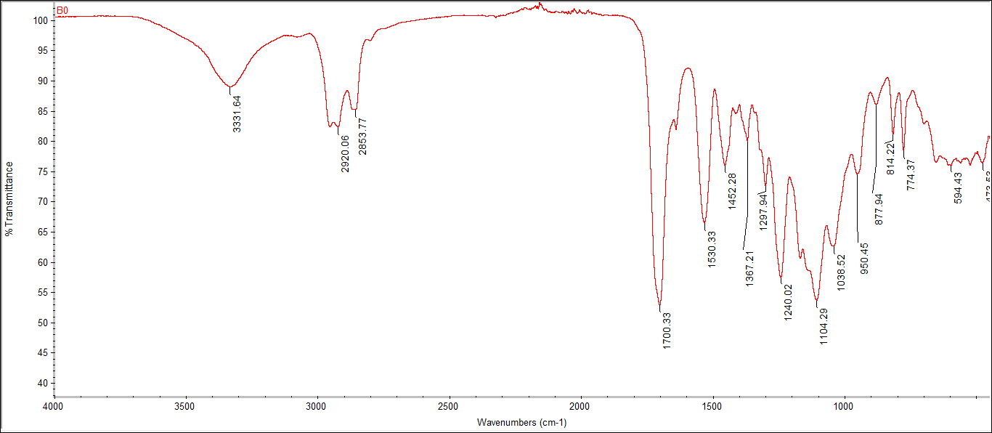
(a)
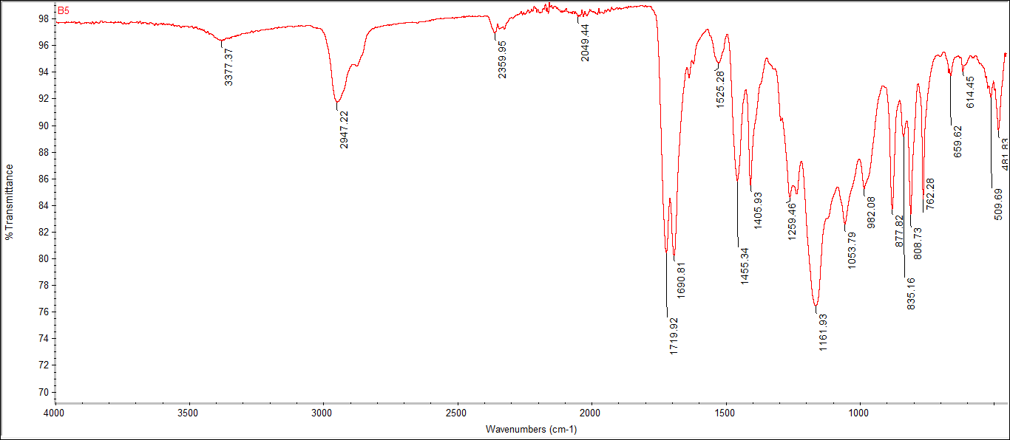
(b)
Figure S4. FTIR spectra of (a) pure photopolymer resin and (b) 5wt.%-PVDF/PR.

