Supporting information

Strong exciton-photon coupling in anthradithiophene microcavities: from isolated molecules to aggregates

J. D. B. Van Schenck,¹ E. K. Tanyi,² L.-J. Cheng,² J. Anthony,³ O. Ostroverkhova^{1*}

¹Department of Physics, Oregon State University, Corvallis, OR 97331
²Department of Electrical Engineering and Computer Science, Oregon State University, Corvallis, OR 97331
³Department of Chemistry, University of Kentucky, Lexington, KY 40506
*E-mail: oksana@science.oregonstate.edu

Calculation of average intermolecular spacing

The method used to calculate diF TES-ADT average molecular spacing in the PMMA host matrix was described in our previous publication.¹ Briefly, films are deposited by spin-casting from toluene solutions of diF TES-ADT:PMMA, where the monomer concentration of PMMA is held fixed at 0.4 M and the concentration of diF TES-ADT is varied between $8.6×{10}^{-4}$ M and $2.8×{10}^{-2}$ M. Two assumptions guide the choice of this range of concentrations: 1) the guest diF TES-ADT molecules are assumed to be isotopically dispersed in the PMMA host matrix and 2) the density of the PMMA host matrix does not change by the diF TES-ADT doping. The isotropic distribution allows the definition of average molecular spacing, $d$, as the average distance between neighboring molecules. The average volume surrounding a single molecule is then:
$$Vol=\frac{4}{3}π{\left(\frac{d}{2}\right)}^{3}$$
Additionally,
$$\frac{1}{Vol}=\frac{\# of molecules of diF TES-ADT in Unit Volume}{Unit Volume}=\frac{N_{A} ρ_{PMMA}}{f M_{PMMA}}$$
where $N_{A}$ is Avogadro’s number, $ρ_{PMMA}$ is the density of bulk PMMA films (fixed at $1.19\frac{g}{cm^{3}}$), $M_{PMMA}$ is the molar mass of a PMMA monomer (fixed at $100\frac{g}{cm^{3}}$), and $f$ is the ratio of the monomer concentration of PMMA to the concentration of diF TES-ADT in toluene solution. Setting the single molecule volumes equal allows the average molecular spacing to be calculated as:
$$d=2 \sqrt[3]{\frac{3 M_{PMMA} f}{4π N_{A} ρ_{PMMA}}}$$

Cavity and film schematic
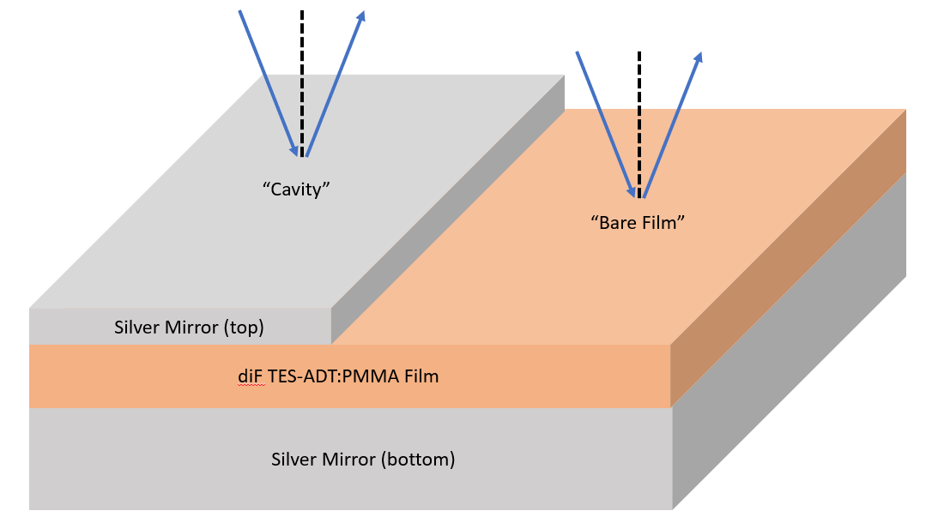

Figure S1: A schematic of the samples used, showing both “cavity” and “bare film” regions of the sample. The silver mirrors had thicknesses of 30 nm (top):100 nm (bottom) (or 45 nm:45 nm in select samples to facilitate optical transmission measurements), while the diF TES-ADT:PMMA films ranged between 100 nm and 150 nm depending upon desired cavity detuning.

The sample fabrication process generates large surface area diF TES-ADT:PMMA films (~1 cm²), and so the deposition of the top mirror was limited to only certain regions of the surface. In this way, “cavity” and “bare film” regions coexisted on the same sample, allowing for direct in-situ comparison of the optical data.

Cross-sectional SEM

Small sections of the original cavity samples (Ag/PMMA/Ag and Ag/diF TES-ADT:PMMA/Ag) containing the three cavity subsections were cut from the main sample for thickness measurements using a scanning electron microscope (SEM) equipped with a Focused-Ion-Beam (FIB). The samples were initially prepared for surface imaging by depositing 10 nm each of gold and palladium. Subsequently, the samples were prepared for cross-sectional analysis using the FIB of a FEI Quanta-Ray 3D dual beam SEM system. The samples were electrically grounded on the sample edges to the imaging stub using silver paste. Then 10 nm of chromium was deposited on the sample using a Varian Thermal evaporator. The chromium provides full electrical grounding of the sample to the stub and a protective layer that prevents beam shifts during the cross-sectional analysis. Prior to the milling of the cross-section, a layer of carbon (0.5 to 1.0 microns) followed by a layer of platinum (0.5 to 1.0 microns) was deposited on the samples. Finally, a cross-section of 5 microns was milled out and cleaned. Then, SEM images of the cross-section were obtained and the thicknesses of the various layers measured.
For example, for the nominal Ag (30 nm)/PMMA (140 nm)/ADT (100 nm) cavity, the following average sample thicknesses were obtained: Ag (64.8 ± 5.2) nm / (137.4 ± 7.1) nm/ (121.2 ± 6.3) nm, Fig. S2. The Ag average thicknesses are about 15-20 nm larger than the “nominal” value (taking into account that the top Ag layer thickness value (64.8 nm) includes the extra 20 nm from the Au and Pd layers). The PMMA layer thickness agrees well with that measured by ellipsometry (130-145 nm depending on the sample).

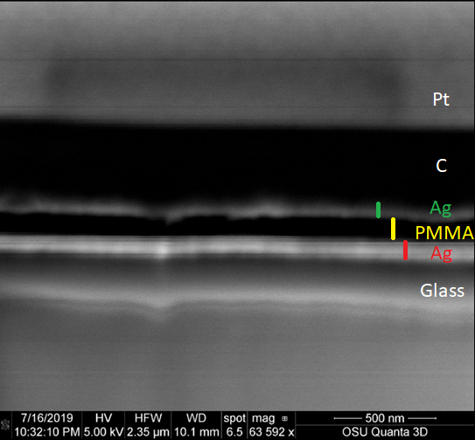

Figure S2: Cross-sectional SEM image of an Ag/PMMA/Ag cavity on glass. The average thicknesses of each layer are given in the text.

Cavity Q-Factors and indices of refraction

To establish basic characteristics of the cavity photon, angle-resolved reflectance was measured for a cavity containing only PMMA film (denoted $P_{∞}$, thickness 140 nm). Figure S3 (top) shows the reflectance upon $P_{∞}$ cavity illumination with s-(p-)polarized light, along with dotted lines indicating the center energy and FWHM extracted from a simple Lorentzian fit:
$$1-R\left(ℏω\right)=B-\frac{A}{π Γ\left(1+{\left(\frac{ℏω-E}{Γ}\right)}^{2}\right) }$$
where $B$ is a background correction, $A$ is the Lorentzian area, $E$ is the center energy and $Γ$ is the HWHM. From these fits, we can also extract the reflectance Q-factor of these PMMA cavities as:
$$Q=\frac{E}{2Γ}≈27$$
Next, the center energies were fit (Fig. S3, bottom) using a simple cavity dispersion model (discussed in the main text) to extract the effective indices of refraction for each polarization of light:
$$E\left(θ\right)=E_{0}{\left(1-{\left(\frac{\sin{θ}}{n_{eff}}\right)}^{2}\right)}^{-\frac{1}{2}}$$
where the fit parameter values are given as insets of Fig. S3 (bottom).

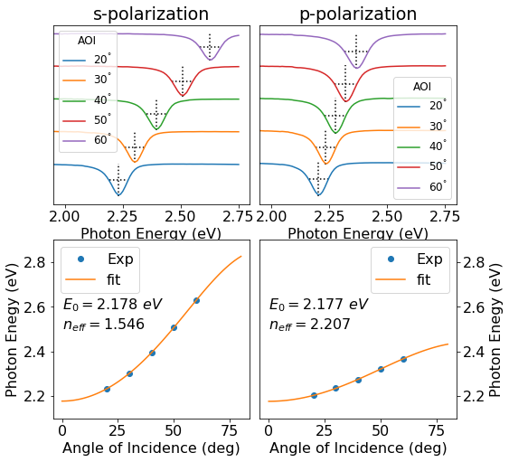

Figure S3: (top) Angle resolved reflectance measurements of a control cavity containing only PMMA, $P_{∞}$, of thickness 150 nm for s-(p-)polarized illumination at various angles of incidence (AOI). Dotted lines indicate the center energies and FWHM of each cavity resonance. (bottom) Dispersion plots of the cavity resonance modes for s-(p-)polarizations. Dots correspond to the center energies extracted from reflectance data (top), and the lines are the fit, with the fit parameters included on the plot.

Since PMMA is not fluorescent in the visible spectral range, it was not possible to measure PL-based Q factors for the PMMA-only cavity $P_{∞}$. Instead, the PL Q-factor was estimated using the LP emission from diF TES-ADT:PMMA cavities containing a low diF TES-ADT concentration (film $P_{5}$, where $d=5 nm$) at large cavity detuning ($Δ≈180 meV$). The PL was fit with a simple Lorentzian (Fig. S4):$$PL\left(ℏω\right)=\frac{A}{π Γ\left(1+{\left(\frac{ℏω-E}{Γ}\right)}^{2}\right) }$$
where $A$ is the Lorentzian area, $E$ is the center energy and $Γ$ is the HWHM From these fits, we extract the PL Q-factor as:
$$Q=\frac{E}{2Γ}≈50$$

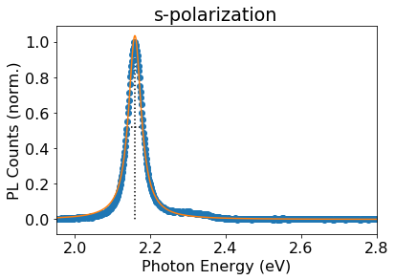

Figure S4: Photoluminescence spectra of cavity $P_{5}$ detected at substrate normal. Symbols correspond to the measured counts (normalized), the line is a Lorentzian fit, and the dotted lines shows the center energy and FWHM.

X-Ray Diffraction

To assess the structure of films with relatively high concentrations of diF TES-ADT ($P_{1.5}$ and $P_{agg}$ films), XRD was measured using a Bruker D8 Discover diffractometer. The results (Fig. S5) show that both $P_{1.5}$ and $P_{agg}$ films contain crystallites with the 00l (l=1 - 4) orientation, similar to those in previous studies of diF TES-ADT polycrystalline films.^{2,3} The $P_{agg}$film has a factor of ~2 larger scattered intensity of dominant 00l peaks, confirming a higher content of preferentially aligned crystallites in the $P_{agg}$film.
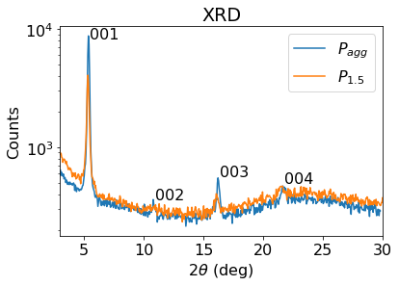
Figure S5: X-ray diffraction data for the “bare” films $P_{agg}$ and $P_{1.5}$. Both show strong peaks consistent with 00l (l=1 -4) oriented crystallites.

Table of parameters

Film | Thickness | Polarization | $$E_{X} \left(eV\right)$$ | $$E_{0} \left(eV\right)$$ | $$n_{eff}$$ | $$V \left(meV\right)$$ | $$Γ \left(meV\right)$$ | $$ℏΩ \left(meV\right)$$
$$P_{agg}$$ | $$120 nm$$ | s | $2.25$*  $2.42$*  $2.60$* | $2.2$† | $2.0$† | $170$†  $160$†  $160$† | $Γ_{p}=65$*  $Γ_{X}=70$* | $340$†  $310$†  $310$†
$$P_{agg}$$ | $$120 nm$$ | p | $2.25$*  $2.42$*  $2.60$* | $2.2$† | $2.7$† | $150$†  $130$†  $150$† | $Γ_{p}=50$*  $Γ_{X}=70$* | $300$†  $260$†  $300$†
$$P_{1.5}$$ | $$100 nm$$ | s | $2.34$*  $2.52$*  $2.69$* | $2.2$† | $1.6$† | $75$†  $55$†  $35$† | $Γ_{p}=80$*  $Γ_{X}=60$* | $150$†  $110$†  $60$†
$$P_{1.5}$$ | $$100 nm$$ | p | $2.34$*  $2.52$*  $2.69$* | $2.2$† | $2.4$† | $80$†  $60$†  $30$† | $Γ_{p}=75$*  $Γ_{X}=60$* | $160$†  $120$†  $60$†
$$P_{2.5}$$ | $$135 nm$$ | s | $2.34$* | $2.2±0.2$‡ | $1.55$* | $20±7$‡ | $Γ_{p}=30$*  $Γ_{X}=40$* | $40±7$‡
$$P_{2.5}$$ | $$135 nm$$ | p | $2.34$* | $2.2±0.2$‡ | $2.21$* | $24±7$‡ | $Γ_{p}=30$*  $Γ_{X}=40$* | $46±7$‡
$$P_{3}$$ | $$130 nm$$ | s | $2.34$* | $2.2±0.2$‡ | $1.55$* | $21±10$‡ | $Γ_{p}=30$*  $Γ_{X}=40$* | $41±10$‡
$$P_{3}$$ | $$130 nm$$ | p | $2.34$* | $2.2±0.2$‡ | $2.21$* | $15±10$‡ | $Γ_{p}=20$*  $Γ_{X}=40$* | $28±11$‡
$$P_{3.5}$$ | $$135 nm$$ | s | $2.34$* | $2.2±0.2$‡ | $1.55$* | $20±5$‡ | $Γ_{p}=32$*  $Γ_{X}=40$* | $39±5$‡
$$P_{3.5}$$ | $$135 nm$$ | p | $2.34$* | $2.2±0.2$‡ | $2.21$* | $17±5$‡ | $Γ_{p}=32$*  $Γ_{X}=40$* | $34±5$‡
$$P_{4}$$ | $$145 nm$$ | s | $2.34$* | $2.2±0.2$‡ | $1.55$* | $17±4$‡ | $Γ_{p}=32$*  $Γ_{X}=40$* | $32±4$‡
$$P_{4}$$ | $$145 nm$$ | p | $2.34$* | $2.2±0.2$‡ | $2.21$* | $18±4$‡ | $Γ_{p}=32$*  $Γ_{X}=40$* | $35±4$‡
$$P_{5}$$ | $$145 nm$$ | s | $2.34$* | $2.2±0.2$‡ | $1.55$* | $18±7$‡ | $Γ_{p}=21$*  $Γ_{X}=40$* | $30±8$‡
$$P_{5}$$ | $$145 nm$$ | p | $2.34$* | $2.2±0.2$‡ | $2.21$* | $12±7$‡ | $Γ_{p}=21$*  $Γ_{X}=40$* | $15±11$‡
Table S1. Summary of parameters discussed in the text. “Film” refers to the diF TES-ADT:PMMA film used in the cavity, labeled $P_{d}$ in correspondence with the main text. “Thickness” refers to the geometrical thickness of the cavity, extracted from spectroscopic ellipsometry. “Polarization” refers to the illumination (detection) polarization used in angle-resolved reflectance in P_{1.5} and P_{agg} (angle-resolved PL in P_{d} with $d≥2.5 nm$). “$E_{X}$” is the bare exciton energy used during fitting. In all cases, the exciton energies were extracted from fits of “bare” film (or solution PL) and held constant during fitting. “$E_{0}$” is the normal incidence photon energy (Eq. (1) in the main text). “$n_{eff}$” is the effective index of refraction of the cavity (extracted from reflectance and held constant during fitting for films $P_{d}$ with $d≥2.5$ nm). “$V$” is the exciton-photon coupling energy. “$Γ$” is the HWHM of the exciton ($Γ_{X})$, extracted from “bare” film reflectance (PL) at 20° angle of incidence (0° angle of detection), and photon ($Γ_{p}$), estimated from the HWHM of cavity LP resonances in reflectance (PL) at 20° angle of incidence (0° angle of detection). “$ℏΩ$” is to the Rabi splitting, given by Eq. (4) in the main text.
Details on the fitting and error bars: the symbol * indicates that a value is extracted from data for either a “bare” film or cavity, and is held constant while fitting to the polariton dispersion models of Eqs. (2) and (3) in the main text. The symbol † indicates that the value comes from a specific fit of a particular sample, and are rounded according to the estimated error (~10%). The error in these fit values are estimated by their sensitivity to the starred (*) constants: varying the starred (*) constants gave rise to ~10% variation in the crossed (†) values. The ‡ symbol indicates that the value is the average over several samples (typically 3-4), and the sample-to-sample variation is given as the error bars.

Simulations

In addition to experimental reflectance measurements, spectroscopic ellipsometry together with transfer matrix formalism was utilized to simulate the reflectance spectra for both $P_{1.5}$ and $P_{agg}$ cavities (Figs. S6 and S7). The simulations for $P_{1.5}$ and $P_{agg}$exhibited close agreement with the experimental data (indicated with dots on plots).

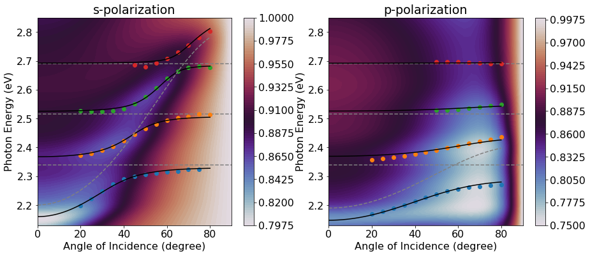

Figure S6: Dispersion plot of cavity $P_{1.5}$ at s-(p-)polarization. The contour plot background represents the simulated angle resolved reflectance of the cavity using transfer matrix formalism together with the complex valued index of refraction, calculated by spectroscopic ellipsometry. Dots represent the center energies extracted from the experimental angle resolved reflectance, using color to differentiate the LP, MP₁, MP₂ and UP branches. The dotted grey lines represent the bare exciton energies and the cavity photon energy and the solid lines represent the polariton dispersions modelled using Eq. (2) in the main text.
In $P_{agg}$, a deviation is observed in the LP energy region (2.0-2.2 eV) at below 40° angles of incidence (AOI), particularly for s-polarized illumination. As discussed in the main text, the experimental spectra show a splitting of the LP branch. This splitting is not reflected in the simulations, rather the simulated LP branch is located approximately between the two LP states. The deviation vanishes at higher AOI, which also corresponds to the coalescing of the two LP in the experimental spectra.

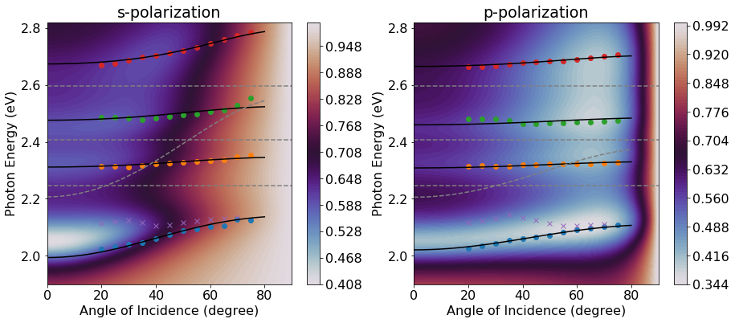

Figure S7: Dispersion plot of cavity $P_{agg}$ at s-(p-)polarization. The contour plot background represents the simulated angle resolved reflectance of the cavity using transfer matrix formalism together with the complex valued index of refraction, calculated by spectroscopic ellipsometry. Dots and crosses represent the center energies extracted from the experimental angle resolved reflectance. Dots give the LP₁, MP₁, MP₂ and UP branches while crosses give the LP₂ energies (not used in fitting). The dotted grey lines represent the bare exciton energies and the cavity photon energy and the solid lines represent the polariton dispersions modelled using Eq. (2) in the main text.

Spectral analysis of the $P_{1.5}$ cavity

Deconvolution of optical spectra of the $P_{1.5}$ “bare” film

In order to separate the contributions of the diF TES-ADT aggregates and of the diF TES-ADT isolated molecules to the absorption spectrum of the $P_{1.5}$ film, the spectrum from a “bare” film (see schematic in Fig. S1) was measured at 20° off normal incidence. This cavity utilized a 45 nm Ag semi-transparent bottom mirror, and thus both the reflectance ($R$) and transmittance ($T$) were measured to calculate the absorption. The baseline reflectance was subtracted out and the reduced absorbance was calculated as:
$$\frac{A\left(ℏω\right)}{ℏω}=-\frac{\log_{10}\left(R+T-Baseline\right)}{ℏω}$$
The absorption from this film is expected to have contributions from both an isolated molecules and aggregates, which were both modelled as vibronic progressions:⁴
$$\frac{A\left(ℏω\right)}{ℏω}=B+\sum_{m=0}^{2}{A_{m}^{agg}W\left(ℏω|E_{X}^{agg}+mE_{V}^{agg},Γ_{m}^{agg}\right)}+\sum_{m=0}^{2}{A_{m}^{iso}W\left(ℏω|E_{X}^{iso}+mE_{V}^{iso},Γ_{m}^{iso}\right)}$$
where $B$ is the background correction, $A_{m}$ is the 0-m replica peak area, $W\left(ℏω | E_{0},Γ_{0}\right)$ is a normalized Lorentzian with center at $E_{0}$ and HWHM of $Γ_{0}$, $E_{X}$ is the exciton energy, $E_{V}$ is the vibrational energy quantum and $Γ_{m}$ is broadening of the 0-m replica peak. The resulting fit is shown in Fig. S8.
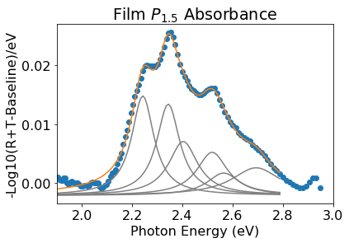

Figure S8: The reduced absorption of film $P_{1.5}$ with deconvolution. Blue dots are experimental spectrum, grey lines are individual absorption resonances and the orange line is the total fit.

The fit parameters are:
$$E_{X}^{agg}=2.24 eV, E_{V}^{agg}=0.161 eV, A_{0}^{agg}=0.0029 \frac{O.D.}{eV}, A_{1}^{agg}=0.0020\frac{O.D.}{eV}, A_{2}^{agg}=0.0010\frac{O.D.}{eV}$$
$$Γ_{0}^{agg}=0.054 eV, Γ_{1}^{agg}=0.070 eV, Γ_{2}^{agg}=0.0080 eV$$
$$E_{X}^{iso}=2.34 eV, E_{V}^{iso}=0.175 eV, A_{0}^{iso}=0.0027 \frac{O.D.}{eV}, A_{1}^{iso}=0.0018\frac{O.D.}{eV}, A_{2}^{iso}=0.0017\frac{O.D.}{eV}$$
$$Γ_{0}^{iso}=0.056 eV, Γ_{1}^{iso}=0.074 eV, Γ_{2}^{iso}=0.12 eV$$

We can estimate the relative contributions of the aggregates and isolated molecules by comparing the sums of the 0-m (m = 0-2) peak areas. Doing so shows that there is a ~50:50 contribution of aggregates:isolated molecules to the spectra.

Cavity $P_{1.5}$ coupling scaling

For the isolated diF TES-ADT molecules in a PMMA film, it is expected that the 0-m replica peak areas should scale with the m^{th} Frank-Condon (FC) factor: ${e^{-S}S^{m}}/{m!}$.^{1,5} In this case the ratio of the first two peak areas is expected to yield:
$$\frac{A_{1}^{iso}}{A_{0}^{iso}}=S=0.71$$
Additionally, the oscillator strength of these replica peaks should also scale with their FC factor. In keeping with Eq. (5), this suggests that the exciton-photon interaction energy should scale with the square root of the FC factor. Figure S9 shows the interaction energies (averaged over polarization) obtained from P_{1.5} cavities (Table S1) plotted versus square root of the FC factors obtained from fits of the isolated molecules contribution of Fig. S8, which confirms this expectation. To assess the goodness-of-fit to a proportional model (Eq. (5) in the main text), a linear fit was also performed (solid green line in Fig. S8). At the 95% confidence intervals, the slope and intercept were found to be 121 ± 14 meV and -12 ± 8 meV respectively. The slope is significantly larger than zero and the intercept is small compared to the measured couplings which together corroborate the validity of a proportional model of Eq. (5).

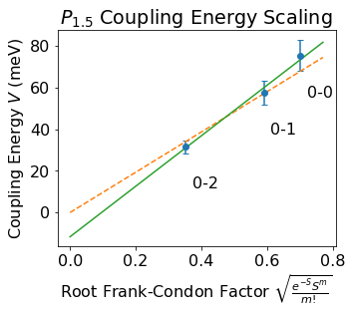
Figure S9: The scaling of the exciton-photon coupling energy V for cavity $P_{1.5}$. Dots show the coupling energy (averaged over polarization) of Table S1 for the 0-m exciton with the cavity photon plotted against the square root of their FC factor (where $FC∝μ^{2}$), assuming an HR factor of S=0.71. Vertical error bars represent 10% uncertainty discussed in Table S1. The dashed orange line represents a proportional fit to Eq. (5) in the main text (intercept fixed at 0), while the solid green line represents a linear fit (intercept as a fitting parameter).

“Bare” film $P_{1.5}$ angle-resolved reflectance spectra

In addition to the 20° reflection (R) and transmission (T) spectra discussed above, R and T were also measured at other angles of incidence. Figure S10 shows a representative set of these measurements expressed at 1-R-T to highlight the exciton absorptions. In particular, the 2.24 eV aggregate 0-0 absorption peak grows relative to the 2.34 eV isolated molecules 0-0 absorption peak as the angle of incidence increases. This effect is considerably pronounced with p-polarized illumination, and is most likely due to the preferential orientation of diF TES-ADT aggregates evidenced by XRD in Fig. S5.
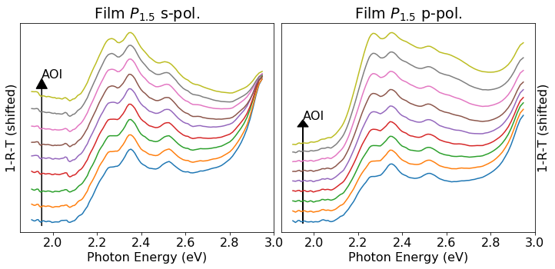

Figure S10: 1-R-T spectra for film $P_{1.5}$ at s-(p-)polarized illumination showing the exciton absorption peaks due to both isolated diF TES-ADT molecules and diF TES-ADT aggregates, with their relative weights.

Spectral analysis of the $P_{agg}$ cavity

Deconvolution of optical spectra of the $P_{agg}$ “bare” film

In order to deconvolve each aggregate excitonic contribution to the $P_{agg}$ film absorption, the spectra from a “bare” film (see Fig. S1) were measured at 20° off normal incidence. This cavity utilized a 100 nm Ag bottom mirror, so no transmission was observed and only the reflectance ($R$) was measured to calculate the absorption of the cavity. The baseline reflectance was subtracted out and the reduced absorbance was calculated as:
$$\frac{A\left(ℏω\right)}{ℏω}=-\frac{\log_{10}\left(R-Baseline\right)}{ℏω}$$
The absorption from this film was modelled as vibronic progression:⁴
$$\frac{A\left(ℏω\right)}{ℏω}=B+\sum_{m=0}^{2}{A_{m}W\left(ℏω|E_{X}+mE_{V},Γ_{m}\right)}$$
where $B$ is the background correction, $A_{m}$ is the 0-m replica peak area, $W\left(ℏω | E_{0},Γ_{0}\right)$ is a normalized Lorentzian with center at $E_{0}$ and HWHM of $Γ_{0}$, $E_{X}$ is the exciton energy, $E_{V}$ is the vibrational energy quantum and $Γ_{m}$ is broadening of the 0-m replica peak. Figure S11 shows the fit.
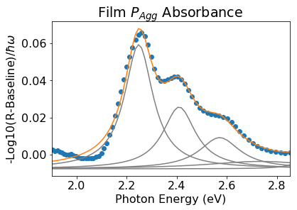

Figure S11: The reduced absorption of film $P_{agg}$ with deconvolution. Blue dots are experimental data, grey lines are individual absorption resonances and the orange line is the total fit.

The fit parameters are:
$$E_{X}=2.25 eV, E_{V}^{agg}=0.16 eV,$$
$$A_{0}=0.014 \frac{O.D.}{eV}, A_{1}=0.0082\frac{O.D.}{eV}, A_{2}=0.0052\frac{O.D.}{eV}, A_{3}=0.0033\frac{O.D.}{eV}$$
$$Γ_{0}=0.069 eV, Γ_{1}=0.079 eV, Γ_{3}=0.098 eV, Γ_{3}=0.26 eV$$

Cavity $P_{agg}$ coupling scaling

Because of intermolecular interactions inside of diF TES-ADT aggregates, the exciton absorption peaks are expected to have a more complicated relationship to their FC factors than is seen for isolated molecules. In order to test the validity of Eq. 5 in describing the variation in couplings among the 0-m transitions for the diF TES-ADT aggregates, we approximate the oscillator strength of each exciton with the square of the absorption peak area calculated above: $\sqrt{A_{m}}$. Comparing with the coupling energies (averaged over polarization) from Table S1 we see that the coupling energies obtained in aggregates do not exhibit proportional relationship with the square root of absorbances (dashed orange line in Fig. S12), in contrast to that for the isolated molecules seen in Fig. S9. To quantify this assertion, a linear fit (intercept as a fit parameter) was performed (solid green line in Fig. S12) to compare with the proportional fit (intercept fixed at 0). In the linear fit at the 95% confidence intervals, the slope and intercept were found to be 15 ± 56 meV and 141 ± 44 meV respectively. The slope is not significantly different from zero, and the measured coupling energies lie within the confidence interval of the intercept, both of which indicate that the proportional dependence is not satisfied.

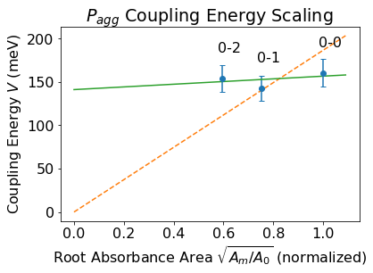
Figure S12: The scaling of the coupling energy for cavity $P_{agg}$. Dots show the coupling energy (averaged over polarization) for the 0-m exciton with the cavity photon plotted against the square root of their absorption peak area ($\sqrt{{A_{m}}/{A_{0}}}$), normalized to the 0-0 exciton value. Vertical error bars represent 10% uncertainty discussed in Table S1. The dashed orange line represents a proportional fit to Eq. (5) in the main text (intercept fixed at 0), while the solid green line represents a linear fit (intercept as a fitting parameter).
Cavity Reflectance

Figure S13 shows angle-resolved reflectance from a $P_{agg}$ cavity at p-polarization.

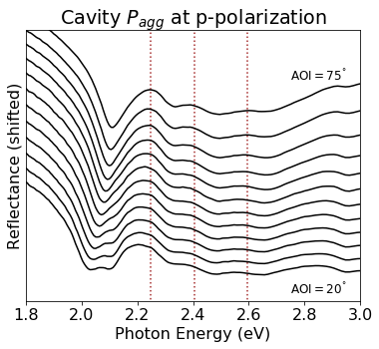
Figure S13: Angle resolved reflectance spectra of cavity $P_{agg}$ with p-polarized illumination. Black lines are the reflectance at various angles of incidence (AOI) between 20° and 75°. Dotted lines are the exciton energies of aggregates in “bare” $P_{agg}$ films (used in fits).
References

(1) W. Shepherd, A. Platt, D. Hofer, O. Ostroverkhova, M. Loth, J. Anthony: Aggregate Formation and Its Effect on (Opto)Electronic Properties of Guest-Host Organic Semiconductors. Appl. Phys. Lett. 97 (16), 163303 (2010).
(2) K. Paudel, B. Johnson, M. Thieme, M. Haley, M. Payne, J. Anthony, O. Ostroverkhova: Enhanced Charge Photogeneration Promoted by Crystallinity in Small-Molecule Donor-Acceptor Bulk Heterojunctions. Appl. Phys. Lett. 105 (4), 043301 (2014).
(3) A. Platt, M. Kendrick, M. Loth, J. Anthony, O. Ostroverkhova: Temperature Dependence of Exciton and Charge Carrier Dynamics in Organic Thin Films. Phys. Rev. B 84 (23), 235209 (2011).
(4) N. Hestand, F. Spano: Expanded Theory of H- and J ‑ Molecular Aggregates : The Effects of Vibronic Coupling and Intermolecular Charge Transfer. Chem. Rev. 118, 7069–7163 (2018).
(5) J. Van Schenck, G. Giesbers, A. Kannegulla, L. Cheng, J. Anthony, O. Ostroverkhova: Molecular Packing-Dependent Exciton and Polariton Dynamics in Anthradithiophene Organic Crystals. MRS Adv. 3, 3465–3470 (2018).

