Supplementary Information

Bioderived protoporphyrin IX incorporation into a metal-organic framework for enhanced photocatalytic degradation of chemical warfare agents
Marilyn S. Lee, Sergio J. Garibay, Ann M. Ploskonka, Jared B. DeCoste
Edgewood Chemical Biological Center, U.S. Army Research, Development, and Engineering Command, 8567 Ricketts Point Rd. Aberdeen Proving Ground, MD 21010

Figure S1. SDS PAGE analysis of whole cell lysate for E. coli strains expressing either HemA (lane A) or the control mRuby (lane mR). The HemA and mRuby protein bands are indicated by a red box.
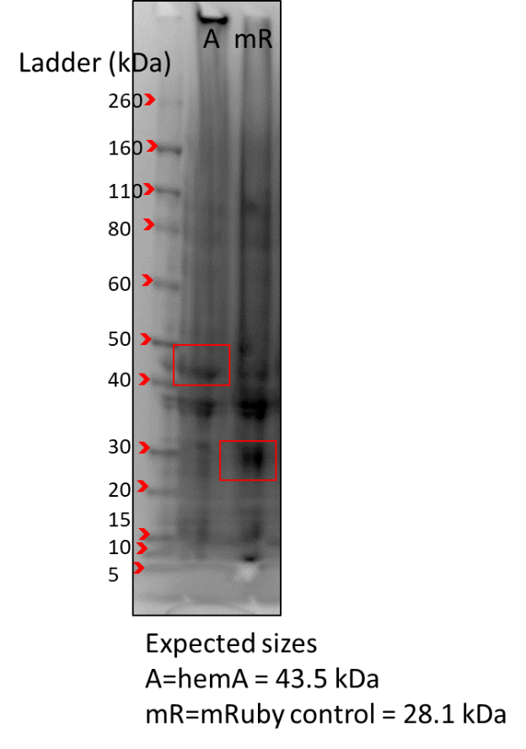

Table S1. Characteristics of Shemin pathway molecules
Molecule | Molecular weight | m/z | Retention time (min)
Uroporphyrin I and III (UP) | 830.23 | 831.4 | 11.7
Pentacarboxyl porphyrin (PCP) | 698.73 | 699.4 | 14.6
Coproporphyrin I and III (CP) | 654.72 | 655.3 | 15.5
Protoporphyrin IX (PPIX) | 562.67 | 563.4 | 20.5

Figure S2. MSD signals for porphyrin standards
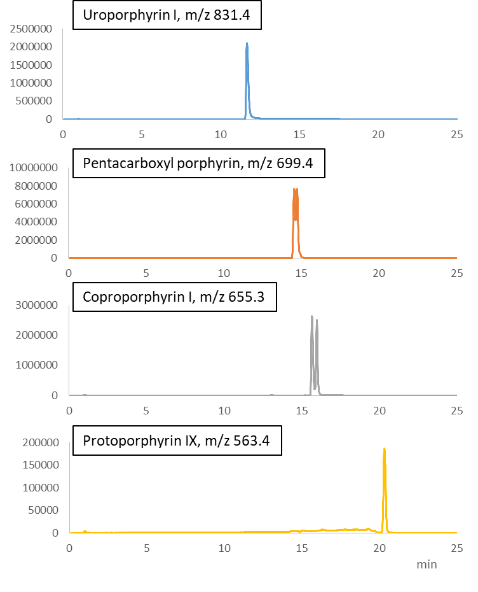

Figure S3. DAD traces and Quantification of porphyrins in media vs cell extract from 1L cultures of E. coli expressing the HemA protein.
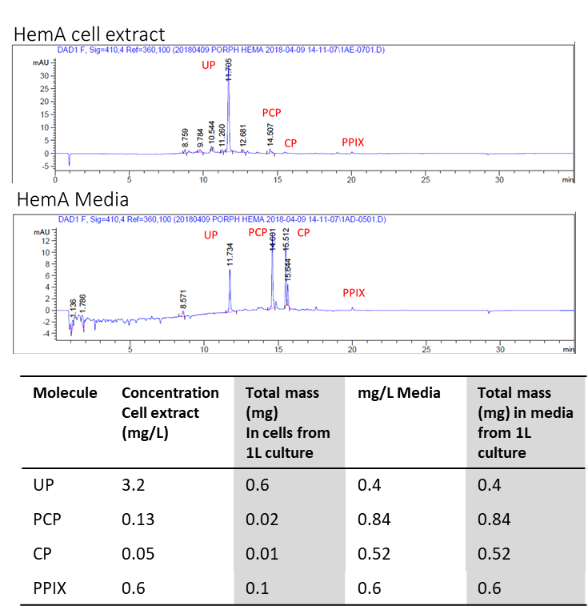
Figure S4. Powder X-ray diffraction patters of NU-1000 (bottom), and PPIX@NU-1000 (top).
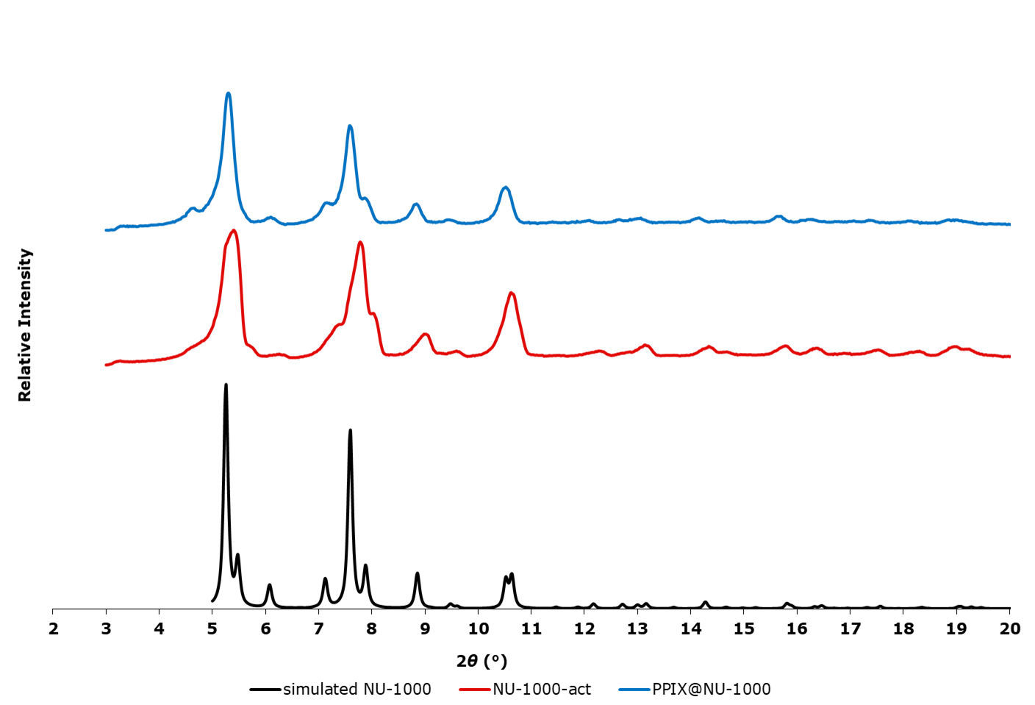

Figure S5. FTIR of NU-1000, PPIX, and PPIX@NU-1000.
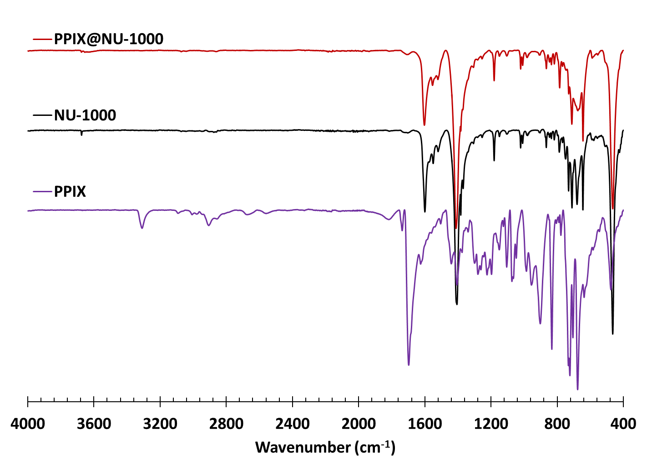

Figure S6. Nitrogen isotherms (top) and pore size distribution (bottom) of NU-1000 (black squares), and PPIX@NU-1000 (red circles). Adsorption = filled, desorption = empty markers.
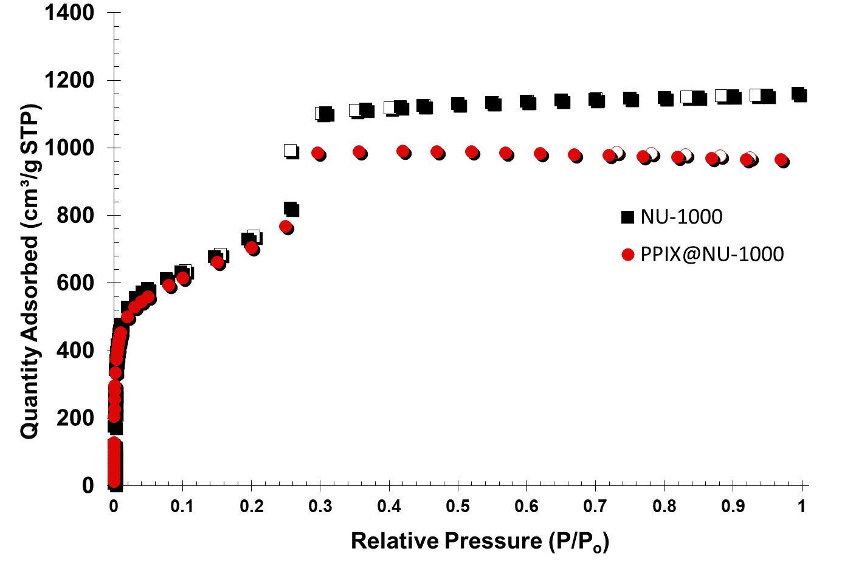
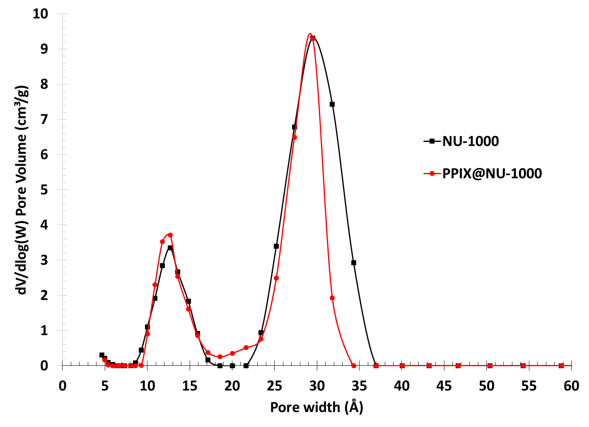

Figure S7. ¹H NMR of digested PPIX@NU-1000.
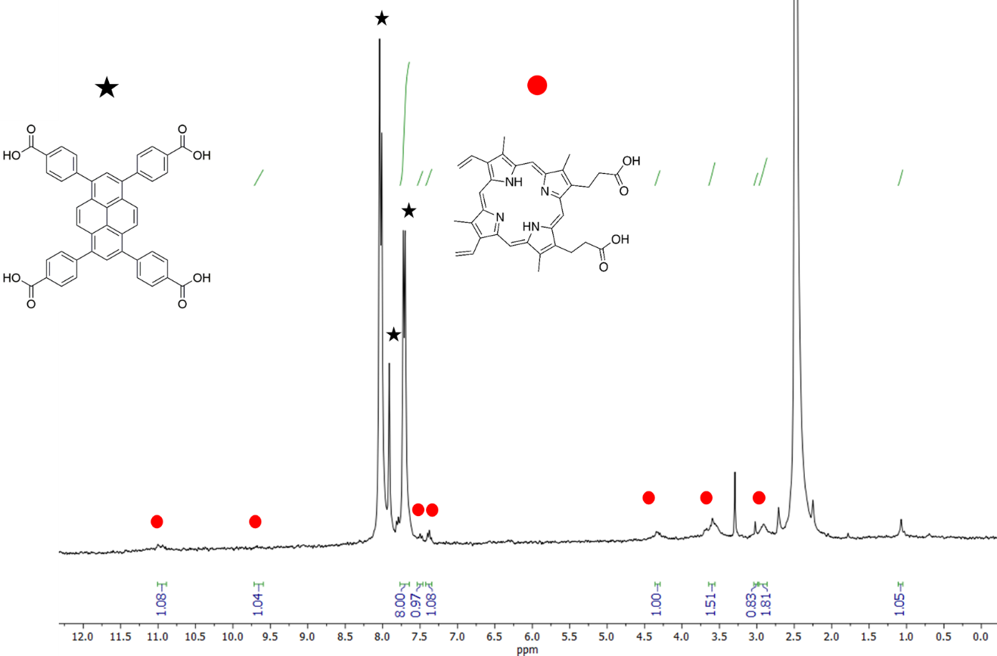

Figure S8. Reaction of CEES in methanol under various control conditions.
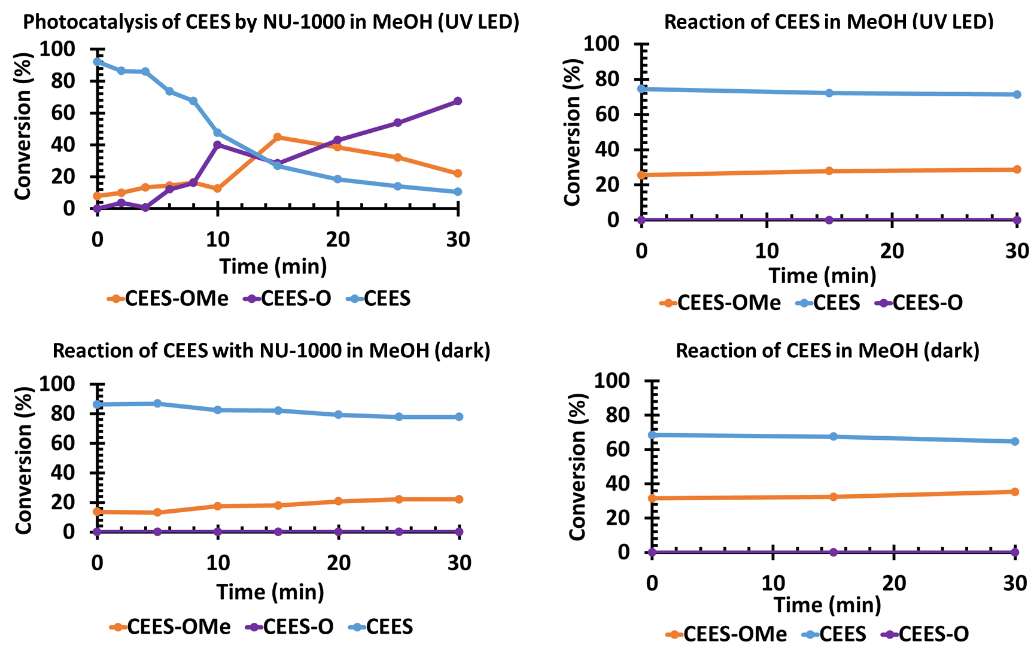

Figure S9. Solid state absorbance spectra of NU-1000, protoporphyrin IX, and PPIX@NU-1000. The H₄TBAPy spectra and other insight into the electronic properties of H₄TBAPy containing MOFs can be found elsewhere.¹

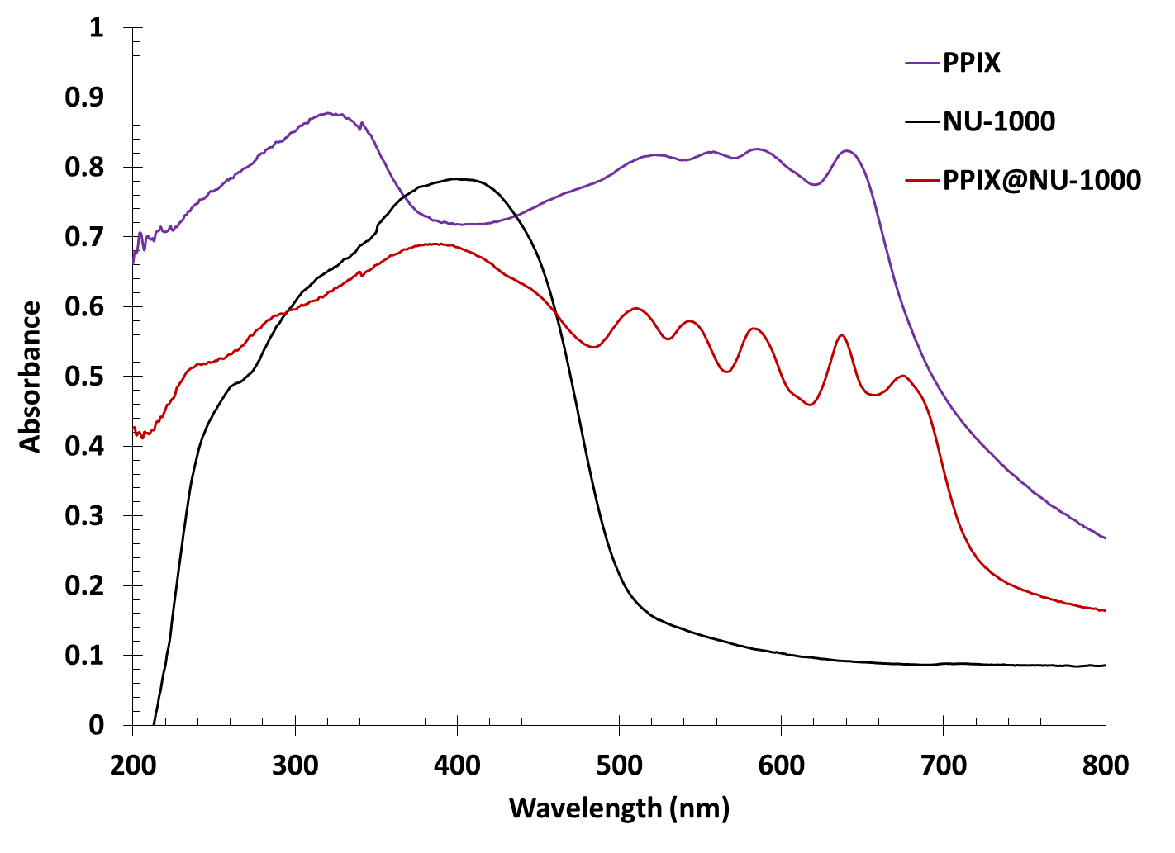
Table S2. LED characteristics
LED Color | Minimum Dominant λ (nm) | Maximum Dominant λ (nm) | Minimum Luminous Flux (lm) @350 nm
Blue | 465 | 480 | 35
Green | 520 | 535 | 100
Red | 620 | 630 | 70
*Additional information about the colored LEDs can be found at http://menarilighting.com/rapidled/documentation/XLampXPE2.pdf and about the white LED at https://www.cree.com/led-components/media/documents/dsxpl2.pdf

References
- Yu, J.; Park, J.,; Van Wyk, A.; Rumbles, G.; Deria, P. Excited-State Electronic Propertis in Zr-Based Metal-Organic Frameworks as a Function of a Topoligcal Network. Journal of the American Chemical Society 2018, 140, 10488-10496. https://doi.org/10.1021/jacs8b04980.

