Supplementary Information for

Hard-Switching Reliability Studies of 1200 V Vertical GaN PiN Diodes

O. Slobodyanª, T. Smithª, J. Flickerª, S. Sandoval^{b}, C. Matthews^{b}, M van Heukelomª, R. Kaplarª, and S. Atcittyª

ª Sandia National Laboratories, Albuquerque, NM 87185, USA
^{b} Sandia National Laboratories, Albuquerque, NM 87185, USA and University of Arkansas, Fayetteville, AR 72701
Contact email: rjkapla@sandia.gov

Vertical GaN PiN Diode Structure

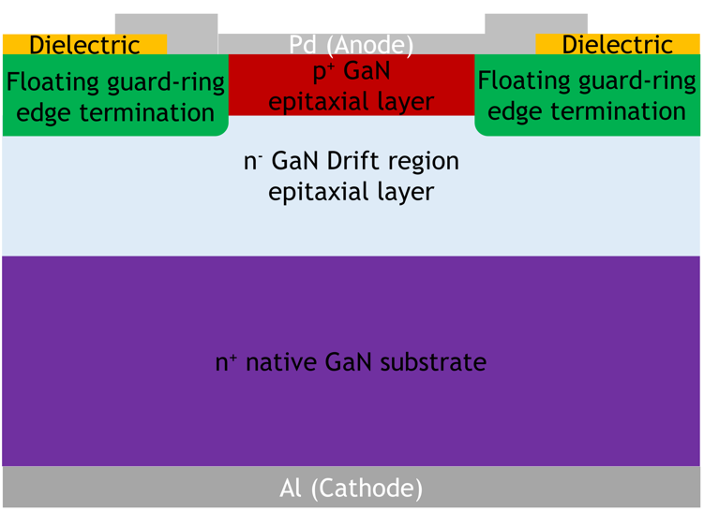
Figure S1. Illustration of a vertical GaN PiN diode, showing the different regions of the device and the contact metals.

500 V
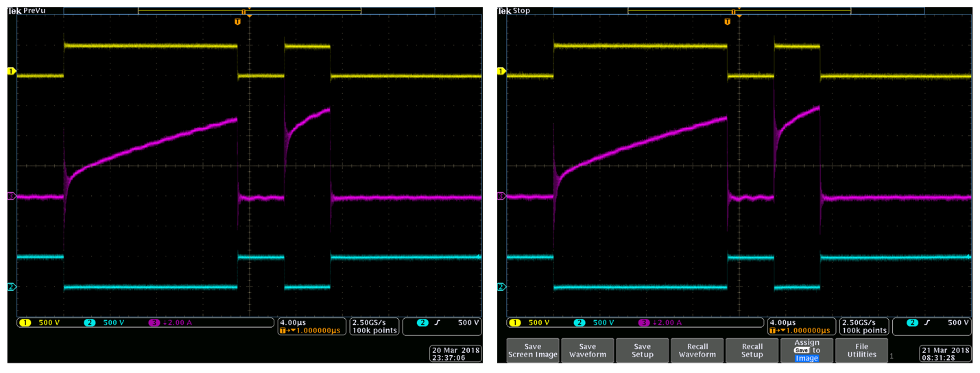
(a) (b)
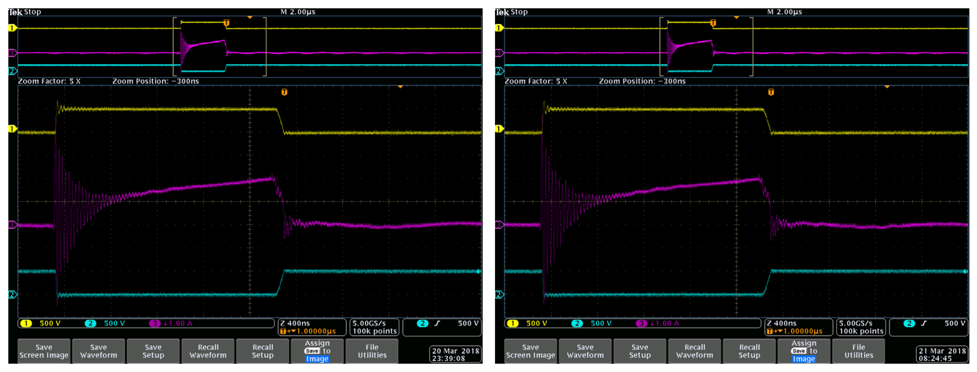
(c) (d)
Figure S2. 500 V stressed v-GaN PiN diode oscilloscope reading of diode voltage in yellow, diode current in magenta, and switch voltage in blue for the double-pulse traces (a) pre-stress and (b) post-stress, along with the stress pulse traces (c) pre-stress and (d) post-stress. The yellow trace is plotted on a scale of 500 V/div at an offset of +1500 V, the blue on a scale of 500 V/div at an offset of -2000 V, and the magenta parts (a, b) are on an inverted scale of 2 A/div at offset of -2A for parts while (c, d) are on an inverted scale of 1 A/div at offset of -1A.

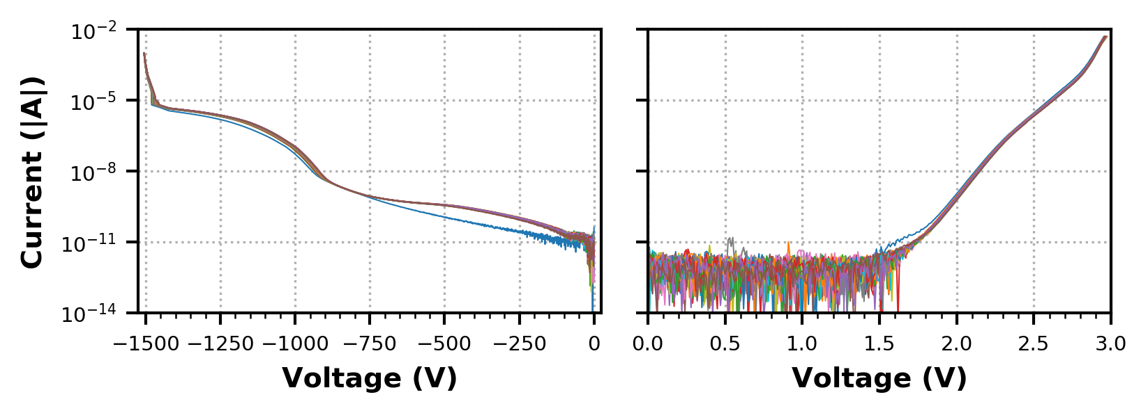
(a) (b)
Figure S3. Cumulative (a) reverse and (b) forward I-Vs over the full duration for the v-GaN stressed at 500 V.

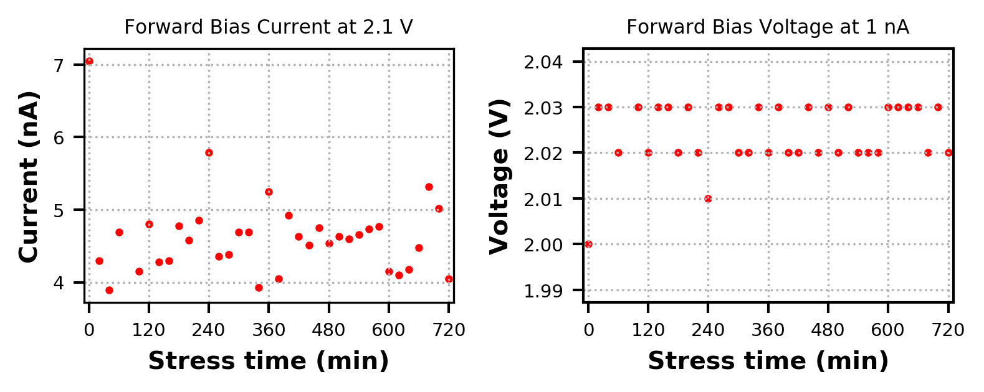
(a) (b)
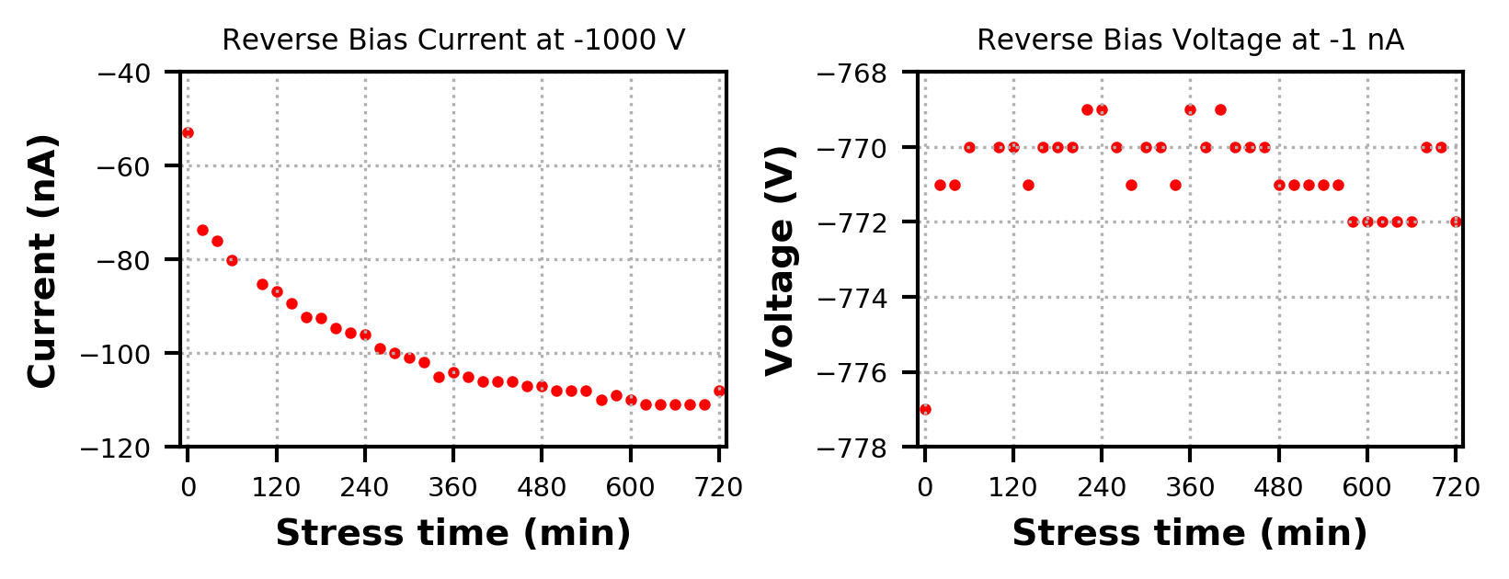
(c) (d)
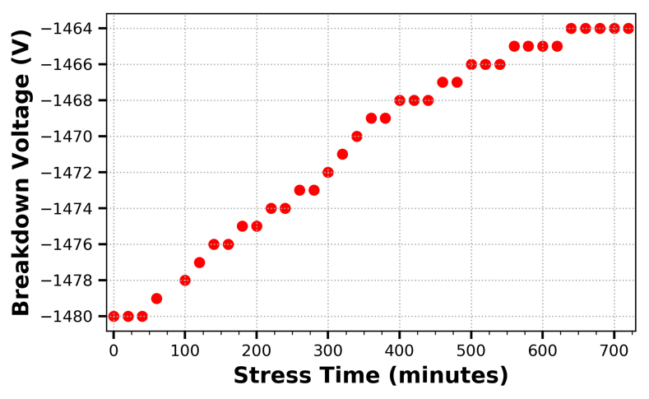
(e)
Figure S4. Forward bias (a) leakage current at 2.1 V and (b) voltage variability at 1 nA, reverse bias (c) leakage current at -1000 V and (d) voltage variability at-1 nA, and (e) breakdown voltage vs. stress time for the v-GaN stressed at 500 V.

750 V
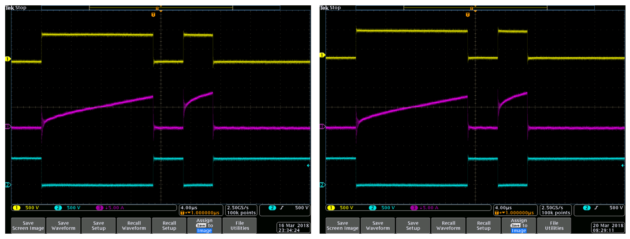
(a) (b)
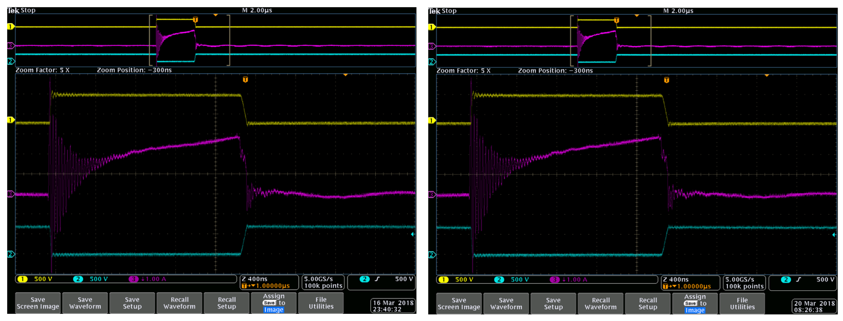
(c) (d)
Figure S5. 750 V stressed v-GaN PiN diode oscilloscope waveforms of diode voltage in yellow, diode current in magenta, and switch voltage in blue for the double-pulse traces (a) pre-stress and (b) post-stress, along with the stress pulse traces (c) pre-stress and (d) post-stress. The yellow trace is plotted on a scale of 500 V/div at an offset of +1500 V, the blue on a scale of 500 V/div at an offset of -2000 V, and the magenta parts (a, b) are on an inverted scale of 5 A/div at offset of -5A for parts while (c, d) are on an inverted scale of 1 A/div at offset of -1A.
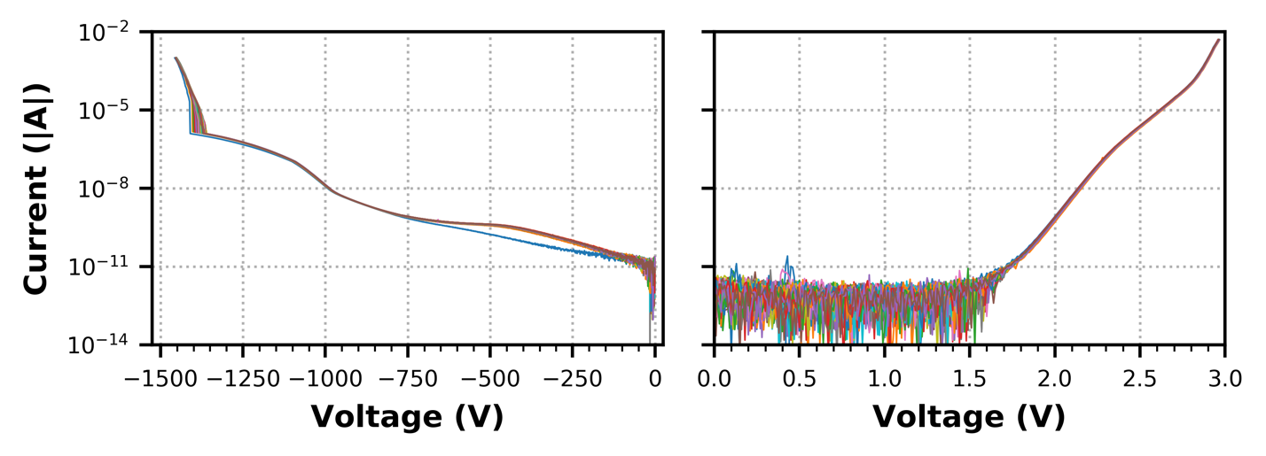
(a) (b)
Figure S6. Cumulative (a) reverse and (b) forward I-Vs over the full stress duration for the v-GaN stressed at 750 V.

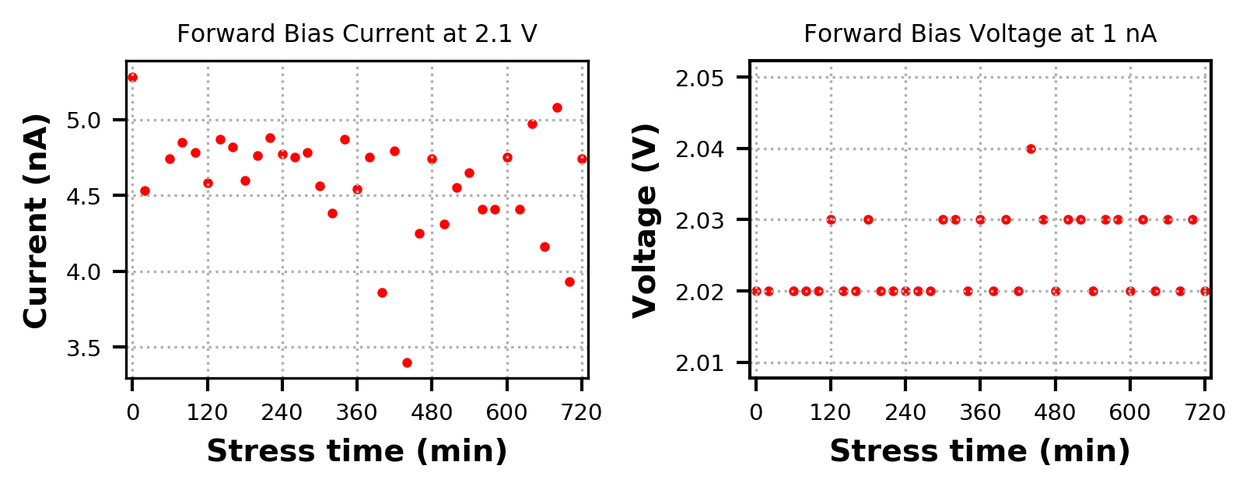
(a) (b)
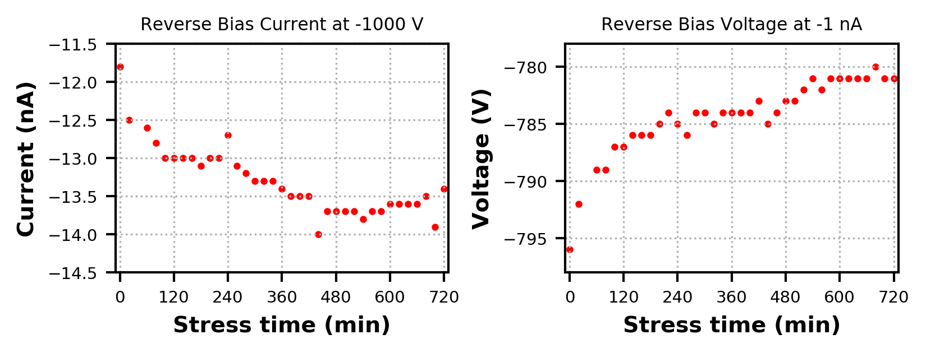
(c) (d)
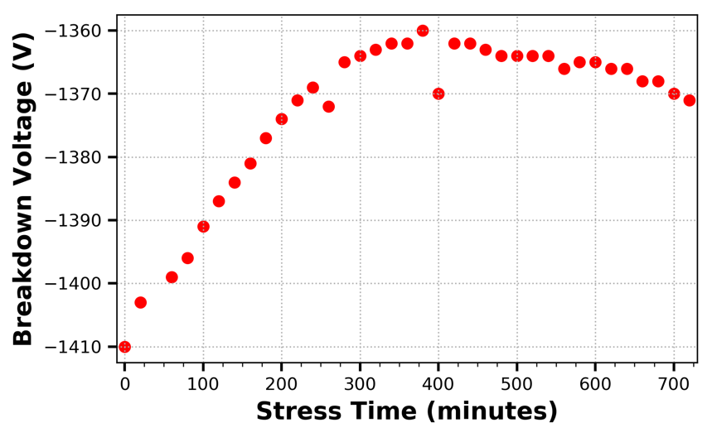
(e)
Figure S7. Forward bias (a) leakage current at 2.1 V and (b) voltage variation at 1 nA, reverse bias (c) leakage current at -1000 V and (d) voltage variation at-1 nA, and (e) breakdown voltage vs. stress time for the v-GaN stressed at 750 V.

1000 V
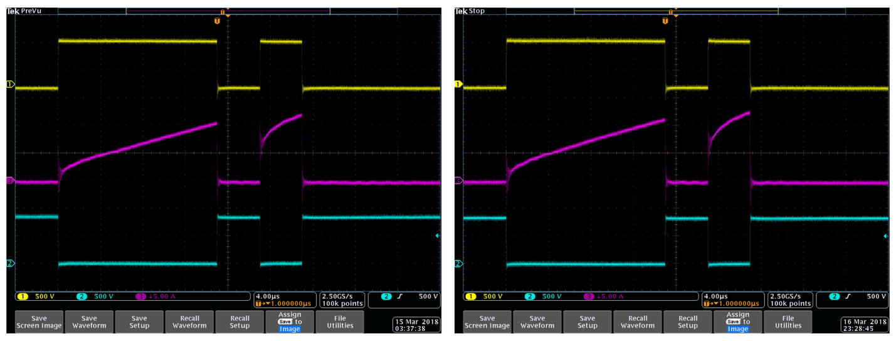
(a) (b)
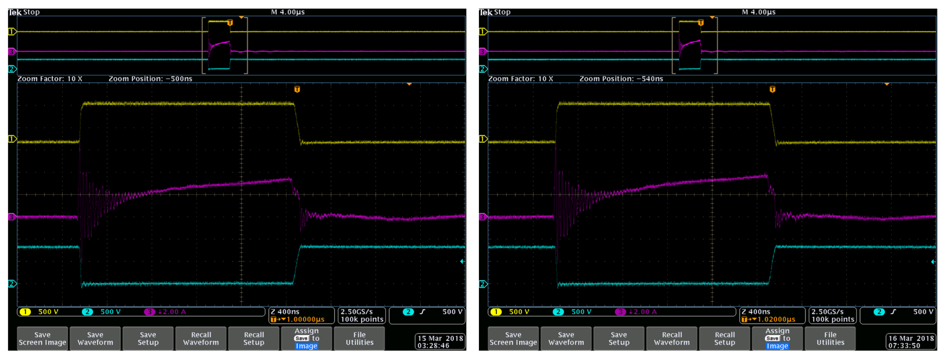
(c) (d)
Figure S8. 1000 V stressed v-GaN PiN diode oscilloscope captures of diode voltage in yellow, diode current in magenta, and switch voltage in blue for the double-pulse traces (a) pre-stress and (b) post- stress, along with stress pulse traces (c) pre-stress and (d) post- stress. The yellow trace is plotted on a scale of 500 V/div at an offset of +1500 V, the blue on a scale of 500 V/div at an offset of -2000 V, and the magenta parts (a, b) are on an inverted scale of 5 A/div at offset of -5A for parts while (c, d) are on an inverted scale of 2 A/div at offset of -2A.

