Supplementary Materials
Polydiacetylene ribbons formed using the controlled evaporative self-assembly (CESA) method
E. Van Keuren,^{1*} C. Pornrungroj,² C. Fu, ² X. Zhang, ¹ S. Okada, ³ H. Katsuyama,³ K. Kikuchi,³ T. Onodera, ² H. Oikawa²
¹ Department of Physics and Institute for Soft Matter Synthesis and Metrology, Georgetown University, Washington DC 20057, USA
² Institute of Multidisciplinary Research for Advanced Materials (IMRAM), Tohoku University, 2-1-1 Katahira, Aoba-ku, Sendai 980-8577, Japan
³ Graduate School of Organic Materials Science, Yamagata University, 3-16 Jonan, Yonezawa 982-8510, Japan
* Author for correspondence, email: erv@georgetown.edu

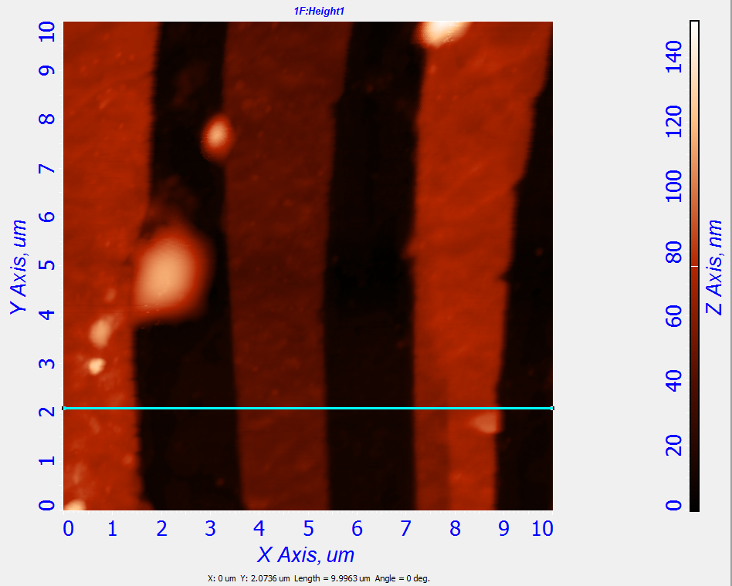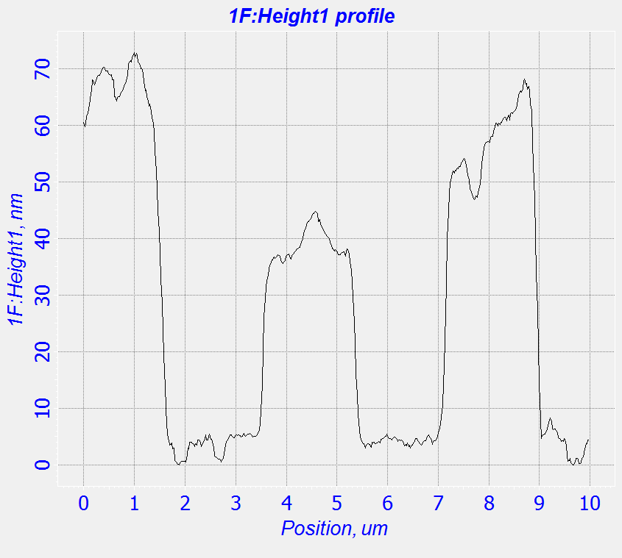
- (b)

Figure S1: (a) AFM 3d rendered image and (b) height profile of poly(DCHD) ribbons.

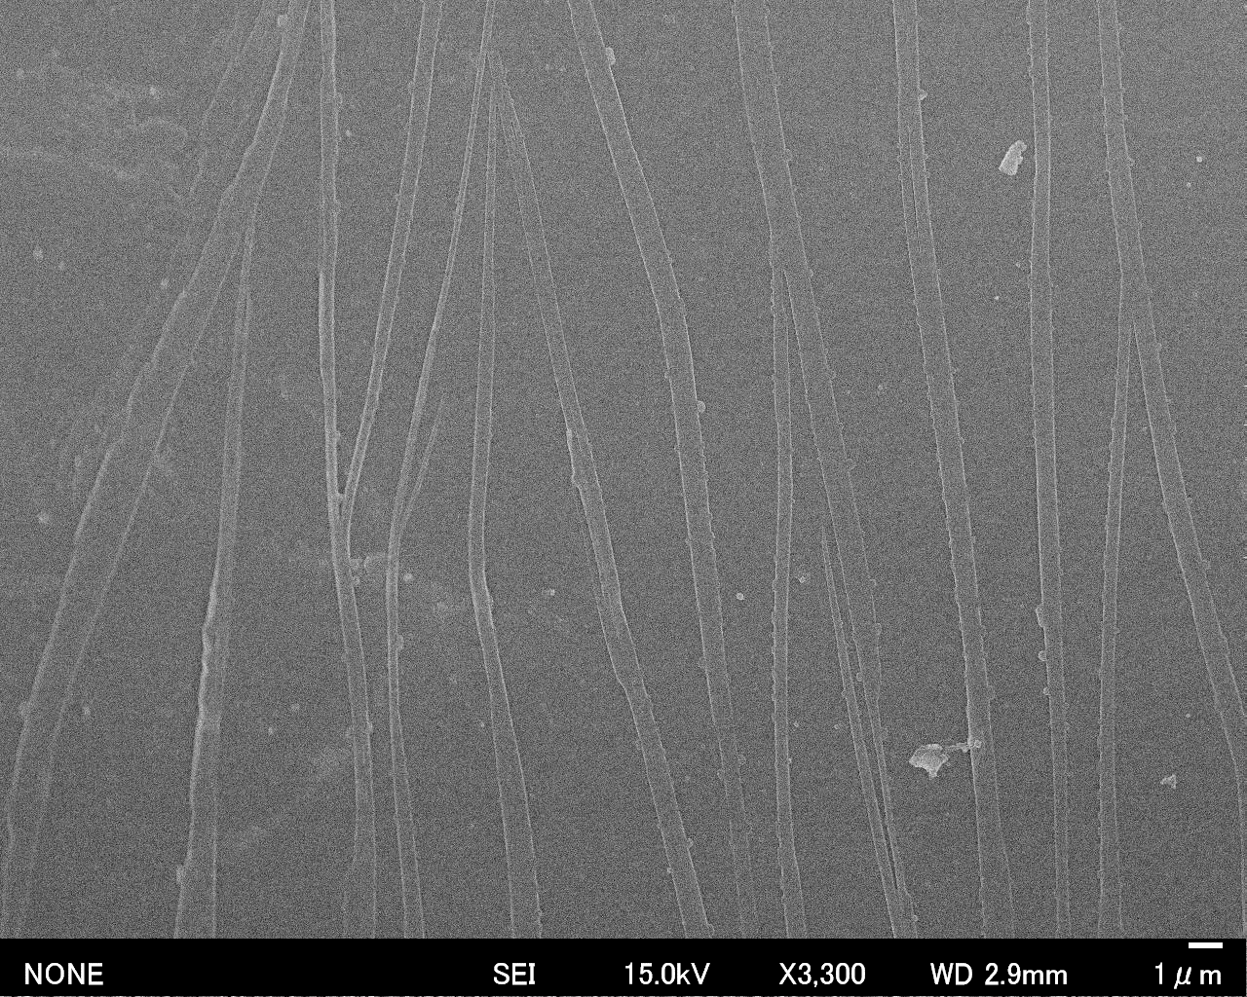
Figure S2: SEM image of poly(DCHD) ribbons (horizontal contact line, motion of contact line from bottom to top of image).

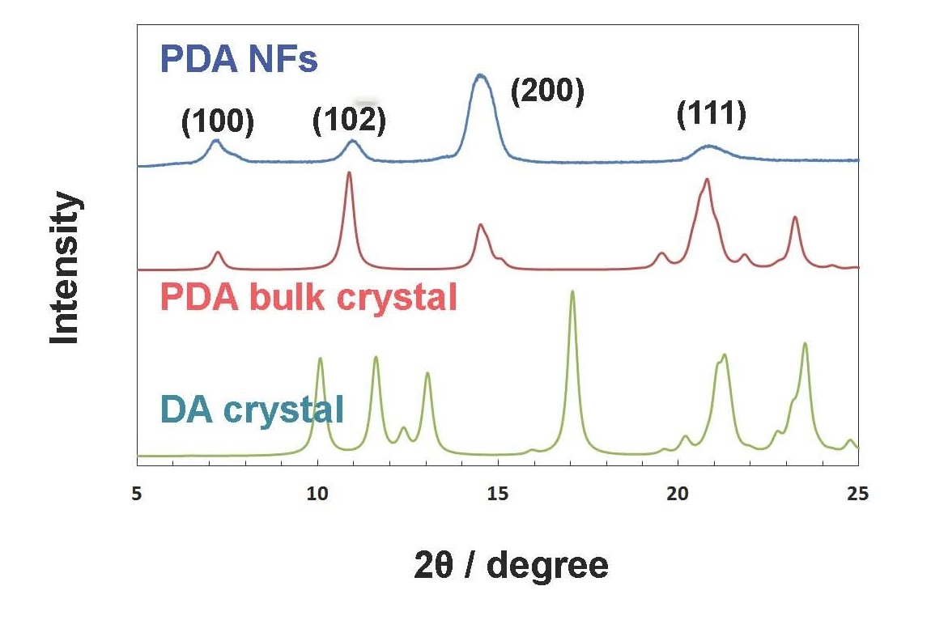

Figure S3: Powder X-ray diffraction patterns from polydiacetylene nanofibers (PDA NFs), polydiacetylene (PDA) bulk crystals and diacetylene (DA) crystals

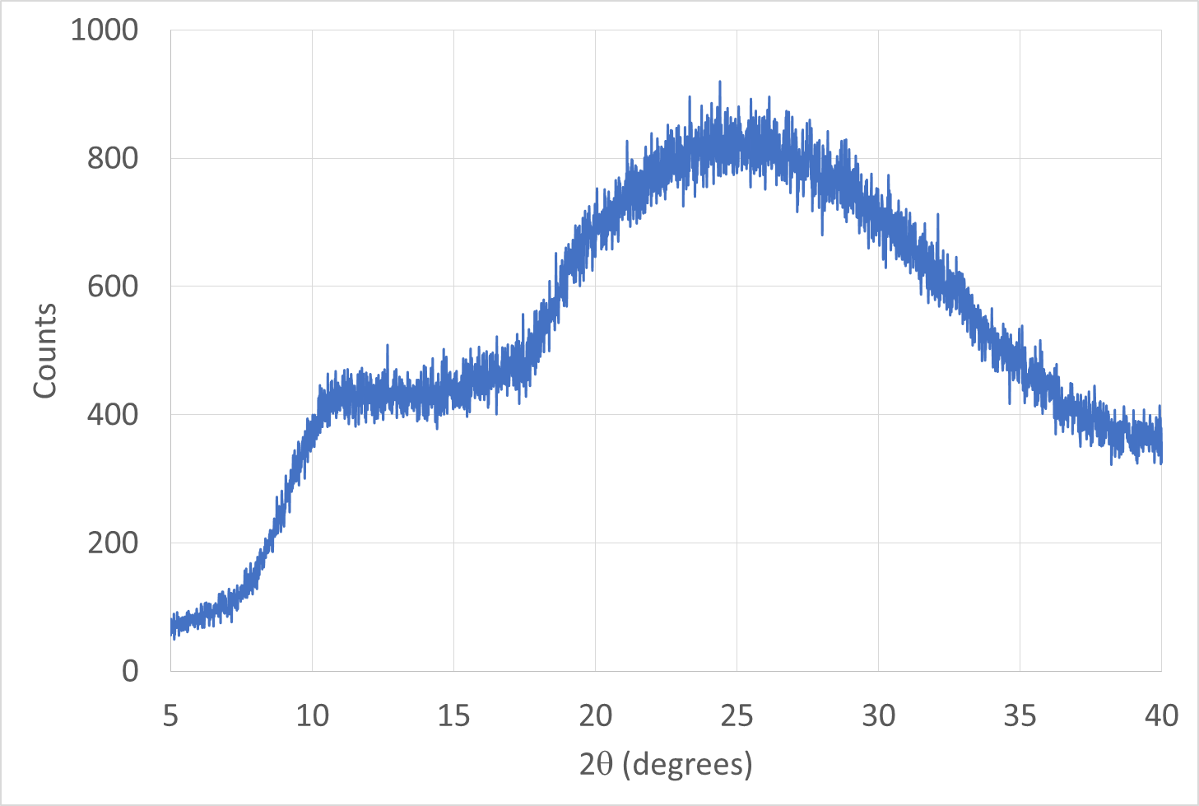
Figure S4: X-ray diffraction from the glass substrate.

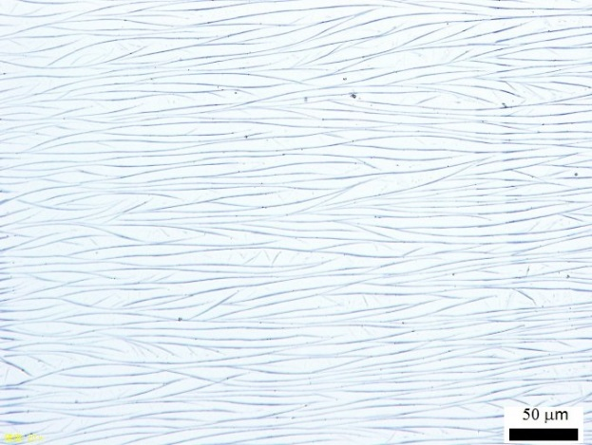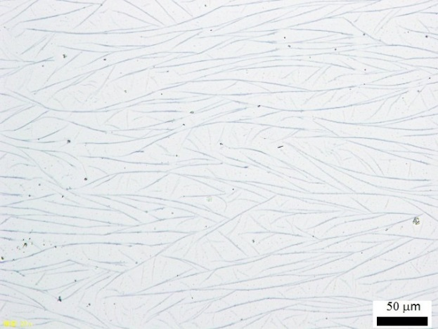
(a) (b)
Figure S5: Images of poly(DCHD) ribbons with initial concentration of 0.2 mM (a) and 0.05 mM (b). The motion of the contact line was from left to right.

