**Supplementary Information**

**Raman Investigation of the Air Stability of 2H Polytype HfSe2 Thin Films**

*Antonio Cruza, Zafer Mutlubξ, Mihrimah Ozkanc, Cengiz S. Ozkana,d\**

*a Materials Science and Engineering Program, University of California, Riverside, CA 92507, USA*

*b Department of Electrical Engineering and Computer Sciences, University of California, Berkeley, CA, 94720, USA*

*c Department of Electrical and Computer Engineering, University of California, Riverside, CA 92507, USA*

*d Department of Mechanical Engineering, University of California, Riverside, CA 92507, USA*

***\*Corresponding Author Email:***[*cozkan@engr.ucr.edu*](mailto:cozkan@engr.ucr.edu)

*ξ Work performed during postdoctoral studies at University of California, Riverside*

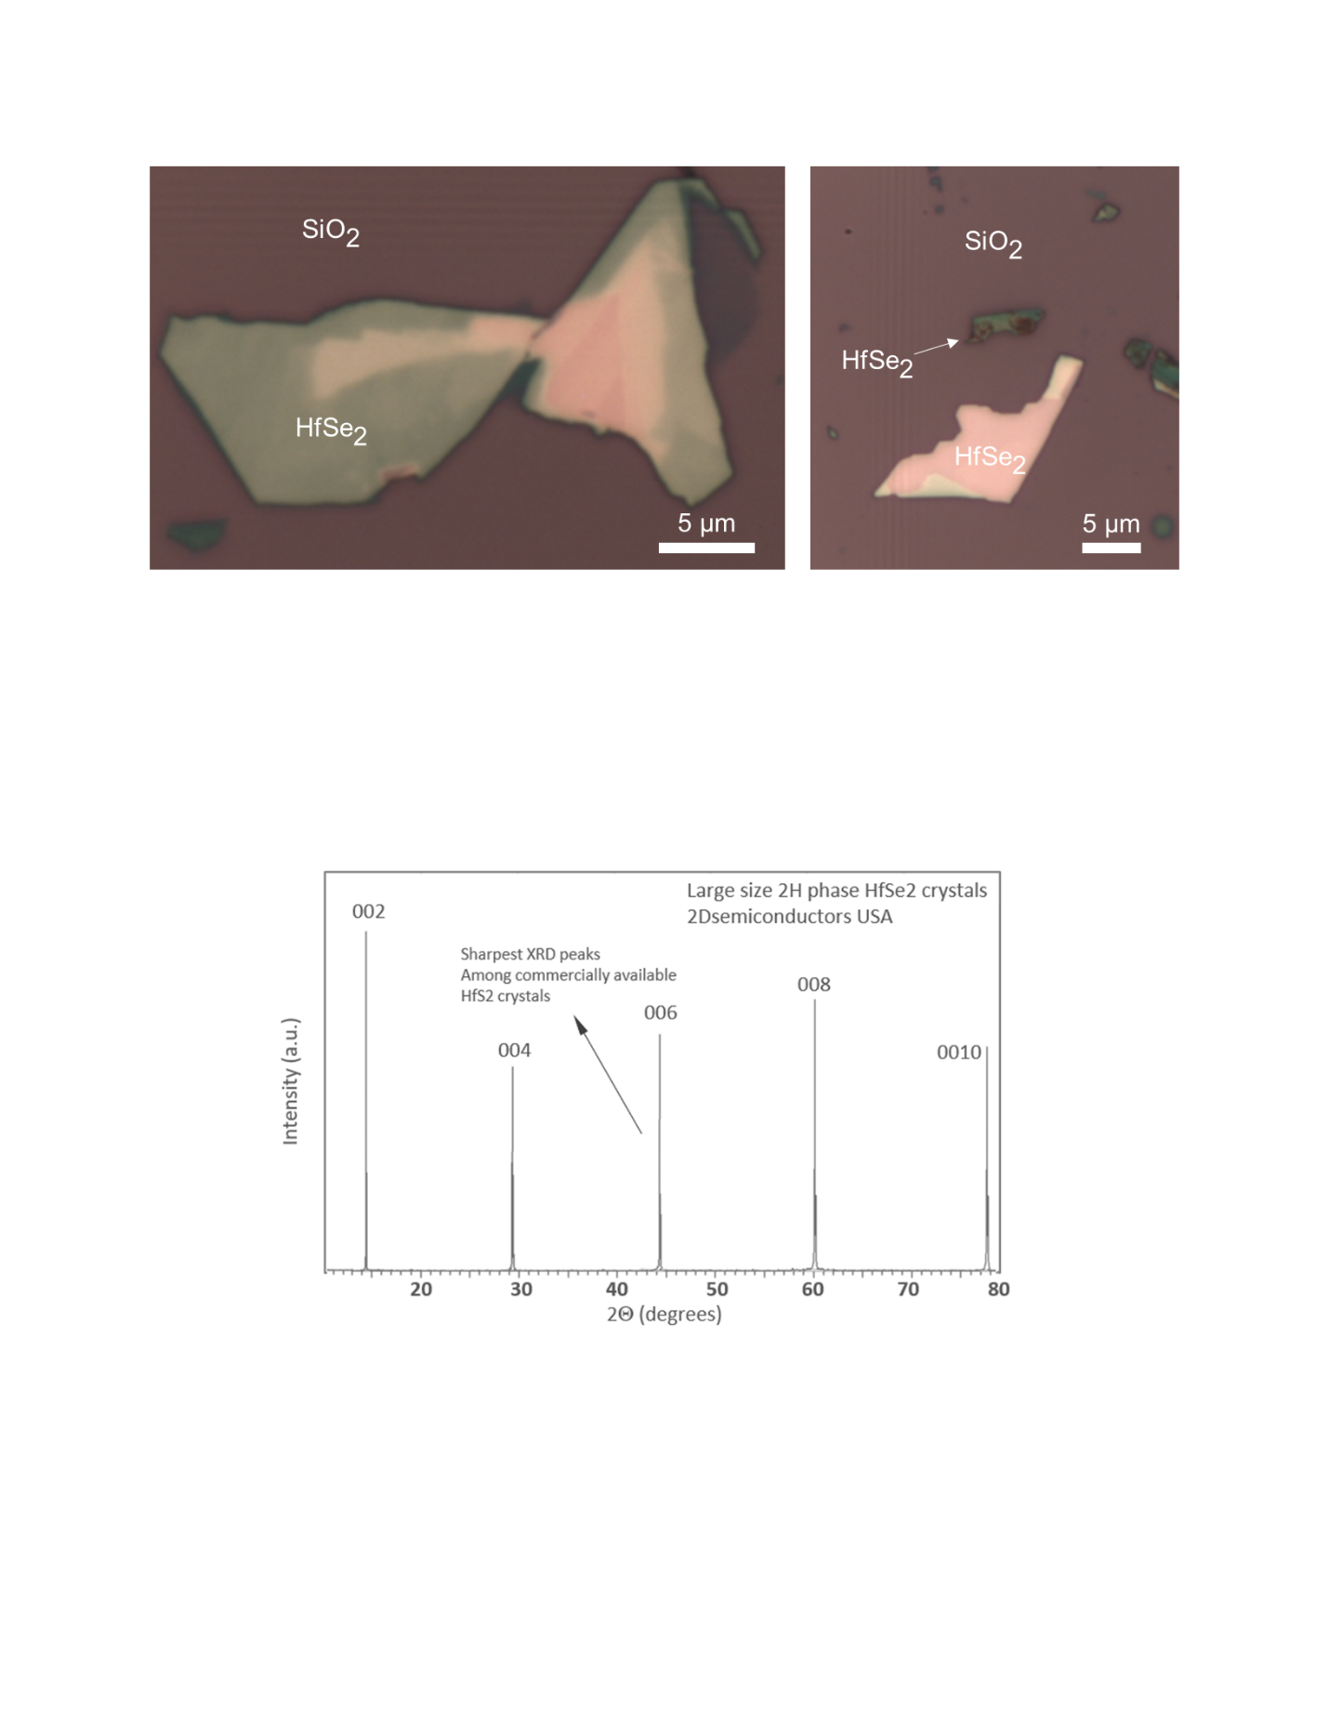

**FIG. S1. Optical microscopy images of $\text{Hf}{\text{Se}}_{\text{2}}$ flakes**. (a) Image of large $\text{Hf}{\text{Se}}_{\text{2}}$ flake showing the variations in contrast among the different thicknesses. (b) Smaller $\text{Hf}{\text{Se}}_{\text{2}}$, with nearby flakes burned by the Raman laser.

**(a)**

**(b)**

|  |  |  |  |  |  |
| --- | --- | --- | --- | --- | --- |
| **Table S1.** Height and roughness values for thick and thin regions labeled 1 and 2 in Figure 2. Analysis was carried out in Gwyddion. | | | | | |
|  | **Max height** | **Avg. height** | **Median height** | **Ra (Sa)** | **Rms (Sq)** |
| **Thick region** | 39.4664 | 2.99 | 2.1259 | 1.87437 | 4.32181 |
| **Thin region** | 19.0397 | 5.2942 | 4.7738 | 2.01067 | 2.7893 |
| All values in nm | | | | | |

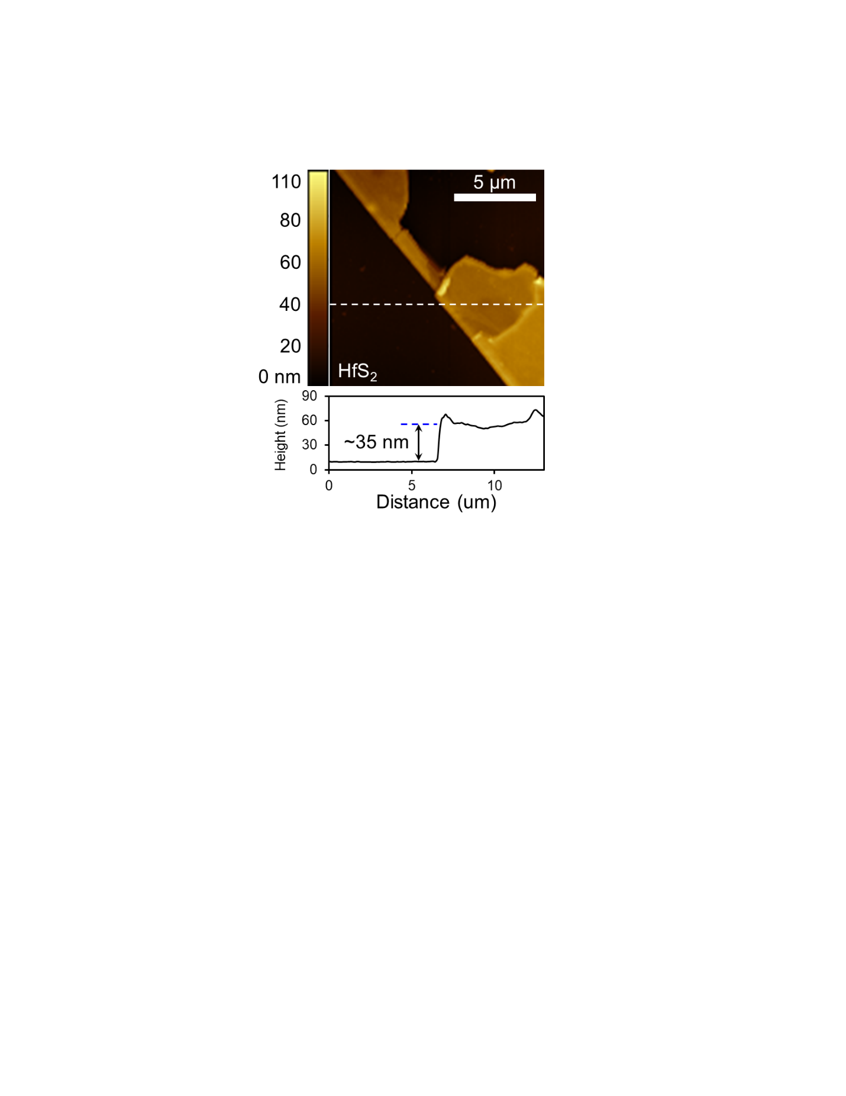

**FIG. S2. AFM image of $\text{Hf}{\text{S}}_{\text{2}}$** . AFM images of $\text{Hf}{\text{S}}_{\text{2}}$ flakes showed no changes to the flake surface after long-term air exposure, indicating a high stability in air compared to $\text{Hf}{\text{S}\text{e}}_{\text{2}}$.