# SUPPLEMENTARY MATERIAL

**The effects of fluid composition and shear conditions on bacterial adhesion to an antifouling peptide-coated surface**

**Alves Pa, Nir Sb, Reches Mb*, and Mergulhão Fa\***

aLEPABE – Department of Chemical Engineering, Faculty of Engineering, University of Porto, Rua Dr. Roberto Frias s/n 4200-465 Porto, Portugal

bInstitute of Chemistry and the Center for Nanoscience and Nanotechnology, The Hebrew University of Jerusalem, Safra Campus, Givat Ram, Jerusalem, 91904, Israel

**\***Corresponding authors:

Filipe J. M. Mergulhão, Chemical Engineering Department, Faculty of Engineering University of Porto, Rua Dr. Roberto Frias, 4200-465 Porto, Portugal. Phone: (+351) 225081668. Fax: (+351) 5081449. E-mail: [filipem@fe.up.pt](mailto:filipem@fe.up.pt)

Meital Reches, Institute of Chemistry and the Center for Nanoscience and Nanotechnology, The Hebrew University of Jerusalem, Safra Campus, Givat Ram, Jerusalem, 91904, Israel. Phone (+972)26584551, [meital.reches@mail.huji.ac.il](mailto:meital.reches@mail.huji.ac.il)

**Table S1.** Contact angles with water (*θw*), formamide (*θF*) and α-bromonaphthalene (*θB*); surface tension parameters (*LW, +* and *-*), hydrophobicity (***Δ****G*) and free energy of adhesion (***Δ****GAdh*) between *E. coli* and each surface. Measurements were made before (top two rows) or after 30 min immersion in the testing media as indicated.



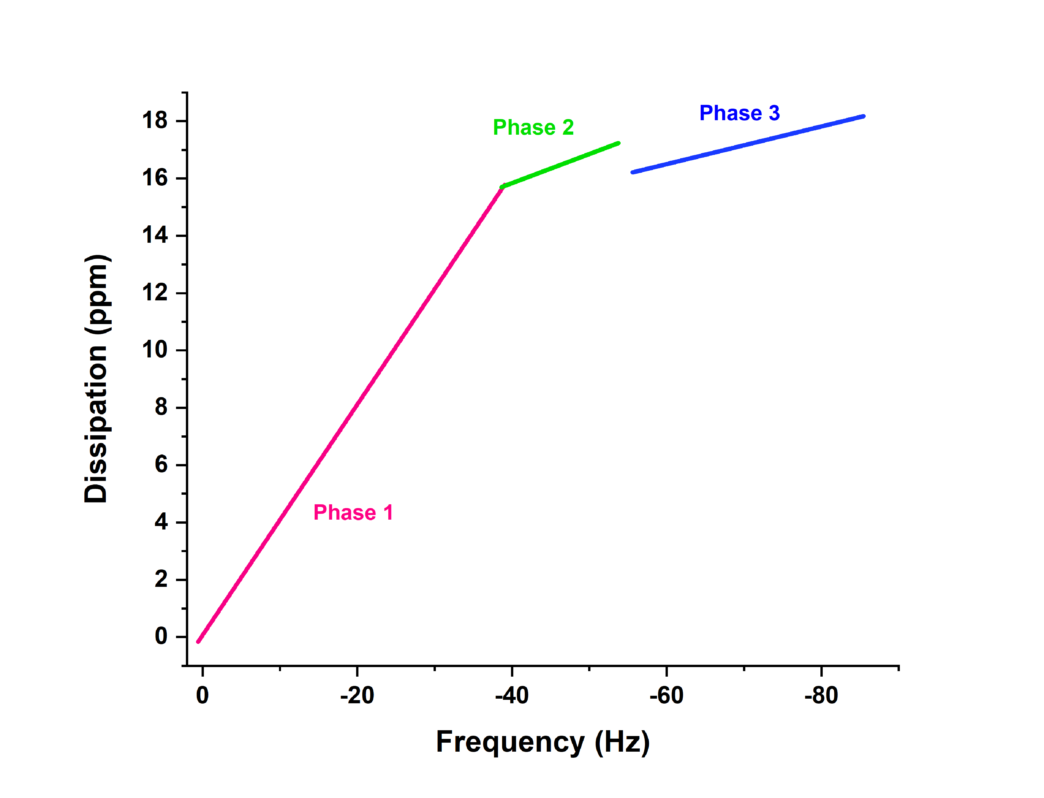

**FIG. S1.** Dissipation *vs*. frequency of the fifth overtone. The adsorption behavior of the peptide changed throughout the run, suggesting different mechanisms of adsorption.

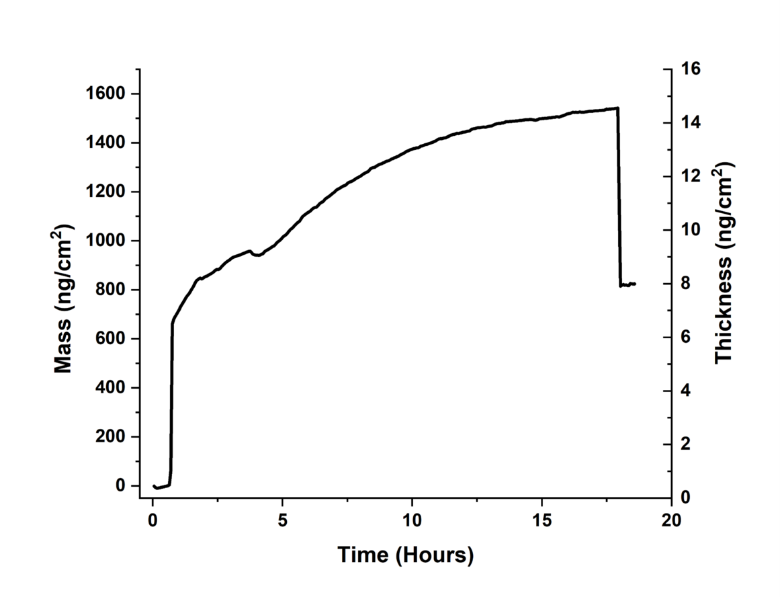

**FIG. S2.** Mass accumulation on the QCM-D sensor and layer thickness across time. After 17 h, the sensor was washed, the free peptide was removed and the total mass and layer thickness decreased.