Observation and characterization of memristive silver filaments in amorphous zinc tin oxide
Hiep N. Tran^{1,*}, Thomas J. Raeber², Zijun C. Zhao³, David R. McKenzie³, Anthony S. Holland¹, Dougal G. McCulloch², Billy J. Murdoch² and Jim G. Partridge²

¹ School of Engineering, RMIT University, GPO Box 2476V, Melbourne VIC 3001, Australia
² School of Science, RMIT University, GPO Box 2476V, Melbourne VIC 3001, Australia
³ School of Physics, The University of Sydney, NSW 2006, Sydney, Australia

*Corresponding author.
Email address: hiep.tranlengoc@rmit.edu.au

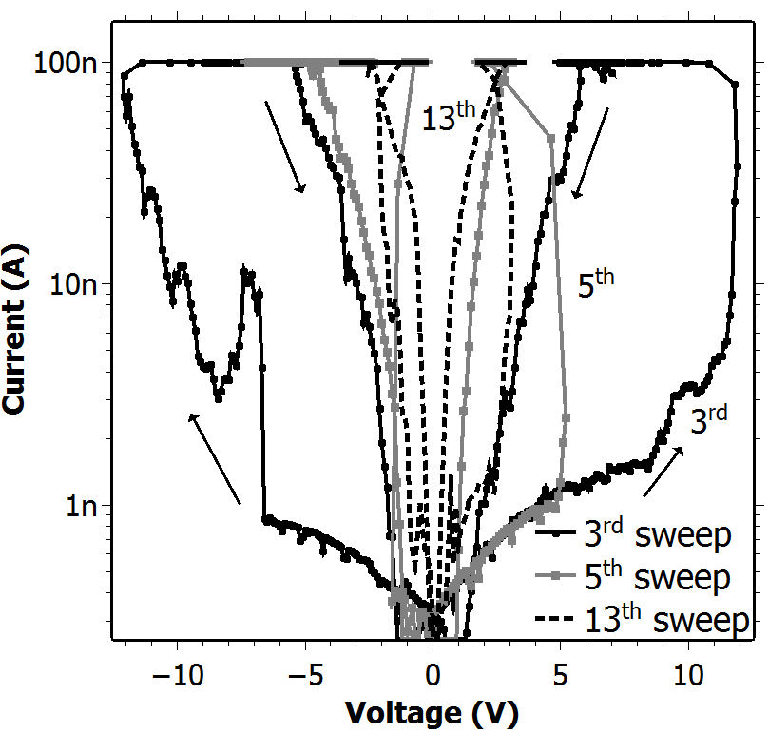
FIG. S1. I-V characteristic of the lateral memristor with 200 nm electrode separation. Reductions in threshold voltage and increased conductance in LRS occur with increased activity (sweep number). This behaviour was common to all devices tested and with electrode separations up to 700 nm (see FIG. 2 and FIG. 4)
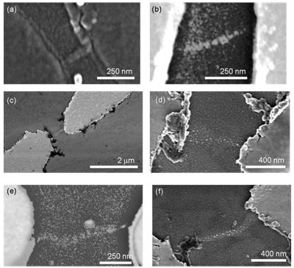
FIG. S2. Scanning electron microscope (SEM) images of embedded Ag nanoparticle filaments in laterally configured Ag/ZTO/Ag memristors with electrode separations of (a) 200 nm, (b-d) 300 nm and (e,f) 700 nm.

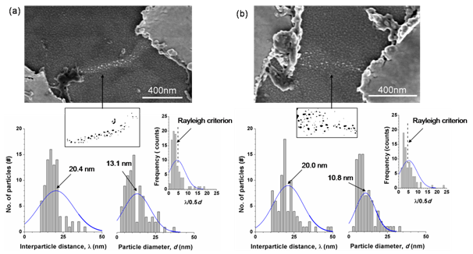
FIG. S3. Interparticle distance (λ) and particle diameter (d) distributions of embedded Ag nanoparticle filaments in laterally configured Ag/ZTO/Ag memristors with electrode separations of (a) 700 nm and (b) 300 nm. The ratio between λ and the particle radii (0.5 d) are also included. Nanoparticle identification was achieved using the software ImageJ. SEM images were inverted and then manually adjusted using a 1-bit threshold filter. The interparticle distance was analysed using the ImageJ plugin by Y. Mao (Next Nearest Neighbour Distances).

Nanoparticles formed by surface diffusion due to Rayleigh instability obey the following relationship (as determined by Nichols & Mullins ^{[1]}),

λ = 8.89L (1)
and
0.5d = 3.78L (2)
where L is the radius of the filament prior to nanoparticle formation. Therefore, if nanoparticles are formed due to Rayleigh instability, λ /0.5d = 4.7. Plots of λ /0.5d in the inset of FIG. S3 (a & b) show that the Rayleigh criterion is satisfied irrespective of electrode spacing.

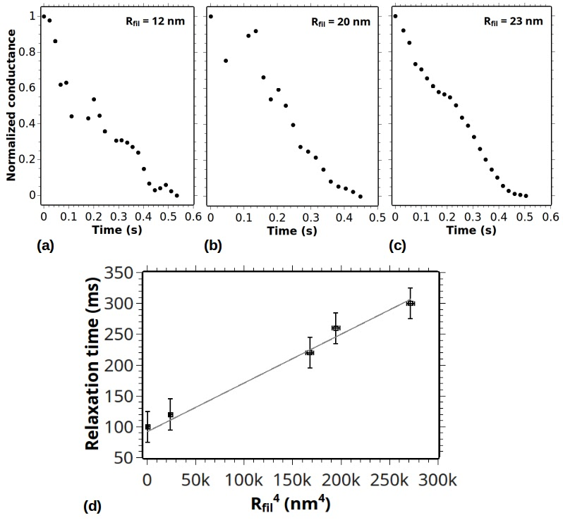

FIG. S4. Typical relaxation characteristics following LRS of memristors with filaments of radius (R_{fil}) (a) 12, (b) 20 and (c) 23 nm, (d) shows that this data follows the relationship often observed in nanoscale filaments subject to Rayleigh instability (see main text). Error bars incorporate variance between repeated measurements and measurement uncertainty.
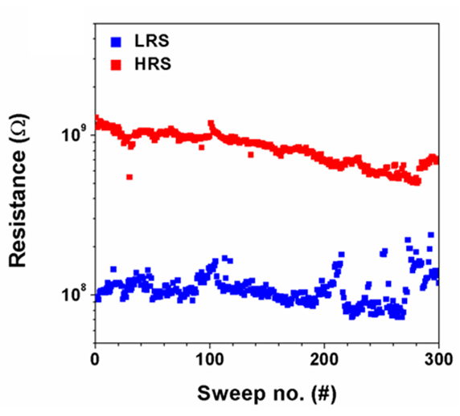
FIG. S5. Resistive switching endurance of a volatile, filamentary Ag/a-ZTO lateral memristor. These characteristics were measured in air at room temperature.

References
1. F. Nichols: Surface-(Interface-) and Volume-Diffusion Contributions to Morphological Changes Driven by Capillarity. Trans. AIME 233, 1840 (1965).

