Supplementary Information

Low-temperature electrical conduction of plasma-treated bilayer MoS₂

Jakub Jadwiszczak^{1,2,3,4}, Yangbo Zhou⁴, Hongzhou Zhang^{1,2,3, ǂ}

¹School of Physics, Trinity College Dublin, Dublin 2, Ireland.
²Centre for Research on Adaptive Nanostructures and Nanodevices (CRANN), Trinity College Dublin, Dublin 2, Ireland.
³Advanced Materials and BioEngineering Research Centre (AMBER), Trinity College Dublin, Dublin 2, Ireland.
⁴School of Material Science and Engineering, Nanchang University, 999 Xuefu Road, Nanchang, Jiangxi, China, 330031.
^{ǂ} Correspondence to: hozhang@tcd.ie

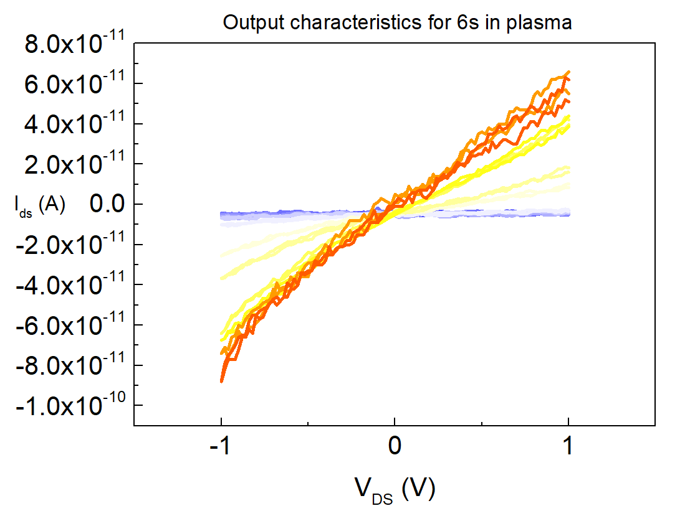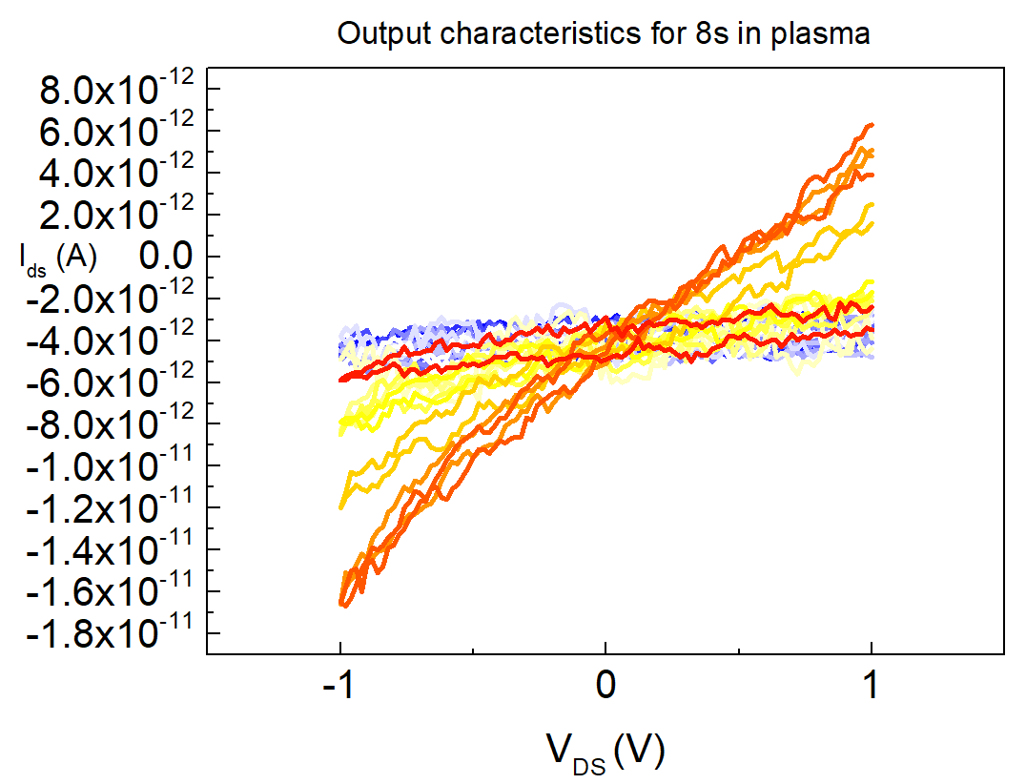

Figure S1. IV curves of same device as in Figs. 1(b)-(c) of the main manuscript after 6 sec and 8 sec of plasma treatment. Measurement temperatures are color-mapped from red (293 K) to blue (83 K). There was no applied gate bias for these measurements. The drop in the conductance is evident from the low magnitude of the output current in both cases.

