MOF-Modified Nitrogen-Doped Graphene ORR Catalyst Synthesized By Nanoscale High Energy Wet Ball Milling-Structural and Electrochemical Characterization

Shiqiang Zhuang¹, Bharath Babu Nunna¹,
Eon Soo Lee^{1*}, eonsoo.lee@njit.edu

¹ Department of Mechanical and Industrial Engineering, New Jersey Institute of Technology, Newark, New Jersey 07102, USA

Supplementary Information
Chemical Characterization
The electrochemical performance of a catalyst is not only related to the physical properties but also chemical properties, especially the chemical structure of active sites. The active sites in N-G catalysts consist of four special nitrogen functional groups include pyrrolic N, pyridinic N, graphitic N, and pyridine N-oxide [8]. Therefore, the nitrogen bonding composition of the N-G catalyst can influence the ORR catalytic activity. The influences of adding ZIF-8 on the chemical properties of N-G catalysts were studied through the chemical characterization by using X-ray photoelectron spectroscopy (XPS). The nitrogen bonding compositions of N-G/MOF precursor, N-G/MOF-200, and N-G/MOF-350 are shown in FIG. S1, FIG. S2, and FIG. S3. The N-G/MOF precursor was prepared by physically mixing 35 g BM-N-G-16-500 powders and 35 g ZIF-8 powders in deionized water. It is observed in FIG. S1 and S2 that the N1s spectra of the N-G/MOF precursor is similar to N-G/MOF-200. It indicated that there was no significant change in the chemical structure of N active sites in N-G/MOF after NHEW ball milling treatment with 200 RPM in 16 hours. The peak at 398.70 eV indicates the nitrogen on imidazole moieties in ZIF-8 and pyridinic N (398.60 eV) in BM-N-G-16-500 [8, 18]. The peaks at 400.30 eV and 396.64 eV indicate –NH₂ group and particular nitrogen group in ZIF-8 [19]. The peak at 401.85 eV indicates the graphitic N in BM-N-G-16-500 [8]. The nitrogen bonding composition of N-G/MOF-350 in FIG. S3 has significant differences compared to N-G/MOF precursor and N-G/MOF-200. It is observed that the particular nitrogen group (396.64) in ZIF-8 was totally decomposed at 300 RPM NHEW ball milling condition. The imidazole moieties in ZIF-8 were decomposed and formed a new C-N nitrogen group at 399.31 eV. The peak at 400.30 eV shifted to 400.71 eV, which indicated that the -NH₂ group in N-G/MOF precursor was changed to pyrrolic N group. The decomposition of ZIF-8 led to significant changes in the concentration percentage of pyridinic N (398.60 eV), pyrrolic N (400.71 eV), graphitic N (401.49 eV) and pyridine N-oxide (403.78 eV) in N-G/MOF-350. The nitrogen active sites in N-G/MOF-350 consist of 47.17% pyridinic N, 24.39% pyrrolic N, 2.76% graphitic N and 1.28% pyridine N-oxide. Therefore, the nitrogen groups in ZIF-8 could be decomposed at 350 RPM NHEW ball milling condition, and transferred to special nitrogen groups in nitrogen active sites. The chemical structure of nitrogen active sites in N-G/MOF-350 led to a better current density than N-G/MOF-200.

Calculation of electron transfer number
The electron transfer number of each sample was calculated by Koutecky-Levich (K-L) equation from J-V curves of each sample tested at different rotation speeds of the working electrode [Justus Masa, Christopher Batchelor-McAuley, Wolfgang Schuhmann, and Richard G. Compton, Nano Research 2014, 7(1): 71–78]. The K-L equation is written as
$\frac{1}{J}=\frac{1}{J_{L}}+\frac{1}{J_{K}}=\frac{1}{Bω^{1/2}}+\frac{1}{J_{K}}$ (1)
with
$J_{K}=nFkC_{0}$ (2)
$B=0.62nFC_{0}(D_{0})^{2/3}υ^{1/6}$ (3)
where J is measured current density which is equal to I/A; A is the area of working electrode (A = 0.12566 cm²); J_{L} is the Levich current density (A/cm²); J_{K} is kinetics current density (A/cm²); n is the number of electrons transferred in the reaction of one O₂ molecule; F is the Faraday constant (F = 96485 C/mol); D₀ is the diffusion coefficient of O₂ (D₀ = 1.9*10⁻⁵ cm²/s); ω is the angular rotation rate of the working electrode (rad/s);υis the kinematic viscosity for 0.5 M KOH (υ= 0.01cm²/s); and C₀ is the concentration of O₂ in the solution (C₀ = 1.2 * 10-6 mol/cm³) [Shuangyin Wang, Lipeng Zhang, Zhenha Xia, Ajit Roy, Dong Wook Chang, Jong-Beom Baek, and Liming Dai, BCN Graphene as Efficient Metal-Free Electrocatalyst for the Oxygen Reduction Reaction, DOI: 10.1002/anie.201109257]. The constant 0.62 is adopted when the unit of rotation speed is rad/s.

Figures
FIG. S1. Nitrogen bonding composition of N-G/MOF precursor.
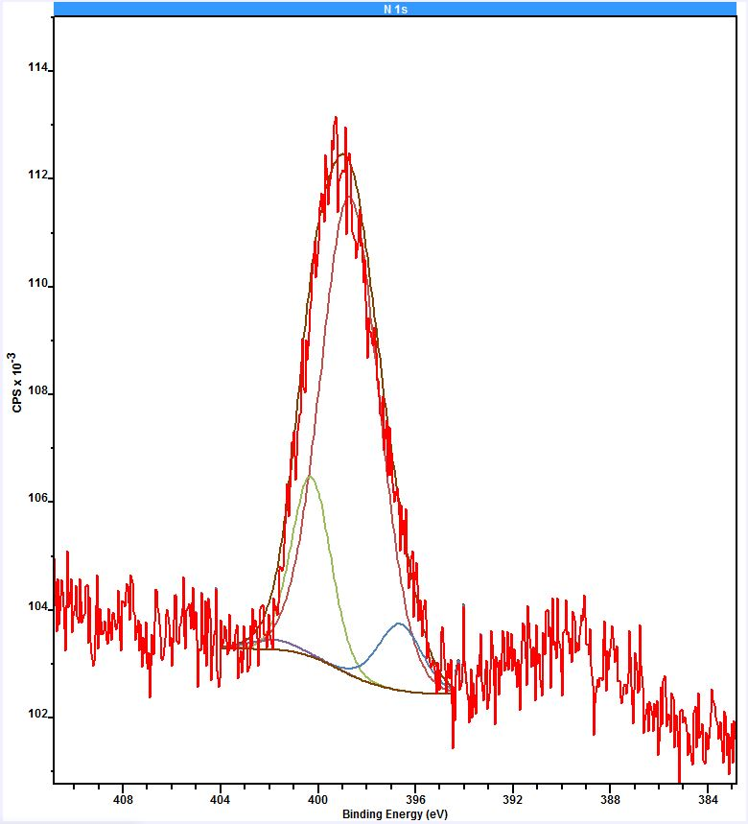
401.85 eV (1.23%)
400.30 eV (18.44%)
396.64
(7.64%)
398.70 eV (72.69%)
FIG. S2. Nitrogen bonding composition of N-G/MOF-200.
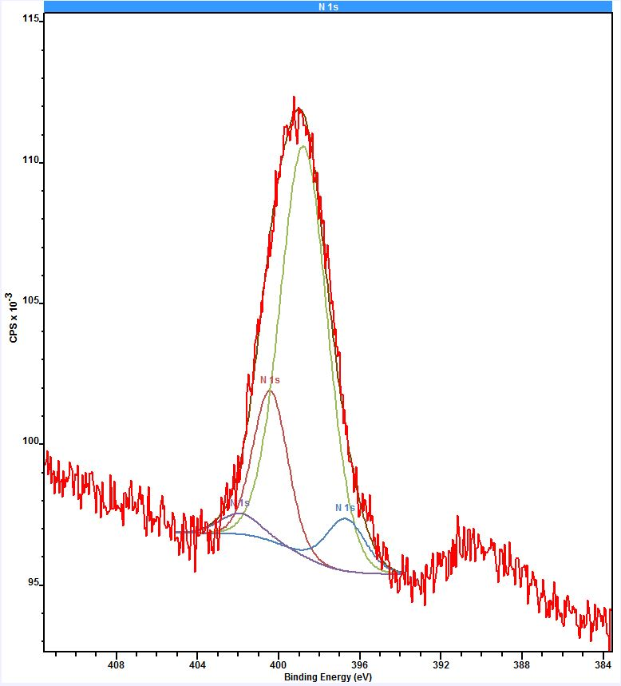
401.91 eV (3.08%)
400.42 eV (18.92%)
398.77 eV (70.45%)
396.70
(7.55%)

FIG. S3. Nitrogen bonding composition of N-G/MOF-350.
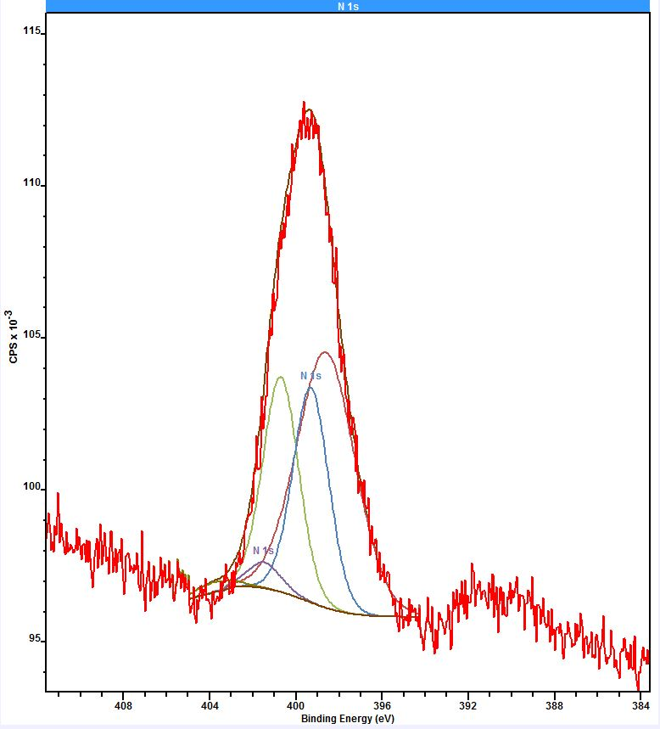
403.78 eV (1.28%)
401.49 eV (2.76%)
400.71 eV (24.39%)
399.31 eV (24.41%)
398.60 eV (47.17%)

FIG. S4. Electron transfer number of N-G catalyst samples and the 10 wt% Pt/C catalyst. Reproduced with permission from Ref. [S. Zhuang, E.S. Lee, L. Lei, B.B. Nunna, L. Kuang and W. Zhang: Synthesis of nitrogen-doped graphene catalyst by high-energy wet ball milling for electrochemical systems. International Journal of Energy Research, 40, 2136 (2016)], [International Journal of Energy Research], [2016].

FIG. S5. The structure of Zeolitic imidazolate framework-8 (ZIF-8), which is one example of MOFs. Reproduced with permission from Ref. [M. Gualino, N. Roques, S. Brandès, L. Arurault and J.-P. Sutter: From ZIF-8@Al2O3Composites to Self-Supported ZIF-8 One-Dimensional Superstructures. Crystal Growth & Design, 15, 3552 (2015)], [Crystal Growth & Design], [2015].
