Supplementary Material

*N*-Phenyl Naphthalene Diimide Pendant Polymer as a Charge Storage Material with High Rate Capability and Cyclability

Subashani Maniam,1* Kouki Oka2 and Hiroyuki Nishide2*

1School of Chemistry, Monash University, Wellington Road, Clayton, Victoria 3800, Australia.

E-mail: subashani.maniam@monash.edu

2 Department of Applied Chemistry, Waseda University, Tokyo 169-8555, Japan.

E-mail: nishide@waseda.jp

Table of Contents

1. Methods and Materials
2. NMR spectra
3. Cyclic Voltammetry and Amperometry
4. FE-SEM

**1. Methods and Materials**

1,4,5,8-Naphthalenetetracarboxylic dianhydride, aniline and 4-nitroaniline were obtained from Sigma-Aldrich and were used as received. Acetone, acetic acid, ethanol, dichloromethane (DCM) and dimethylformamide (DMF) were purchased from commercial suppliers. Vapor-grown carbon nanofiber (VGCF) and the binder, poly(vinylidene difluoride) (PVdF) resin were purchased from Showa Denko Co. and Kureha Chemical Co., respectively.

Analytical thin layer chromatography was performed on aluminium plates coated with silica gel (Silica 60 F254).

Column chromatographywas conducted using Merck silica gel 60, with a pore size between 0.063 and 0.200 mm. The eluent conditions are expressed as volume-to-volume *(v/v)* ratios.

High-resolution electron impact mass spectrometry(HR-ESI) was performed on an Agilent Technologies 6220 Accurate-Mass Time-of-Flight LC/MS as the solutions specified. [M]+ denotes the molecular ion. Analyses were performed in positive ion mode (EI+) unless otherwise stated.

1H and 13C nuclear magnetic resonance(NMR) spectra were recorded using a Bruker DRX 400 MHz NMR spectrometer (400 MHz for 1H NMR, 100 MHz for 13C NMR) and a Bruker AV 600 MHz NMR spectrometer (600 MHz for 1H NMR, 150 MHz for 13C NMR). Chemical shifts are reported relative to the resonances of residual CHCl3 at δ = 7.26 (H) and δ = 77.2 (C). For 1H NMR spectra each resonance was assigned according to the following convention: chemical shift (δ) measured in parts per million (ppm), multiplicity, coupling constant, (*J* Hz), number of protons and assignment. Multiplicities are denoted as (s) singlet, (d) doublet, (t) triplet, (q) quartet, (p) pentet, or (m) multiplet and prefixed (br) broad where appropriate. The 13C NMR spectra were recorded using proton decoupled pulse sequence unless stated otherwise. For 13C NMR each resonance was assigned according to the following convention: chemical shift (δ) measured in parts per million (ppm) and assignment (where known).

Absorbance spectra were run on a Varian model Cary 60 UV-visible spectrophotometer using solid state samples.

Molecular weight of **5** was determined by GPC with a TOSOH high performance GPC system equipped with UV-8320 TSK GEL and DMF was used as the solvent. Polystyrene standards, TSK standard polystyrene purchased from TOSOH, were used to obtain calibration curves for the GPC analysis.

Thermal analysis of the polymers were performed using a Mettler Toledo TGA/DSC thermogravimetric and StarE software over a temperature range of 30–500 oC (heating rate: 10 oC/min−1) in N2 (flow rate: 20 mL/min−1).

The FE-SEM observation of the mixture casted on a slide glass was performed by S-4500 (HITACHI). The sample was shielded with Pt–Pd.

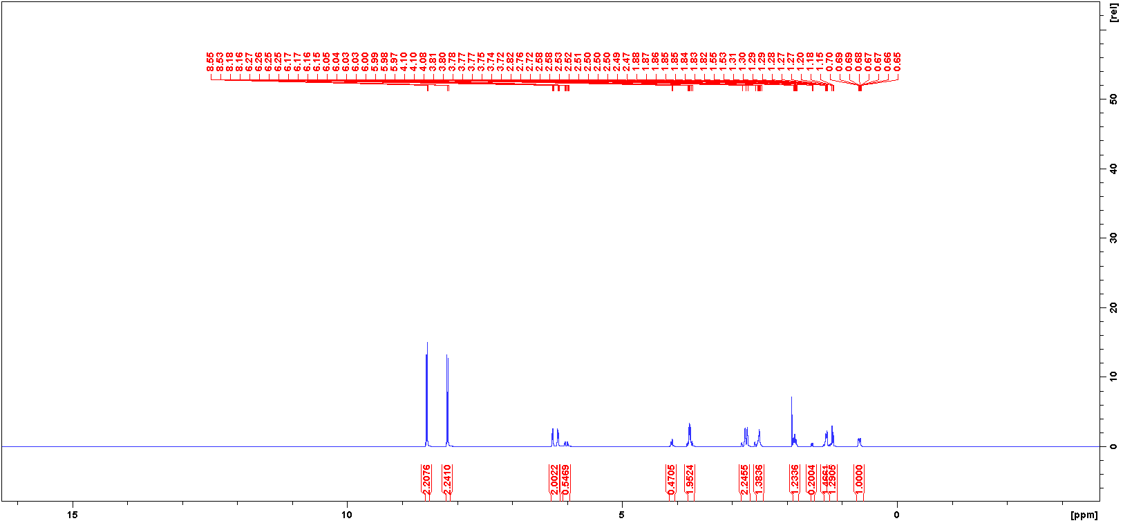**2. NMR Spectra**

**FIG. S1** 400 MHz 1H NMR (300 K, DMSO-*d*6) spectrum of compound ***2****.*

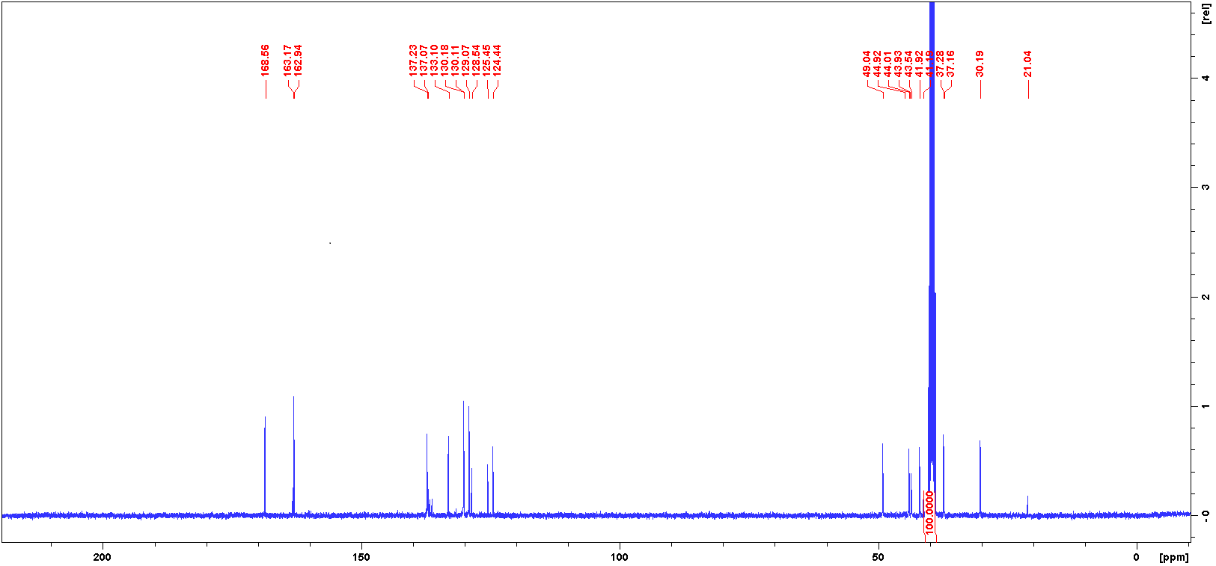

**FIG. S2** 100 MHz 13C NMR (300 K, DMSO-*d*6) spectrum of compound ***2***.

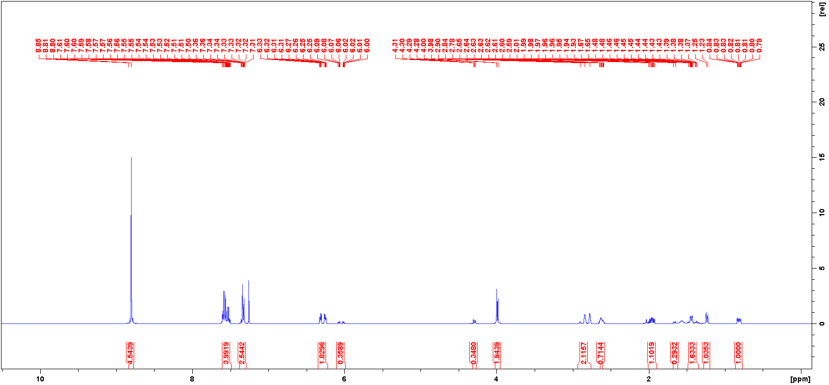

**FIG. S3** 400 MHz 1H NMR (300 K, CDCl3) spectrum of compound ***3****.*

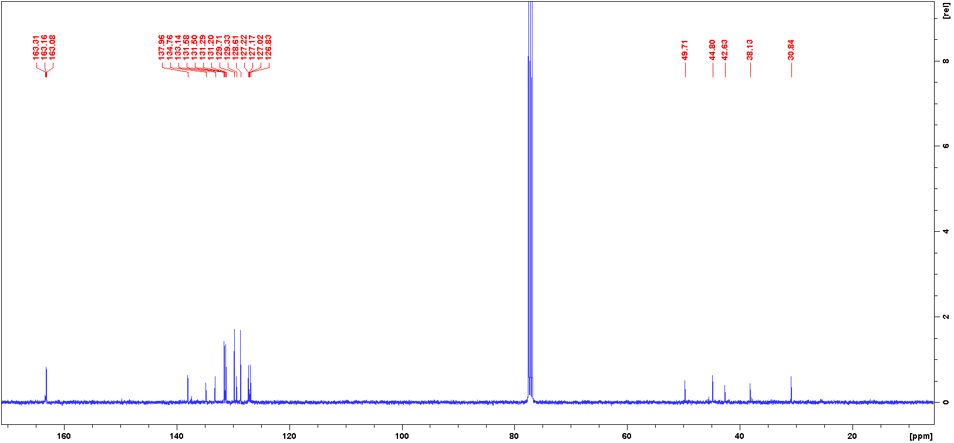

**FIG. S4** 100 MHz 13C NMR (300 K, CDCl3) spectrum of compound ***3***.

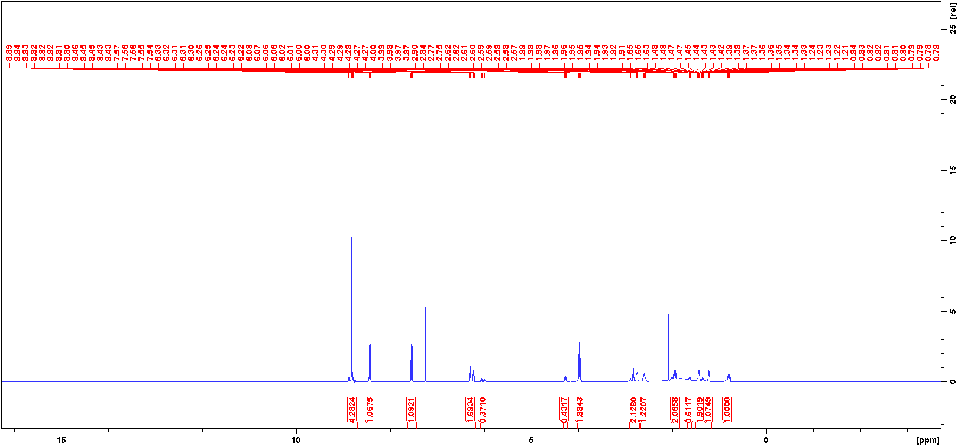

**FIG. S5** 400 MHz 1H NMR (300 K, CDCl3) spectrum of compound ***4****.*

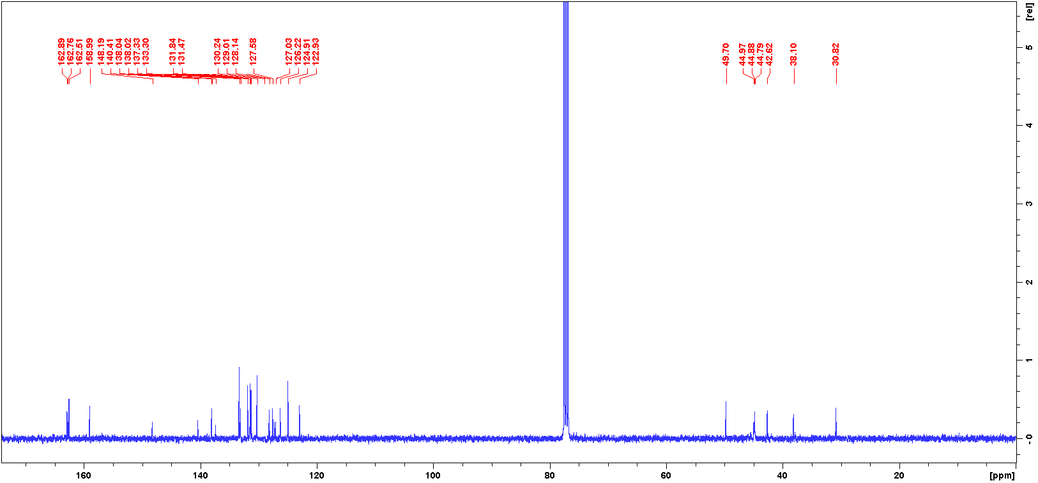

**FIG. S6** 100 MHz 13C NMR (300 K, CDCl3) spectrum of compound ***4***.

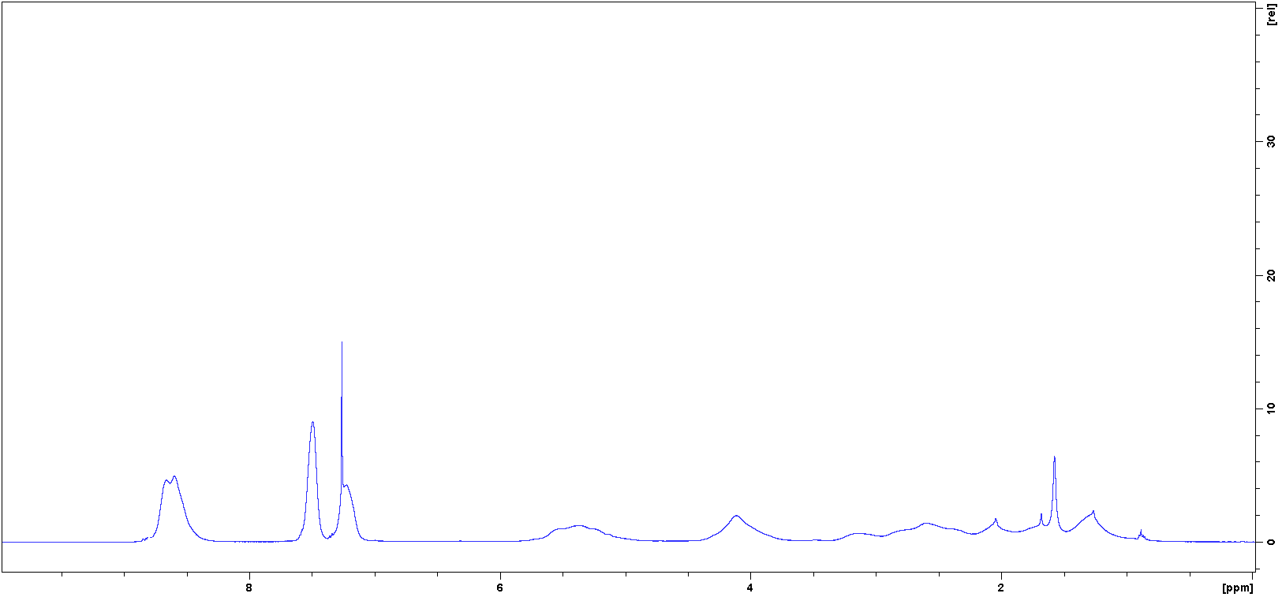

**FIG. S7** 400 MHz 1H NMR (300 K, CDCl3) spectrum of compound ***5****.*

**3. Cyclic Voltammograms**

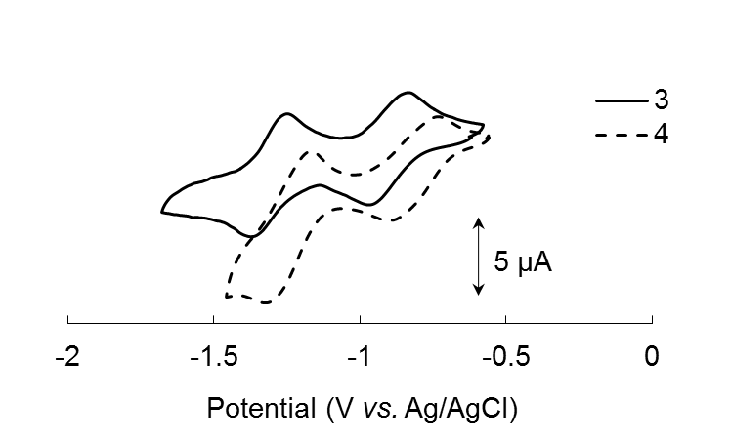

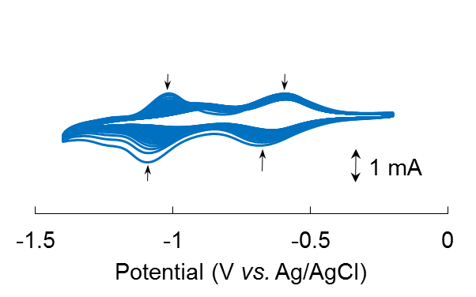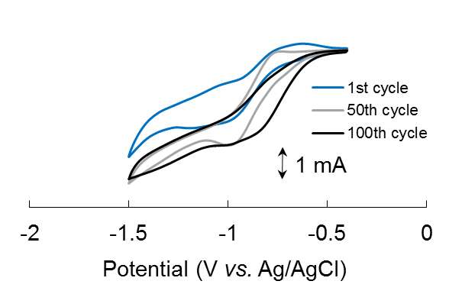**FIG. S8** Cyclic voltammograms of 1 mM monomers (c) **3** and (d) **4** in 0.1 M TEAP/acetonitrile at a scan rate of 10 mV/s.

(a)

(b)

**FIG. S9** Cyclic voltammograms of polymer **6** in (a) 0.1 M and (b) 1 M TBAP/acetonitrile at a scan rate of 10 mV/s.

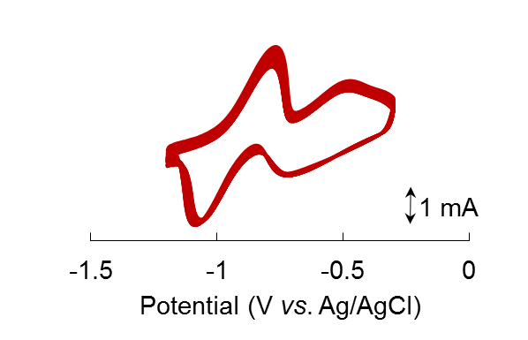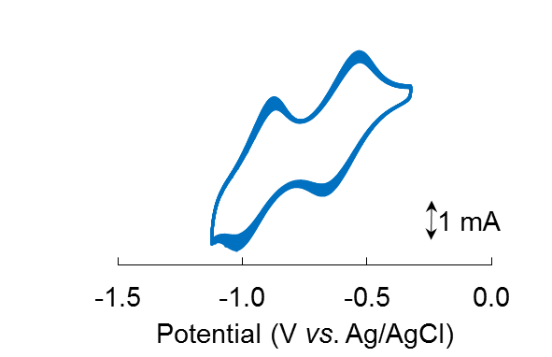

(a)

(b)

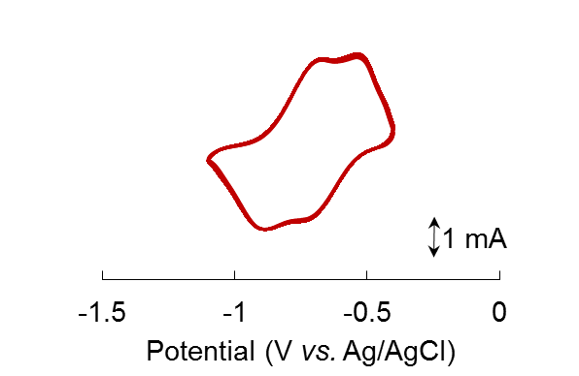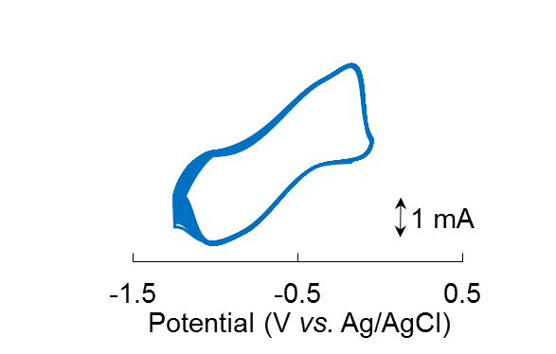

(c)

(d)

**FIG. S10** Cyclic voltammograms of (a) **5** and (b) **6** in 1 M TEAP/acetonitrile and (c) **5** and (d) **6** in 1 M LiClO4/GBL electrolyte at a scan rate of 10 mV/s for 500 cycles.

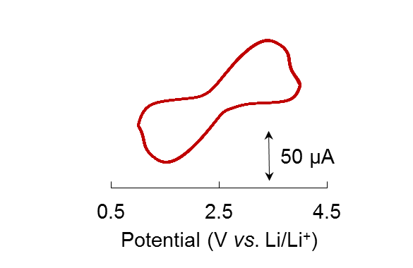

(a)

(b)

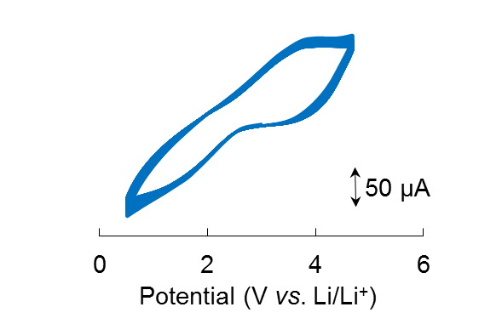

**FIG. S11** Cyclic voltammograms of (a) **5** and (b) **6** coin cells at a scan rate of 5 mV/s for 500 cycles.

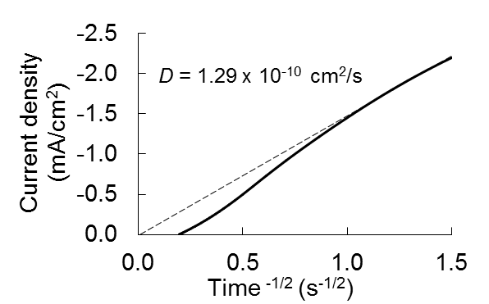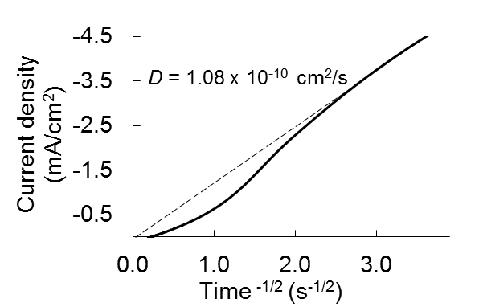

(a)

(b)

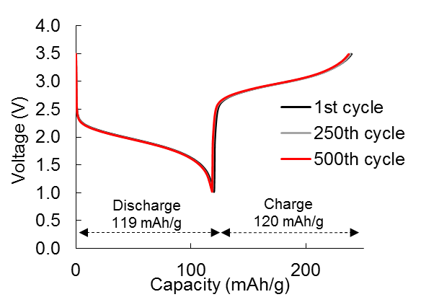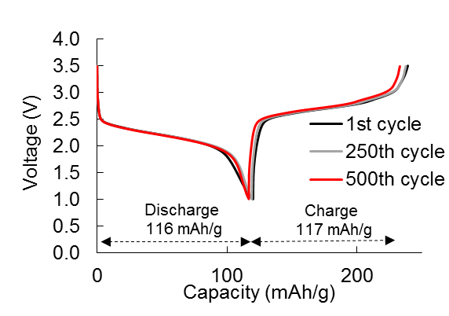**FIG. S12** Cottrell plots of the redox responses of polymer (a) **5** and (b) **6** layers in 1 M LiClO4 GBL electrolyte to determine their diffusion coefficients.

10C

5C

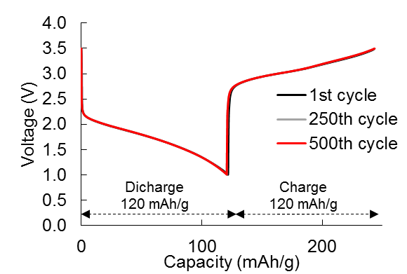

20C

**FIG. S13** Discharging and charging curves of the coin cells fabricated with polymer **5** at different C-rates.

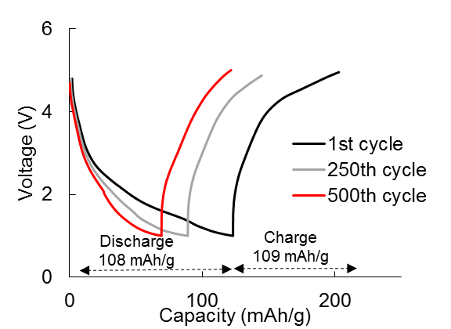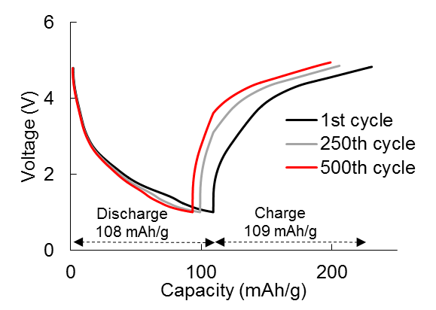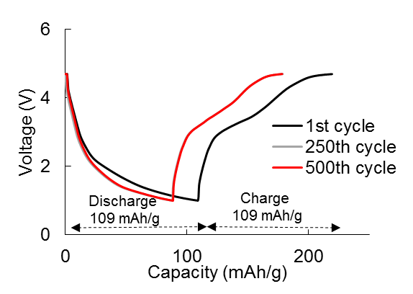

5C

10C

20C

**FIG. S14** Discharging and charging curves of the coin cells fabricated with polymer **6** at different C-rates.

**4. FE-SEM**

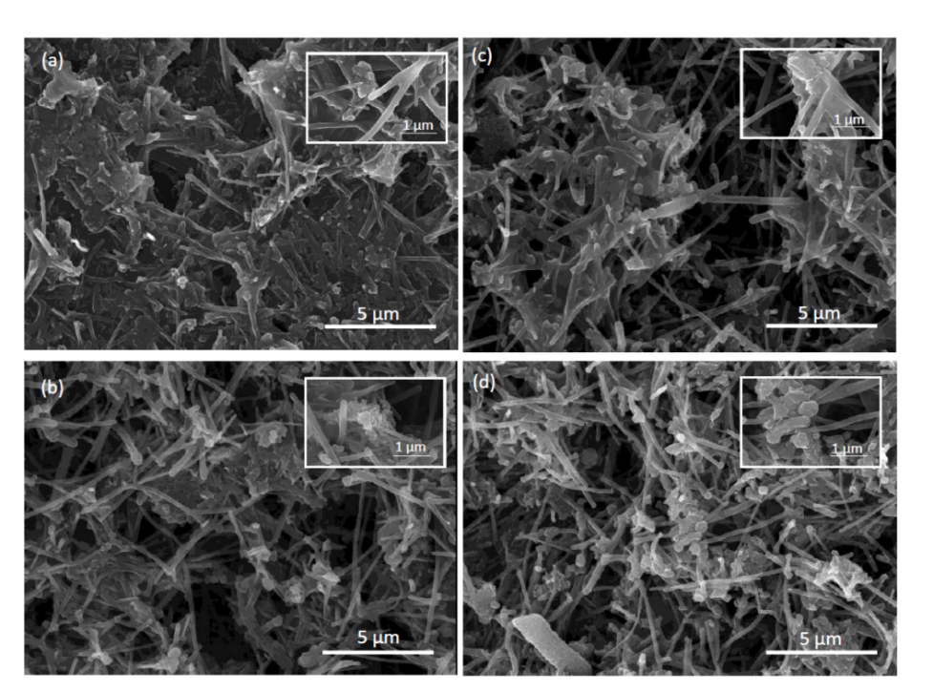

**FIG. S15** Field emission - scanning electron microscope (FE-SEM) images of the carbon composite redox materials before cyclic voltammetry cycles (a) **5** & (b) **6** and after 100 cycles (c) **5** and (d) **6**.