Supporting Information for:

Increased piezoelectric response in functional nanocomposites through MWCNT interface and fused-deposition modeling 3D printing

Hoejin Kim*, Fernando Torres, Md Tariqul Islam, Md Didarul Islam, Luis A. Chavez, Carlos A. Garcia Rosales, Bethany R. Wilburn, Calvin M. Stewart, Juan C. Noveron, Tzu-Liang B. Tseng, Yirong Lin
The University of Texas at El Paso 500W. University Ave. El Paso Texas, 79968, USA
E-mail: hkim4@miners.utep.edu

Methods
Method S1. 3D printing of MW-CNTs/BaTiO₃/PVDF nanocomposites film
For the cyclic load frame test, eight layers are printed with varying concentration of BT powders: 0, 6, 12, and 15 weight percentages and MWCNTs: 0, 0.1, 0.4 weight percentages. Increasing the weight content above 18%-BT would increase severe clogging within the nozzle which could potentially damage the 3D printer. In addition, increasing the weight content above 0.4%-MWCNTs would increase the electrical break down during the electric poling process. For the printing parameter, the film is printed at 230°C of nozzle temperature, 23°C of heating bed temperature, and 10mm/s of extrusion speed. The printing pattern is described in Figure S1. Final film was 0.55 mm in thickness with dimensions of 6 × 35 mm.

Method S2. Calculation of β-phase contents for nanocomposites film
The β-phase contents of each sample are calculated, specifically, at the absorption bands of 764 and 840 cm⁻¹ which are characteristics of α- and β-phases respectively. Assuming that the infrared absorption follows the Lambert-Beer law, $A_{α}$ and $A_{β}$ absorbance at 764 and 840 cm⁻¹, respectively, are given by equation (1) below.^{[1]}:
$A_{α,β}=Log\left(\frac{{I }_{α,β}^{0}}{{I }_{α,β}}\right)=C·K_{α,β}·X_{α,β}·L$ (1)
where the subscripts α and β are defined as the crystalline phases, $I^{0}$ and $I$ are the incident and transmitted intensities of the radiation, respectively. The $L$ is defined as a sample thickness, $C$ is an average monomer concentration, $K$ is the absorption coefficient at the respective wave number, and $X$ is the degree of crystallinity of each phase.^{[1]} For a system containing α- and β-phases, the relative fraction of the β-phase, $F(β)$, can be calculated using equation (2).^{[1]}:
$F(β)= \frac{X_{β}}{X_{α}+X_{β}}= \frac{A_{β}}{{(K}_{β}/K_{α})A_{α}+A_{β}}= \frac{A_{β}}{{1.26A}_{α}+A_{β}}$ (2)
where $K_{α}$ (6.1 × 10⁴ cm²/mol) and $K_{β}$ (7.7 × 10⁴ cm²/mol) are the absorption coefficients at the respective wave number.

Method S3. Calculation of Piezoelectric Coefficient (d₃₁)
To calculate the piezoelectric coefficient (d₃₁) by using the equation (3) below:
$D_{i}=d_{ij}σ_{j}$ (3)
where $D_{i}$ is the electrical displacement, $d_{ij}$ is the piezoelectric coefficient, and $σ_{j}$ is the applied stress. In this case, subscripts $i$ and $j$ are defined as 3 (applying force direction) and 1 (poling direction) respectively as shown in Figure 2a-i. Therefore, the equation can then be expressed as $D_{3}=d_{31}σ_{1}$. Considering the areas of the electrode and cross-section of the sample, equation (4) can then be expressed as
$\frac{Q}{A_{elect}}=d_{31}\frac{νF}{A_{cross}}$ (4)
where $Q$ is charge, $A_{elect}$ and $A_{cross}$ are areas of electrode and cross-section respectively, $ν$ is Poisson’s ratio which is 0.34,^{[2]} and $F$ is an applied force. The $Q$ is equal to $CV$ which are capacitance and voltage, respectively. $C$ can be expressed to$ε_{r}ε_{0}A_{elect}/d$. Then, the piezoelectric coefficient can be expressed as
$d_{31}=\frac{ε_{r}ε_{0}A_{cross}V}{vdF}$ (5)
where $ε_{r}$ is relative permittivity of the printed nanocomposites film, $ε_{0}$ is 8.854×10⁻¹² C/Vm, and d is its thickness. $A_{cross}$ are 2.47 mm². Then $d_{31}^{max}$ and $d_{31}^{min}$ are determined at maximum and minimum of voltages and forces as equation (6) describes.
$d_{31}^{max}=\frac{ε_{r}ε_{0}A_{cross}V_{max}}{vdF_{max}}, d_{31}^{min}= \frac{ε_{r}ε_{0}A_{cross}V_{min}}{vdF_{min}}$ (6)
$F_{max}$ and $F_{min}$ are 5 N and 45 N, respectively. Each attained $d_{31}$ is divided by 2 for $± d_{31}$ as shown in following equation (7)
${± d}_{31}$ = $\frac{d_{31}^{max} - d_{31}^{min}}{2}$ (7)

Figures and Tables

Figure S1: Printing pattern design
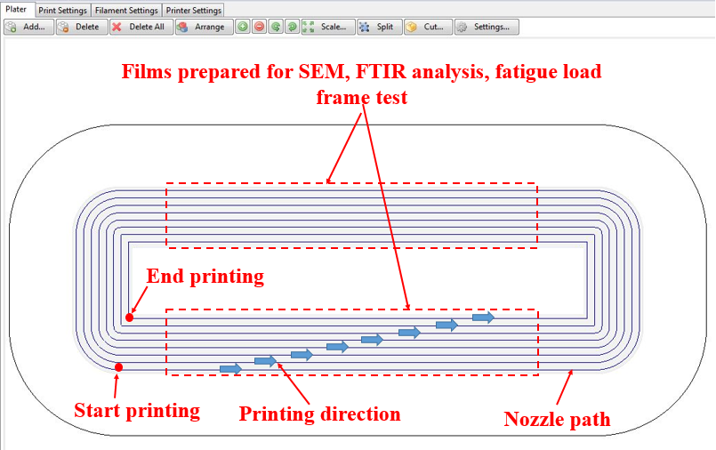
Figure S1. A captured image of concentric fill pattern design created in Slic3r software used for SEM, FTIR, and fatigue load frame test.

Figure S2: Scanning electron microscopy images of the printed nanocomposites
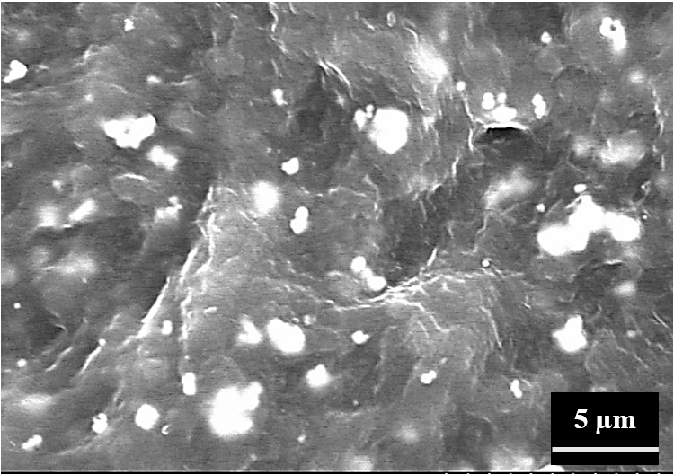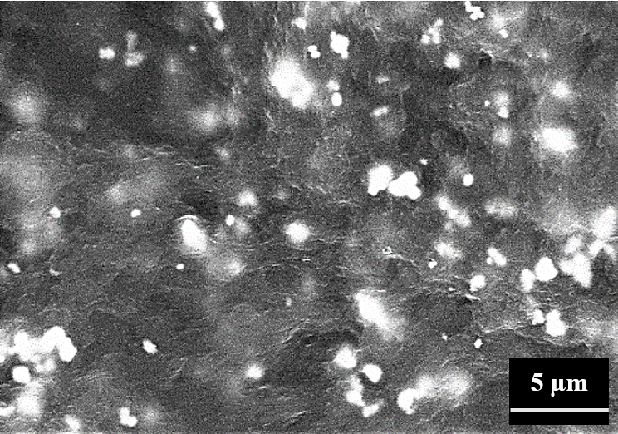
(b)
(a)
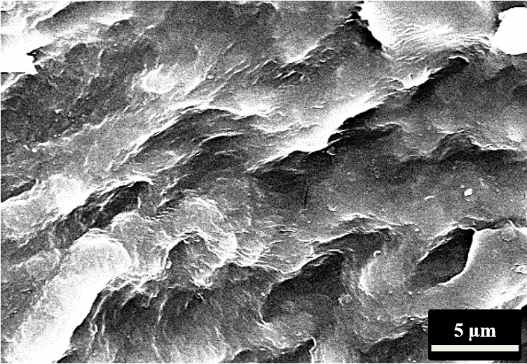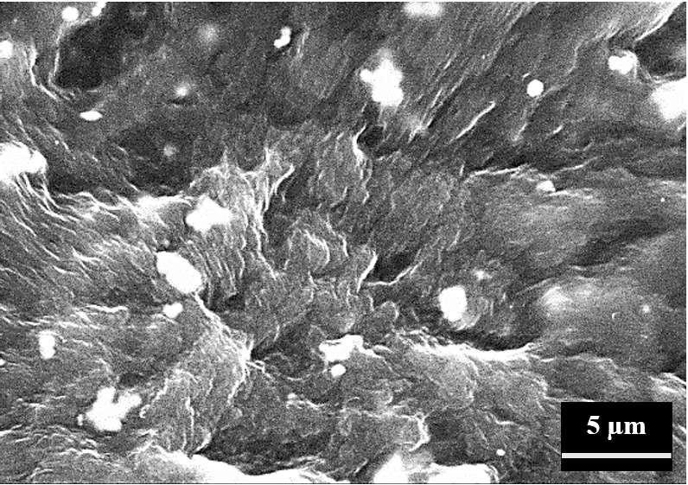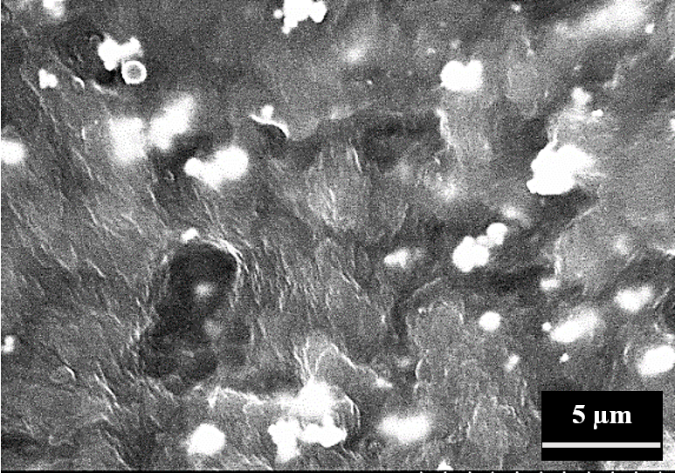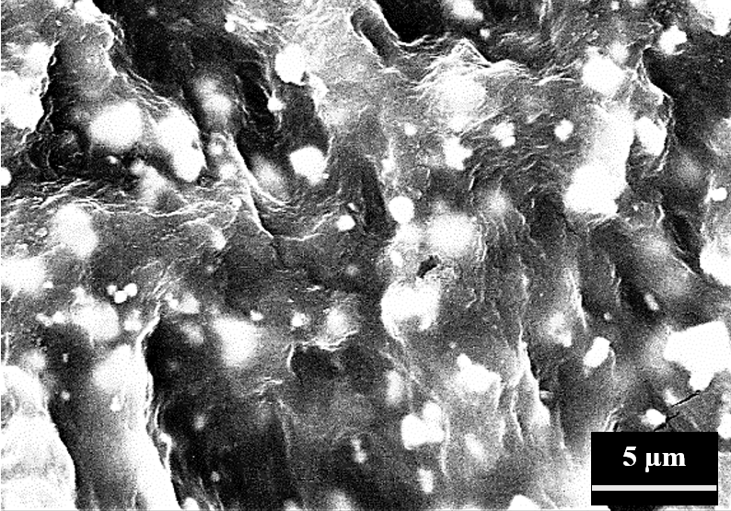
(d)
(f)
(e)
(c)
Figure S2. SEM images of (a) 12wt.%-BT/PVDF, (b) 0.1wt.%-MWCNTs/12wt.%-BT/PVDF, (c) 0.4wt.%-MWCNT/PVDF, (d) 0.4wt.%-MWCNT/6wt.%-BT/PVDF, (e) 0.4wt.%-MWCNT/12wt.%-BT/PVDF, (f) 0.4wt.%-MWCNT/18wt.%-BT/PVDF.

Figure S3: Fourier transform infrared spectroscopy (FTIR) spectra
- FTIR spectra before electric poling process
α (763)
β/γ (840)
α (854)
γ (811)
α (795)
α (614)
α (976)
β (1275)
γ (1234)
(b)
(a)
(f)
(e)
(d)
(c)
- FTIR spectra after electric poling process

Figure S3. FTIR spectra of the printed nanocomposites (1) before and (2) after electric poling: (a) 12wt.%-BT/PVDF, (b) 0.1wt.%-MWCNT/12wt.%-BT/PVDF, (c) 0.4wt.%-MWCNT /PVDF, (d) 0.4wt.%-MWCNT/6wt.%-BT/PVDF, (e) 0.4wt.%-MWCNT/12wt.%-BT/PVDF, (f) 0.4wt.%-MWCNT/18wt.%-BT/PVDF.

Table S1: Dielectric Properties of the Printed MWCNT/BT/PVDF Nanocomposites Films
Composition | Relative Permittivity ($ε_{r})$ at 1 kHz
12wt.%-BT/PVDF | 16.9
0.1wt.%-MWCNT/12wt.%-BT/PVDF | 31.2
0.4wt.%-MWCNT/PVDF | 30.5
0.4wt.%-MWCNT/6wt.%-BT/PVDF | 31.7
0.4wt.%-MWCNT/12wt.%-BT/PVDF | 25.0
0.4wt.%-MWCNT/18wt.%-BT/PVDF | 36.5

References
[1] V. Sencadas, M. V. Moreira, S. Lanceros-Méndez, A. S. Pouzada, and R. Gregório Filho, "α-to β Transformation on PVDF films obtained by uniaxial stretch," in Materials science forum, 2006, pp. 872-876.
[2] A. Vinogradov and F. Holloway, "Electro-mechanical properties of the piezoelectric polymer PVDF," Ferroelectrics, vol. 226, pp. 169-181, 1999.

