**Birth of Silicon Nano-wires Covered with Protective Insulating Blanket**

Krishna Nama Manjunathaa, Shashi Paula*

aEmerging Technologies Research Center, De Montfort University, The gateway,

Leicester,LE18BH,United Kingdom

Characterisation techniques

As grown Si-SiOx nanowires are investigated (growth morphology and elemental composition) with the help of a scanning transmission electron microscope (STEM) coupled with energy-dispersive X-ray (EDX) and secondary electron (SE) detectors. In this work, Carl-Zeiss EvoHD 15 STEM, Leica S430 SEM and OXFORD INCA X-MAX EDX with detector size of 80mm2 were used for analysis. SiNWs were sprinkled onto a carbon coated copper grids for STEM analysis and voltage was varied between 5kV to 30kV for data presented in this work.

H:\Desktop\DMU\Journal n conf\Si-SiOx nanowires\MRS Communications\Figures\Fig-8 Supp info.tif

*FIG. S1. Self-assembled MONPs with different diameters in the same sample/substrate is analysed individually to see the differences in the diameter of catalyst and nanowires. Diameter of nanowires increases as diameter of MONPs increases. Diameter of MONPS are always larger compared to nanowires.*

H:\Desktop\DMU\Journal n conf\Si-SiOx nanowires\MRS Communications\Figures\Fig-9 Supp info.tif

*FIG. S2. Keeping all the process parameters same and varying the temperature in the range of 200, 300 and 400 °C show that core-shell nanowires are obtained at 300 °C.*

Growth was performed at three different temperatures (200, 300 and 400 °C) to check reduction/decomposition of a compound catalyst. Growth of nanowires is not observed at 200 °C and had a thick amorphous silicon deposition. At 400 °C, growth of core-shell nanowire is not observed where MONPs possibly have completely reduced to either Sn particles by losing oxygen which would precipitate Si alone. Similar growth behavior is observed for precipitating Si nanowires by SnO2 in the temperature range between 300 – 600 °C with different deposition process parameters (RF power density, time, gas flow and pressure) that are very sensitive to the growth process [16]. By maintaining the appropriate temperature and process parameters is it possible to achieve core-shell nanowire growth, and this work observed that 300 °C is ideal to obtain such growth where particles have not completely reduced to Sn.

H:\Desktop\Picture1.tif

*FIG. S3. Histogram of Core shell nanowires: Average diameter of nanowires is found to be 845nm with a standard deviation of 125nm compared amongst 200 nanowires spread across 500 μm2 area over the substrate.*

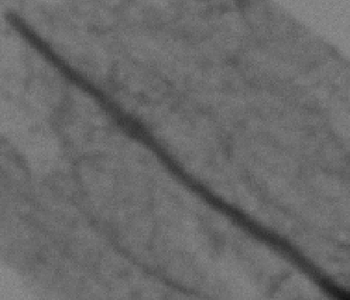

FIG. S4. Diameter vs. distance along growth axis plot showing variation in the Core and shell diameters.

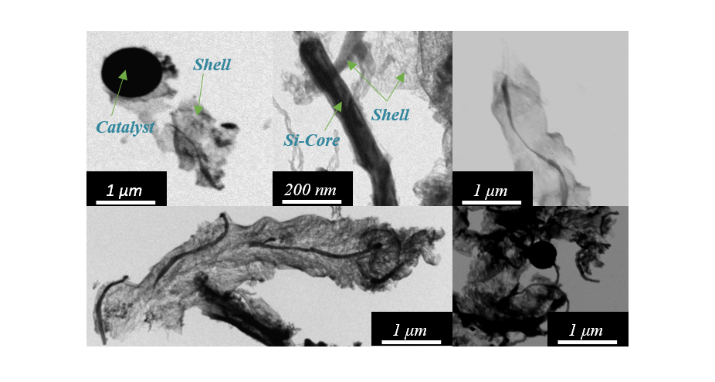

FIG. S5. STEM images of Core-shell nanowires suspended on carbon coated copper mesh intentionally damaged using micro-positioner tungsten probe tip (0.7μm tip diameter).