Tungsten Disulfide Thin Film/p-type Si Heterojunction Photocathode for Efficient Photochemical Hydrogen Production

Supporting Information

Ki Chang Kwon^{1,2,‡}, Seokhoon Choi^{1,‡}, Kootak Hong¹, Dinsefa Mensur Andoshe¹, Jun Min Suh¹, Jeong Hyeon Oh², Changyeon Kim¹, Kyoung Soon Choi³, Soo Young Kim^{2,*}, Ho Won Jang^{1,*}
¹Department of Materials Science and Engineering, Research Institute of Advanced Materials, Seoul National University, Seoul 08826, Republic of Korea
²School of Chemical Engineering and Materials Science, Chung-Ang University, Seoul 06974, Republic of Korea
³Advanced Nano Surface Research Group, Korea Basic Science Institute, Daejeon 34133, Republic of Korea.
KEYWORDS. Tungsten disulfide, photoelectrochemical hydrogen production, silicon photocathode.
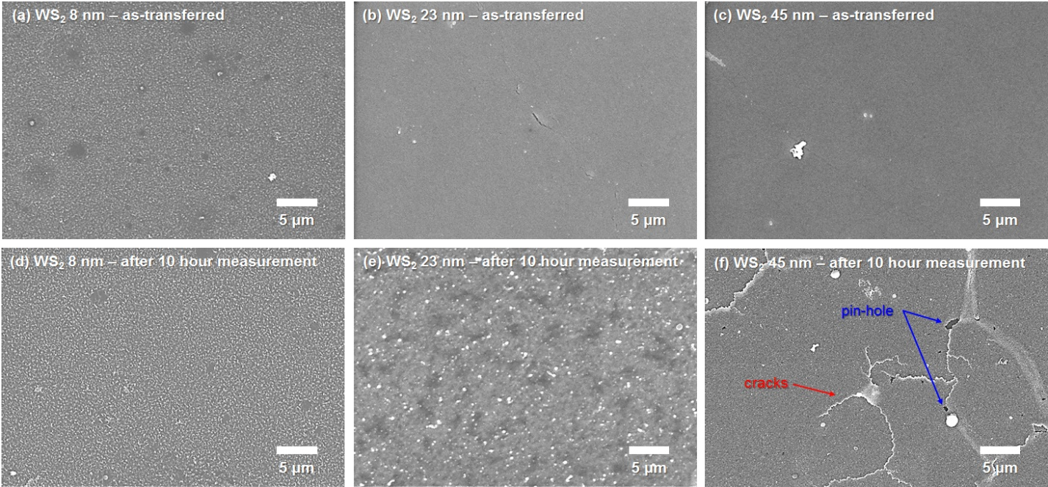
Fig. S1. The top-view field-emission scanning electron microscopy (FE-SEM) images of as-transferred and chronoamperometry measured (for 10 hours) samples for 8-, 23-, 45-nm-thick WS₂ thin films on p-Si. In the case of the 45-nm-thick WS₂ thin film catalyst, the thin film significantly degraded after 10 hour chronoamperometry measurement.

