Supporting Information
Solution-based Synthesis of Carbon-Hematite Composite Thin Films for High Performance Supercapacitor Applications
Jinzhan Su*, Shangpu Liu, Jian Wang, Cong Liu, Yufeng Li, Dongyang Wu
International Research Centre for Renewable Energy, State Key Laboratory of Multiphase Flow in Power Engineering, Xi’an Jiaotong University, Shaanxi 710049, P. R. China. E-mail: j.su@mail.xjtu.edu.cn
Supporting Information

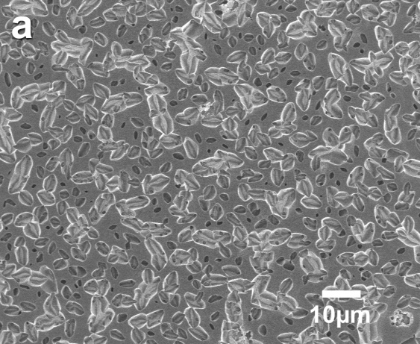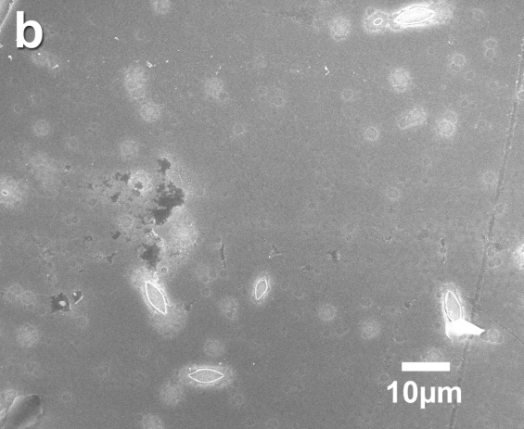
Figure S1. SEM images of C/Fe₂O₃ electrodes with different heating rates: (a) 550℃/40s; (b) 550℃/10min.

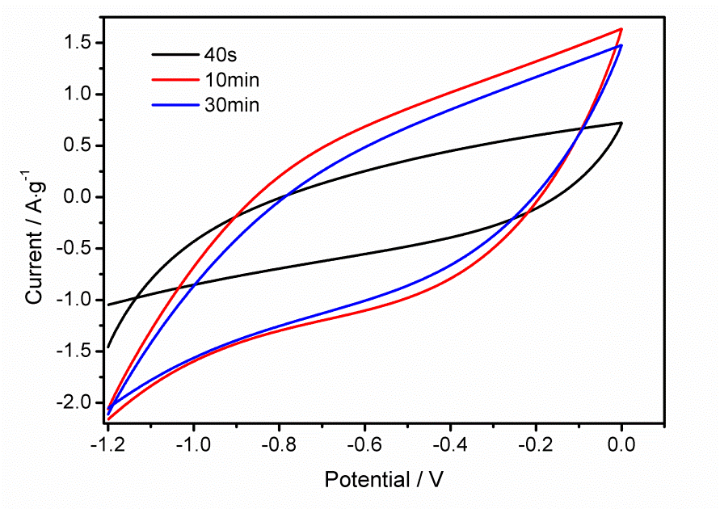
Figure S2 I-V curve of different heating rate (time taken to increase temperature to 550ºC) of C/Fe₂O₃ electrode for supercapacitor (0.1V/s)

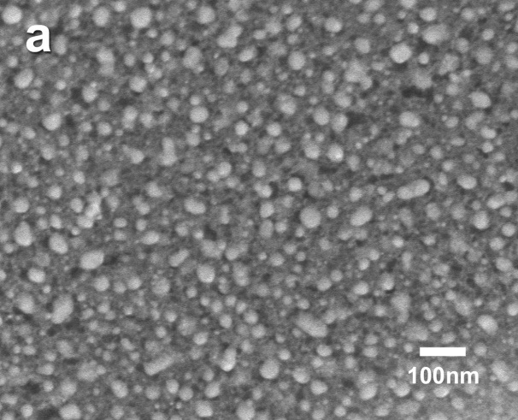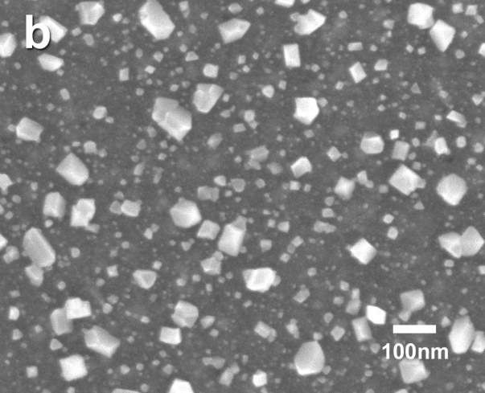
Figure S3. SEM images of C/Fe₂O₃ electrodes annealed at 500ºC with different heating time: (a) 50min; (b) 72min.
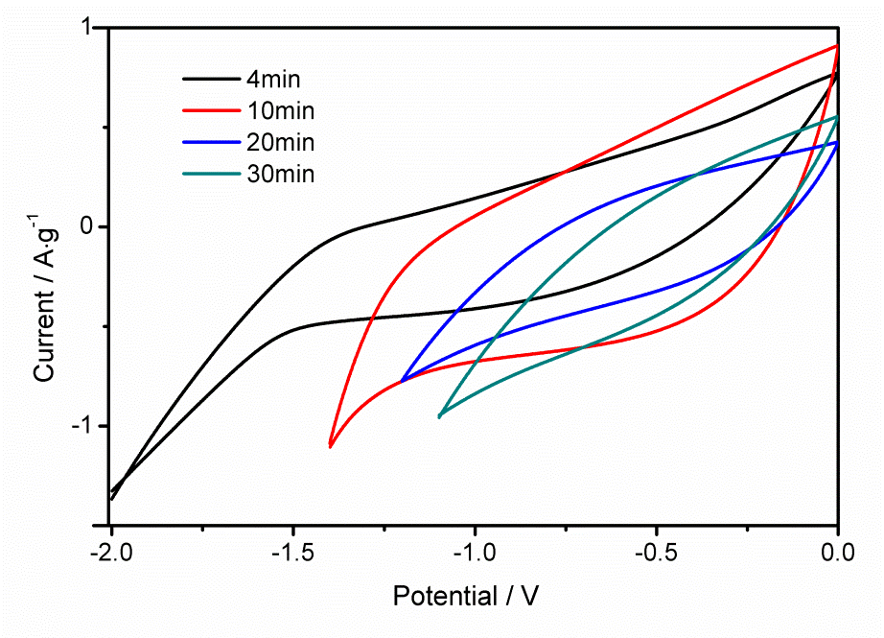
Figure S4. I-V curves of different annealing time (at 550 ºC) of C/Fe₂O₃ electrode for supercapacitor (4 min, 10 min, 20 min and 30min).
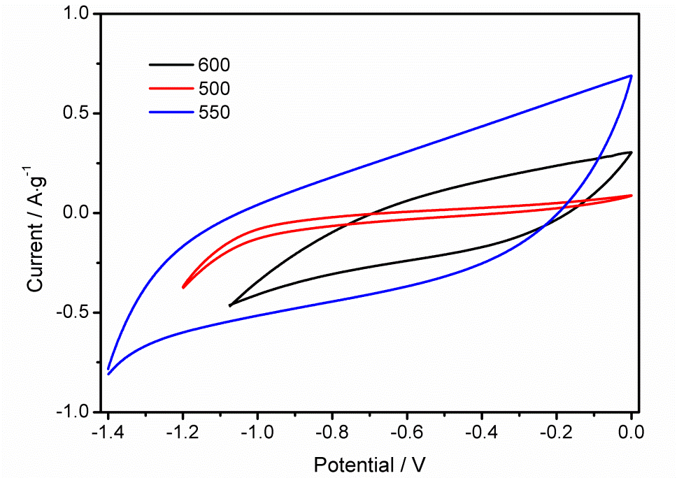
Figure S5. I-V curves of different annealing temperature of C/Fe₂O₃ electrode for supercapacitor (500 ºC, 550 ºC, 600 ºC).

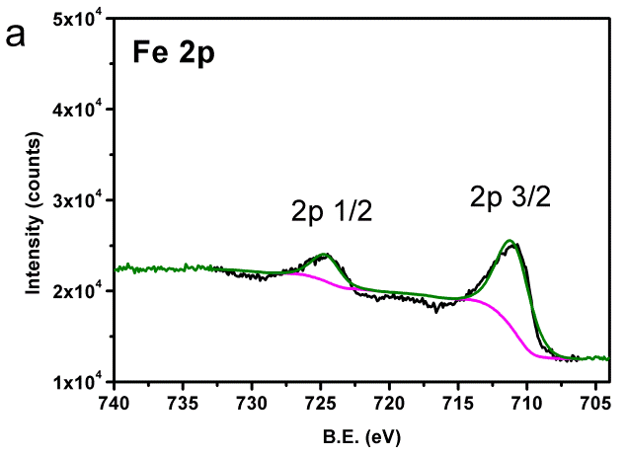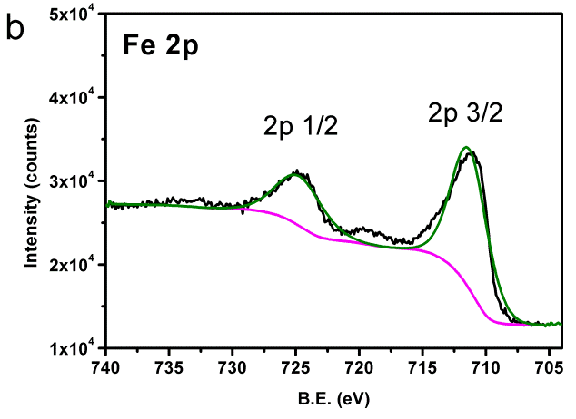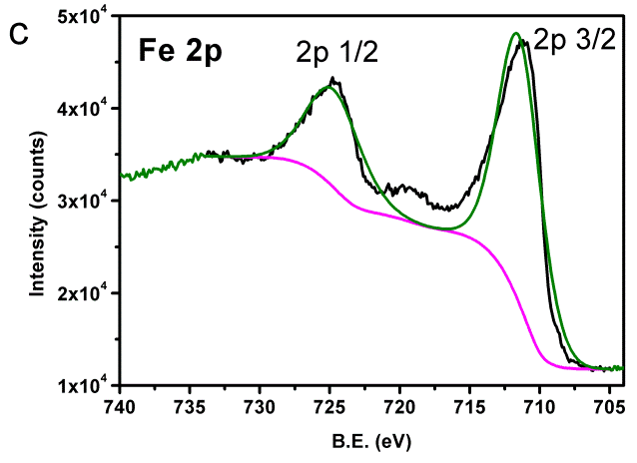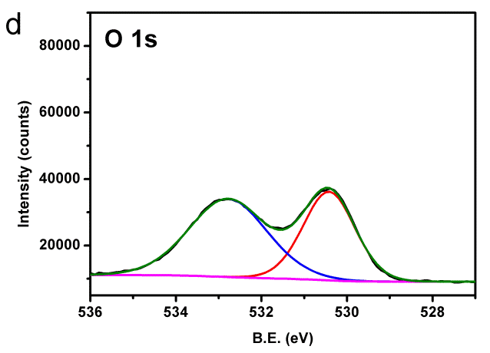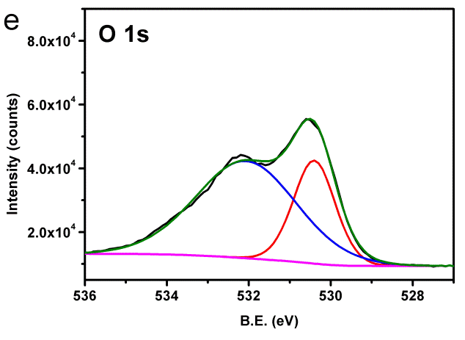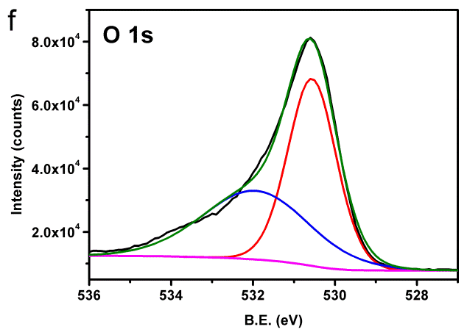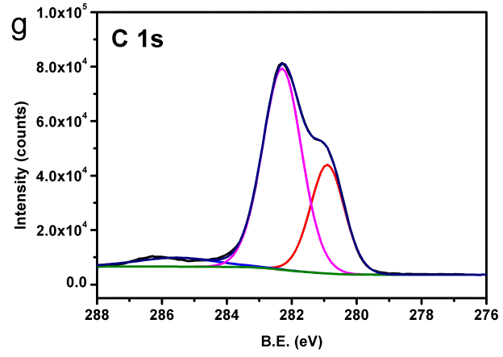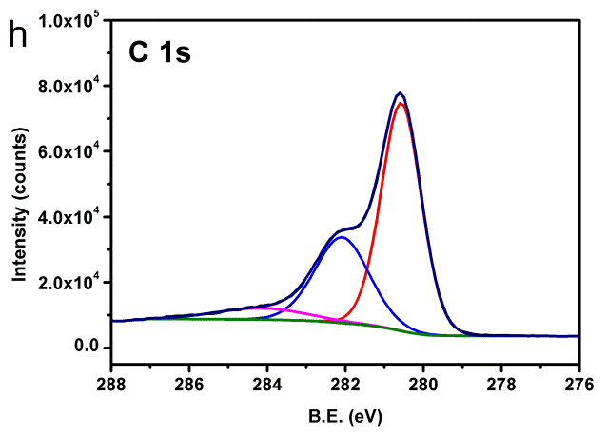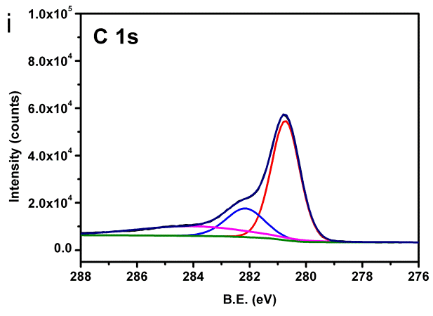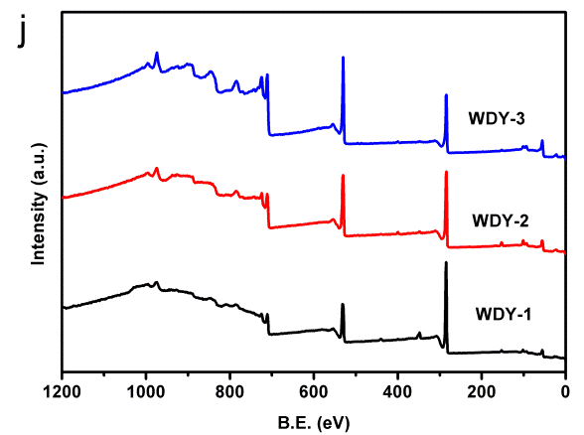
Figure S6. XPS spectra of C/Fe₂O₃ electrode with different glucose to ferric nitrate weight ratios (C₆H₁₂O₆: Fe(NO₃)₃⋅9H₂O). Fe2p for sample with ratio = (a) 2:1 (b) 1:1 (c) 1:2, O1s for sample with ratio(d) 2:1 (e) 1:1 (f) 1:2 , C1s for sample with ratio (g) 2:1 (h) 1:1 (i) 1:2 and (j) full survey spectra.

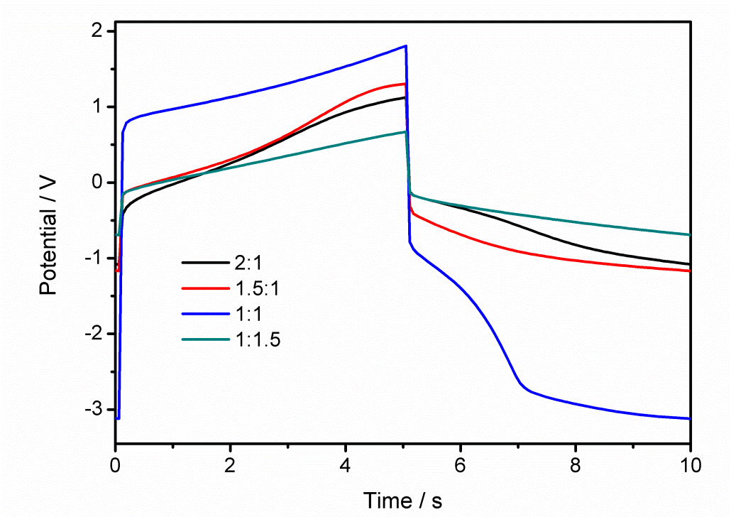
Figure S7 galvanostatic charge-discharge behaviors for C/Fe₂O₃ samples with different C/Fe₂O₃ ratios in 8 M KOH electrolyte (J=1mA/cm²)
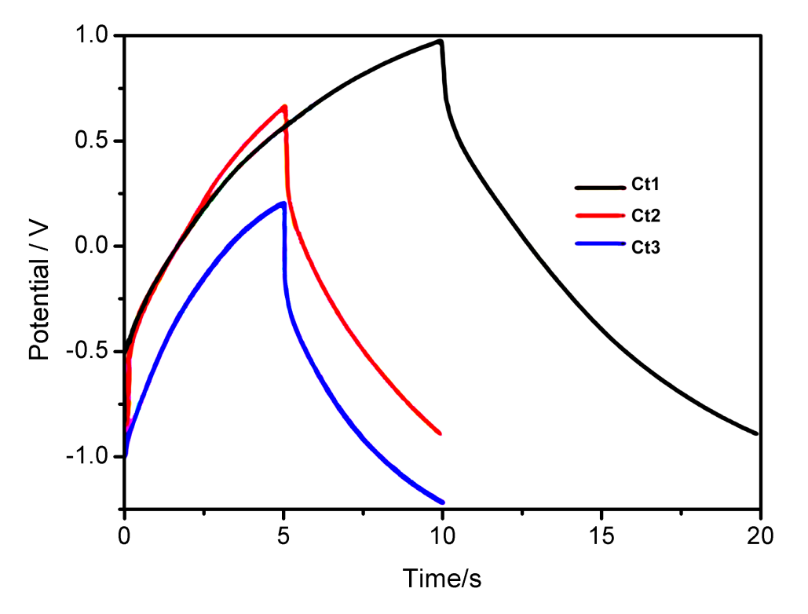

Figure S8 Galvanostatic charge/discharge (GCD) curve of C/Fe₂O₃/Co₃O₄ electrode Ct1:0.5g/20ml;Ct2:1g/20ml;Ct3:2g/20ml (J=1mA/cm²)

