SUPPLEMENTARY MATERIAL

Efficiency Enhancement via Metal-coated Porous Amorphous Silicon Back Reflectors Incorporated in Amorphous Silicon Solar Cells
Shweta Bhandaru, Interdisciplinary Graduate Program in Material Science, Vanderbilt University, Nashville, TN 37235, USA
Angelo Bozzola, Department of Physics, University of Pavia, via Bassi 6, I-27100 Pavia, Italy *Present affiliation: Istituto Italiano di Tecnologia, via Morego 30, I-16159, Genova, Italy
Marco Liscidini, Department of Physics, University of Pavia, via Bassi 6, I-27100 Pavia, Italy
Sharon M. Weiss, Department of Electrical Engineering and Computer Science, Vanderbilt University, Nashville, TN 37235, USA

Address all correspondence to Sharon M. Weiss at sharon.weiss@vanderbilt.edu and Marco Liscidini at marco.liscidini@unipv.it

S1. Reflectance spectra comparison for RCWA simulation

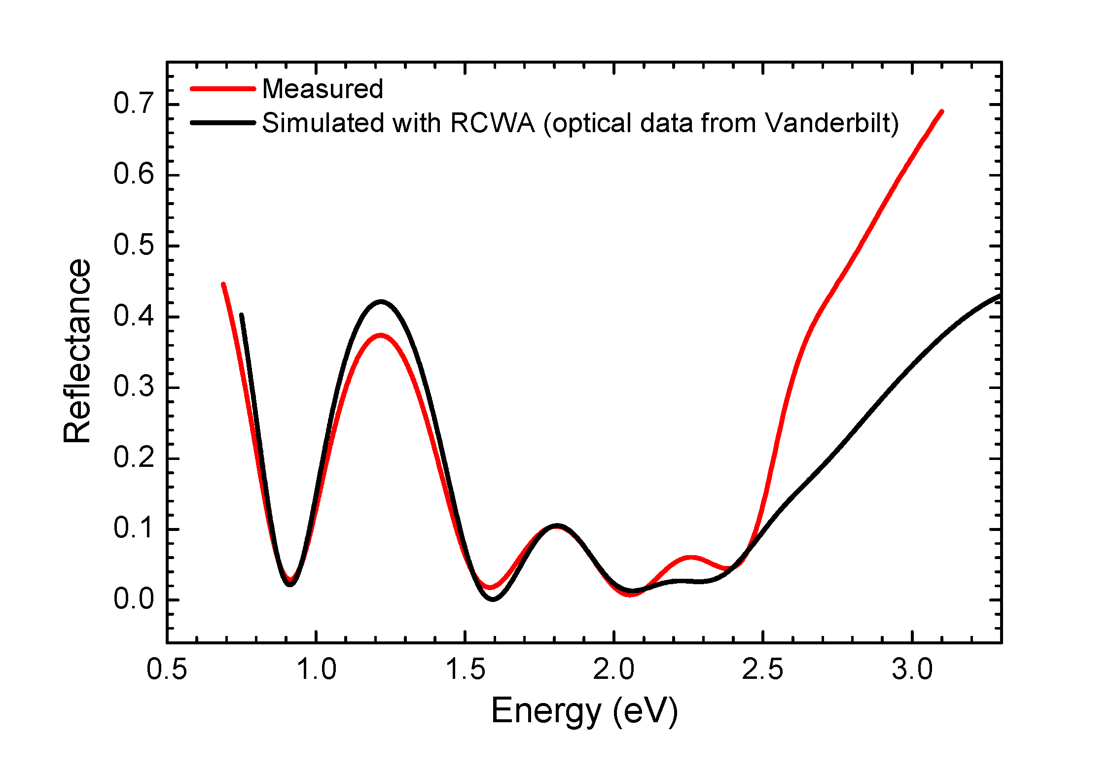

Figure S1. Comparison of reflectance spectra between experiment and simulation of the n-i-p
a-Si:H cell on glass/SiO₂ indicates good agreement for energies less than 2.4 eV. The structures compared here are flat cells and do not include the porous a-Si:H layer.

S2. Metal assisted chemical (MAC) etch process window in amorphous silicon
As a part of the MAC etch process development, ~750 nm thick a-Si:H films were deposited on SiO₂ films on silicon wafers. The intermediary, approximately 100 nm thick, SiO₂ layer improved adhesion of a-Si:H to the silicon substrate and also helped clearly distinguish the a-Si:H film from the silicon substrate during SEM imaging. Silicon substrates were preferred over glass substrates for process development to facilitate sample preparation for and minimize charging during cross-sectional SEM imaging.
We found that the molar concentration of the etch solution played a strong role in the resulting morphology of the porous a-Si:H layer. The molar ratio (ρ%), defined in equation (S1) where [HF] and [H₂O₂] represent the respective molar concentrations in the etch solution,^{[1]} was varied from 20% to 80% and all samples were etched for a duration of 75 seconds in this initial experiment.
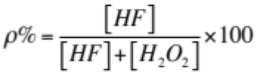 (S1)
As shown in Fig. S2.1, an etch solution with ρ% = 80% resulted in dense, spike-like structures, ρ% = 50% led to a grass-like surface, and ρ% = 20% resulted in surface coverage with sparse short stumps. Etch solutions with intermediary molar ratios exhibited morphologies that were characterized by surface structures intermediary to those shown in Fig. S2.1. A molar ratio of ρ% = 50% provided the highest aspect ratio features most favorable for light trapping and also most favorable for ease of imprinting the grating pattern.
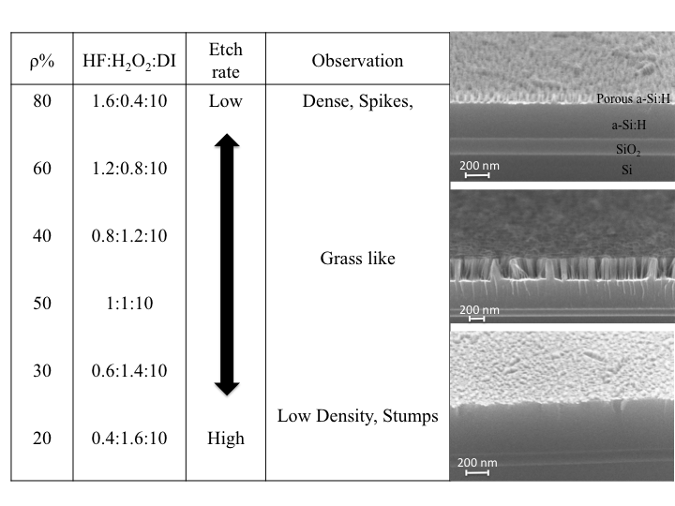
Figure S2.1. Process window for MAC etch composition where ρ% is defined in Eqn. S1. SEM images of selected examples corresponding to the morphology obtained from the MAC etch of
a-Si:H are shown. A MAC etch solution with ρ% = 50% was considered most favorable for both the textured back reflector and for imprintation of the grating back reflector.

Next, the effect of varying the MAC etch time was investigated. For etch times shorter than about 90 s, the thickness of the porosified region of the a-Si:H film increased linearly with etch duration. For longer etch times, the etch rate dropped significantly. Moreover, as shown in Fig. S2.2, etch times longer than about 2 min led to film delamination at the SiO₂ / a-Si:H interface.

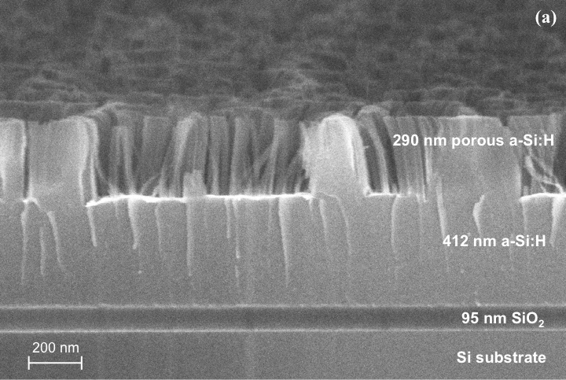
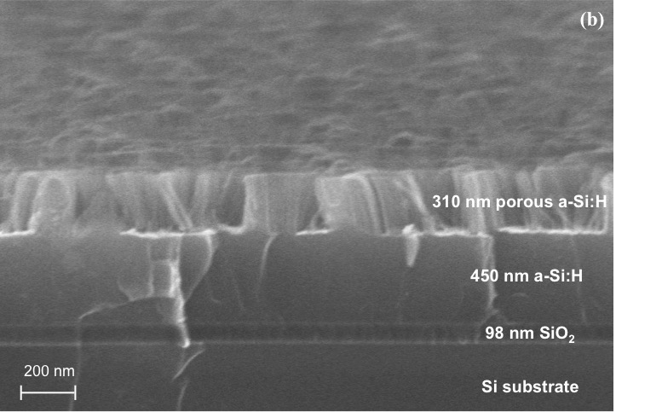
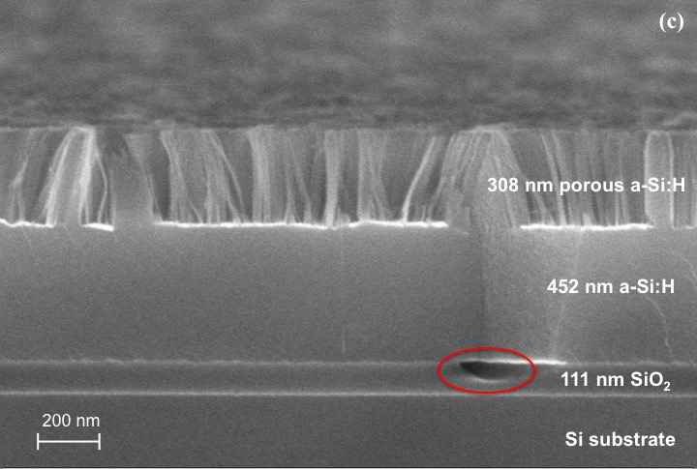
Figure S2.2. Cross-sectional SEM images of porous a-Si:H formed via MAC etch (HF:H₂O₂:DI = 1:1:4) for (a) 1 min 30 s, (b) 2 min, and (c) 2 min 30 s. The gold-catalyzed etch is performed on a ~750 nm thick, lightly p-doped a-Si:H film deposited on a silicon substrate coated with 100 nm of SiO₂. At the longest time point, the start of a-Si:H film delamination can be observed (red circle). Some regions of the porous a-Si:H layer were dislodged during sample cleavage for SEM preparation.
S3. Amorphous silicon solar cell fabrication details

The n-i-p layers of the a-Si:H solar cell were deposited via PECVD using the following recipes:
25 nm thick n-layer: 600 mT, 200 °C, 4 W, 60 sccm SiH₄*, 7 sccm PH₃*, 500 sec
180 nm thick i-layer: 600 mT, 200 °C, 2 W, 60 sccm SiH₄, 3131 sec
12 nm thick p-layer: 600 mT, 200 °C, 2 W, 60 sccm SiH₄, 16.5 sccm B(CH₃)₃*, 144 sec
*Gases used were diluted as follows: 10% SiH₄ diluted with He; 1% PH₃ diluted with He; 2% B(CH₃)₃ diluted in H₂.

References
[1] C. Chartier, S. Bastide, and C. Lévy-Clément: Metal-assisted chemical etching of silicon in HF–H₂O₂. Electrochimica Acta. 53, 5509 (2008).

