Electronic Supplementary Information for

Preparation of Mn-dopped BiOBr Microspheres as Efficient Visible-Light Induced Photocatalysis

Zhen Wei, ^{a,b}, Guohua Jiang, ^{a,b,}∗ Liang Shen, ^{c} Xia Li, ^{a,b} Xiaohong Wang, ^{a,b} Wenxing Chen ^{a,b}

ª Key Laboratory of Advanced Textile Materials and Manufacturing Technology (ATMT), Ministry of Education, Zhejiang Sci-Tech University, Hangzhou 310018, P. R. China
^{b} Department of Materials Engineering, College of Materials and Textile, Zhejiang Sci-Tech University, Hangzhou 310018, P. R. Chin
^{c} College of Material Chemistry and Chemical Engineering, Hangzhou Normal University, Hangzhou 310036, China

∗ To whom correspondence should be addressed. Tel: +86 571 86843527; E-mail address: ghjiang_cn@aliyun.com (G. Jiang).
.
Experimental section
Preparation of Mn-doped BiOBr microspheres
In the typical preparation, 0.6g of Bi(NO₃)₃•5H₂O was dissolved into 60 ml 2-methoxyethanol to from a clean solution, and then a certain amounts of manganese acetate tetrahydrate (Mn(C₂H₆O₄)₂•4H₂O) was added. After that, 1.2 g of CTAB was added slowly to the solution with sonication. The resultant solution transferred into a Teflon-lined stainless steel autoclave, followed by a solvothermal treatment at 160 ºC for 24 h. After cooled to room temperature, the precipitates were washed with deionized water and ethanol six times and dried in a vacuum oven at 50 ºC for 12 h.
Characterization
Structures of the as-prepared samples were analyzed with a SIEMENS Diffraktometer D5000 X-ray diffractometer using Cu Kα radiation source at 35 kV, with a scan rate of 0.02° s⁻¹ in the 2θ range of 10-80°. The morphologies were investigated by ULTRA-55 field-emission scanning electron microscopy (FE-SEM) equipped with an energy dispersive X-ray spectrum (EDS, Inca Energy-200) at an accelerating voltage of 10 kV and JSM-2100 transmission electron microscopy (TEM). The Brunauer-Emmet-Teller (BET) specific surface area of the samples were determined by a specific surface area and pore size analyzer with static volumetric method (3H-2000PS1, China).
Photocatalytic Activity
The photocatalytic activity of the as-prepared samples was investigated by the photo-degradation of RhB. The photo-degradation experiments were carried out under visible light irradiation whose source was an 11 W daylight lamp (25 Hz) equipped with UV cutoff filter to provide visible light (λ ≥ 400 nm). 50 mg of the as-prepared catalysts was suspended in 50 mL RhB aqueous solution (C₀ = 0.2g·L⁻¹) with constant stirring. Prior to irradiation, the suspensions were stirred in the dark for 40 min to ensure the adsorption-desorption equilibrium. The temperature of suspensions was maintained below 283 K by a flow of cooling water during the reaction. The change of RhB concentrations (C) in accordance with the irradiation time was measured by JASCO V-570 UV/Vis/NIR spectrophotometer (Japan). Active species trapping experiment is carried out to investigate the effect of active species during the photocatalytic process. The catalytic process was same as described as above except the concentration of quencher of active species was kept at 2 mM.

EDS spectra
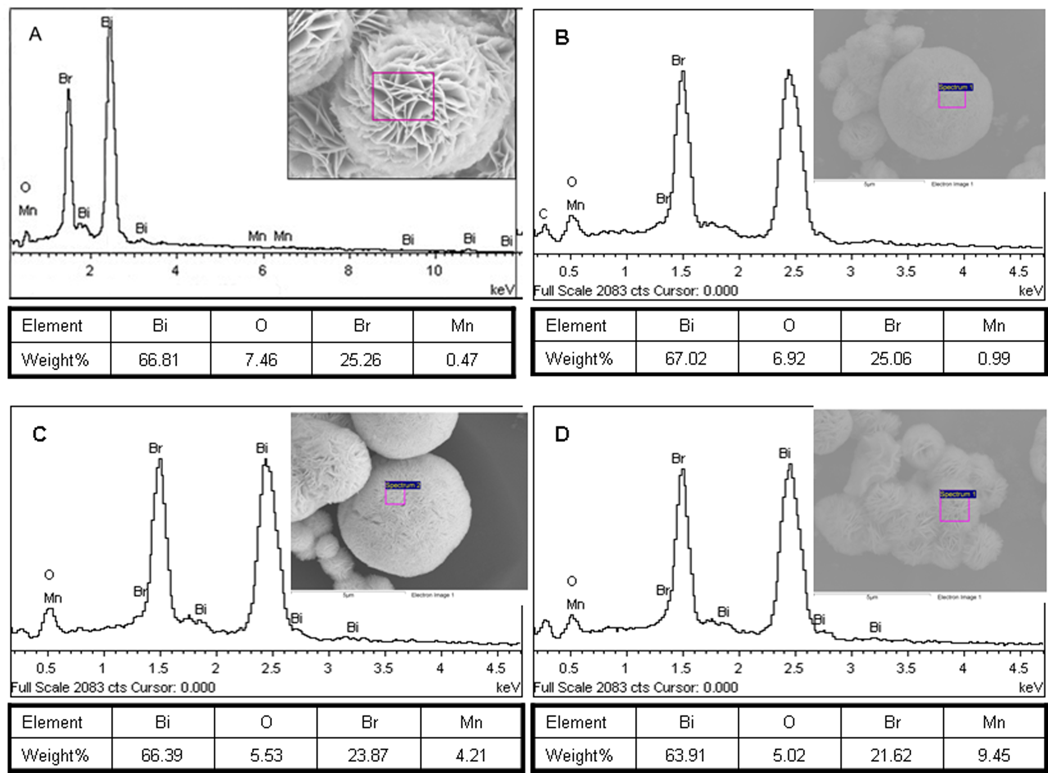
Fig S1. EDS spectra of the Mn-doped BiOBr microspheres with the different amount of doped Mn at 0.5% (A), 1% (B), 5% (C) and 10% (D).

FE-SEM images
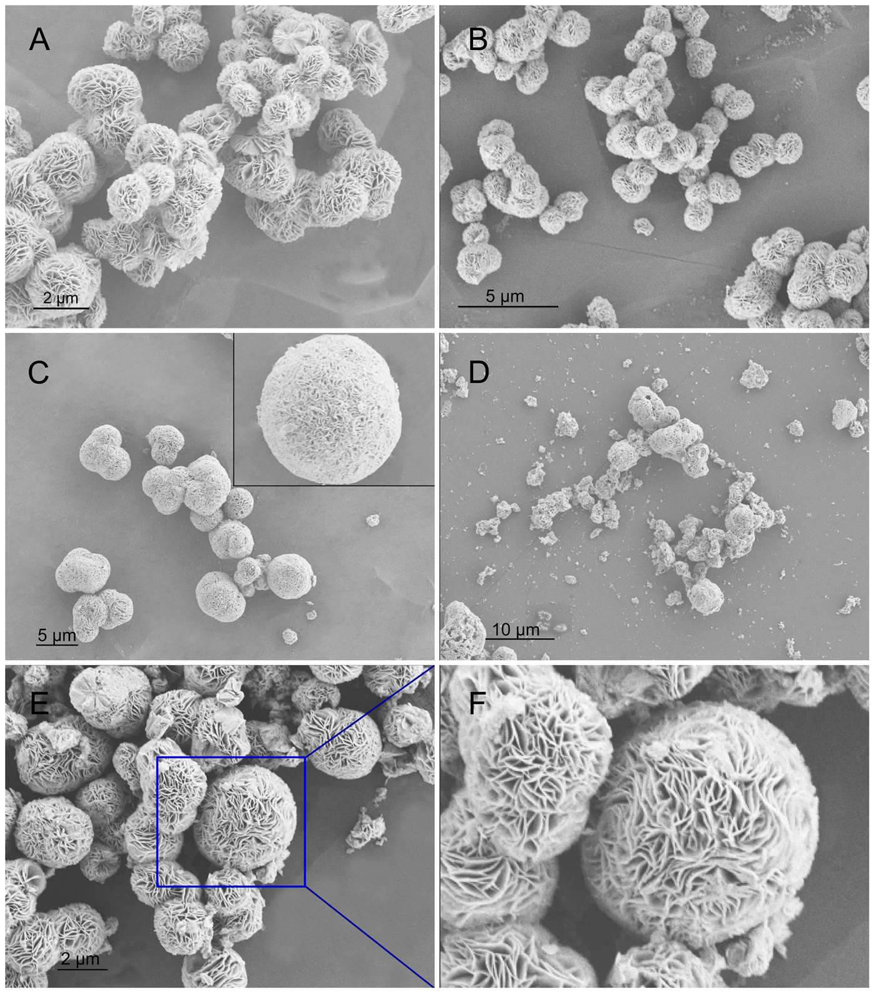
Fig S2. SEM images of the Mn doped BiOBr microspheres with the amount of doped Mn at 0.5% (A), 1% (B), 5% (C), 10% (D). (E and F) shows the SEM image of pure BiOBr.

 To whom correspondence should be addressed. Tel: +86 571 86843527; E-mail address: ghjiang_cn@aliyun.com (G. Jiang).

