Supplementary Material

Table S1. Characteristics of microsatellite markers used, including their chromosomal locations, fragment sizes, and number of alleles observed in overall samples.
Marker | Chromosome¹ | Expected Allele range (bp)² | Observe fragment size (bp)³ | Observed number of alleles
ADL0268 | 1 | 102-116 | 101-112 | 6
MCW0111 | 1 | 96-120 | 91-118 | 10
MCW0183 | 7 | 296-326 | 288-322 | 10
MCW0206 | 2 | 221-249 | 225-249 | 7
MCW0222 | 3 | 220-226 | 300-318 | 7
MCW0034 | 2 | 212-246 | 217-246 | 12
MCW0037 | 3 | 154-160 | 175-187 | 8
MCW0067 | 10 | 176-186 | 175-187 | 7
MCW0069 | 26 | 158-176 | 158-177 | 10
MCW0081 | 5 | 112-135 | 114-135 | 7
LEI0258 | 16 | - | 194-550 | 46
MCW0371 | 16 | - | 198-207 | 10
¹ From the FAO (2011); ² Expected allele size range from FAO (2011); ³Detected allele size range (bp) in eight chicken populations.

Supplementary Figures

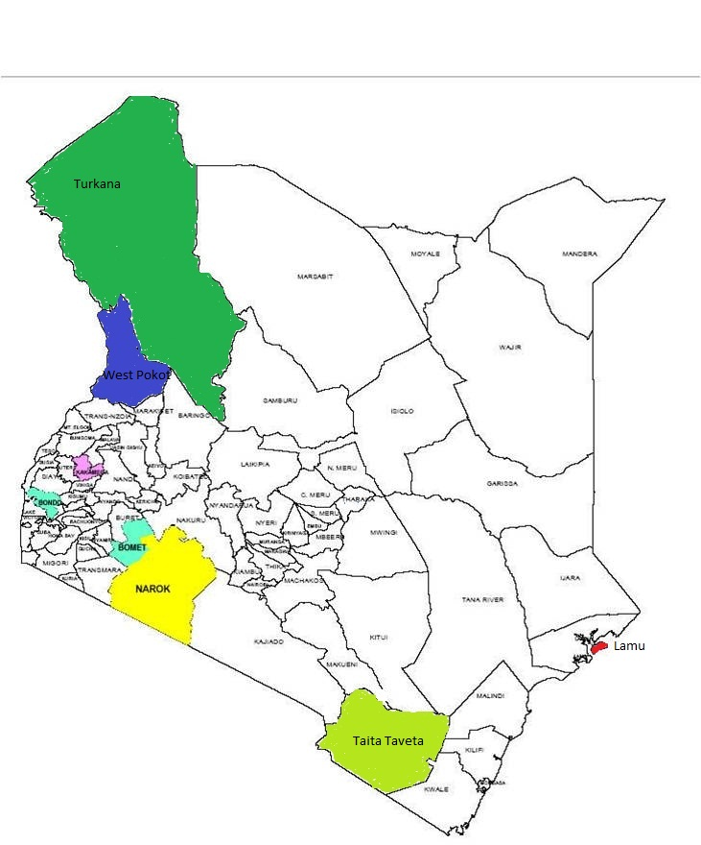
Bomet (BM)
Taita-Taveta (TT)
West Pokot (WP) (WP)
Kakamega (KK)
Turkana (TK)
Lamu (LM)
Narok (NR)
Siaya (BN)

Figure S1. Map of Kenya showing locations where blood samples were collected

