Figure A: High-level Workflow of the UCSD Regulatory Environment
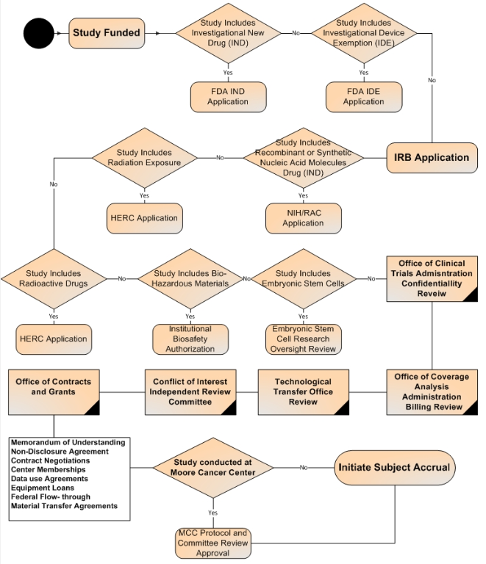

Figure B: Simplified Workflow Travel lanes Diagram of UCSD IRB, Office of Coverage Analysis and Office of Contracts and Grants
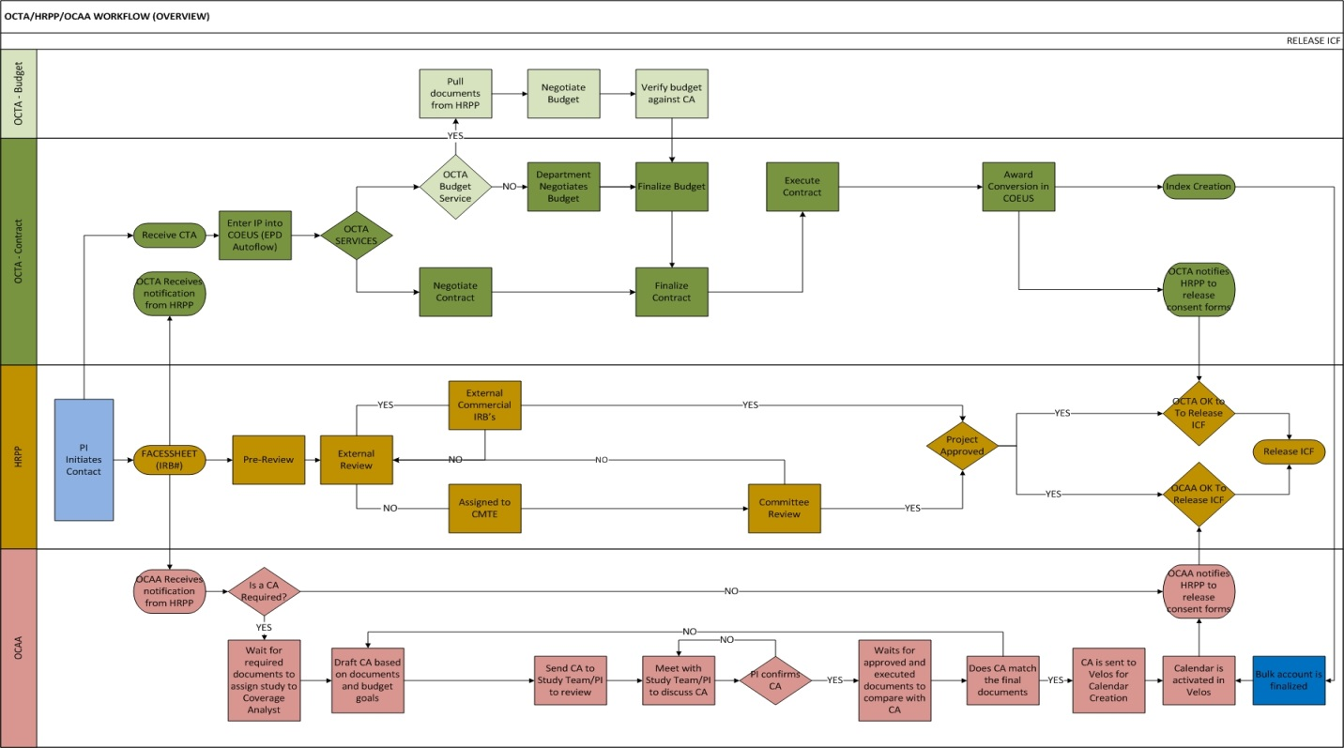

Table C
Table Showing Relationship between Number of Protocols per FTE Analyst and Time Required to receive IRB Approval
Year | FTE Analysts | Ratio of Protocols to FTE’s | Median Days Administrative Review | Median Days Committee Review | Median Days to Approval (Interquartile)
2013 | 17 | 69:1 | 13 | 50 | 75 (42/122)
2014 | 17 | 66:1 | 14 | 40 | 70 (43/112)
2015 | 17 | 70:1 | 19 | 47 | 88 (56/140)
2016 | 17 | 72:1 | 25 | 48 | 86 (53/126)

Figure D: Statistically Significant Differences in Approval Times Between IRB Committees for Phase III Multi-Site Clinical Trials. Additional training for the outlier committee improved performance and decreased the differences compared with other committees.

Figure E: Statistically Significant Relationship Between Number of Study Arms and Time to Complete Coverage Analysis. Coverage analysis for studies with multiple arms requires substantially more time.

