ONLINE APPENDIX

The Effects of Teenage Childbearing on Education, Physical Health and Mental Distress: Evidence from Mexico

Pinar Mine Gunes
Department of Economics, University of Alberta, Edmonton, AB, Canada
Email: gunes@ualberta.ca

Magda Tsaneva (corresponding author)
Department of Economics, Clark University, Worcester, MA, US
Email: mtsaneva@clarku.edu

Online Appendix 1: IPW model with treatment within 2 years of baseline survey
 | Education and Labor market outcomes |  |  | Physical health outcomes |  |  |  | Mental Health outcomes |  |  | Health Behaviors
 | Dropped out of school | Working |  | Overweight (BMI≥ 25) | Anemic | Reports good health |  | Mental distress score | Normal range of mental health |  | Exercises | Exercise frequency
 | (1) | (2) |  | (3) | (4) | (5) |  | (6) | (7) |  | (8) | (9)
Teenage childbearing | 0.2837*** | -0.0594 |  | 0.1649** | 0.1195* | 0.0092 |  | 0.8674 | -0.0804 |  | -0.1738*** | -0.6676***
 | (0.0612) | (0.0650) |  | (0.0660) | (0.0703) | (0.0551) |  | (0.9730) | (0.0499) |  | (0.0240) | (0.0931)
Observations | 773 | 773 |  | 614 | 528 | 651 |  | 651 | 651 |  | 651 | 651
Notes:
[1] All models control for the following individual and household characteristics: age fixed effects, household asset ownership (house, car, washing machine, domestic appliances), household size, size of area of residence, state fixed effects, years of survey fixed effects.
[2] Robust standard errors in parentheses.

[3] * denotes significance at the 10% level, ** denotes significance at the 5% level

Online Appendix 2: Bounding

If teenage childbearing was random, then an OLS model comparing the average outcomes of girls who had their first birth as a teenager, TC, and those who did not would yield unbiased estimates of the treatment effect, $β_{0}$:
$$Y=α+β_{0}TC+W_{1}β_{1}+ϵ$$
where 𝑌 is the outcome of interest, $W_{1}$ is a vector of observed individual, household and community characteristics and 𝜖 is a random error term.
Estimating this model may yield biased results if the true model also includes unobservable characteristics, $W_{2}$, which are correlated with teenage fertility as well as health and education outcomes:
$$Y=α+β_{0L}TC+W_{1}β_{1L}+W_{2}β_{2}+u$$
We can bound the treatment effect using a bounding-approach proposed by Altonji, Elder and Taber (2005) and Oster (2017). This method is based on a common approach that examines coefficient movements as observed controls are added to the regression model to test the robustness of the results to omitted variable bias. The common approach relies on the idea that the bias from observed characteristics is informative about the bias from unobserved characteristics. Altonji, Elder and Taber (2005) showed that the role of the unobservables, $Cov(W_{2},TF)/Var(W_{2}),$ is proportional to the role of observables with a coefficient of proportionality δ. In other words:
$$Cov(W_{2},TC)/Var(W_{2}) =δ*Cov(W_{1},TC)/Var(W_{1}).$$
The coefficient of proportionality, δ, can be interpreted as representing how large the effect of unobservables needs to be relative to the effect of observables for the treatment effect$β_{0}$, to be zero. For example, if δ=4, then the unobservables would need to be four times as important as the observables to eliminate the treatment effect. Altonji, Elder and Taber (2005) use an upper bound of δ=1 for robustness of the results to unobservable selection bias. Thus, the treatment effect is considered to be robust when the value of δ is greater than 1. Following this approach, we also estimate the bounds of the treatment effects using a proportionality factor =1. As in the main regression model, the observable characteristics we control for include: age fixed effects, household asset ownership (house, car, washing machine, domestic appliances), household size, size of area of residence, state fixed effects, and year of survey fixed effects.

Online Appendix 2: OLS Estimates with Bounding

 | Education and Labor market outcomes |  |  | Physical health outcomes |  |  |  | Mental Health outcomes |  |  | Health Behaviors
 | Dropped out of school | Working |  | Overweight  (BMI≥ 25) | Anemic | Reports good health |  | Mental distress score | Normal range of mental health |  | Exercises | Exercise frequency
 | (1) | (2) |  | (3) | (4) | (5) |  | (6) | (7) |  | (8) | (9)
Treatment effect | 0.2976** | 0.0074 |  | 0.1361** | 0.1687** | -0.0659 |  | -0.1956 | -0.0065 |  | -0.1447** | -0.5987**
Bounds on the treatment effect | (0.289, 0.2976) | (0.0074, 0.0236) |  | (0.132, 0.1361) | (0.1687, 0.175) | (-0.0686, -0.0659) |  | (-0.223, -0.1956) | (-0.0065, -0.00509) |  | (-0.15, -0.1447) | (-0.629, -0.5987)
Treatment effect excludes 0 | Yes | Yes |  | Yes | Yes | Yes |  | Yes | Yes |  | Yes | Yes
Delta | 7.499 | -0.487 |  | 8.068 | 11.53 | 51.47 |  | -12.74 | 3.892 |  | 18.13 | 31.83
Notes:
[1] Bounds on the treatment effect are calculated using Oster (2019)'s Stata code psacalc.
[2] Delta, δ, is a coefficient of proportionality that describes how large the effect of unobservables needs to be in proportion to the effect of observables for the treatment effect to be equal to 0.

Online Appendix 3: Effects of teenage childbearing restricting the sample to women who gave birth (IPW)
 | Education and Labor market outcomes |  |  |  | Physical health outcomes |  |  |  |  |  |  |  | Mental Health outcomes |  |  |  |  |  | Health Behaviors
 | Dropped out of school | Working |  |  | Overweight (BMI≥ 25) |  | Anemic |  | Reports good health |  |  |  | Mental distress score |  | Normal range of mental health |  |  |  | Exercises |  | Exercise frequency
 | (1) | (2) |  |  | (3) |  | (4) |  | (5) |  |  |  | (6) |  | (7) |  |  |  | (8) |  | (9)
Teenage childbearing | 0.1687** | 0.0569 |  |  | 0.2001** |  | 0.0978 |  | 0.0219 |  |  |  | 0.9319 |  | -0.0707 |  |  |  | -0.1448*** |  | -0.5397***
 | (0.0675) | (0.0733) |  |  | (0.0888) |  | (0.0779) |  | (0.0660) |  |  |  | (1.0257) |  | (0.0562) |  |  |  | (0.0425) |  | (0.1697)
Observations | 236 | 236 |  |  | 215 |  | 184 |  | 235 |  |  |  | 235 |  | 235 |  |  |  | 235 |  | 235
Notes:
[1] Model controls for the following individual and household characteristics: age fixed effects, household asset ownership (house, car, washing machine, domestic appliances), household size, size of area of residence, state fixed effects, years of survey fixed effects.
[2] Robust standard errors in parentheses.
[3] * denotes significance at the 10% level, ** denotes significance at the 5% level

Online Appendix 4: Effects of teenage childbearing controlling for being overweight at baseline (IPW)
 | Education and Labor market outcomes |  |  | Physical health outcomes |  |  |  | Mental Health outcomes |  |  | Health Behaviors
 | Dropped out of school | Working |  | Overweight (BMI≥ 25) | Anemic | Reports good health |  | Mental distress score | Normal range of mental health |  | Exercises | Exercise frequency
 | (1) | (2) |  | (3) | (4) | (5) |  | (6) | (7) |  | (8) | (9)
Teenage childbearing | 0.2262*** | -0.0462 |  | 0.1183** | 0.1863*** | -0.0358 |  | 1.4057 | -0.0799* |  | -0.1837*** | -0.6836***
 | (0.0671) | (0.0587) |  | (0.0601) | (0.0648) | (0.0594) |  | (0.9318) | (0.0472) |  | (0.0244) | (0.1000)
Observations | 729 | 729 |  | 584 | 548 | 617 |  | 617 | 617 |  | 617 | 617
Notes:
[1] Model controls for the following individual and household characteristics: age fixed effects, household asset ownership (house, car, washing machine, domestic appliances), household size, size of area of residence, state fixed effects, years of survey fixed effects, and baseline overweight status.
[2] Robust standard errors in parentheses.
[3] * denotes significance at the 10% level, ** denotes significance at the 5% level

Online Appendix 5: Common Support

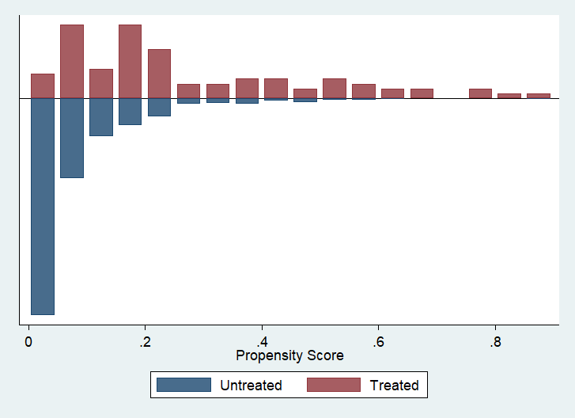

Online Appendix 6: Reduction bias across covariates

