Online Resource 3 to ’The Cost of Mental Disorders: A systematic review’

Christensen MK, Lim CCW, Saha S, Plana-Ripoll O, Cannon D, Presley F, Weye N, Momen NC, Whiteford H, Iburg KM, McGrath JJ.

  - Contents

eFigure 1: Number of studies by disorder group 2
eFigure 2: Societal cost per patient by disorder and country (USD) 3
eFigure 3: Societal cost per patient by study 4
eFigure 4: Societal cost per patient by disorder group 5
eFigure 5: Societal cost per patient, ranked by USD PPP 6
eFigure 6: Societal cost per patient without two multi-site studies 7
eFigure 7: Societal cost per patient by country without two multi-site studies 8
eFigure 8: Societal cost per patient according to quality reporting score 9
eFigure 9: Societal cost by country according to quality reporting score 10
eFigure 10: Societal cost by study according to quality reporting score 11
References 12

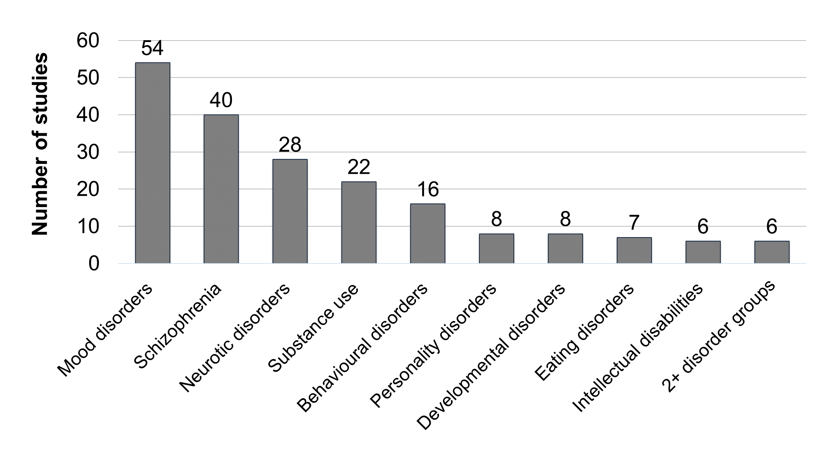
eFigure 1: Number of studies by disorder group
Notes: Some studies report estimates for more than one disorder group type, entailing the numbers do not add up to the number of included studies (143).

eFigure 2: Societal cost per patient by disorder and country (USD)
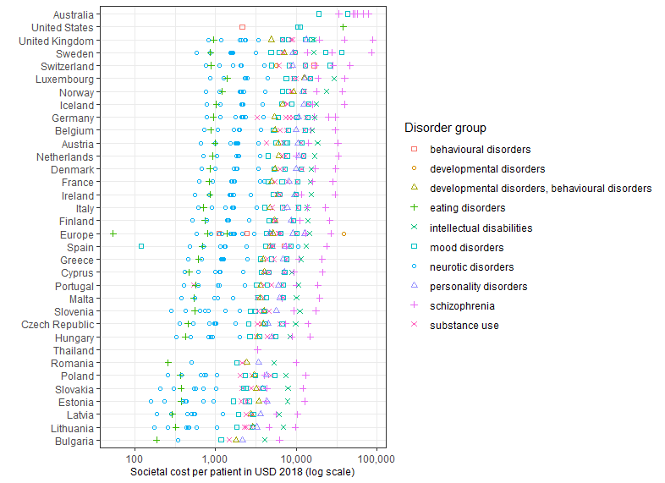
The figure shows the societal cost per patient in US dollars adjusted for inflation until year 2018 by disorder group and country. The x-axis is on a logarithmic scale. The estimates are illustrated with different symbols and colours depending on the disorder type.

eFigure 3: Societal cost per patient by study
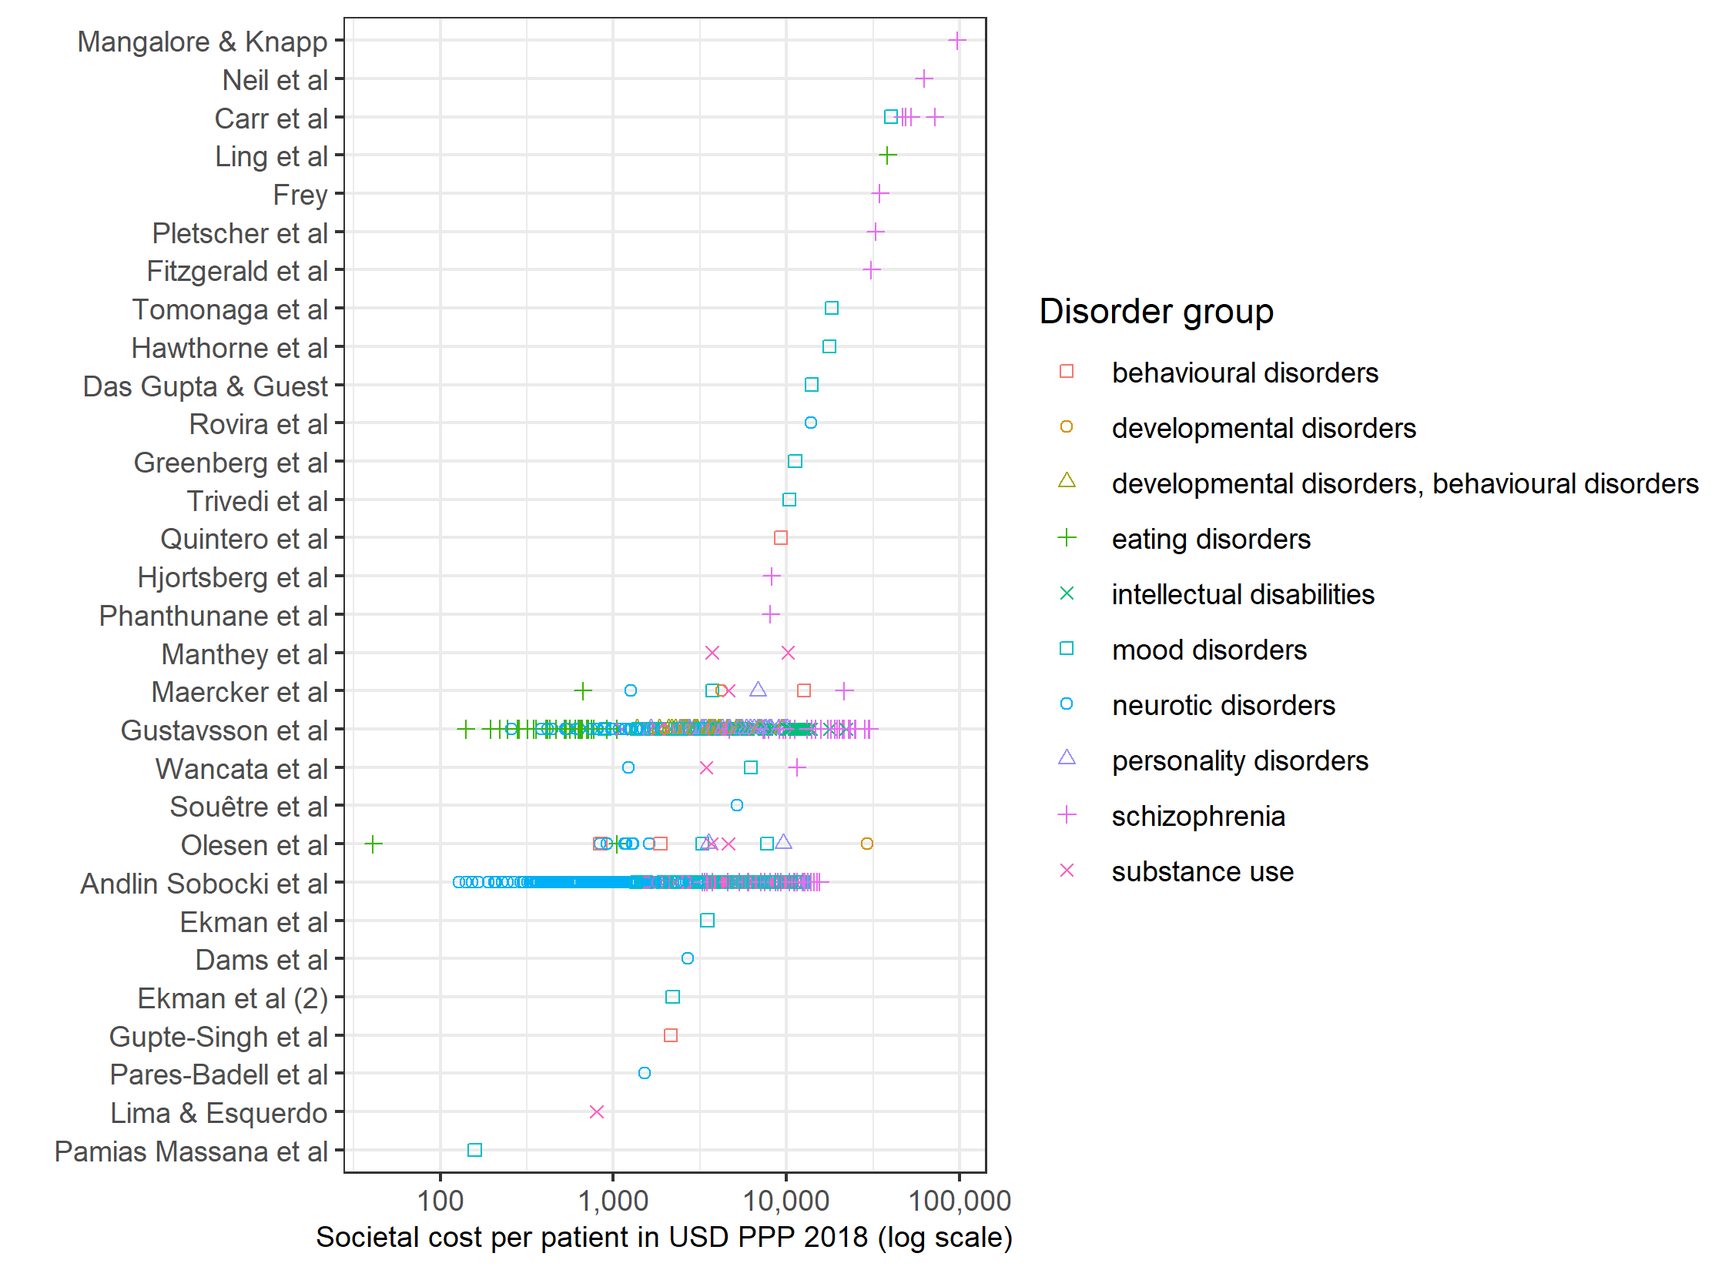
The figure shows the societal cost per patient in US dollars adjusted by country’s purchasing power parity and inflation until year 2018 (USD PPP 2018) by disorder group and study, ranked by USD PPP 2018. The x-axis is on a logarithmic scale. The estimates are illustrated with different symbols and colours depending on the disorder type.

eFigure 4: Societal cost per patient by disorder group
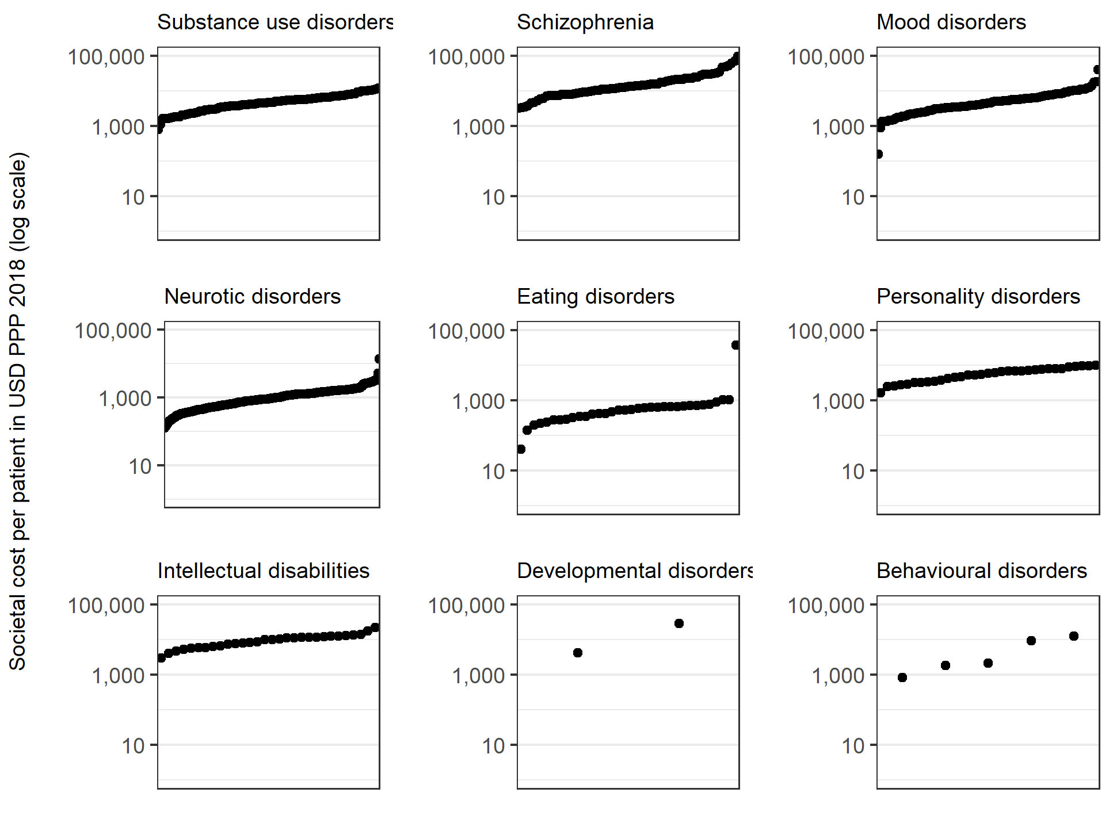
The figures show the societal cost per patient in US dollars adjusted by country’s purchasing power parity and inflation until year 2018 (USD PPP 2018), ranked by USD PPP 2018, for each disorder group. The y-axis is on a logarithmic scale.

eFigure 5: Societal cost per patient, ranked by USD PPP
Societal cost per patient in US dollars adjusted by country’s purchasing power parity and inflation until year 2018 (USD PPP 2018) by disorder group, ranked by USD PPP 2018
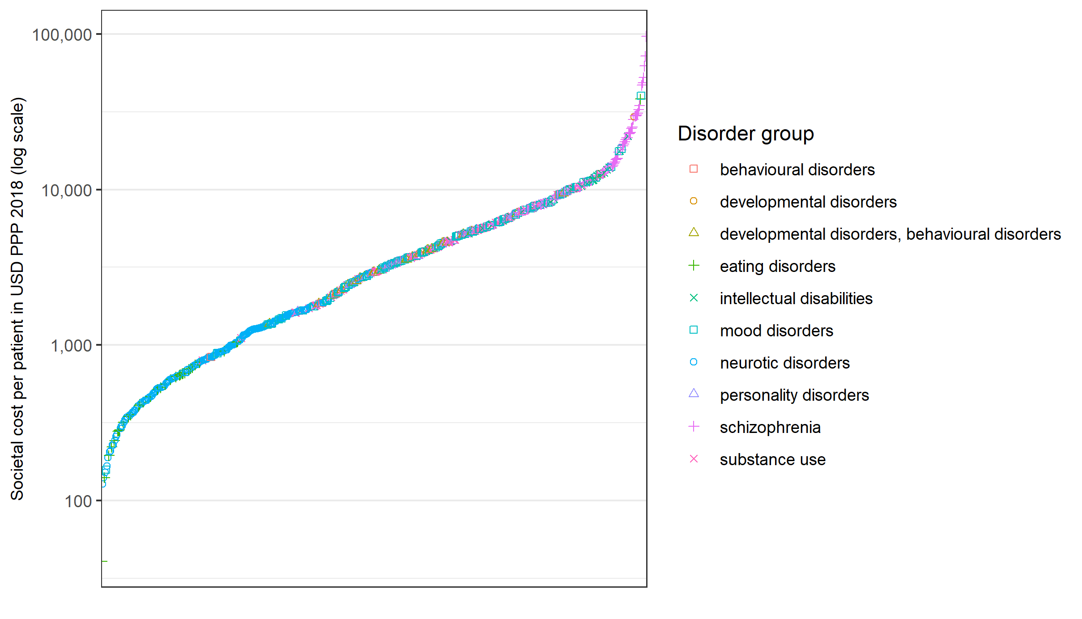

eFigure 6: Societal cost per patient without two multi-site studies
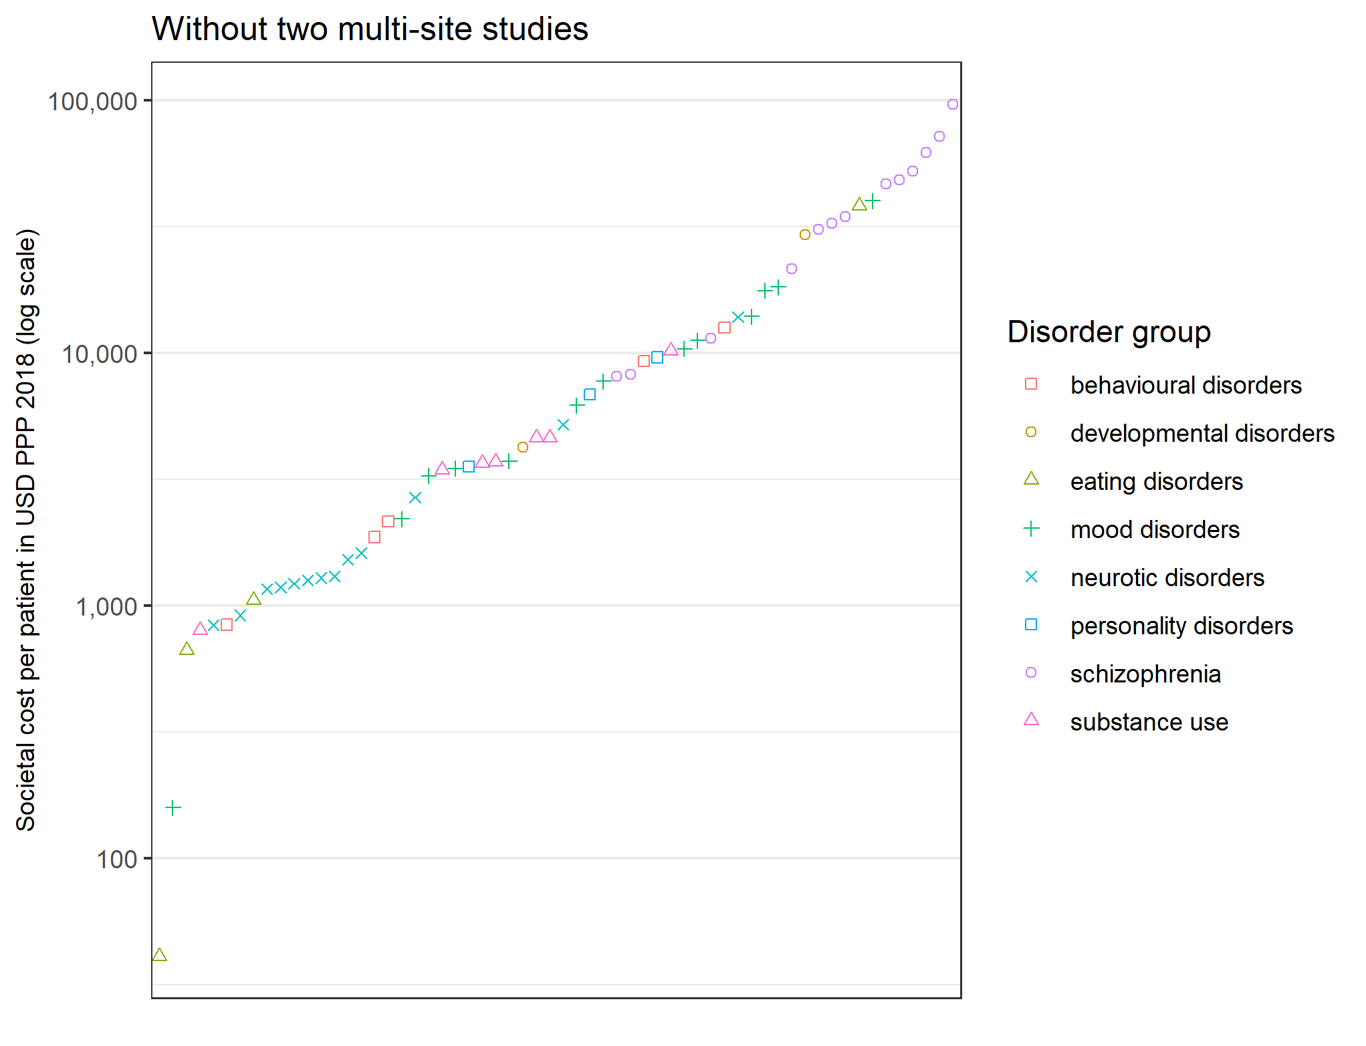
The figure shows the societal cost per patient in US dollars adjusted by country’s purchasing power parity and inflation until year 2018 (USD PPP 2018) by disorder group, ranked by USD PPP 2018, without two multi-site studies (Andlin-Sobocki et al., 2005; Gustavsson et al., 2011).

eFigure 7: Societal cost per patient by country without two multi-site studies
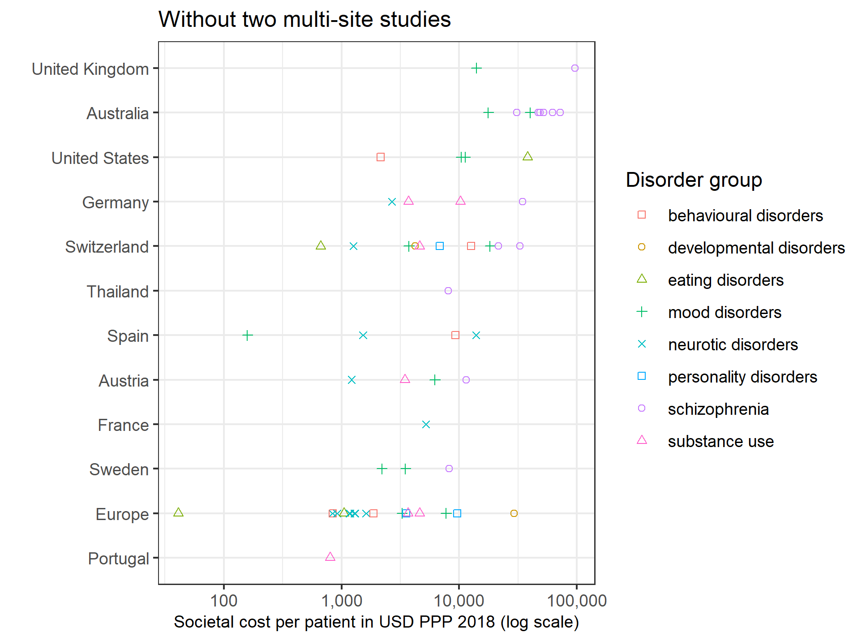
The figure shows the societal cost per patient in US dollars adjusted by country’s purchasing power parity and inflation until year 2018 (USD PPP 2018) by disorder group and country without two multi-site studies (Andlin-Sobocki et al., 2005; Gustavsson et al., 2011).

eFigure 8: Societal cost per patient according to quality reporting score
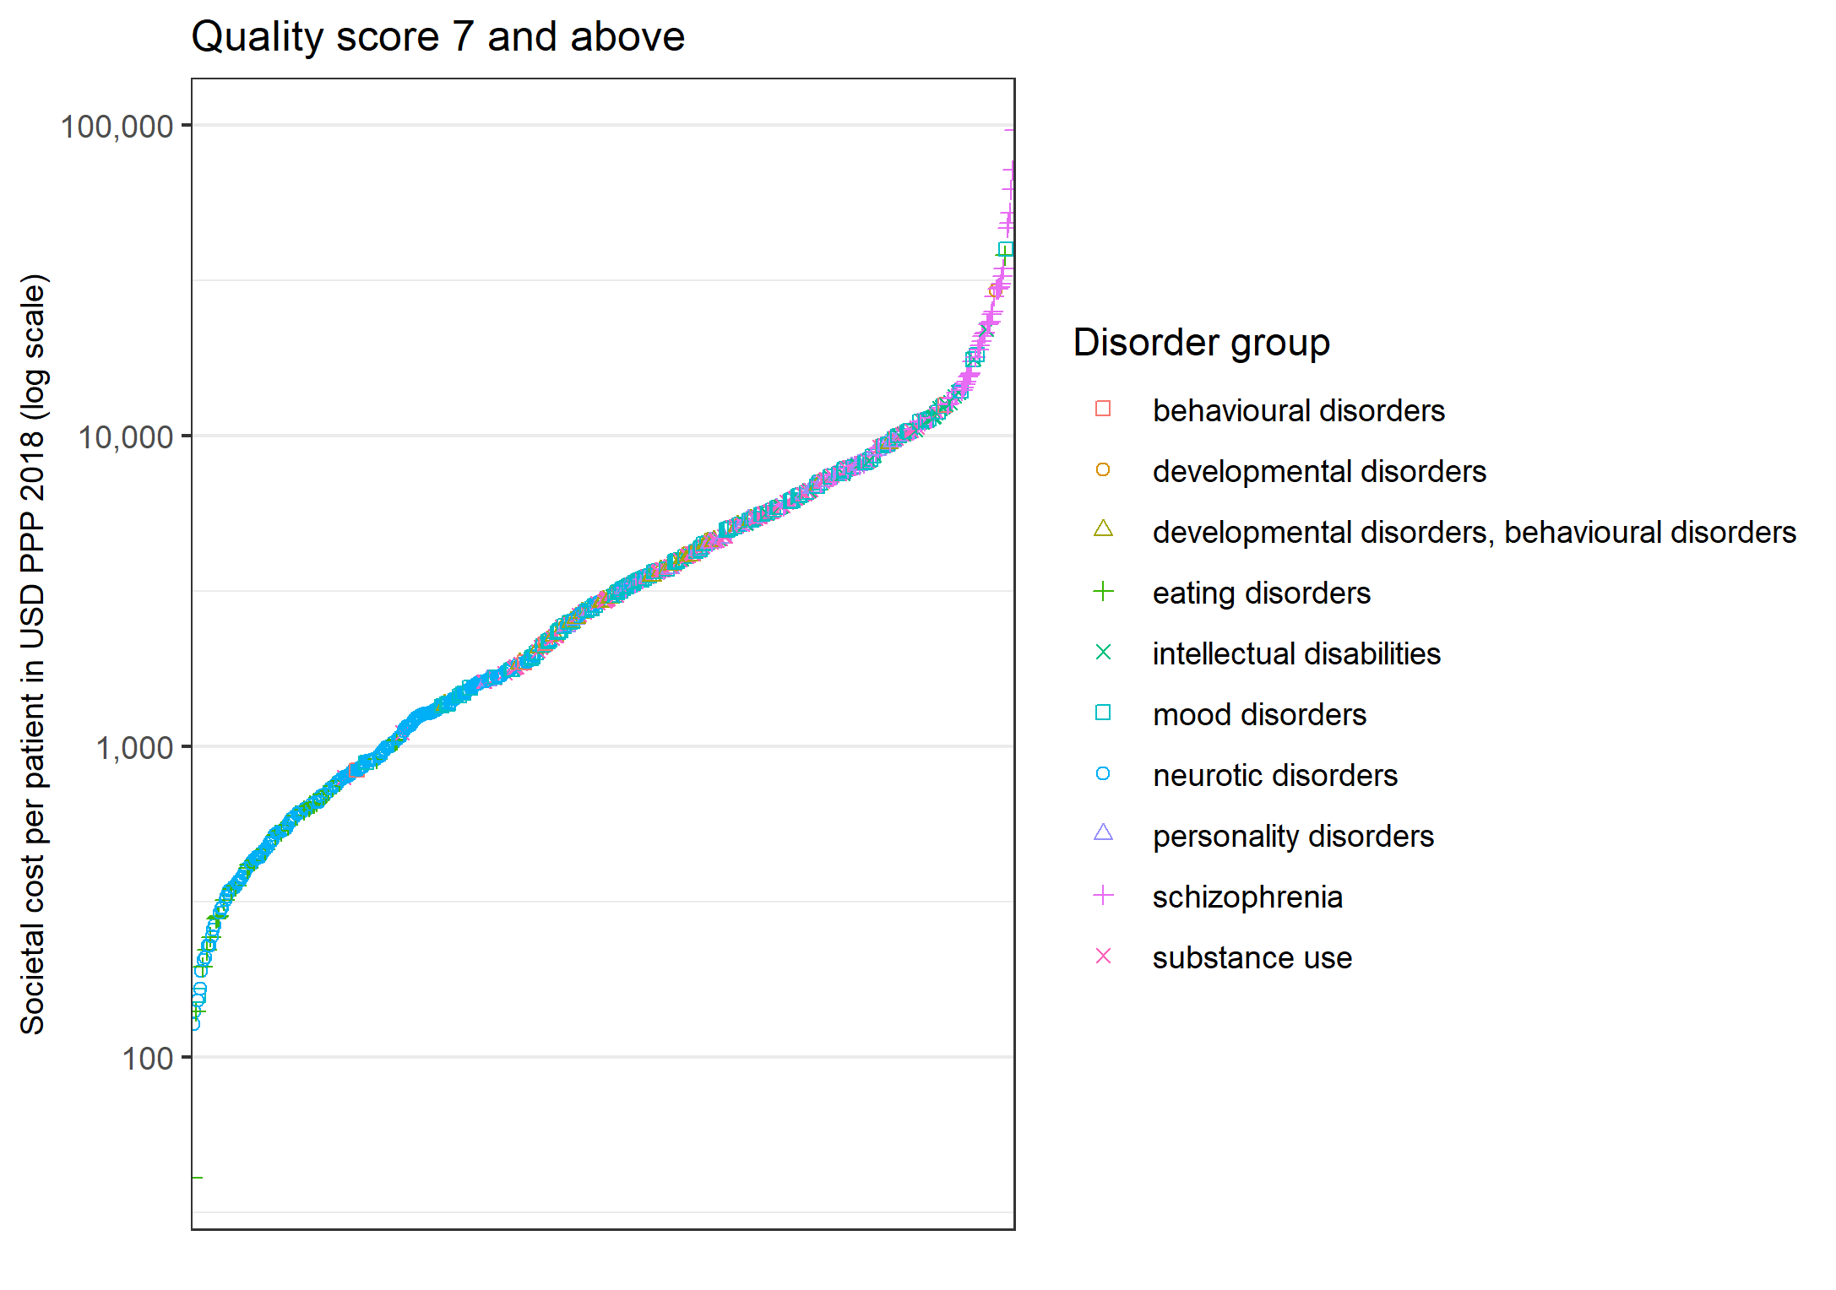
The figure shows the societal cost per patient in US dollars adjusted by country’s purchasing power parity and inflation until year 2018 (USD PPP 2018) by disorder group, ranked by USD PPP 2018 and restricted to studies with a quality reporting score of 7 and above.

eFigure 9: Societal cost by country according to quality reporting score
The figure shows the societal cost per patient in US dollars adjusted by country’s purchasing power parity and inflation until year 2018 (USD PPP 2018) by disorder group and country for studies with a quality reporting score of 7 and above.
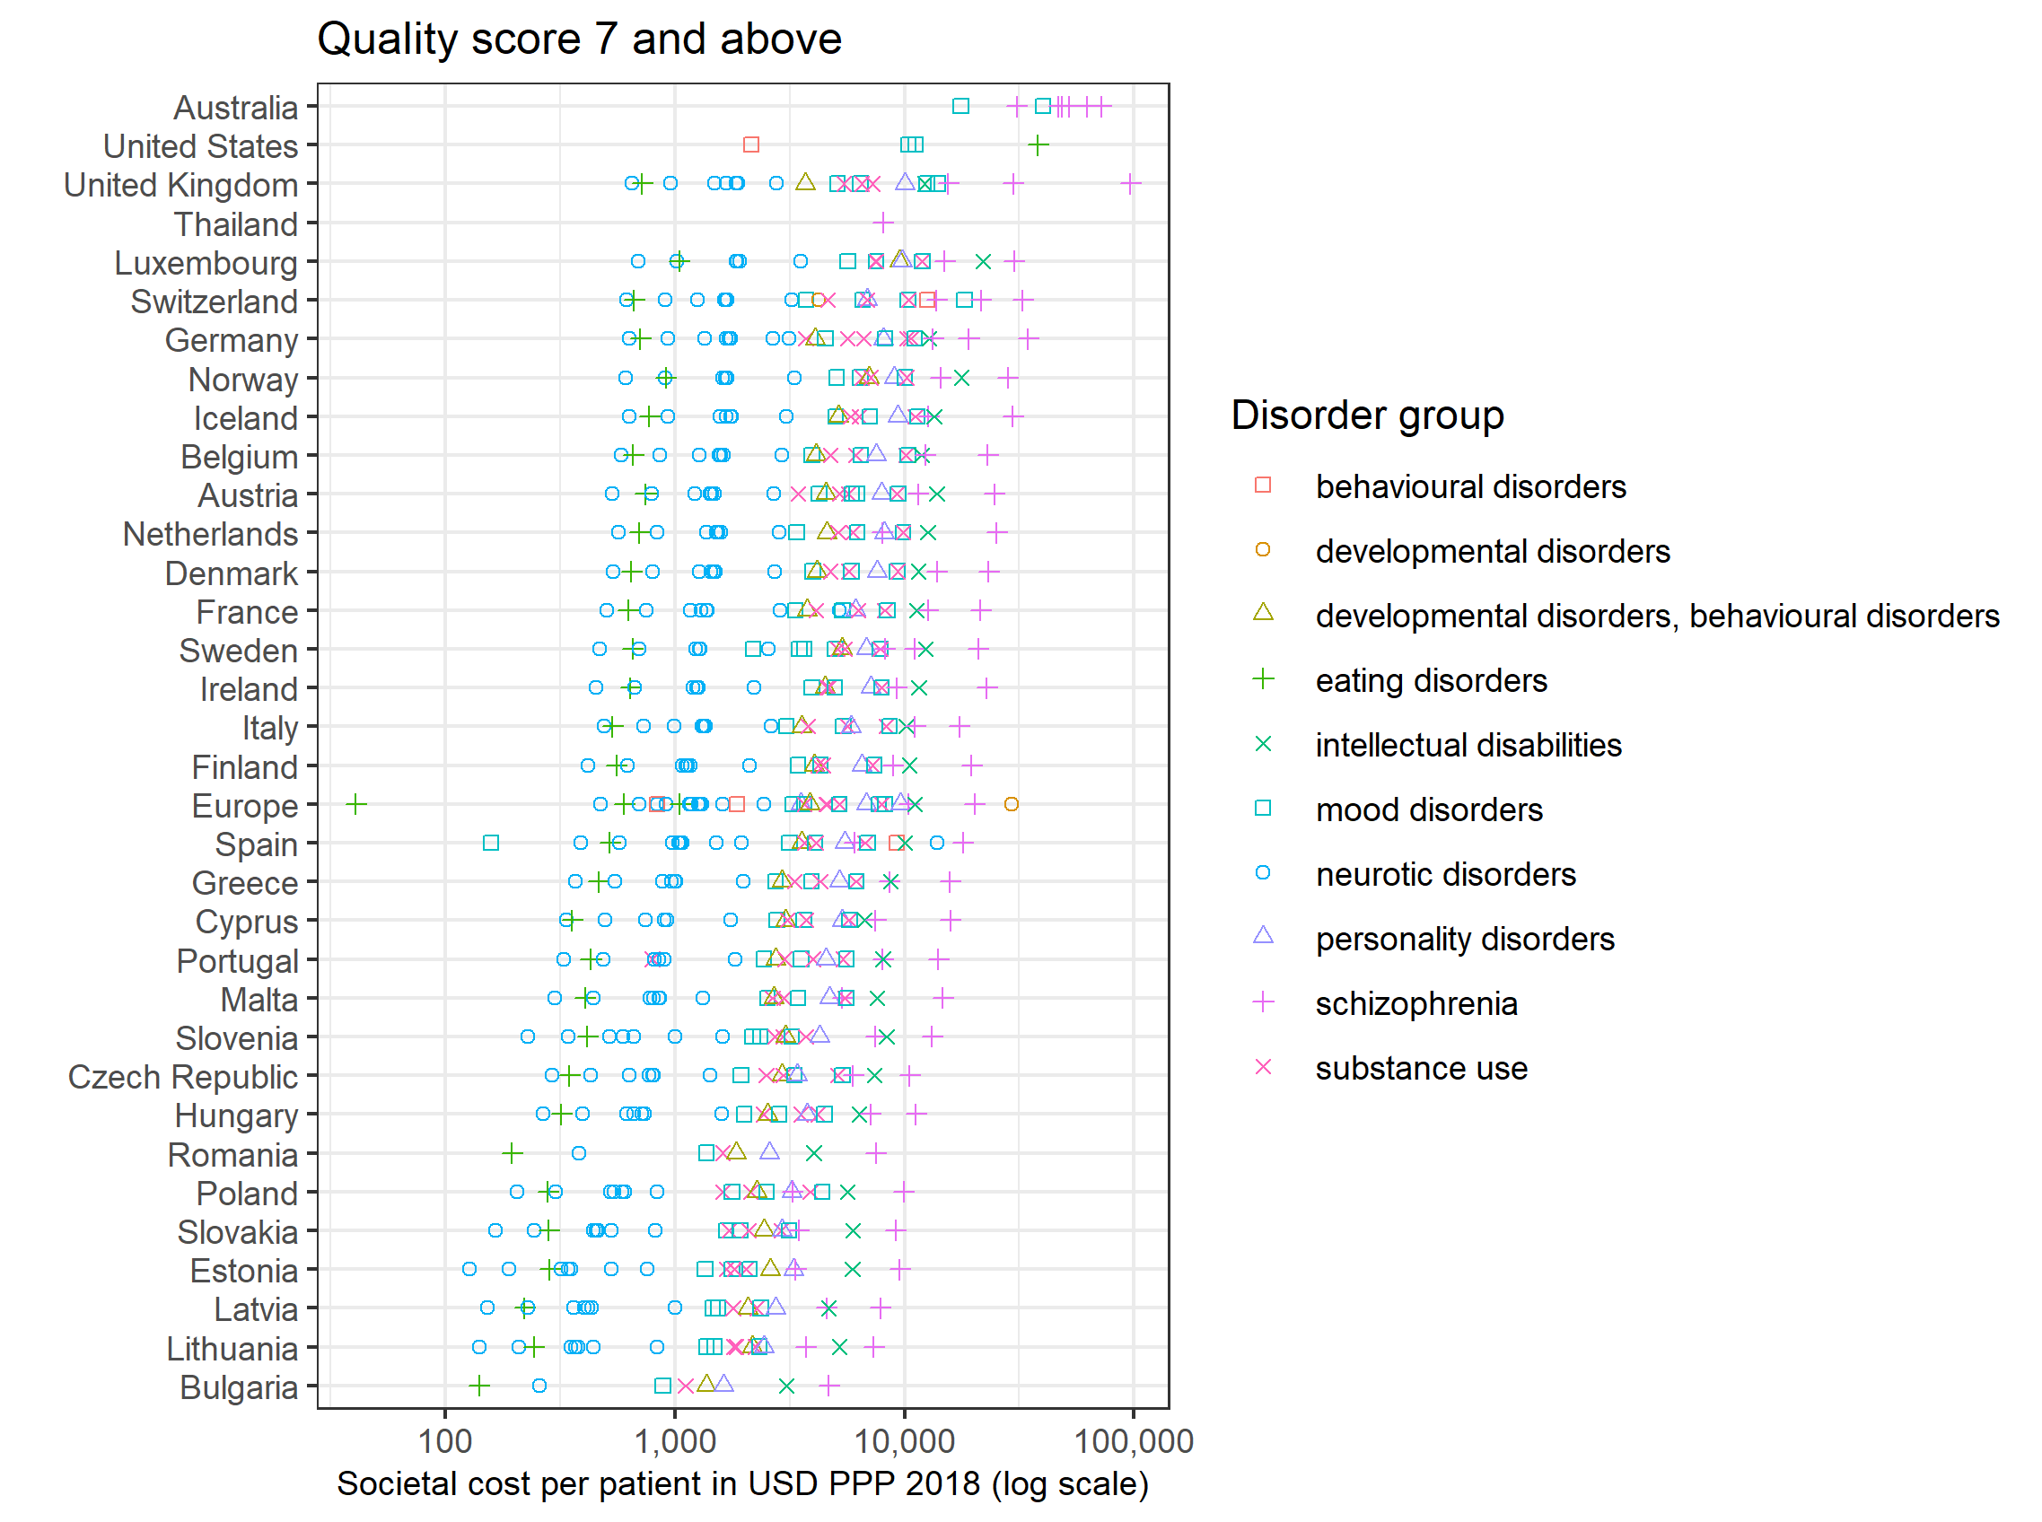

eFigure 10: Societal cost by study according to quality reporting score
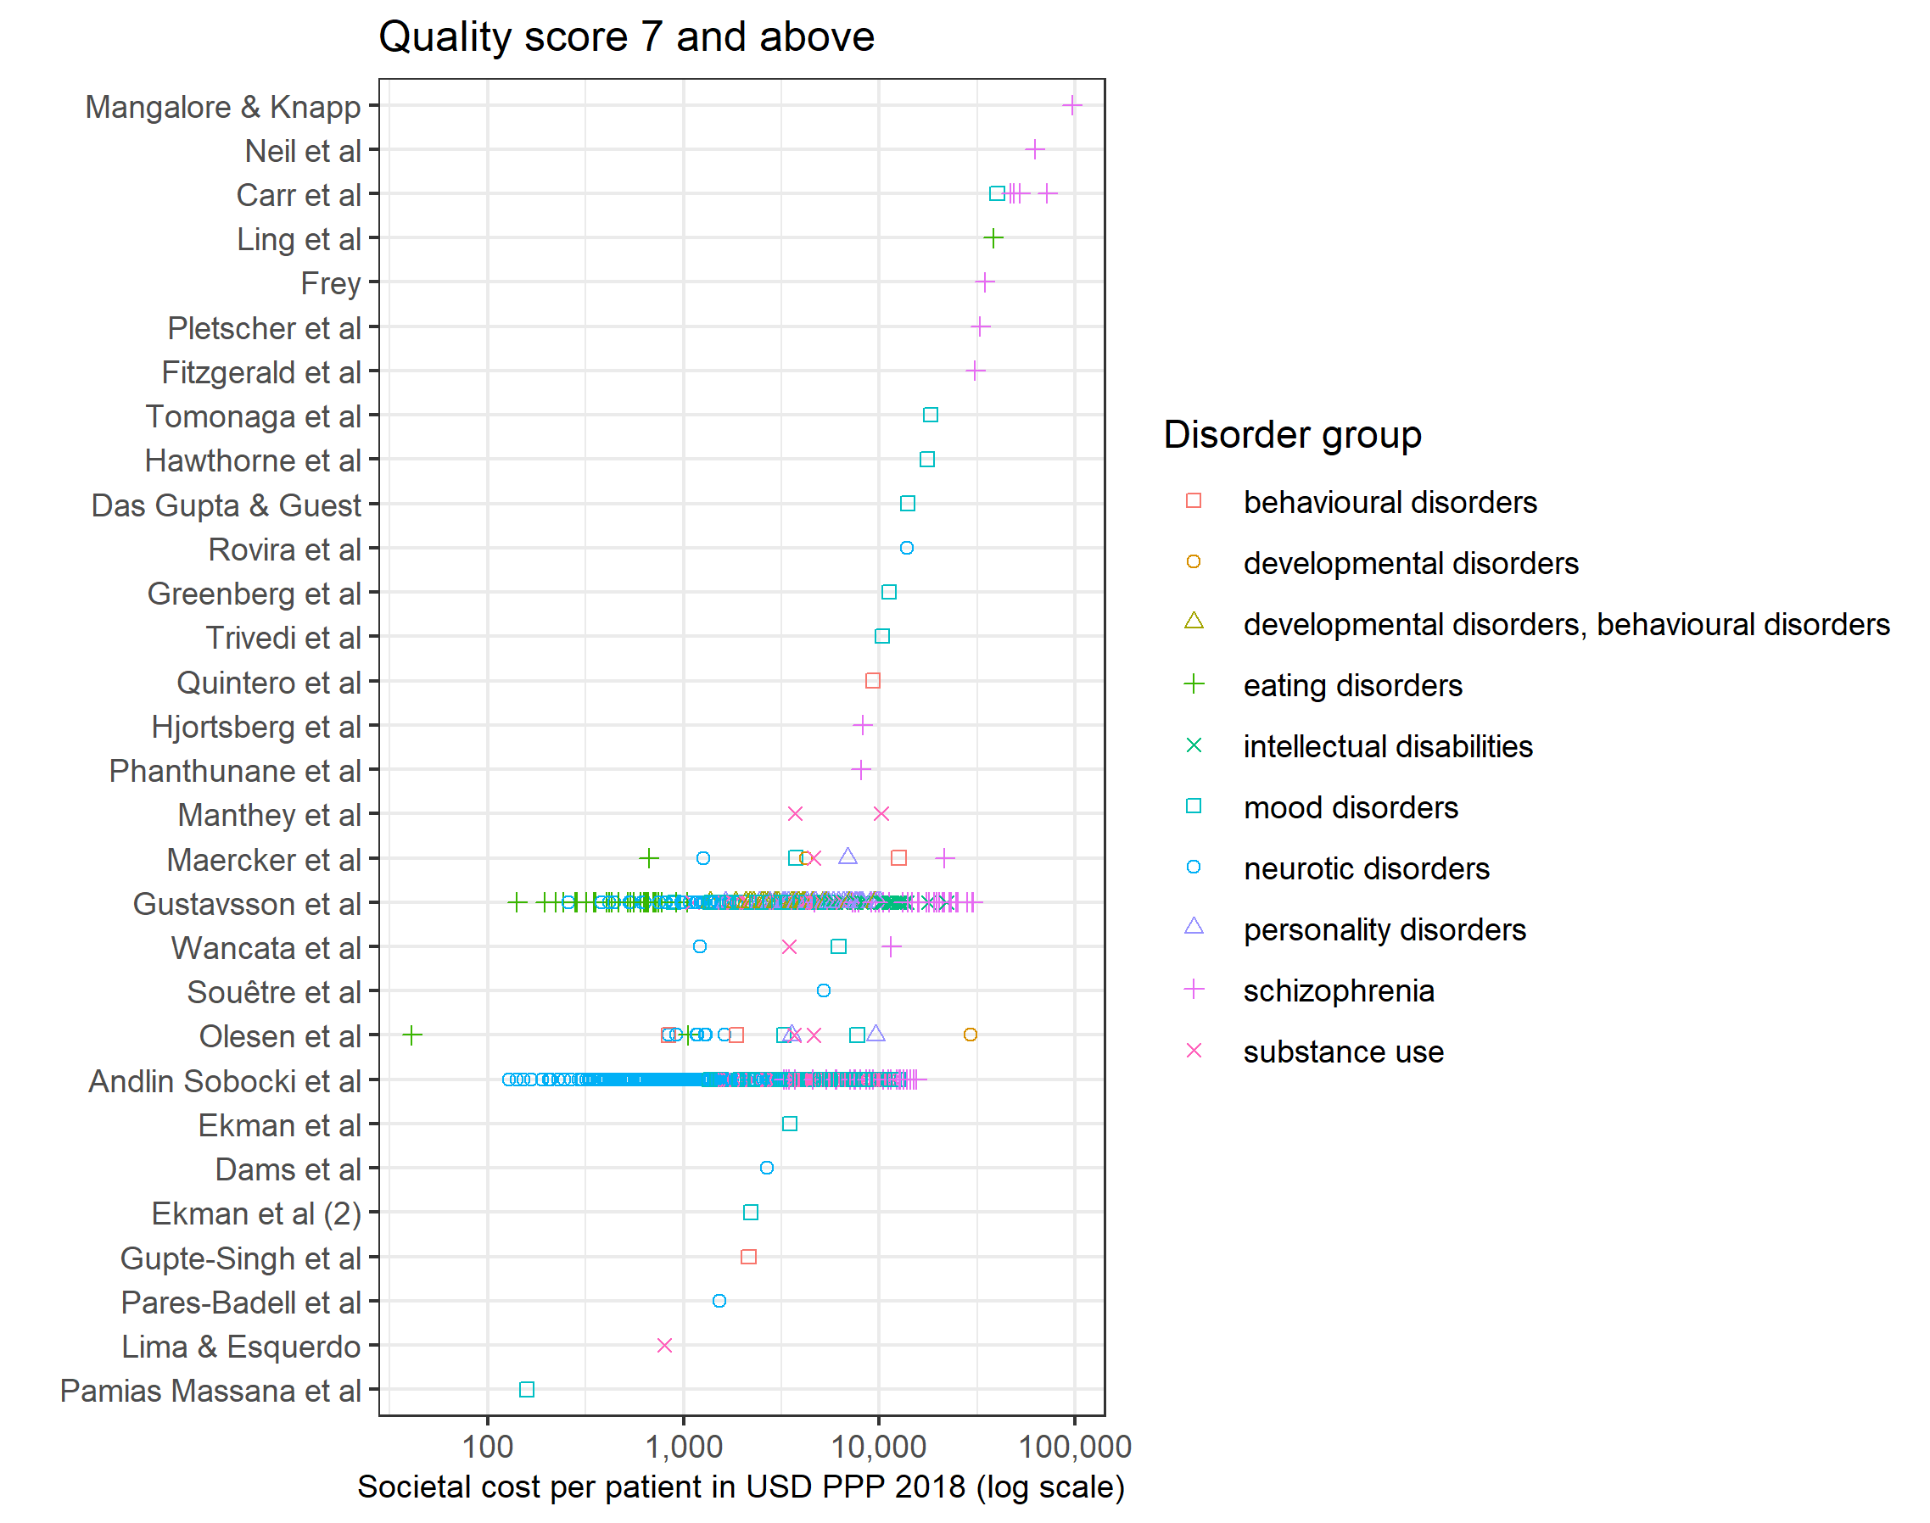
The figure shows the societal cost per patient in US dollars adjusted by country’s purchasing power parity and inflation until year 2018 (USD PPP 2018) by disorder group and study for studies with a quality reporting score of 7 and above. See Online Resource 2 for study references.

References
Andlin-Sobocki P, Jönsson B, Wittchen HU and Olesen J. (2005) Cost of disorders of the brain in Europe. European Journal of Neurology 12: 1-27.
Gustavsson A, Svensson M, Jacobi F, Allgulander C, Alonso J, Beghi E, Dodel R, Ekman M, Faravelli C, Fratiglioni L, Gannon B, Jones DH, Jennum P, Jordanova A, Jonsson L, Karampampa K, Knapp M, Kobelt G, Kurth T, Lieb R, Linde M, Ljungcrantz C, Maercker A, Melin B, Moscarelli M, Musayev A, Norwood F, Preisig M, Pugliatti M, Rehm J, Salvador-Carulla L, Schlehofer B, Simon R, Steinhausen HC, Stovner LJ, Vallat JM, Van den Bergh P, van Os J, Vos P, Xu W, Wittchen HU, Jonsson B, Olesen J and Group CD. (2011) Cost of disorders of the brain in Europe 2010. European Neuropsychopharmacology 21: 718-779.

