Supplemental Table 1. Characteristics of the studies included in the meta-analysis
No. | Principal author (year) | References | Country/Territory | Time of survey | Study design | Sampling method | Diagnostic criteria of BP | Source of patients | Sample size | Mean age (year) | Proportion of men (%) | Time-frame of SA | Quality score
1 | Duko B. (2018) | (Duko and Ayano, 2018) | Ethiopia | 2016 | Cross-sectional | Random | DSM-IV | NA | 272 | 32.6 | 72.1 | Lifetime | 5
2 | Bobo W. V. (2018) | (Bobo et al., 2018) | USA | 2009- | Cohort | NR | DSM-IV | NA | 1465 | 42.7 | 39.2 | Lifetime | 5
3 | Altamura A. C. (2018) | (Altamura et al., 2018) | Italy | NA | Cross-sectional | Consecutive | DSM-IV | Both | 1498 | NA | NA | Lifetime | 7
4 | Kattimani S. (2017) | (Kattimani et al., 2017) | India | 2012-2014 | Cross-sectional | Convenience | DSM-IV | Both | 150 | 37.8 | 48.0 | Lifetime | 6
5 | Cremaschi L. (2017) | (Cremaschi et al., 2017) | Italy | NA | Cross-sectional | NR | DSM-IV | Both | 362 | 48.6 | 47.5 | Lifetime | 5
6 | Bezerra S. (2017) | (Bezerra et al., 2017) | Finland | 2010-2014 | Cross-sectional | Convenience | DSM-IV | Outpatient | 120 | 43.5 | 23.3 | Lifetime | 8
7 | Bellivier F. (2017) | (Bellivier et al., 2017) | Multicenter (14 European countries) | 2002- | Cohort | NR | DSM-IV/ICD-10 | Both | 3390 | 44.6 | 44.5 | Lifetime | 5
8 | Baldessarini R. J. (2017) | (Baldessarini et al., 2017) | Italy | 2006-2011 | Cross-sectional | Consecutive | DSM-IV | Inpatient | 462 | NA | NA | Lifetime | 6
9 | Passos I. C. (2016) | (Passos et al., 2016) | USA | 2006-2009 | Cross-sectional | Convenience | DSM-IV | Outpatient | 284 | 36.7 | 33.8 | Lifetime | 5
10 | Kvitland L. R. (2016) | (Kvitland et al., 2016) | Norway | 2003-2013 | Cross-sectional | Consecutive | DSM-IV | Both | 101 | 31.1 | 39.6 | Lifetime | 6
11 | Jimenez E. (2016) | (Jimenez et al., 2016) | Spain | 1992- | Cohort | NR | DSM-IV | Outpatient | 215 | 48.6 | 46.0 | Lifetime | 5
12 | Izci F. (2016) | (Izci et al., 2016) | Turkey | 2013 | Cross-sectional | NR | DSM-IV | Outpatient | 101 | 35.7 | 70.3 | Lifetime | 4
13 | Gigante A. (2016) | (Gigante et al., 2016) | Brazil | NA | Cross-sectional | NR | DSM-IV | Outpatient | 577 | 40.7 | 29.5 | Lifetime | 4
14 | Berkol T. D. (2016) | (Berkol et al., 2016) | Turkey | 2013-2014 | Cross-sectional | NR | DSM-IV | Outpatient | 218 | 42.7 | 33.9 | Lifetime | 4
15 | Zimmerman M. (2015) | (Zimmerman et al., 2015) | USA | NA | Cross-sectional | NR | DSM-IV | Outpatient | 236 | 38.2 | 45.8 | Lifetime | 4
16 | Tundo A. (2015) | (Tundo et al., 2015) | Italy | 2002-2006 | Cross-sectional | Consecutive | DSM-IV | Outpatient | 407 | 39.3 | 34.4 | During episodes | 5
17 | Popovic D. (2015) | (Popovic et al., 2015) | Multicenter (6 European and 2 African Countries) | 2009-2010 | Cross-sectional | NR | DSM-IV | NA | 1170 | NA | NA | Lifetime | 5
18 | Kim J. S. (2015) | (Kim et al., 2015) | South Korea | 2004-2012 | Cohort | NR | DSM-IV | NA | 512 | 34.9 | 30.5 | Lifetime | 4
19 | Henry C. (2015) | (Henry et al., 2015) | France | NA | Cohort | NR | DSM-IV | Outpatient | 839 | 41.6 | 42.3 | Lifetime | 4
20 | Dell'Osso B. (2015) | (Dell'Osso et al., 2015) | USA | 2000-2011 | Cross-sectional | NR | DSM-IV | Outpatient | 503 | 35.6 | 41.7 | Lifetime | 4
21 | Caribe A. (2015) | (Caribe et al., 2015) | Brazil | 2012-2014 | Cross-sectional | NR | DSM-IV | Outpatient | 164 | 43.0 | 27.4 | Lifetime | 7
22 | Sandberg J. V. (2014) | (Sandberg et al., 2014) | Sweden | 2005-2008 | Cohort | NR | ADE | Outpatient | 120 | 39.6 | 40.8 | Lifetime | 4
23 | Holma K. M. (2014) | (Holma et al., 2014) | Finland | NA | Cohort | NR | DSM-IV | Both | 176 | NA | 48.3 | Lifetime | 6
24 | Finseth P. I. (2014) | (Finseth et al., 2014) | Norway | NA | Cross-sectional | NR | DSM-IV | Both | 526 | NA | NA | Lifetime | 4
25 | Berutti M. (2014) | (Berutti et al., 2014) | Brazil | NA | Cross-sectional | Consecutive | DSM-IV | Outpatient | 488 | 40.6 | 28.7 | Lifetime | 6
26 | Benedetti F. (2014) | (Benedetti et al., 2014) | Italy | NA | Cross-sectional | Consecutive | DSM-IV | Inpatient | 136 | 46.4 | 31.6 | Lifetime | 5
27 | Aas M. (2014) | (Aas et al., 2014) | Norway & France | NA | Cross-sectional | NR | DSM-IV | Both | 587 | 40.6 | 39.9 | Lifetime | 5
28 | Tamminga C. A. (2013) | (Tamminga et al., 2013) | USA | 2008-2012 | Cross-sectional | NR | DSM-IV | NA | 295 | NA | NA | Lifetime | 4
29 | Shabani A. (2013) | (Shabani et al., 2013) | Iran | 2008-2011 | Cohort | Consecutive | DSM-IV | Inpatient | 100 | 35.9 | 67.0 | Lifetime | 6
30 | Pawlak J. (2013) | (Pawlak et al., 2013) | Poland | NA | Cross-sectional | NR | DSM-IV | NA | 495 | NA | 41.8 | Lifetime | 5
31 | Parker G. (2013) | (Parker et al., 2013) | Australia | 2008-2012 | Cross-sectional | NR | DSM-IV | NA | 131 | NA | NA | Lifetime | 4
32 | Mitchell P. B. (2013) | (Mitchell et al., 2013) | Australia | 2007 | Cross-sectional | Randomly | DSM-IV | Outpatient | 217 | NA | NA | 1 year | 6
33 | Kenneson A. (2013) | (Kenneson et al., 2013) | USA | 2001-2003 | Cross-sectional | NA | DSM-IV | NA | 158 | NA | NA | Lifetime | 5
34 | Eroglu M. Z. (2013) | (Eroglu et al., 2013) | Turkey | NA | Cohort | Consecutive | DSM-IV | Outpatient | 122 | 35.6 | 50.8 | Lifetime | 6
35 | Coryell W. (2013) | (Coryell et al., 2013) | USA | 1978-1981 | Cohort | NR | RDC | Both | 427 | 36.3 | 41.9 | During episode | 4
36 | Bani-Fatemi A. (2013) | (Bani-Fatemi et al., 2013) | Canada | NA | Cross-sectional | NR | DSM-IV | NA | 341 | 35.6 | 38.7 | Lifetime | 5
37 | Song J. Y. (2012) | (Song et al., 2012) | South Korea | NA | Cross-sectional | NR | DSM-IV | NA | 212 | 32.2 | 45.8 | Lifetime | 5
38 | Nery-Fernandes F. (2012) | (Nery-Fernandes et al., 2012) | Brazil | 2003-2009 | Cross-sectional | Consecutive | DSM-IV | Outpatient | 268 | 40.5 | 31.7 | Lifetime | 8
39 | de Abreu L. N. (2012) | (de Abreu et al., 2012) | Brazil | 2006-2008 | Cross-sectional | NR | DSM-IV | Outpatient | 108 | 41.4 | 33.3 | Lifetime | 4
40 | D'Ambrosio V. (2012) | (D'Ambrosio et al., 2012) | Italy | 2006-2011 | Cross-sectional | Consecutive | DSM | Both | 211 | 48.4 | 39.3 | Lifetime | 6
41 | Brietzke E. (2012) | (Brietzke et al., 2012) | Brazil | NA | Cohort | NR | DSM-IV | Outpatient | 339 | 41.5 | 28.9 | Lifetime | 4
42 | Baldessarini R. J. (2012) | (Baldessarini et al., 2012) | Multicenter (3 European and 2 North American Countries) | NA | Cohort | NR | DSM-IV | NA | 1368 | 43.5 | 44.6 | Lifetime | 6
43 | Mitchell P. B. (2011) | (Mitchell et al., 2011) | Australia | NA | Cross-sectional | NR | DSM-IV | NA | 244 | NA | 36.1 | Lifetime | 5
44 | Karakus G. (2011) | (Karakus and Tamam, 2011) | Turkey | 2006-2008 | Cross-sectional | Consecutive | DSM-IV | Outpatient | 124 | 33.9 | 49.2 | Lifetime | 6
45 | Dervic K. (2011) | (Dervic et al., 2011) | USA | NA | Cross-sectional | NR | DSM-III | NA | 200 | 35.6 | 40.5 | Lifetime | 5
46 | Schaffer A. (2010) | (Schaffer et al., 2010) | Canada | 2002 | Cross-sectional | Random | DSM-IV | Outpatient | 467 | 37.6 | 44.1 | Lifetime | 7
47 | Joyce P. R. (2010) | (Joyce et al., 2010) | New Zealand | NA | Cross-sectional | Convenience | DSM-IV | Outpatient | 110 | NA | NA | Lifetime | 6
48 | Gomes F. A. (2010) | (Gomes et al., 2010) | Brazil | 2004-2007 | Cross-sectional | Consecutive | DSM-IV | Outpatient | 255 | 41.5 | 27.5 | Lifetime | 6
49 | Bolton J. M. (2010) | (Bolton and Robinson, 2010) | USA | 2004-2005 | Cross-sectional | NR | DSM-IV | NA | 2587 | NA | NA | Lifetime | 6
50 | Swann A. C. (2009) | (Swann et al., 2009) | USA | NA | Cross-sectional | Convenience | DSM-IV | NA | 112 | 36.1 | 53.6 | Lifetime | 5
51 | Sanchez-Gistau V. (2009) | (Sanchez-Gistau et al., 2009) | Spain | NA | Cohort | NR | DSM-IV | NA | 390 | 41.8 | 45.4 | Lifetime | 5
52 | Neves F. S. (2009) | (Neves et al., 2009) | NA | 2005-2007 | Cross-sectional | Consecutive | DSM-IV | Both | 239 | 40.9 | 28.5 | Lifetime | 5
53 | Mitchell P. B. (2009) | (Mitchell et al., 2009) | Australia | 2000- | Cohort | NR | DSM-IV | Outpatient | 217 | 38.6 | 44.7 | Lifetime | 6
54 | Fiedorowicz J. G. (2009) | (Fiedorowicz et al., 2009) | USA | NA | Cohort | NR | DSM-IV | NA | 435 | 36.3 | 42.5 | Lifetime | 5
55 | Nakagawa A. (2008) | (Nakagawa et al., 2008) | NA | NA | Cross-sectional | NR | DSM-III/DSM-IV | Both | 116 | 38.5 | 34.5 | Lifetime | 5
56 | Manchia M. (2008) | (Manchia et al., 2008) | Italy | NA | Cross-sectional | NR | RDC | Outpatient | 181 | 42.8 | 42.0 | Lifetime | 4
57 | Kim B. (2008) | (Kim et al., 2008) | South Korea | NA | Cross-sectional | NR | DSM-IV | NA | 169 | 37.5 | 44.4 | Lifetime | 5
58 | Gonzalez V. M. (2008) | (Gonzalez, 2008) | USA | NA | Cohort | Random/Convenience | ICD-9 | NA | 297 | NA | NA | Lifetime/1 year | 5
59 | Ghanizadeh A. (2008) | (Ghanizadeh and Sahraian, 2008) | Iran | NA | Cross-sectional | Random | DSM-IV | Inpatient | 176 | 29.7 | 61.9 | Lifetime | 5
60 | Cardoso B. M. (2008) | (Cardoso et al., 2008) | Brazil | 2003-2007 | Cross-sectional | Consecutive | DSM-IV | Outpatient | 186 | 42.80 | 29.0 | Lifetime | 6
61 | Azorin J. M. (2008) | (Azorin et al., 2008) | France | 2000-2002 | Cross-sectional | Consecutive | DSM-IV | Inpatient | 1090 | 43 | 42.3 | Lifetime | 5
62 | Romero S. (2007) | (Romero et al., 2007) | Spain | 2001-2004 | Cohort | NR | DSM-IV | Outpatient | 359 | NA | NA | Lifetime | 5
63 | Valtonen H. (2005) | (Valtonen et al., 2005) | Finland | 2002-2003 | Cohort | NR | DSM-IV | Both | 191 | 37.7 | 47.1 | During episode | 7
64 | Negash A. (2005) | (Negash et al., 2005) | Ethiopia | NA | Cross-sectional | NR | DSM-IV | Outpatient | 290 | NA | NA | Lifetime | 5
65 | Engström C. (2004) | (Engström et al., 2004) | Sweden | NA | Cross-sectional | NR | DSM-IV | Both | 100 | 55.8 | 40.0 | Lifetime | 4
66 | Comtois K. A. (2004) | (Comtois et al., 2004) | USA | 1996-2003 | Cross-sectional | NR | DSM-IV | Inpatient | 1938 | 37.8 | 54.0 | Lifetime | 6
67 | Henry C. (2003) | (Henry et al., 2003) | France | NA | Cross-sectional | Consecutive | DSM-IV | Inpatient | 318 | 53.3 | 40.9 | Lifetime | 5
68 | Dalton E. J. (2003) | (Dalton et al., 2003) | Canada | 1996-2001 | Cross-sectional | Convenience | DSM-IV | NA | 336 | 35.4 | 38.4 | Lifetime | 5
69 | Akiskal H. S. (2003) | (Akiskal et al., 2003) | France | NA | Cohort | Consecutive | DSM-IV | Both | 196 | 45.5 | 26.5 | Lifetime/1year | 6
70 | Leverich G. S. (2002) | (Leverich et al., 2002) | Germany & USA | NA | Cohort | Consecutive | DSM-IV | Outpatient | 651 | 41.0 | 42.1 | Lifetime | 5
71 | Souery D. (2001) | (Souery et al., 2001) | Multicenter (9 European Countries) | NA | Cross-sectional | NR | DSM-III/DSM-IV | NA | 527 | NA | NA | Lifetime | 4
72 | Lopez P. (2001) | (Lopez et al., 2001) | Spain | 1994-1996 | Cross-sectional | NR | DSM-III | Both | 169 | 29.0 | 42.0 | Lifetime | 5
73 | Perugi G. (2000) | (Perugi et al., 2000) | Italy | NA | Cross-sectional | Consecutive | DSM-III | Both | 320 | 38.4 | 44.1 | Lifetime | 5
74 | Kruger S. (2000) | (Kruger et al., 2000) | Germany | NA | Cross-sectional | NR | DSM-III | Inpatient | 143 | 44.0 | 37.1 | Lifetime | 4
75 | Tsai S. Y. (1999) | (Tsai et al., 1999) | Taiwan | 1995-1996 | Cohort | NR | DSM-III | NA | 101 | 44.8 | 35.6 | Lifetime | 4
76 | Furlong R. A. (1998) | (Furlong et al., 1998) | UK | NA | Cross-sectional | NR | RDC | Both | 116 | NA | 45.7 | Lifetime | 5
77 | Bellivier F. (1998) | (Bellivier et al., 1998) | France | NA | Cross-sectional | Consecutive | DSM-III/RDC | Inpatient | 152 | 46.9 | 44.7 | Lifetime | 6
78 | Chen Y. W. (1996) | (Chen and Dilsaver, 1996) | USA | NA | Cross-sectional | NR | DSM-III | NA | 168 | NA | 31.0 | Lifetime | 4
79 | Endicott J. (1985) | (Endicott et al., 1985) | NA | 1983- | Cross-sectional | NR | RDC | Both | 178 | NA | 41.0 | Lifetime | 4
ADE=Affective Disorder Evaluation; Both=inpatients and outpatients; DSM=Diagnostic and Statistical Manual of Mental Disorders; ICD=International Statistical Classification of Diseases and Related Health Problems; NR=Nor report; RDC=Research Diagnostic Criteria; SA=suicide attempt.

Supplemental Table 2. PRISMA Checklist
Section/topic | # | Checklist item | Reported on page #
TITLE
Title | 1 | Identify the report as a systematic review, meta-analysis, or both. | 1
ABSTRACT
Structured summary | 2 | Provide a structured summary including, as applicable: background; objectives; data sources; study eligibility criteria, participants, and interventions; study appraisal and synthesis methods; results; limitations; conclusions and implications of key findings; systematic review registration number. | 2
INTRODUCTION
Rationale | 3 | Describe the rationale for the review in the context of what is already known. | 3
Objectives | 4 | Provide an explicit statement of questions being addressed with reference to participants, interventions, comparisons, outcomes, and study design (PICOS). | 4
METHODS
Protocol and registration | 5 | Indicate if a review protocol exists, if and where it can be accessed (e.g., Web address), and, if available, provide registration information including registration number. | 5
Eligibility criteria | 6 | Specify study characteristics (e.g., PICOS, length of follow-up) and report characteristics (e.g., years considered, language, publication status) used as criteria for eligibility, giving rationale. | 5
Information sources | 7 | Describe all information sources (e.g., databases with dates of coverage, contact with study authors to identify additional studies) in the search and date last searched. | 5
Search | 8 | Present full electronic search strategy for at least one database, including any limits used, such that it could be repeated. | 5
Study selection | 9 | State the process for selecting studies (i.e., screening, eligibility, included in systematic review, and, if applicable, included in the meta-analysis). | 5
Data collection process | 10 | Describe method of data extraction from reports (e.g., piloted forms, independently, in duplicate) and any processes for obtaining and confirming data from investigators. | 6
Data items | 11 | List and define all variables for which data were sought (e.g., PICOS, funding sources) and any assumptions and simplifications made. | 6
Risk of bias in individual studies | 12 | Describe methods used for assessing risk of bias of individual studies (including specification of whether this was done at the study or outcome level), and how this information is to be used in any data synthesis. | 7
Summary measures | 13 | State the principal summary measures (e.g., risk ratio, difference in means). | 7
Synthesis of results | 14 | Describe the methods of handling data and combining results of studies, if done, including measures of consistency (e.g., I²) for each meta-analysis. | 7
Risk of bias across studies | 15 | Specify any assessment of risk of bias that may affect the cumulative evidence (e.g., publication bias, selective reporting within studies). | 7
Additional analyses | 16 | Describe methods of additional analyses (e.g., sensitivity or subgroup analyses, meta-regression), if done, indicating which were pre-specified. | 7
RESULTS
Study selection | 17 | Give numbers of studies screened, assessed for eligibility, and included in the review, with reasons for exclusions at each stage, ideally with a flow diagram. | 22
Study characteristics | 18 | For each study, present characteristics for which data were extracted (e.g., study size, PICOS, follow-up period) and provide the citations. | 7
Risk of bias within studies | 19 | Present data on risk of bias of each study and, if available, any outcome level assessment (see item 12). | 8
Results of individual studies | 20 | For all outcomes considered (benefits or harms), present, for each study: (a) simple summary data for each intervention group (b) effect estimates and confidence intervals, ideally with a forest plot. | 8
Synthesis of results | 21 | Present results of each meta-analysis done, including confidence intervals and measures of consistency. | 8
Risk of bias across studies | 22 | Present results of any assessment of risk of bias across studies (see Item 15). | 8
Additional analysis | 23 | Give results of additional analyses, if done (e.g., sensitivity or subgroup analyses, meta-regression [see Item 16]). | 9
DISCUSSION
Summary of evidence | 24 | Summarize the main findings including the strength of evidence for each main outcome; consider their relevance to key groups (e.g., healthcare providers, users, and policy makers). | 9-11
Limitations | 25 | Discuss limitations at study and outcome level (e.g., risk of bias), and at review-level (e.g., incomplete retrieval of identified research, reporting bias). | 12
Conclusions | 26 | Provide a general interpretation of the results in the context of other evidence, and implications for future research. | 13
FUNDING
Funding | 27 | Describe sources of funding for the systematic review and other support (e.g., supply of data); role of funders for the systematic review. | 14

Supplemental Table 3. Quality assessment of the studies included in the meta-analysis
NO. | Study | 1. Is the target population clearly defined? | 2. Was either of the following ascertainment methods used [must be one or the other]?(1) probability sampling, or (2) entire population surveyed | 3. Is the response rate >70% | 4. Are non-responders clearly described? | 5. Is the sample representative of the target population? | 6. Were data collection methods standardized? | 7. Were validated criteria used to assess for the presence/absence of disease? | 8. Are the estimates of prevalence given with confidence intervals and in detail by subgroup (if applicable)? | Total score
1 | Duko B. (2018) | 1 | 1 | 0 | 0 | 1 | 1 | 1 | 0 | 5
2 | Bobo W. V. (2018) | 1 | 0 | 0 | 0 | 1 | 1 | 1 | 1 | 5
3 | Altamura A. C. (2018) | 1 | 1 | 1 | 0 | 1 | 1 | 1 | 1 | 7
4 | Kattimani S. (2017) | 1 | 1 | 0 | 0 | 1 | 1 | 1 | 1 | 6
5 | Cremaschi L. (2017) | 1 | 0 | 0 | 0 | 1 | 1 | 1 | 1 | 5
6 | Bezerra S. (2017) | 1 | 1 | 1 | 1 | 1 | 1 | 1 | 1 | 8
7 | Bellivier F. (2017) | 1 | 0 | 0 | 0 | 1 | 1 | 1 | 1 | 5
8 | Baldessarini R. J. (2017) | 1 | 1 | 0 | 0 | 1 | 1 | 1 | 1 | 6
9 | Passos I. C. (2016) | 1 | 1 | 0 | 0 | 1 | 1 | 1 | 0 | 5
10 | Kvitland L. R. (2016) | 1 | 1 | 0 | 0 | 1 | 1 | 1 | 1 | 6
11 | Jimenez E. (2016) | 1 | 0 | 0 | 0 | 1 | 1 | 1 | 1 | 5
12 | Izci F. (2016) | 1 | 0 | 0 | 0 | 1 | 1 | 1 | 0 | 4
13 | Gigante A. (2016) | 1 | 0 | 0 | 0 | 1 | 1 | 1 | 0 | 4
14 | Berkol T. D. (2016) | 1 | 0 | 0 | 0 | 1 | 1 | 1 | 0 | 4
15 | Zimmerman M. (2015) | 1 | 0 | 0 | 0 | 1 | 1 | 1 | 0 | 4
16 | Tundo A. (2015) | 1 | 1 | 0 | 0 | 1 | 1 | 1 | 0 | 5
17 | Popovic D. (2015) | 1 | 0 | 0 | 0 | 1 | 1 | 1 | 1 | 5
18 | Kim J. S. (2015) | 1 | 0 | 0 | 0 | 1 | 1 | 1 | 0 | 4
19 | Henry C. (2015) | 1 | 0 | 0 | 0 | 1 | 1 | 1 | 0 | 4
20 | Dell'Osso B. (2015) | 1 | 0 | 0 | 0 | 1 | 1 | 1 | 0 | 4
21 | Caribe A. (2015) | 1 | 0 | 1 | 1 | 1 | 1 | 1 | 1 | 7
22 | Sandberg J. V. (2014) | 1 | 0 | 0 | 0 | 1 | 1 | 1 | 0 | 4
23 | Holma K. M. (2014) | 1 | 0 | 1 | 0 | 1 | 1 | 1 | 1 | 6
24 | Finseth P. I. (2014) | 1 | 0 | 0 | 0 | 1 | 1 | 1 | 0 | 4
25 | Berutti M. (2014) | 1 | 1 | 0 | 0 | 1 | 1 | 1 | 1 | 6
26 | Benedetti F. (2014) | 1 | 1 | 0 | 0 | 1 | 1 | 1 | 0 | 5
27 | Aas M. (2014) | 1 | 0 | 0 | 0 | 1 | 1 | 1 | 1 | 5
28 | Tamminga C. A. (2013) | 1 | 0 | 0 | 0 | 1 | 1 | 1 | 0 | 4
29 | Shabani A. (2013) | 1 | 1 | 0 | 0 | 1 | 1 | 1 | 1 | 6
30 | Pawlak J. (2013) | 1 | 0 | 0 | 0 | 1 | 1 | 1 | 1 | 5
31 | Parker G. (2013) | 1 | 0 | 0 | 0 | 1 | 1 | 1 | 0 | 4
32 | Mitchell P. B. (2013) | 1 | 1 | 0 | 0 | 1 | 1 | 1 | 1 | 6
33 | Kenneson A. (2013) | 1 | 0 | 0 | 0 | 1 | 1 | 1 | 1 | 5
34 | Eroglu M. Z. (2013) | 1 | 1 | 1 | 0 | 1 | 1 | 1 | 0 | 6
35 | Coryell W. (2013) | 1 | 0 | 0 | 0 | 1 | 1 | 1 | 0 | 4
36 | Bani-Fatemi A. (2013) | 1 | 0 | 0 | 0 | 1 | 1 | 1 | 1 | 5
37 | Song J. Y. (2012) | 1 | 0 | 0 | 0 | 1 | 1 | 1 | 1 | 5
38 | Nery-Fernandes F. (2012) | 1 | 1 | 1 | 1 | 1 | 1 | 1 | 1 | 8
39 | de Abreu L. N. (2012) | 1 | 0 | 0 | 0 | 1 | 1 | 1 | 0 | 4
40 | D'Ambrosio V. (2012) | 1 | 1 | 1 | 0 | 1 | 1 | 1 | 0 | 6
41 | Brietzke E. (2012) | 1 | 0 | 0 | 0 | 1 | 1 | 1 | 0 | 4
42 | Baldessarini R. J. (2012) | 1 | 0 | 1 | 0 | 1 | 1 | 1 | 1 | 6
43 | Mitchell P. B. (2011) | 1 | 0 | 0 | 0 | 1 | 1 | 1 | 1 | 5
44 | Karakus G. (2011) | 1 | 1 | 0 | 0 | 1 | 1 | 1 | 1 | 6
45 | Dervic K. (2011) | 1 | 0 | 0 | 0 | 1 | 1 | 1 | 1 | 5
46 | Schaffer A. (2010) | 1 | 1 | 1 | 0 | 1 | 1 | 1 | 1 | 7
47 | Joyce P. R. (2010) | 1 | 1 | 0 | 0 | 1 | 1 | 1 | 1 | 6
48 | Gomes F. A. (2010) | 1 | 1 | 0 | 0 | 1 | 1 | 1 | 1 | 6
49 | Bolton J. M. (2010) | 1 | 0 | 1 | 0 | 1 | 1 | 1 | 1 | 6
50 | Swann A. C. (2009) | 1 | 1 | 0 | 0 | 1 | 1 | 1 | 0 | 5
51 | Sanchez-Gistau V. (2009) | 1 | 0 | 0 | 0 | 1 | 1 | 1 | 1 | 5
52 | Neves F. S. (2009) | 1 | 1 | 0 | 0 | 1 | 1 | 1 | 0 | 5
53 | Mitchell P. B. (2009) | 1 | 0 | 1 | 1 | 1 | 1 | 1 | 0 | 6
54 | Fiedorowicz J. G. (2009) | 1 | 0 | 0 | 0 | 1 | 1 | 1 | 1 | 5
55 | Nakagawa A. (2008) | 1 | 0 | 0 | 0 | 1 | 1 | 1 | 1 | 5
56 | Manchia M. (2008) | 1 | 0 | 0 | 0 | 1 | 1 | 1 | 0 | 4
57 | Kim B. (2008) | 1 | 0 | 0 | 0 | 1 | 1 | 1 | 1 | 5
58 | Gonzalez V. M. (2008) | 1 | 1 | 0 | 0 | 1 | 1 | 1 | 0 | 5
59 | Ghanizadeh A. (2008) | 1 | 1 | 0 | 0 | 1 | 1 | 1 | 0 | 5
60 | Cardoso B. M. (2008) | 1 | 1 | 0 | 0 | 1 | 1 | 1 | 1 | 6
61 | Azorin J. M. (2008) | 1 | 1 | 0 | 0 | 1 | 1 | 1 | 0 | 5
62 | Romero S. (2007) | 1 | 0 | 0 | 0 | 1 | 1 | 1 | 1 | 5
63 | Valtonen H. (2005) | 1 | 0 | 1 | 1 | 1 | 1 | 1 | 1 | 7
64 | Negash A. (2005) | 1 | 0 | 1 | 0 | 1 | 1 | 1 | 0 | 5
65 | Engström C. (2004) | 1 | 0 | 0 | 0 | 1 | 1 | 1 | 0 | 4
66 | Comtois K. A. (2004) | 1 | 0 | 1 | 0 | 1 | 1 | 1 | 1 | 6
67 | Henry C. (2003) | 1 | 1 | 0 | 0 | 1 | 1 | 1 | 0 | 5
68 | Dalton E. J. (2003) | 1 | 1 | 0 | 0 | 1 | 1 | 1 | 0 | 5
69 | Akiskal H. S. (2003) | 1 | 1 | 1 | 0 | 1 | 1 | 1 | 0 | 6
70 | Leverich G. S. (2002) | 1 | 1 | 0 | 0 | 1 | 1 | 1 | 0 | 5
71 | Souery D. (2001) | 1 | 0 | 0 | 0 | 1 | 1 | 1 | 0 | 4
72 | Lopez P. (2001) | 1 | 0 | 0 | 0 | 1 | 1 | 1 | 1 | 5
73 | Perugi G. (2000) | 1 | 1 | 0 | 0 | 1 | 1 | 1 | 0 | 5
74 | Kruger S. (2000) | 1 | 0 | 0 | 0 | 1 | 1 | 1 | 0 | 4
75 | Tsai S. Y. (1999) | 1 | 0 | 0 | 0 | 1 | 1 | 1 | 0 | 4
76 | Furlong R. A. (1998) | 1 | 0 | 0 | 0 | 1 | 1 | 1 | 1 | 5
77 | Bellivier F. (1998) | 1 | 1 | 0 | 0 | 1 | 1 | 1 | 1 | 6
78 | Chen Y. W. (1996) | 1 | 0 | 0 | 0 | 1 | 1 | 1 | 0 | 4
79 | Endicott J. (1985) | 1 | 0 | 0 | 0 | 1 | 1 | 1 | 0 | 4

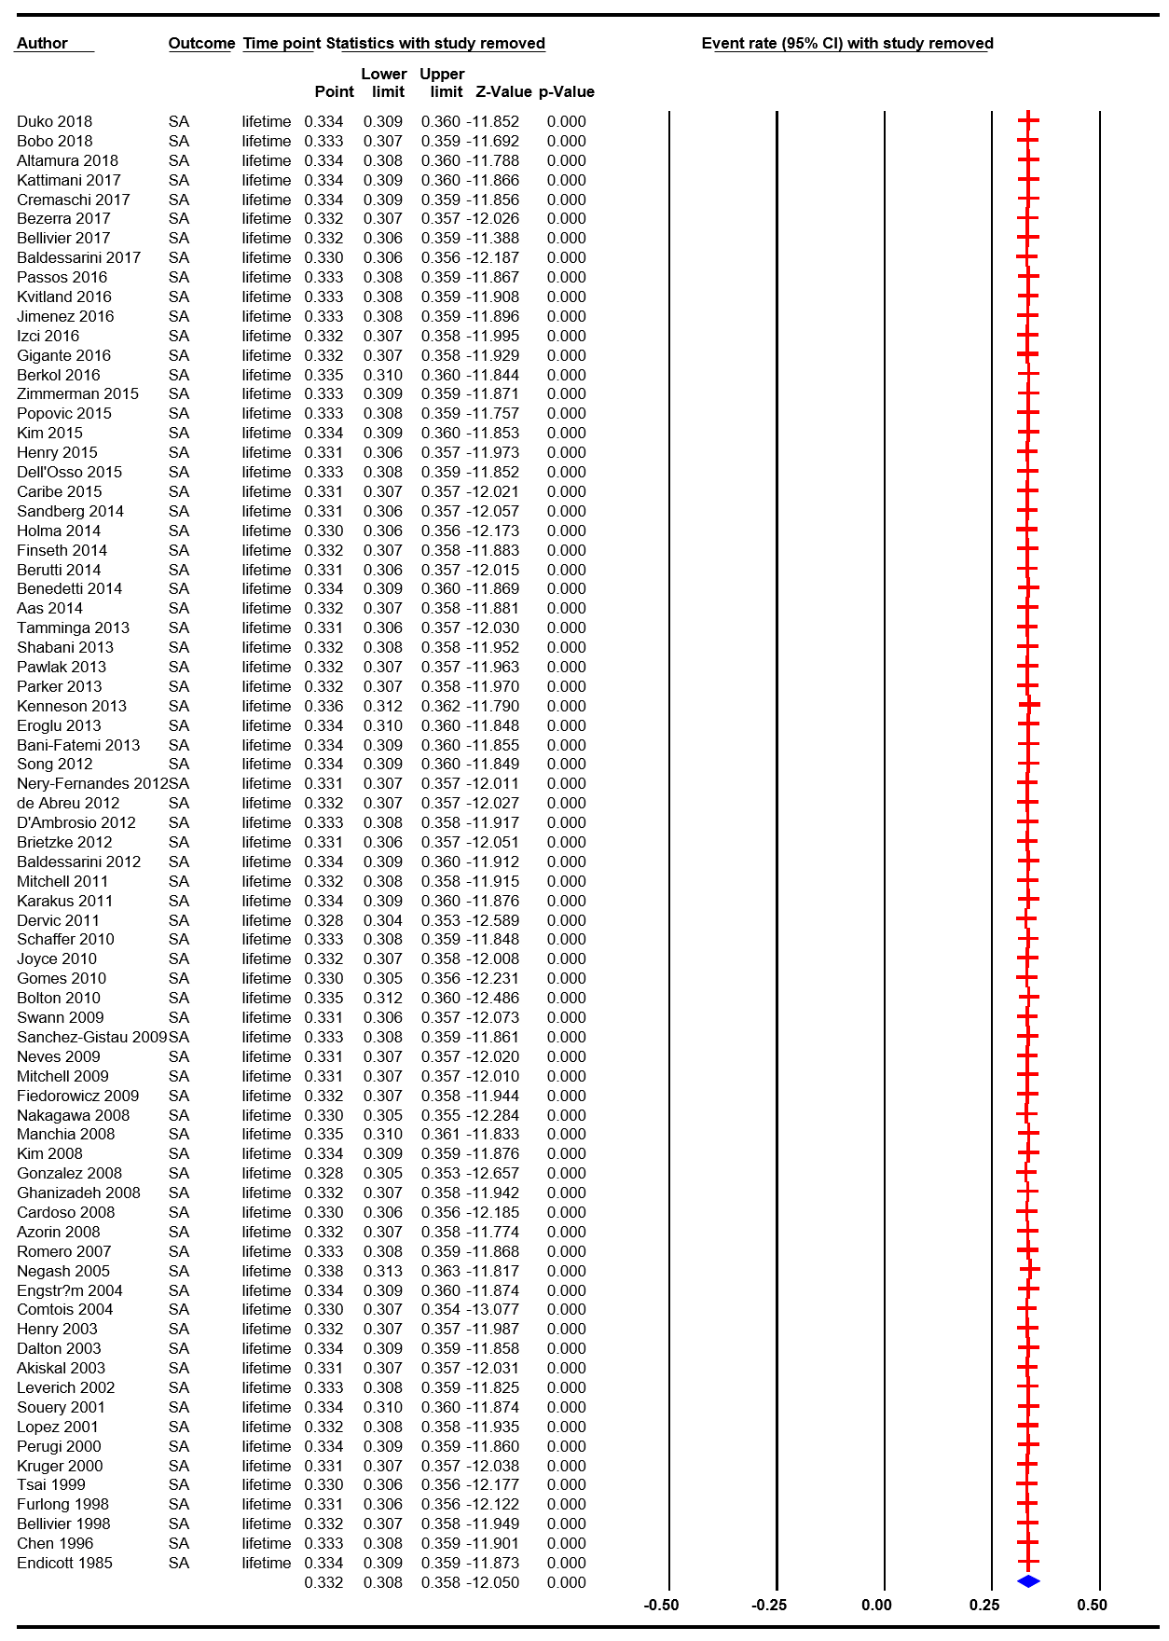
Supplemental Figure 1. Forest plot of the sensitivity analysis

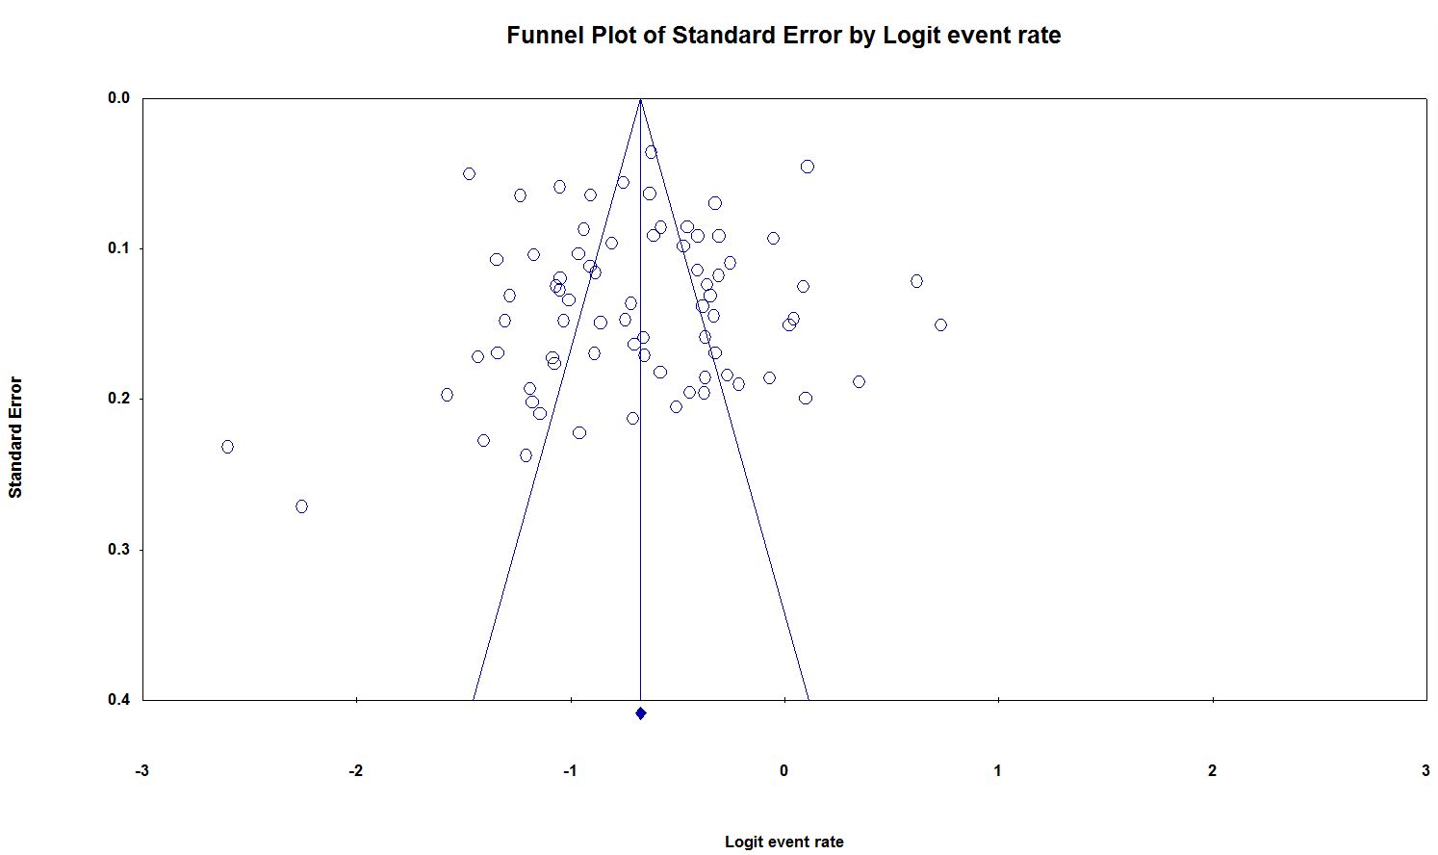
Supplemental Figure 2. Funnel plot of publication bias for lifetime prevalence of suicide attempts in bipolar disorder

