Effect of neonatal orally administered S-allyl-cysteine in high-fructose diet fed Wistar rats
*B. W. Lembede¹, K. H. Erlwanger¹, P. Nkomozepi² and E. Chivandi¹
¹School of Physiology, Faculty of Health Sciences, University of the Witwatersrand, 7 York Road, Parktown, Johannesburg, Republic of South Africa
²Department of Human Anatomy and Physiology, Faculty of Health Sciences, University of Johannesburg, Corner Siemert and Beit Street, Doornfontein, Johannesburg, Republic of South Africa
* Corresponding author: Busisani W. Lembede, ¹School of Physiology, Faculty of Health Sciences, University of the Witwatersrand, 7 York Road, Parktown, Johannesburg, Republic of South Africa
Tel.: 0117172140
Email: Busisani.Lembede@wits.ac.za

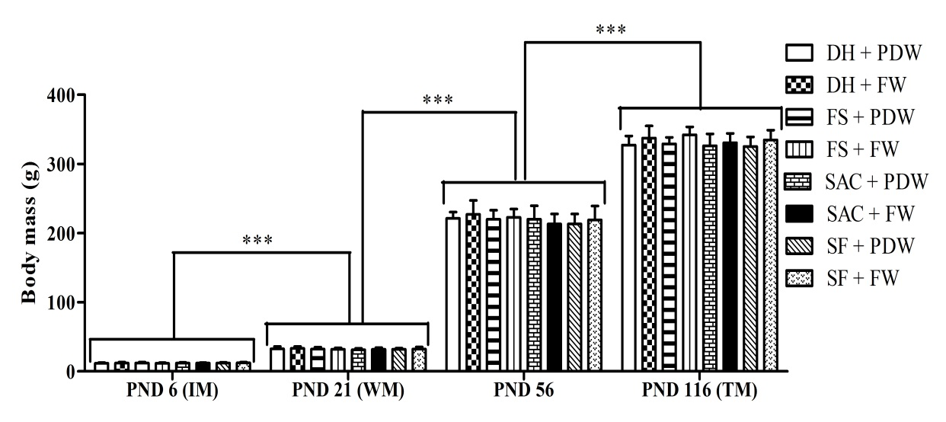
Supplementary Figure 1a. Effect of high-fructose diet on body masses of the male rat pups orally administered S-allyl-cysteine during suckling.
*** p < 0.0001. Induction, weaning, PND 56, and terminal body masses of the rats were similar across treatment regimens. The rats grew (p < 0.0001) significantly at all experimental stages. DH + PDW = gavage with 10 ml/kg body mass per day distilled water during suckling + plain drinking water in adulthood; DH + FW = gavage with 10 ml/kg body mass per day distilled water during suckling + 20% fructose (w/v) as their drinking fluid in adulthood; FS + PDW = gavage with 10 ml/kg body mass per day 20% fructose solution (w/v) during suckling + plain drinking water in adulthood; FS + FW = gavage with 10 ml/kg body mass per day 20% fructose solution (w/v) during suckling + 20% fructose (w/v) as the drinking fluid in adulthood; SAC + PDW = gavage with 150 mg/kg body mass per day S-allyl-cysteine during suckling + plain drinking water in adulthood; SAC + FW = gavage with 150 mg/kg body mass per day S-allyl-cysteine during suckling + 20% fructose (w/v) as their drinking fluid in adulthood; SF + PDW = gavage with 150 mg/kg body mass per day S-allyl-cysteine and 10 ml/kg body mass per day 20% fructose solution (w/v) during suckling + plain drinking water in adulthood; SF + FW = gavage with 150 mg/kg body mass per day S-allyl-cysteine and 10 ml/kg body mass per day 20% fructose solution (w/v) during suckling + 20% fructose (w/v) as their drinking fluid in adulthood; IM = induction mass; PND = postnatal day; TM = terminal mass; WM = weaning mass. Data presented as mean ± SD; n = 7 per treatment regimen.

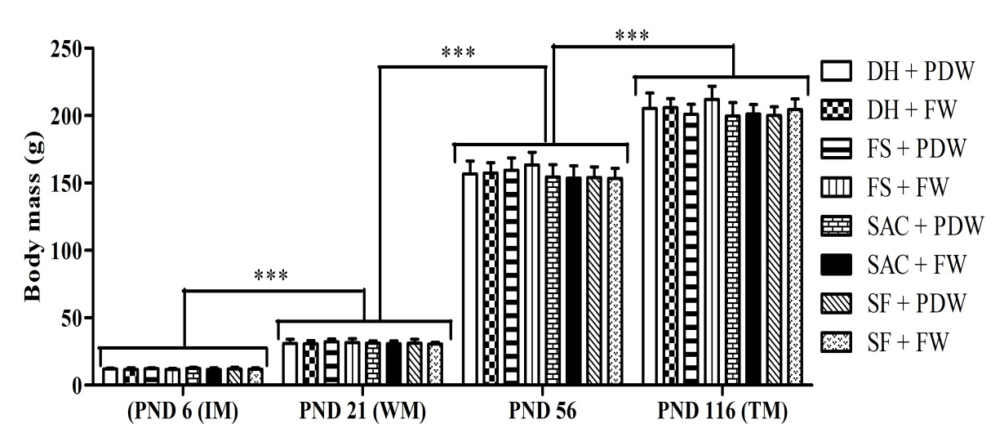
Supplementary Figure 1b. Effect of high-fructose diet on body masses of the female rat pups orally administered S-allyl-cysteine during suckling.
*** p < 0.0001. Induction, weaning, PND 56, and terminal body masses were similar across all treatment regimens. The rats grew (p < 0.0001) significantly at all experimental stages. DH + PDW = gavage with 10 ml/kg body mass per day distilled water during suckling + plain drinking water in adulthood; DH + FW = gavage with 10 ml/kg body mass per day distilled water during suckling + 20% fructose (w/v) as their drinking fluid in adulthood; FS + PDW = gavage with 10 ml/kg body mass per day 20% fructose solution (w/v) during suckling + plain drinking water in adulthood; FS + FW = gavage with 10 ml/kg body mass per day 20% fructose solution (w/v) during suckling + 20% fructose (w/v) as the drinking fluid in adulthood; SAC + PDW = gavage with 150 mg/kg body mass per day S-allyl-cysteine during suckling + plain drinking water in adulthood; SAC + FW = gavage with 150 mg/kg body mass per day S-allyl-cysteine during suckling + 20% fructose (w/v) as their drinking fluid in adulthood; SF + PDW = gavage with 150 mg/kg body mass per day S-allyl-cysteine and 10 ml/kg body mass per day 20% fructose solution (w/v) during suckling + plain drinking water in adulthood; SF + FW = gavage with 150 mg/kg body mass per day S-allyl-cysteine and 10 ml/kg body mass per day 20% fructose solution (w/v) during suckling + 20% fructose (w/v) as their drinking fluid in adulthood; IM = induction mass; PND = postnatal day; TM = terminal mass; WM = weaning mass. Data presented as mean ± SD; n = 7 per treatment regimen.

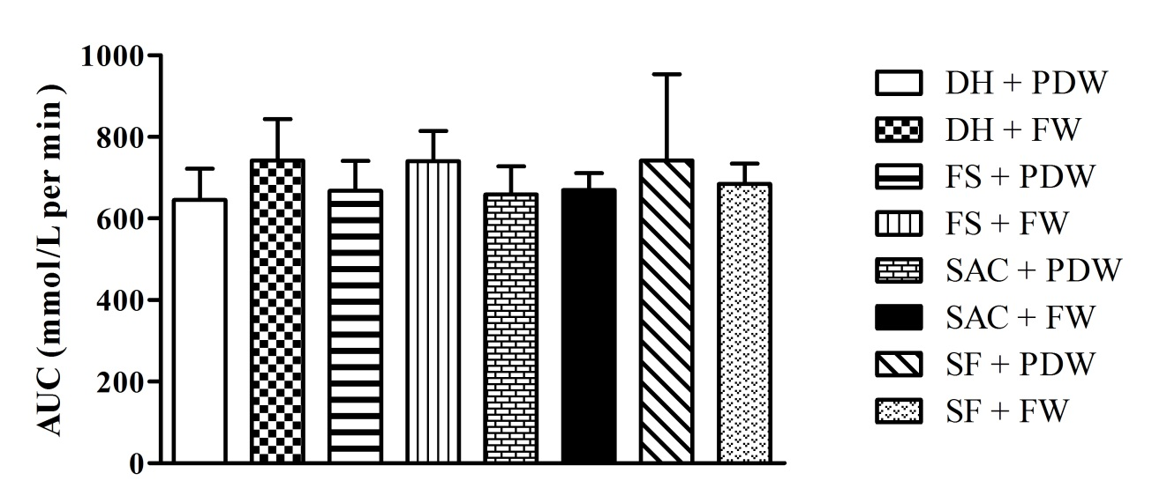
Supplementary Figure 2a. Effects of high-fructose diet on total area under the curve of oral glucose tolerance of adult male rats orally administered S-allyl-cysteine during suckling.
The total area under the curve of oral glucose tolerance of male rats was similar across treatment regimens. DH + PDW = gavage with 10 ml/kg body mass per day distilled water during suckling + plain drinking water in adulthood; DH + FW = gavage with 10 ml/kg body mass per day distilled water during suckling + 20% fructose (w/v) as their drinking fluid in adulthood; FS + PDW = gavage with 10 ml/kg body mass per day 20% fructose solution (w/v) during suckling + plain drinking water in adulthood; FS + FW = gavage with 10 ml/kg body mass per day 20% fructose solution (w/v) during suckling + 20% fructose (w/v) as the drinking fluid in adulthood; SAC + PDW = gavage with 150 mg/kg body mass per day S-allyl-cysteine during suckling + plain drinking water in adulthood; SAC + FW = gavage with 150 mg/kg body mass per day S-allyl-cysteine during suckling + 20% fructose (w/v) as their drinking fluid in adulthood; SF + PDW = gavage with 150 mg/kg body mass per day S-allyl-cysteine and 10 ml/kg body mass per day 20% fructose solution (w/v) during suckling + plain drinking water in adulthood; SF + FW = gavage with 150 mg/kg body mass per day S-allyl-cysteine and 10 ml/kg body mass per day 20% fructose solution (w/v) during suckling + 20% fructose (w/v) as their drinking fluid in adulthood; AUC = area under the curve. Data presented as mean ± SD; n = 7 per treatment regimen.

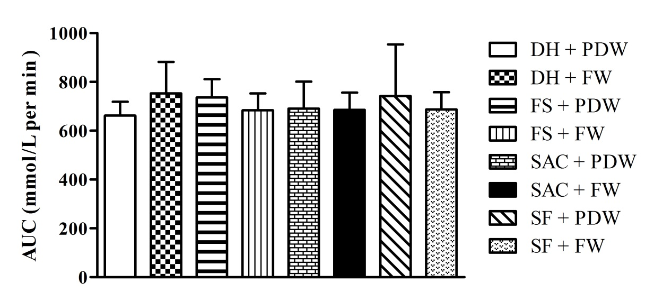
Supplementary Figure 2b. Effects of high-fructose diet on total area under the curve of oral glucose tolerance of adult female rats orally administered S-allyl-cysteine during suckling.
The total area under the curve of oral glucose tolerance of female rats was similar across treatment regimens. DH + PDW = gavage with 10 ml/kg body mass per day distilled water during suckling + plain drinking water in adulthood; DH + FW = gavage with 10 ml/kg body mass per day distilled water during suckling + 20% fructose (w/v) as their drinking fluid in adulthood; FS + PDW = gavage with 10 ml/kg body mass per day 20% fructose solution (w/v) during suckling + plain drinking water in adulthood; FS + FW = gavage with 10 ml/kg body mass per day 20% fructose solution (w/v) during suckling + 20% fructose (w/v) as the drinking fluid in adulthood; SAC + PDW = gavage with 150 mg/kg body mass per day S-allyl-cysteine during suckling + plain drinking water in adulthood; SAC + FW = gavage with 150 mg/kg body mass per day S-allyl-cysteine during suckling + 20% fructose (w/v) as their drinking fluid in adulthood; SF + PDW = gavage with 150 mg/kg body mass per day S-allyl-cysteine and 10 ml/kg body mass per day 20% fructose solution (w/v) during suckling + plain drinking water in adulthood; SF + FW = gavage with 150 mg/kg body mass per day S-allyl-cysteine and 10 ml/kg body mass per day 20% fructose solution (w/v) during suckling + 20% fructose (w/v) as their drinking fluid in adulthood; AUC = area under the curve. Data presented as mean ± SD; n = 7 per treatment regimen.

Tables
Supplementary Table 1a. Effects of high-fructose diet on glucose, triglyceride, cholesterol leptin, insulin and HOMA-IR indices of adult male rats orally administered S-allyl-cysteine during suckling
Treatments | Blood glucose (mmol/L) | Triglyceride (mmol/L) | Cholesterol (mmol/L) | Leptin (ng/mL) | Insulin (ng/mL) | HOMA-IR
DH + PDW | 4.45 ± 0.30 | 1.84 ± 0.36 | 1.22 ± 0.57 | 2.53 ± 0.63 | 21.01 ± 7.48 | 4.16 ± 1.50
DH + FW | 4.15 ± 0.68 | 1.70 ± 0.48 | 1.35 ± 0.51 | 2.93 ± 1.00 | 40.58 ± 22.05 | 6.97 ± 3.73
FS + PDW | 4.30 ± 0.41 | 1.91 ± 0.44 | 1.66 ± 0.30 | 2.73 ± 0.54 | 29.95 ± 20.15 | 5.90 ± 4.00
FS + FW | 4.43 ± 0.51 | 2.00 ± 0.59 | 1.28 ± 0.63 | 2.58 ± 0.96 | 35.47 ± 22.89 | 7.24 ± 5.11
SAC + PDW | 4.35 ± 0.63 | 1.64 ±0.88 | 1.23 ± 0.40 | 2.82 ± 0.85 | 27.73 ± 13.49 | 5.17 ± 2.73
SAC + FW | 3.94 ± 0.56 | 1.99 ± 0.86 | 1.57 ± 0.83 | 2.80 ± 0.76 | 24.36 ± 17.59 | 4.18 ± 3.10
SF + PDW | 4.38 ± 0.68 | 1.49 ± 0.43 | 1.31 ± 0.40 | 2.62 ± 0.60 | 27.75 ± 7.38 | 5.13 ± 1.35
SF + FW | 3.98 ± 0.52 | 2.12 ± 0.43 | 1.12 ± 0.22 | 2.63 ± 1.13 | 11.52 ± 7.91 | 2.08 ± 1.46
Fasting blood glucose, triglyceride, cholesterol, plasma leptin and insulin and HOMA-IR were similar across treatment regimens. DH + PDW = gavage with 10 ml/kg body mass per day distilled water during suckling + plain drinking water in adulthood; DH + FW = gavage with 10 ml/kg body mass per day distilled water during suckling + 20% fructose (w/v) as their drinking fluid in adulthood; FS + PDW = gavage with 10 ml/kg body mass per day 20% fructose solution (w/v) during suckling + plain drinking water in adulthood; FS + FW = gavage with 10 ml/kg body mass per day 20% fructose solution (w/v) during suckling + 20% fructose (w/v) as the drinking fluid in adulthood; SAC + PDW = gavage with 150 mg/kg body mass per day S-allyl-cysteine during suckling + plain drinking water in adulthood; SAC + FW = gavage with 150 mg/kg body mass per day S-allyl-cysteine during suckling + 20% fructose (w/v) as their drinking fluid in adulthood; SF + PDW = gavage with 150 mg/kg body mass per day S-allyl-cysteine and 10 ml/kg body mass per day 20% fructose solution (w/v) during suckling + plain drinking water in adulthood; SF + FW = gavage with 150 mg/kg body mass per day S-allyl-cysteine and 10 ml/kg body mass per day 20% fructose solution (w/v) during suckling + 20% fructose (w/v) as their drinking fluid in adulthood. Data presented as mean ± SD; n = 7 per treatment regimen.
Supplementary Table 1b: Effects of high-fructose diet on glucose, glucose, triglyceride, cholesterol leptin, insulin and HOMA-IR indices of adult female rats administered S-allyl-cysteine during suckling
Treatments | Blood glucose (mmol/L) | Triglyceride (mmol/L) | Cholesterol (mmol/L) | Leptin (ng/mL) | Insulin (ng/mL) | HOMA-IR
DH + PDW | 4.52 ± 0.60 | 1.71 ± 0.74 | 1.48 ± 0.20 | 2.68 ± 0.50 | 11.58 ± 7.27 | 2.28 ± 1.36
DH + FW | 4.41 ± 0.38 | 2.45 ± 0.73 | 1.26 ± 0.28 | 2.41 ± 0.70 | 32.47 ± 11.86 | 6.40 ± 2.58
FS + PDW | 4.67 ± 0.72 | 1.67 ± 0.44 | 1.51 ± 0.30 | 3.20 ± 1.21 | 17.11 ± 14.35 | 3.63 ±3.62
FS + FW | 4.11 ± 0.50 | 2.07 ± 0.86 | 1.63 ± 0.30 | 2.68 ± 0.86 | 19.05 ± 15.60 | 3.27 ± 2.58
SAC + PDW | 4.76 ± 0.67 | 1.75 ± 0.94 | 1.52 ± 0.35 | 2.72 ± 0.65 | 16.67 ± 5.60 | 3.45 ± 0.75
SAC + FW | 4.30 ± 0.68 | 1.83 ± 0.52 | 1.30 ± 0.50 | 2.93 ± 0.82 | 15.49 ± 15.58 | 3.06 ± 3.33
SF + PDW | 4.51 ± 0.47 | 1.47 ±0.72 | 1.36 ± 0.27 | 2.51 ± 0.57 | 22.73 ± 12.08 | 4.61 ± 2.70
SF + FW | 4.44 ± 0.45 | 1.95 ± 0.85 | 1.57 ± 0.21 | 3.54 ± 1.12 | 19.73 ± 15.34 | 4.14 ± 3.30
Fasting blood glucose, triglyceride, cholesterol, leptin, insulin and HOMA-IR were similar in female rats across all the treatment regimens. DH + PDW = gavage with 10 ml/kg body mass per day distilled water during suckling + plain drinking water in adulthood; DH + FW = gavage with 10 ml/kg body mass per day distilled water during suckling + 20% fructose (w/v) as their drinking fluid in adulthood; FS + PDW = gavage with 10 ml/kg body mass per day 20% fructose solution (w/v) during suckling + plain drinking water in adulthood; FS + FW = gavage with 10 ml/kg body mass per day 20% fructose solution (w/v) during suckling + 20% fructose (w/v) as the drinking fluid in adulthood; SAC + PDW = gavage with 150 mg/kg body mass per day S-allyl-cysteine during suckling + plain drinking water in adulthood; SAC + FW = gavage with 150 mg/kg body mass per day S-allyl-cysteine during suckling + 20% fructose (w/v) as their drinking fluid in adulthood; SF + PDW = gavage with 150 mg/kg body mass per day S-allyl-cysteine and 10 ml/kg body mass per day 20% fructose solution (w/v) during suckling + plain drinking water in adulthood; SF + FW = gavage with 150 mg/kg body mass per day S-allyl-cysteine and 10 ml/kg body mass per day 20% fructose solution (w/v) during suckling + 20% fructose (w/v) as their drinking fluid in adulthood. Data presented as mean ± SD; n = 7 per treatment regimen.
Supplementary Table 2a: Effects of high-fructose diet on the size and density of hepatocytes from adult male rats orally administered S-allyl-cysteine during suckling
Treatments | Hepatocyte size (µm) | Hepatocyte density (cells per 100 µm)
DH + PDW | 9.83 ± 1.61 | 10.16 ± 0.76
DH + FW | 9.83 ± 1.15 | 10.00 ± 1.00
FS + PDW | 9.66 ± 1.53 | 10.16 ± 0.28
FS + FW | 9.67 ± 0.58 | 10.33 ± 0.57
SAC + PDW | 9.16 ± 1.25 | 10.67 ± 1.26
SAC + FW | 9.67 ± 0.30 | 10.67 ± 0.76
SF + PDW | 9.50 ± 0.5 | 11.00 ± 1.00
SF + FW | 9.67 ± 0.28 | 10.17 ± 0.57
Hepatocyte size and density of male rats were similar across treatment regimens. DH + PDW = gavage with 10 ml/kg body mass per day distilled water during suckling + plain drinking water in adulthood; DH + FW = gavage with 10 ml/kg body mass per day distilled water during suckling + 20% fructose (w/v) as their drinking fluid in adulthood; FS + PDW = gavage with 10 ml/kg body mass per day 20% fructose solution (w/v) during suckling + plain drinking water in adulthood; FS + FW = gavage with 10 ml/kg body mass per day 20% fructose solution (w/v) during suckling + 20% fructose (w/v) as the drinking fluid in adulthood; SAC + PDW = gavage with 150 mg/kg body mass per day S-allyl-cysteine during suckling + plain drinking water in adulthood; SAC + FW = gavage with 150 mg/kg body mass per day S-allyl-cysteine during suckling + 20% fructose (w/v) as their drinking fluid in adulthood; SF + PDW = gavage with 150 mg/kg body mass per day S-allyl-cysteine and 10 ml/kg body mass per day 20% fructose solution (w/v) during suckling + plain drinking water in adulthood; SF + FW = gavage with 150 mg/kg body mass per day S-allyl-cysteine and 10 ml/kg body mass per day 20% fructose solution (w/v) during suckling + 20% fructose (w/v) as their drinking fluid in adulthood. Data presented as mean ± SD; n = 4-5 per treatment.

Supplementary Table 2b: Effects of high-fructose diet on the size and density of hepatocytes from adult female rats orally administered S-allyl-cysteine during suckling
Treatments | Hepatocyte size (µm) | Hepatocytes (cells per 100 µm)
DH + PDW | 8.00 ± 0.86 | 13.00 ± 0.50
DH + FW | 8.33 ± 0.76 | 12.00 ± 0.50
FS + PDW | 8.00 ± 0.50 | 12.00 ± 0.86
FS + FW | 8.17 ± 1.04 | 12.00 ± 1.32
SAC + PDW | 8.17 ± 0.28 | 13.00 ± 0.50
SAC + FW | 8.33 ± 1.04 | 12.67 ± 0.28
SF + PDW | 8.50 ± 0.86 | 12.00 ± 1.32
SF + FW | 8.17 ± 0.76 | 12.67 ± 1.26
Hepatocyte size and density of female rats were similar across treatment regimens. DH + PDW = gavage with 10 ml/kg body mass per day distilled water during suckling + plain drinking water in adulthood; DH + FW = gavage with 10 ml/kg body mass per day distilled water during suckling + 20% fructose (w/v) as their drinking fluid in adulthood; FS + PDW = gavage with 10 ml/kg body mass per day 20% fructose solution (w/v) during suckling + plain drinking water in adulthood; FS + FW = gavage with 10 ml/kg body mass per day 20% fructose solution (w/v) during suckling + 20% fructose (w/v) as the drinking fluid in adulthood; SAC + PDW = gavage with 150 mg/kg body mass per day S-allyl-cysteine during suckling + plain drinking water in adulthood; SAC + FW = gavage with 150 mg/kg body mass per day S-allyl-cysteine during suckling + 20% fructose (w/v) as their drinking fluid in adulthood; SF + PDW = gavage with 150 mg/kg body mass per day S-allyl-cysteine and 10 ml/kg body mass per day 20% fructose solution (w/v) during suckling + plain drinking water in adulthood; SF + FW = gavage with 150 mg/kg body mass per day S-allyl-cysteine and 10 ml/kg body mass per day 20% fructose solution (w/v) during suckling + 20% fructose (w/v) as their drinking fluid in adulthood. Data presented as mean ± SD; n = 4-5 per treatment.

Supplementary Table 3a: Effects of high-fructose diet on non-alcoholic fatty liver disease activity score (NAS) of adult male rats orally administered S-allyl-cysteine during suckling
Treatments | Steatosis score | Ballooning score | Lobular inflammation score | Total NAS
DH + PDW | 0 (0, 0) | 0 (0, 0) | 2.5 (0, 3) | 2.5 (0, 3)
DH + FW | 0 (0, 1) | 0 (0, 1) | 2 (2, 3) | 2.5 (2, 4)
FS + PDW | 0 (0, 2) | 0 (0, 0) | 2 (1, 2) | 2 (1, 4)
FS + FW | 0 (0, 2) | 0 (0, 0) | 2 (2, 3) | 3 (2, 5)
SAC + PDW | 0 (0, 0) | 0 (0, 0) | 2 (2, 3) | 2 (2, 3)
SAC + FW | 0 (0, 0) | 0 (0, 0) | 2 (1, 3) | 2 (1, 3)
SF + PDW | 0 (0, 0) | 0 (0, 1) | 2 (1, 3) | 2 (2, 3)
SF + FW | 0 (0, 1) | 0 (0, 1) | 2 (0, 3) | 2.5 (0, 5)
Non-alcoholic fatty liver disease activity scores (NAS) of male rats were similar across treatment regimens. DH + PDW = gavage with 10 ml/kg body mass per day distilled water during suckling + plain drinking water in adulthood; DH + FW = gavage with 10 ml/kg body mass per day distilled water during suckling + 20% fructose (w/v) as their drinking fluid in adulthood; FS + PDW = gavage with 10 ml/kg body mass per day 20% fructose solution (w/v) during suckling + plain drinking water in adulthood; FS + FW = gavage with 10 ml/kg body mass per day 20% fructose solution (w/v) during suckling + 20% fructose (w/v) as the drinking fluid in adulthood; SAC + PDW = gavage with 150 mg/kg body mass per day S-allyl-cysteine during suckling + plain drinking water in adulthood; SAC + FW = gavage with 150 mg/kg body mass per day S-allyl-cysteine during suckling + 20% fructose (w/v) as their drinking fluid in adulthood; SF + PDW = gavage with 150 mg/kg body mass per day S-allyl-cysteine and 10 ml/kg body mass per day 20% fructose solution (w/v) during suckling + plain drinking water in adulthood; SF + FW = gavage with 150 mg/kg body mass per day S-allyl-cysteine and 10 ml/kg body mass per day 20% fructose solution (w/v) during suckling + 20% fructose (w/v) as their drinking fluid in adulthood; NAS = non-alcoholic fatty liver disease activity score. Total NAS is the sum of values recorded for each category. Total NAS score interpretation: <2 = not steatohepatitis; 3–4 = uncertain; >5 = probable or definite steatohepatitis. Data presented as median and range (min; max); n = 4-5 per treatment.

Supplementary Table 3b: Effects of high-fructose diet on non-alcoholic fatty liver disease activity score (NAS) of adult female rats orally administered S-allyl-cysteine during suckling
Treatments | Steatosis score | Ballooning score | Lobular inflammation score | Total NAS
DH + PDW | 0 (0, 0) | 0 (0, 0) | 3 (2, 3) | 3 (2, 3)
DH + FW | 0 (0, 1) | 0 (0, 1) | 2 (1, 3) | 2 (1, 5)
FS + PDW | 1 (0, 2) | 0 (0, 0) | 2 (2, 2) | 3 (2, 4)
FS + FW | 0 (0, 2) | 0 (0, 0) | 2 (2, 2) | 2 (2, 4)
SAC + PDW | 0 (0, 1) | 0 (0, 1) | 3 (1, 3) | 3.5 (1, 4)
SAC + FW | 1 (0, 0) | 0 (0, 0) | 2 (1, 3) | 3 (1, 4)
SF + PDW | 0 (0, 1) | 0 (0, 1) | 2 (1, 2) | 2 (1, 3)
SF + FW | 0 (0, 0) | 0 (0, 1) | 2 (1, 3) | 2.5 (1, 3)
Non-alcoholic fatty liver disease activity scores (NAS) of female rats were similar across treatment regimens. DH + PDW = gavage with 10 ml/kg body mass per day distilled water during suckling + plain drinking water in adulthood; DH + FW = gavage with 10 ml/kg body mass per day distilled water during suckling + 20% fructose (w/v) as their drinking fluid in adulthood; FS + PDW = gavage with 10 ml/kg body mass per day 20% fructose solution (w/v) during suckling + plain drinking water in adulthood; FS + FW = gavage with 10 ml/kg body mass per day 20% fructose solution (w/v) during suckling + 20% fructose (w/v) as the drinking fluid in adulthood; SAC + PDW = gavage with 150 mg/kg body mass per day S-allyl-cysteine during suckling + plain drinking water in adulthood; SAC + FW = gavage with 150 mg/kg body mass per day S-allyl-cysteine during suckling + 20% fructose (w/v) as their drinking fluid in adulthood; SF + PDW = gavage with 150 mg/kg body mass per day S-allyl-cysteine and 10 ml/kg body mass per day 20% fructose solution (w/v) during suckling + plain drinking water in adulthood; SF + FW = gavage with 150 mg/kg body mass per day S-allyl-cysteine and 10 ml/kg body mass per day 20% fructose solution (w/v) during suckling + 20% fructose (w/v) as their drinking fluid in adulthood; NAS = non-alcoholic fatty liver disease activity score. Total NAS is the sum of values recorded for each category. Total NAS score interpretation: <2 = not steatohepatitis; 3–4 = uncertain; >5 = probable or definite steatohepatitis. Data presented as median and range (min, max); n = 4-5 per treatment.

Appendix 1: Animal ethics clearance certificate

Appendix 2: Modification of the ethics clearance

Scores for steatosis (score 0 to 3), lobular
inﬂammation (score 0 to 3), and ballooning (score 0
to 2), were also summed to produce the NAS, thus
ranging from 0 to 8.
Scores for steatosis (score 0 to 3), lobular
inﬂammation (score 0 to 3), and ballooning (score 0
to 2), were also summed to produce the NAS, thus
ranging from 0 to 8.
Scores for steatosis (score 0 to 3), lobular
inﬂammation (score 0 to 3), and ballooning (score 0
to 2), were also summed to produce the NAS, thus
ranging from 0 to 8.

