Appendices
Table A.1. Summary of aerial seedings conducted in 2016 on plots included in analysis. An “x” in the “Post-Hoc Analysis” or “Pre/Post Treatment Analysis” means that some plots in the analysis fell within the boundaries of these seedings. Grass seedlings of the seeded species were generally not observed within the SamplePoint photos of aerially seeded plots. None of the species in the aerial seeded forb mix were recorded in the SamplePoint photos of the plots used for analysis within the “Aerial, Forb – Native” treatment except for Balsamorhiza sagittata and Crepis occidentalis, which were no more frequently recorded in plots within that seeding treatment than plots outside of it (fisher’s exact test, p = 0.46, p = 0.40). Pure live seed (PLS) rates were similar between seeded Artemisia sp. and subspecies: on average they were 22% PLS for Artemisia arbuscula, 24% for basin Artemisia tridentata ssp. tridentata, and 19% for Artemisia tridentata ssp. wyomingensis.
Seeding Treatment | Species | Rate (bulk kg · ha⁻¹) | Ha | Post-Hoc Analysis | Pre/Post Treatment Analysis
Aerial, grass - Native | Pseudoroegneria spicata, Elymus lanceolatus, Poa secunda | 13.3 | 7289 |  | x
Aerial, grass - Native/Introduced | Agropyron fragile, Elymus wawaweiensis, Pseudoroegneria spicata, Poa secunda | 13.8 | 7482 | x | x
Aerial, grass - Native/Introduced | Agropyron fragile, Poa secunda, Elymus elymoides | 15.7 | 4416 | x | x
Aerial, Shrub - Native | Artemisia arbuscula | 0.9 | 7549 | x | x
Aerial, Shrub/Forb | Medicago sativa, Sanguisorba minor, Achillea millefolium, Artemisia tridentata ssp. wyomingensis | 3.5-6.4 | 56195 | x | x
Aerial, Shrub/Forb | Medicago sativa, Sanguisorba minor, Achillea millefolium, Artemisia tridentata ssp. tridentata | 3.4 | 6839 | x | x
Aerial, Forb - Native | Penstemon eatonii, Penstemon acuminatus, Sphaeralcea grossulariifolia, Sphaeralcea munroana, Crepis occidentalis, Balsamorhiza sagittata, Astragulus filipes, Lomatium triternatum, Malacothrix glabrata | 0.9 | 2886 | x | x

Table A.2. List of all species used in analysis (common and scientific name) and the functional group to which they were assigned.
Functional Group | Common Name | Scientific Name
Exotic Annual Forbs | Desert madwort | Alyssum desertorum Stapf
 | Prostrate Pigweed | Amaranthus albus L.
 | Corn gromwell | Buglossoides arvensis (L.) I.M. Johnst.
 | Curveseed butterwort | Ceratocephala testiculata (Crantz) Roth
 | Crossflower | Chorispora tenella (Pall.) DC.
 | Spring draba | Draba verna L.
 | Red stork's bill | Erodium cicutarium (L.) L'Her ex. Aiton
 | Spreading wallflower | Erysimum repandum L.
 | Saltlover | Halogeton glomeratus (M. Bieb) C.A. Mey
 | Jagged chickweed | Holosteum unbellatum L.
 | Black bindweed | Polygonum convolvulus L.
 | Prickly Russian Thistle | Salsola tragus L.
 | Field pennycress | Thlaspi arvense L.
Exotic Annual Grasses | Field brome | Bromus arvensis L.
 | Cheatgrass | Bromus tectorum L.
 | Medusahead | Taeniatherum caput-medusae (L.) Nevski
 | North Africa grass | Ventenata dubia (Leers) Coss.
 | Vulpia | Vulpia sp.
Exotic Biennial Forbs | Littlepod false flax | Camelina microcarpa Andrz. Ex DC.
 | Herb sophia | Descurainia sophia (L.) Webb ex Prantl
 | Prickly lettuce | Lactuca serriola L.
 | Field pepperweed | Lepidium campestre (L.) W.T. Aiton
 | Clasping pepperweed | Lepidium perfoliatum L.
 | Tall tumblemustard | Sisymbrium altissimum L.
 | Yellow salsify | Tragopogon dubius Scop.
Exotic Perennial Forbs | Hairy whitetop | Cardaria pubescens (C.A. Mey.) Jarmolenko
 | Whitetop | Cardaria draba (L.) Desv.
 | Rush skeletonweed | Chondrilla juncea L.
 | Canada thistle | Cirsium arvense (L.) Scop.
 | Bull thistle | Cirsium vulgare (Savis) Ten.
 | Blue flax | Linum perenne L.
 | Common mallow | Malva neglecta Wallr.
 | Sweetclover | Melilotus officinalis (L.) Lam.
 | Scotch cottonthistle | Onopordum acanthium L.
 | Curly dock | Rumex crispus L.
 | Common dandelion | Taraxacum officinale F.H. Wigg
 | Moth mullein | Verbascum blattaria L.
 | Common mullein | Verbascum thapsus L.
Native Annual Forbs | Annual agoseris | Agoseris heterophylla (Nutt.) Greene
 | Fiddleneck | Amsincka sp.
 | Rough eyelashweed | Blepharipappus scaber Hook
 | Plataeu primrose | Camissonia andina (Nutt.) P.H. Raven
 | Browneyes | Camissonia claviformis (Torr. & Frem.) P.H. Raven
 | Lambsquarters | Chenopodium album L.
 | Narrowleaf goosefoot | Chenopodium leptophyllum (Moq.) Nutt. Ex S. Watson
 | Desert goosefoot | Chenopodium pratericola Rydb.
 | Pinkfairies | Clarkia pulchella Pursh
 | Blue eyed Mary | Collinsia parviflora Lindl.
 | Grand collomia | Collomia grandifolia Douglas ex Lindl.
 | Tiny trumpet | Collomia linearis Nutt.
 | Canadian horseweed | Conyza canadensis (L.) Cronquist
 | Cryptantha | Cryptantha sp.
 | Western tansymustard | Descurainia pinnata (Walter) Britton
 | Tall annual willowherb | Epilobium brachycarpum C. Presl
 | Wickstem buckwheat | Eriogonum vimineum Douglas ex Benth.
 | Ribseed sandmat | Euphorbia glytosperma Engelm.
 | Spotted sandmat | Euphorbia maculata (L.) Small
 | Bedstraw | Galium sp.
 | Spreading groundsmoke | Gayophytum diffusum Torr. & A. Gray
 | Carolina gernaium | Gernaium carolinianum L.
 | Shy gilia | Gilia inconspicua (Sm.) Sweet
 | Common sunflower | Helianthus annus L.
 | Rareflower heterocodon | Heterocodon rariflorumNutt.
 | Branched lagophylla | Lagophylla ramosissima Nutt.
 | Flatspine stickseed | Lappula occidentalis (S. Watson) Greene
 | Harkness' flaxflower | Leptosiphon harknessii (Curran) J.M. Porter & L.A. Johnson
 | Northern linanthus | Leptosiphon septentrionalis (H. Mason) J.M. Porter & L.A. Johnson
 | Hoary tansyaster | Machaeranthera canescens (Pursh) A. Gray
 | Small tarweed | Madia exigua (Sm.) A. Gray
 | Smooth desertdandelion | Malacothrix glabrata (A. Gray ex E.C. Eaton) A. Gray
 | Whitestem blazingstar | Mentzelia albicaulis (Hook.) Toor & A. Gray
 | Slender phlox | Microsteris gracilis (Hook.) Greene
 | Monkeyflower | Mimulus suksdorfii A. Gray
 | Forget-me-not | Myosotis sp.
 | Ground nama | Nama aretiodes (Hook. & Arn.) Brand
 | Needleleaf navarretia | Navarretia intertexta (Benth.) Hook.
 | Smallflower nemophila | Nemophila parviflora Douglas ex Benth
 | Louisiana broomrape | Orobanche ludoviciana Nutt.
 | Oneflowered broomrape | Orobanche uniflora L.
 | Threadleaf phacelia | Phacelia linearis (Pursh) Holz.
 | Wireweed | Pigiopappus leptocladus A. Gray
 | Pacific popcornflower | Plagiobothrys tenellus (Nutt. Ex Hook). A. Gray
 | Annual polemonium | Polemonium micranthum Benth.
 | Douglas' knotweed | Polygonum douglasii Greene.
 | Cutleaf nightshade | Solanum triflorum Nutt.
 | Bigbract verbena | Verbena bracteata Cav. Ex Lag. & Rodr.
Deep-rooted perennial bunchgrasses | Thurber's needlegrass | Achnatherum thurberianum (Piper) Barkworth
 | Indian ricegrass | Achnatherum hymenoides (Roem. & Schult.) Barkworth
 | Crested wheatgrass | Agropyron cristatum (L.) Gaertn.
 | Siberian wheatgrass | Agropyron fragile (Roth) P. Candargy
 | Purple threeawn | Aristida purpurea Nutt.
 | Squirreltail | Elymus elymoides (Raf.) Swezey
 | Snake River wheatgrass | Elymus wawawaiensis J. Carlson & Barkworth
 | Idaho fescue | Festuca idahoensis Elmer
 | Needle and Thread | Hesperostipa comata (Trin. & Rupr.) Barkworth
 | Prairie junegrass | Koeleria macrantha (Ledeb.) Schult.
 | Basin wildrye | Leymus cinereus (Scribn. & Merr.) A. Love
 | Bluebunch wheatgrass | Pseudoroegneria spicata (Pursh) Á. Löve
Native Perennial Forbs | Common yarrow | Achillea millefolium L.
 | Bigflower agoseries | Agoseris grandiflora (Nutt.) Greene
 | Onion | Allium sp. L.
 | Low pussytoes | Antennaria dimorpha (Nutt.) Torr. & A. Gray
 | King's sandwort | Arenaria kingii (S.Watson) M.E. Jones
 | Spearleaf arnica | Arnica longifolia D.C. Eaton
 | Twin arnica | Arnica sororia Greene
 | Woollypod milkvetch | Astragalus purshii Douglas ex Hook.
 | Milkvetch | Astragalus sp. L.
 | Basalt milkvetch | Astragalus filipes Torr. ex A. Gray
 | Hooker's balsamroot | Balsamorhiza hookeri (Hook.) Nutt.
 | Arrowleaf balsamroot | Balsamorhiza sagittata (Pursh) Nutt.
 | Mariposa lily | Calochortus sp. Pursh
 | Hawksbeard | Crepis sp. L.
 | Fleabane | Erigeron sp.L.
 | Rayless shaggy fleabane | Erigeron aphanactis (A. Gray) Greene
 | Shaggy fleabane | Erigeron pumilus Nutt.
 | Parsnipflower buckwheat | Eriogonum heracleoides Nutt.
 | Smallflower woodland-star | Lithophragma parviflorum (Hook.) Nutt. ex Torr. & A. Gray
 | Western stoneseed | Lithospermum ruderale Douglas ex Lehm.
 | Nineleaf biscuitroot | Lomatium triternatum (Pursh) J.M. Coult. & Rose
 | Fernleaf biscuitroot | Lomatium dissectum (Nutt.) Mathias & Constance
 | Lupine | Lupinus sp. L.
 | Alfalfa | Medicago sativa L.
 | Silverpuffs | Microseris D. Don
 | Sagebrush false dandelion | Nothocalais troximoides (A. Gray) Greene
 | Gardner's Yampah | Perideridia gairdneri (Hook. & Arn.) Mathias
 | Longleaf phlox | Phlox longifolia Nutt.
 | Thorn skeletonweed | Pleiacanthus spinosus (Nutt.) Rydb.
 | Largehead clover | Trifolium macrocephalum (Pursh) Poir.
 | Canary violet | Viola praemorsa Douglas ex Lindl.
 | Meadow deathcamas | Zigadenus venenosus S. Watson
Shallow-rooted Perennial Grasses | Sandburg's bluegrass | Poa secunda J. Presl

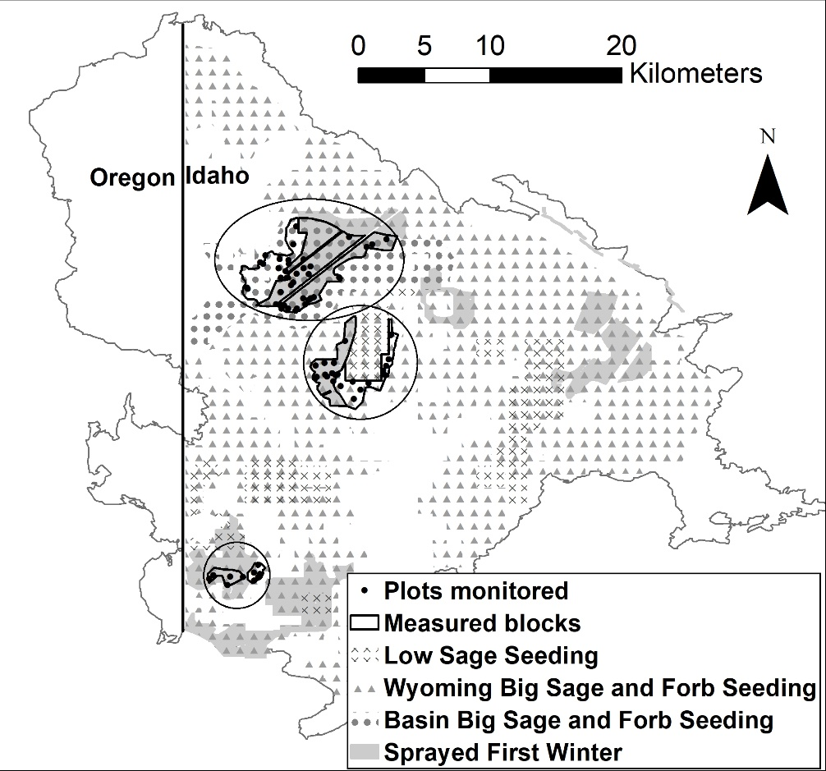
Figure A.1. Location of January 2016 shrub and forb aerial seedings (“Low Sage Seeding” – Artemisia arbuscula, “Wyoming Big Sage and Forb Seeding” – Artemisia tridentata ssp. wyomingensis and forbs, “Basin Big Sage and Forb Seeding” – Artemisica tridentata ssp. tridentata and forbs), the boundaries of the areas where herbicide was sprayed in the first winter post-fire, and the boundaries of measured blocks and plots monitored within blocks used to assess the effects of herbicide on seeded shrub and forb abundance between the control (no herbicide) and areas sprayed in the first winter post-fire. Regions in which the blocks occur are circled but the plots monitored shows exact locations of data collection.
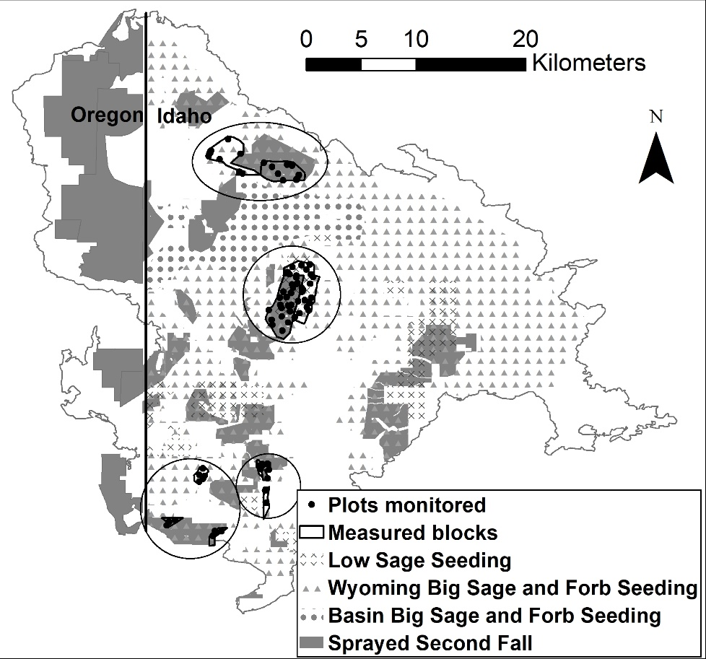
Figure A.2. Location of January 2016 shrub and forb aerial seedings (“Low Sage Seeding” – Artemisia arbuscula, “Wyoming Big Sage and Forb Seeding” – Artemisia tridentata ssp. wyomingensis and forbs, “Basin Big Sage and Forb Seeding” – Artemisica tridentata ssp. tridentata and forbs) , the boundaries of the areas sprayed in the second fall post-fire, and the boundaries of measured blocks and plots monitored within blocks used to assess the effects of herbicide on seeded shrub and forb abundance between the control (no herbicide) and areas sprayed in the second fall post-fire. Regions in which the blocks occur are circled but the plots monitored shows exact locations of data collection.

