**Appendix 1: PPC Surge Plan Outline**

**A Plan Outline for Increasing Pediatric Critical Care Surge Capacity**

Note: This outline PICU surge plan is intended to be used for creating an initial plan. Once filled in, it is not a plan in itself, rather it can provide a strong basis for an individual hospital plan depending on each hospitals specific needs, which change unit to unit. We did not write this plan ourselves—we gathered universally relevant segments from PDC recommendation documents and various PICU surge plans written by PDC participating hospitals and put them together in a coherent and schematic flow.

**Approval Form**

**The plan described in this document has been approved by the following people:**

*_____________________________________________________________*

­­­­­­­­­­­­­­

**Plan Revisions:**

The Plan for Increasing Pediatric Critical Care (PCC) Surge Capacity at _____should be revised annually.

|  |  |  |  |
| --- | --- | --- | --- |
| **Revision Number** | **Plan version** | **Date** | **Approved by** |
| Plan Created | V1 |  |  |
|  |  |  |  |
|  |  |  |  |
|  |  |  |  |
|  |  |  |  |
|  |  |  |  |
|  |  |  |  |
|  |  |  |  |
|  |  |  |  |

**Mission Statement:**

The plan intends to increase the PCC service capabilities at ______ beyond its regular capacity. The implementation of the PCC surge plan (PCCSP) encompasses the PICU and the floor as well as Epilepsy monitoring rooms.

**Definitions:**

PICU – A space within a hospital in which critically ill pediatric patients are hospitalized, monitored and managed.

PCC service – The clinical service delivered by the pediatric critical care medical and nursing staff. This service is most commonly provided in the PICU, but could also be provided elsewhere in the hospital when adequate personnel, equipment and supplies are made available for that purpose.

**Scope:**

The PCC P of ______ is designed to respond to a large influx, or to an impending risk of a large influx, of victims who might be critically ill or injured. Surge capacity is defined as the ability to expand care capabilities to meet sudden and/or more prolonged demand for patient triage and treatment. A surge capacity plan addresses issues of availability of space, personnel, medications, supplies, and equipment.

The pediatric critical care surge plan is an integral part of the overall Emergency Preparedness Plan of ______. It refers to disasters that require implementation of the hospital’s surge capacity in general and for critical care in particular. Surge capacity incidents may occur as a result of natural disasters (i.e. earthquakes), pandemics, or human-induced disasters (i.e. mass-casualty hazardous materials exposures, mass-casualty transportation incidents, and terrorist activities).

In an incident has resulted in or is likely to result in a number of patients that may overwhelm the hospital’s ability to manage by using standard operating procedures, the hospital should activate its Emergency Management Plan. The Pediatric Critical Care Surge Capacity Plan is part of that plan and requires specific responses by the ED, the floors and the Division of Pediatric Critical Care.

The standard of care during a surge plan implementation may change from optimal care to sufficient care without compromising adequate utilization of skills, diligence and reasonable judgment in delivery of patient care. The goal is to save as many lives as possible with the best possible neurologic and functional outcomes.

**Risk Assessment – Incidents That Will Most Likely Require Surge Capacity (example):**

* The Hazard Vulnerability Assessment (HVA) tool for ______ is periodically evaluated and updated.
* The most likely surge-capacity incidents for ______-PCC are:
  + - Mass-casualty traumas due to transportation incidents
    - Infectious disease epidemic (Pandemic Flu, SARS etc) resulting in respiratory failure and hemodynamic instability (shock)
    - Mass-casualty due to hazardous materials exposure incidents (non-terrorism)
    - CBRNE Terrorist incident (chemical, biological, radiologic, nuclear and explosive)

Notification

(Pg 6)

Discharge from PICU

(Pg 6)

Home

Floor

Step down PICU

Enlist additional staff

(Pg 7)

Physicians

Nurses

Open alternate site PICU

(Pg 7-8)

Ventilators and gasses

Monitors

Meds and code carts

Sockets and power

Surge sustained for 96 hours

Isolation Surge capacity

(Pg 8)

Accessing equipment and supplies

(Pg 9)

RPDT

(Pg 6)

PEDS ED,

HICS/AOD

**Communication and Notification**

Once notified of incident, be sure to communicate regularly with ED (Tel____) and HICS/AOD (Tel____)

1. **Information Dissemination**

Most surge-capacity incidents will occur without warning (i.e. earthquake, mass-casualty transportation incidents or non-terrorism hazardous materials exposure incidents). Pandemics will most likely have a known build-up period.

Potential terrorist incidents may be preceded by alerts issued by the Department of Homeland Security. The NYC-DOH and/or FDNY may use a notification system to forward such alerts to their corresponding healthcare networks.

1. **Detection of Surge-Capacity Incidents**

In most instances, the Emergency Department or an Outpatient Clinic will be the first unit at the hospital to become aware of a suspected/confirmed surge-capacity incident. This will result from either the receipt of a DOH/FDNY alert notification or by virtue of encountering a cluster of patients with specific symptoms (sentinel event).

Once a receipt of external notification of a suspected/confirmed surge-capacity incident arrives to any hospital unit, or the ED detects possible surge-capacity incident indicators, ______ Chief of Staff, Chairman of Pediatrics, and ______ Chairman of Pediatric Emergency Preparedness must be immediately notified as per an existing and periodically updated roster (Appendix 1).

**Discharge from PICU (see Appendix 2,3):**

Patients are discharged home, to floor, or “step down” PICU in rooms ____________

**Rapid discharge team:**

1. Bed management committee which includes________________ (possibly: attending/ fellow/ nursing/ resident/ bed manager) meets at nurses station

2. Obtain accurate bed census

3. Conduct “walk through” and decide which patient can be discharged home, to the floor, or to step down unit (if you have one designated in a disaster)

4. Meet at the beginning of each shift to maximize discharges

**Activation of the Rapid Discharge Team (RDT) to ensure beds availability:**

Space for admission is first made available by transferring patients within the hospital, utilizing a rapid discharge/transfer team. This team aims at assessing periodically beds availability. An RDT that includes an attending, a chief resident and a nurse manager, should assess the existing bed situation within the hospital and make recommendations about transfer of patients to Chief of PCC and Chief of ED (or their designees):

* Floor patients could be discharged to home as per existing tool (Appendix 12)
* Mild patients on the floors could be moved to the hallways
* Patients older than ___years of age could be transferred to Adult ICU
* Patients in the PICU could be transferred to the floors using a management tool for ‘sicker than usual’ (former PICU) patients

**Enlist additional staff: (rosters in Appendix 1 pg. 9)**

**Physicians:**

Unit director

Attendings on call

___________hospitalists trained in FPCCS

NICU

Also call____________________

**Nurses:**

Nurse manager

Clinical nurse specialist – PCC trained

Nurse Manager – PCC trained

_________FPCCS trained

____________ nurses cross trained for floor and PICU

**Open Alternate PICU Site:**

Number of beds open:

Location/Rooms __________

Floor and PICU distance_________

Initial Surge space: rooms ________________located ____________________

Additional room/ space: __________________

Relevant Tel______________________

**Ventilators and gasses:**

PICU has __________dedicated vents

Additional vents: from _______________

Gasses:

All rooms have gas and suction outlets.

RT: Hospital has______ Respiratory therapists who treat children. RT should be included in planning.

RT Tel______________________

**Meds and code carts:**

Total code carts needed__________

___________code carts located at PICU and Floor

Meds available in code carts and in stock PICU and Floor

Additional meds: pharmacy extension on floor ____ or at central pharmacy 24/7

Additional carts obtained from:

Additional code carts anesthesia___, radiology_____

**Monitors:**

Total monitors carts needed__________

_______monitors in PICU

______hard-wire in rooms __________

**Sockets and power:**

Electric sockets available in all surge and alternate rooms.

Red sockets (generator) also available in room___

**Isolation Surge Capacity (see Appendix 4)**

Should a severe contagious pandemic event or a bioterrorism event occur, more isolation capabilities may be needed.

Negative pressure: _______beds room ________

Cohort ____patients at rooms__________

**NOTIFICATION OF DECONTAMINATION OPERATIONS**

If a patient(s) presents with indications of exposure to hazardous materials, or if the Medical Center requires decontamination, the system HazMat Team will be notified. Any staff, identifying a hazardous material event has the authority to call the Operator to activate the system HazMat Team. Information will be supplied to the Operator stating the nature of the event. A hazardous materials event impacting Medical Center Operations will automatically activate the Medical Center’s Emergency Operations Plan at Level II, unless otherwise specified by the Incident Commander.

**Accessing equipment and supplies**

Equipment and supplies for decontamination operations are located in the ED Pyxis, Security, Engineering and/or Safety Departments.

Security: Extension:

Safety: Extension:

Engineering: Extension:

**Appendix 1**

Using existing rosters to enlist staff (should include cell, home, pager, any additional numbers)

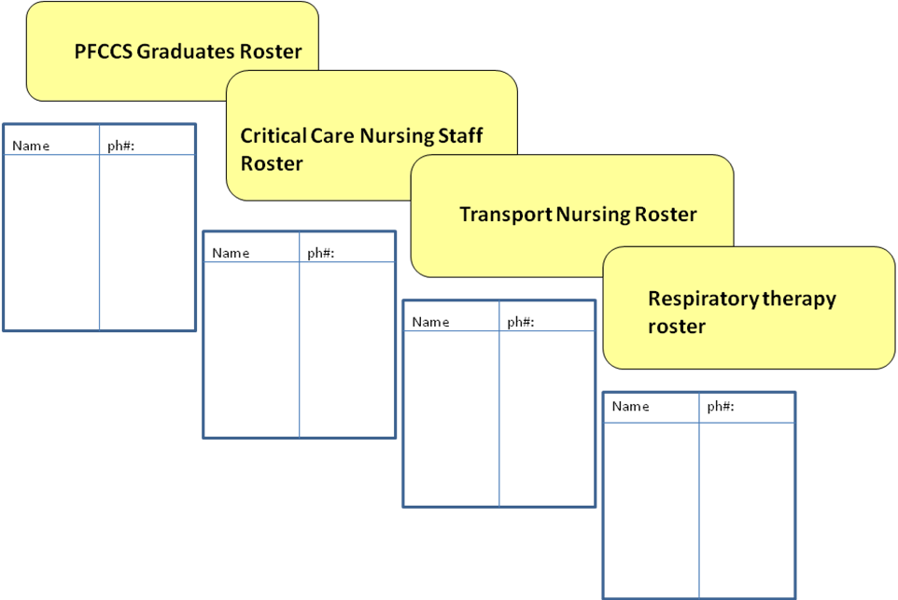

|  |  |  |  |
| --- | --- | --- | --- |
| Roster | Responsible officer | Discipline | Ph# cell/office |
| PFCCS |  | Ped. CC |  |
| CC nursing |  | Nursing |  |
| Transport nursing |  | Nursing |  |
| Resp. Therapy |  | Resp. Therapy |  |

**Appendix 2**

**Discharge of Patients to Home During Disasters**

|  |  |  |  |  |  |  |
| --- | --- | --- | --- | --- | --- | --- |
| Room# | Pt. Name | Diagnosis | ______ attending Approving Discharge | Approving Pediatrician | Destination | Parental consent |
|  |  |  |  |  |  |  |
|  |  |  |  |  |  |  |
|  |  |  |  |  |  |  |
|  |  |  |  |  |  |  |
|  |  |  |  |  |  |  |
|  |  |  |  |  |  |  |
|  |  |  |  |  |  |  |
|  |  |  |  |  |  |  |
|  |  |  |  |  |  |  |
|  |  |  |  |  |  |  |
|  |  |  |  |  |  |  |
|  |  |  |  |  |  |  |
|  |  |  |  |  |  |  |

**Appendix 3**

**Management of ‘Sicker Patients than Usual’ on the Floors form: to be completed by chief resident**

|  |  |  |  |  |  |  |
| --- | --- | --- | --- | --- | --- | --- |
| Room# at ______ | Pt. Name | Diagnosis | On drips of | FiO2 and BiPAP settings | Supervising PICU attg or fellow | Supervising PICU RN or Transport RN |
|  |  |  |  |  |  |  |
|  |  |  |  |  |  |  |
|  |  |  |  |  |  |  |
|  |  |  |  |  |  |  |
|  |  |  |  |  |  |  |
|  |  |  |  |  |  |  |
|  |  |  |  |  |  |  |
|  |  |  |  |  |  |  |
|  |  |  |  |  |  |  |
|  |  |  |  |  |  |  |
|  |  |  |  |  |  |  |
|  |  |  |  |  |  |  |
|  |  |  |  |  |  |  |

**Appendix 4**

**The Hospital Isolation Surge Capacity Plan**

|  |  |  |
| --- | --- | --- |
| Negative pressure room # | # of beds | Location |
|  |  |  |
|  |  |  |
|  |  |  |
|  |  |  |

|  |  |  |
| --- | --- | --- |
| Placing HEPA filters in room # | # of beds | Location |
|  |  |  |
|  |  |  |
|  |  |  |

|  |  |  |
| --- | --- | --- |
| Use of PPE for room # | Type of PPE | Procedure |
|  |  |  |
|  |  |  |
|  |  |  |

**Appendix 5**

**RPDT (NYC PDC)**

tool 11

**Acronyms:**

YH – Your Hospital

ED - Emergency Department

FDNY - Fire Department of New York City

FISC – Family Information and Support Center

HEICS - Hospital Emergency Incident Command System

NYCDOHMH - New York City Department of Health and Mental Hygiene

NYSDOH - New York State Department of Health

PCCSP - Pediatric Critical Care Surge Plan

PICU - Pediatric Intensive Care Unit

PCC - Pediatric Critical Care