Supplementary material

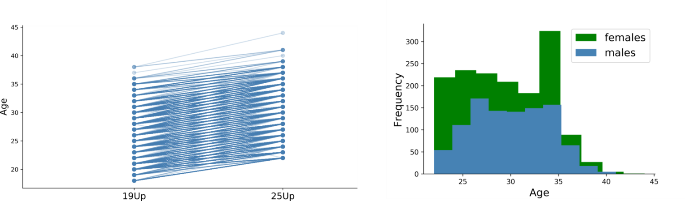

Supplementary Figure 1: Age distribution of the 25Up Cohort
Left panel depicts the increase of age between the 19Up and 25Up cohorts. Right side depicts 25Up age distribution stratified by sex.

Supplementary Figure 2: Response to invitation to participate in the 25Up study
Pie chart depicts the distribution of participants’ responses upon receiving an invitation to participate in the 25Up study. Completed refers to individuals that have completed at least TFU1.

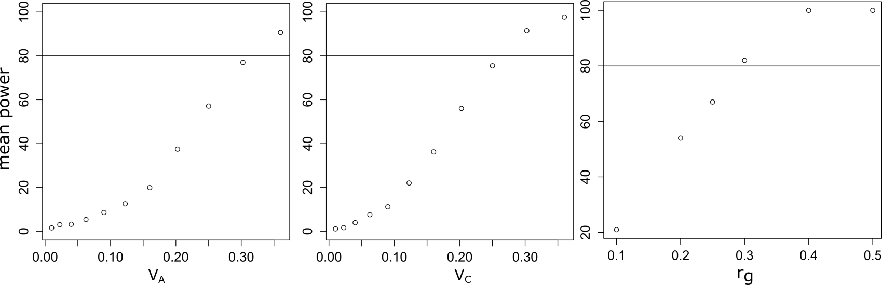
Supplementary Figure 3: Twin study power on the 25Up Cohort.
Results of simulations of power analysis through simulations of phenotypes following an ACE variance composition (see methods). The panels depict the power to detect an additive genetic component (left) and a common environment component (right).

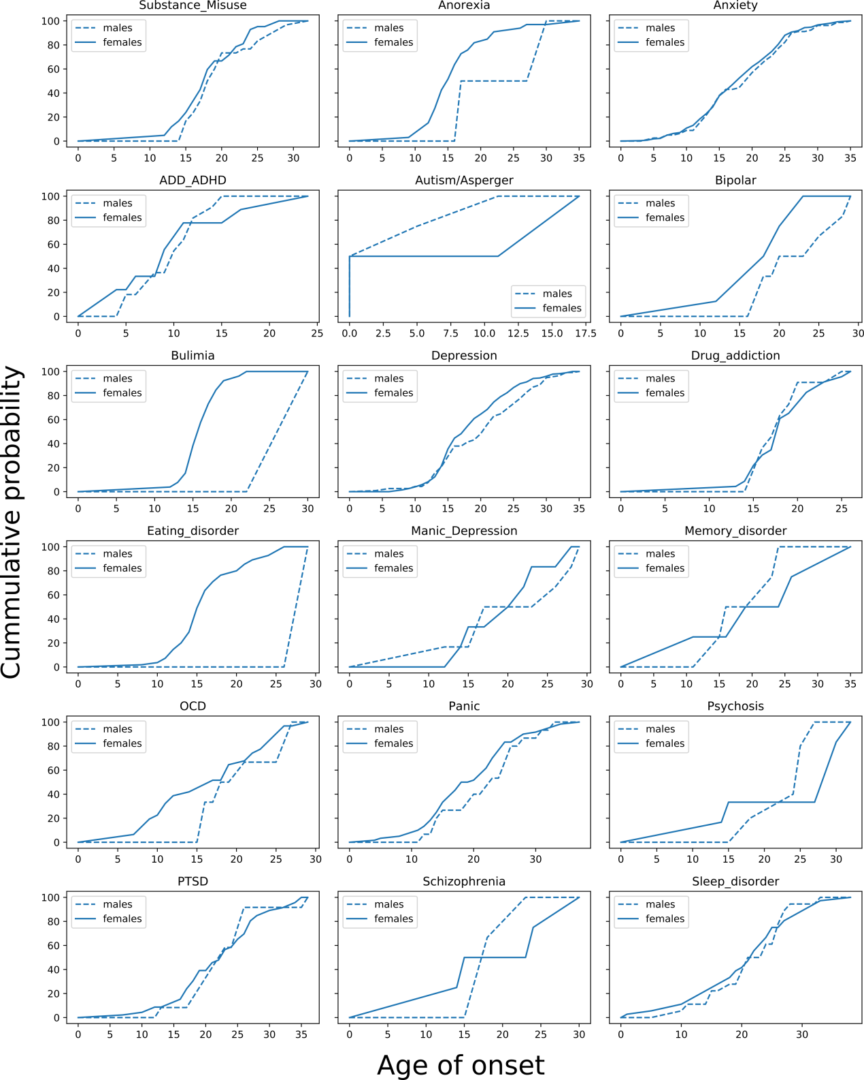
Supplementary Figure 4: 25Up self-reported conditions age of onset
Plots depict the cumulative probability for each disorder and its relationship with age of onset stratified by sex.

