TWIN RESEARCH AND HUMAN GENETICS

SUPPLEMENTARY MATERIAL

Blood Eosinophil Count and Metabolic, Cardiac and Pulmonary Outcomes:
A Mendelian Randomization Study

Amini, M., Vonk, J. M., Abbasi, A., Prins, B. P., Bruinenberg, M., Franke, L., van der Harst, P., Navis, G., Koppelman, G. H., Wolffenbuttel, B. H. R., Boezen, H. M., Snieder, H., Chasman, D. I., Alizadeh, B. Z.

Supplementary Methods 3
- Genetic variants selection 3
Supplementary Table S1 3
- Cohorts specific description 3
LifeLines description 3
LifeLines genotyping 3
Women’s Genome Health Study description 4
Women’s Genome Health Study genotyping 4
iii. Data analysis 5
Supplementary Results 6
- Characteristic of participants in cohorts 6
- Characteristic of genetic variants in cohorts 6
Supplementary Table S2 7
Supplementary Table S3 8
- Association meta-analysis results of eosinophil genetic variants with eosinophil count, quantitative traits and diseases 9
Supplementary Figure S1 10
Supplementary Figure S2 11
Supplementary Figure S3 12
- Eosinophil genetic variants association effect versus traits and diseases from public available consortia data 13
Supplementary Figure S4 13
Supplementary Figure S5 15
Supplementary References 16

Supplementary Methods
i. Genetic variants selection
Supplementary Table S1. Characteristic of GWAS significant loci associated with eosinophil count in 21,510 combined European samples (Gudbjartsson et al., 2009).

SNP | Chr. (position) | Genes | Effect allele (Iceland frequency) | Beta ± SE (p-value)*
rs3184504 | 12 (110,368,991) | SH2B3 | T (0.38) | 7.6 ± 0.87 (6.5×10⁻¹⁹)
rs4143832 | 5 (131,890,876) | IL5 | C (0.16) | 7.1 ± 1.07 (1.2×10⁻¹⁰)
rs12619285 | 2 (213,532,290) | IKZF2 | G (0.74) | 6.3 ± 1.02 (5.4×10⁻¹⁰)
rs4857855 | 3 (129,743,240) | GATA2 | T (0.82) | 9.4 ± 1.12 (8.6×10⁻¹⁷)
rs1420101 | 2 (102,324,148) | IL1RL1 | A (0.41) | 6.4 ± 0.87 (5.3×10⁻¹⁴)
*Effect sizes in study were reported in percentages of standard deviation units.

ii. Cohorts specific description
LifeLines description
The LifeLines cohort study is a multi-disciplinary prospective population-based cohort study examining in a unique three-generation design the health and health-related behaviors of 167,729 persons living in the North East region of The Netherlands. It employs a broad range of investigative procedures in assessing the biomedical, socio-demographic, behavioral, physical and psychological factors which contribute to the health and disease of the general population, with a special focus on multi-morbidity and complex genetics (Klijs et al., 2015; Scholtens et al., 2014; Stolk et al., 2008). The sample size available for the present study was 13, 301 with data on genetic and phenotypic information. The LifeLines study has been approved by the review board of the University Medical Center, Groningen, and adheres to the principles expressed in the Declaration of Helsinki. All study participants provided written informed consent.
LifeLines genotyping
Genotyping for Lifelines was performed on the Illumina CytoSNP12 v2 chip. Samples were excluded based on call rates below 0.95, gender mismatch, duplicate discordance and genetic similarity. Population stratification was assessed by principal component analysis over the sample correlation matrix, based on 16,842 independent SNPs. Samples were excluded when they diverged from the mean with at least three SDs (Z-score >3) for the first five principal components. SNPs were excluded with a MAF of <0.01, call rate <0.95 or deviation from HWE (P<1.0×10⁻⁵). Genome wide genotype imputation was performed using Beagle v. 3.1.0, using the NCBI build 36 of phase II HapMap CEU data (release 22) as a reference panel.
Women’s Genome Health Study description
The Women’s Genome Health Study (WGHS) is a prospective cohort of initially healthy, female North American health care professionals at least 45 years old at baseline representing participants in the Women’s Health Study (WHS) who provided a blood sample at baseline and consent for blood-based analyses. The WHS was a 2x2 trial beginning in 1992-1994 of vitamin E and low dose aspirin in prevention of cancer and cardiovascular disease with about 10 years of follow-up. Since the end of the trial, follow-up has continued in observational mode. Measurement of lipid fractions was performed in plasma from the baseline blood sample and additional information related to health and lifestyle were collected by questionnaire throughout the WHS trial and continuing observational follow-up (Ridker et al., 2008).
Women’s Genome Health Study genotyping
Genotyping in the WGHS sample was performed using the HumanHap300 Duo ‘‘+’’ chips or the combination of the HumanHap300 Duo and iSelect chips (Illumina, San Diego, CA) with the Infinium II protocol. In either case, the custom SNP content was the same; these custom SNPs were chosen without regard to minor allele frequency (MAF) to saturate candidate genes for cardiovascular disease as well as to increase coverage of SNPs with known or suspected biological function, e.g. disease association, non-synonymous changes, substitutions at splice sites, etc. For quality control, all samples were required to have successful genotyping using the BeadStudio v. 3.3 software (Illumina, San Diego, CA) for at least 98% of the SNPs. A subset of 23,294 individuals were identified with self-reported European ancestry that could be verified on the basis of multidimensional scaling analysis of identity by state using 1443 ancestry informative markers in PLINK v. 1.06. In the final dataset of these individuals, a total of 339,596 SNPs were retained with MAF >1%, successful genotyping in 90% of the subjects, and deviations from Hardy-Weinberg equilibrium not exceeding p=10⁻⁶ in significance. Among the final 23,294 individuals of verified European ancestry, genotypes for a total of 2,608,509 SNPs were imputed from the experimental genotypes for 340,349 SNPs and LD relationships implicit in the HapMap r. 22 CEU samples. Imputation was performed with MaCH 1.0.16. Analysis is typically performed with ProbABEL (Ridker et al., 2008).
iii. Data analysis: As a sensitivity analysis, we assessed the association of the five genetic variants with eosinophil count, different traits and diseases using meta-analysis of two large cohorts LifeLines and WGHS with total 36,595 individuals. Multiple linear and logistic regression analyses were performed using lm and glm modules in R, respectively. All analyses in LifeLines were adjusted for the age and gender. As WGHS was female individuals, the analyses just adjusted for age. The pooled effect values of two cohorts were estimated using fixed effects meta-analyses as implemented in REVMAN software (version 5.3, Cochrane Collaboration, Oxford, United Kingdom). Provided effects estimate were expressed as the change in the number of SDs in log-transformed quantitative traits and the odds ratio (OR) for complex diseases per each copy increase in number of the effect allele (range 0-2).

Supplementary Results
i. Characteristic of participants in cohorts
Supplementary Table S2 shows the characteristic of LifeLines participants. Among 13,301 LifeLines subjects 58.2% were women (age 51.3 ± 11.1 years). The median of eosinophil count was 160 cells/µl. Mean or median of the major quantitative traits were within normal ranges. The prevalence of HTN in LifeLines participants was 29.9%, followed by metabolic syndrome (17.6%), obesity (16.4%), COPD (9.5%), asthma (7.3%), T2D (3.8%) and MI (1.4%). The 23,294 WGHS women had mean age of 55.0 ± 7.1 years and mean or median of the quantitative traits were within the normal ranges. The prevalence of diseases in WGHS were 24.6% for HTN, 23.0% for metabolic syndrome and 17.5% for obesity; and no data were available on eosinophil count, T2D, MI, COPD and asthma and related quantitative traits (Supplementary Table S3).
ii. Characteristic of genetic variants in cohorts: In the LifeLines, from the five genetic variants, rs3184504, rs4143832, rs12619285, and rs4857855 were directly genotyped and rs1420101 was imputed (imputation quality=0.76). Allele frequency of five genetic variants rs3184504*T , rs4143832*G, rs12619285*G, rs4857855*C, rs1420101*A in LifeLines were 0.44, 0.82, 0.29, 0.81, and 0.34, respectively. In WGHS genotype data, the five genetic variants were directly genotyped and the allele frequency of rs3184504*T, rs4143832*G, rs12619285*G, rs4857855*C, rs1420101*A were 0.48, 0.81, 0.26, 0.82, and 0.37, respectively. The allele frequencies in both population were consistent with the allele frequencies in CEU HapMap data.

Supplementary Table S2. The characteristic of participants in LifeLines cohort study (n=13,301)

 | Mean ± SD/ Median (interquartile range) /n(%)
Gender: n (Female %) |  | 7,744 (58.2)
Age (yrs.) |  | 51.3 ± 11.1
Lipid lowering medication: n (%) |  | 851 (6.4)
Antihypertensive medication: n (%) |  | 3,029 (22.8)
Current smoking: n (%) |  | 2,973 (22.4)
Pack-years |  | 13.3 ± 11.7
Eosinophils (cells/µl) |  | 160.0 (100.0-300.0)
BMI (kg/m2) |  | 25.8 (13.9-28.6)
Triglycerides (mmol/L) |  | 1.04 (0.05-1.47)
Total Cholesterol (mmol/L) |  | 5.1 ± 1.0
High-density lipoprotein (mmol/L) |  | 1.4 ± 0.4
Low-density lipoprotein (mmol/L) |  | 3.3 ± 0.9
HbA1c (%) |  | 5.5 ± 0.3
Fasting glucose (mmol/L) |  | 5.0 ± 0.6
Imputed SBP (mmHg) † |  | 130.0 (86.0-237.0)
Imputed DBP (mmHg) † |  | 76.0 (35.0-150.0)
Mean Arterial Pressure (mmHg) |  | 94.3 (59.0-178.0)
Pulse Pressure (mmHg) |  | 53.0 (22.0-124.0)
FEV₁ (L) |  | 3.4 ± 0.8
FEV₁/FVC |  | 0.8 ± 0.07
Metabolic syndromes: n (%)^{I} |  | 2,337 (17.6)
Obesity: n (%)^{II} |  | 2,185 (16.4)
Type 2 diabetes: n (%)^{III} |  | 507 (3.8)
Hypertension: n (%)^{IV} |  | 3,921 (29.9)
Myocardial infarction: n (%)^{V} |  | 190 (1.4)
COPD: n (%)^{VI} |  | 1,265 (9.5)
Asthma: n (%)^{VII} |  | 967 (7.3)
BMI: body mass index, HbA1c: Hemoglobin A1c, SBP: systolic blood pressure, DBP: diastolic blood pressure, FEV₁: Forced expiratory volume in one second, FVC: Forced vital capacity, COPD: Chronic Obstructive Pulmonary Disease.
† Imputed SBP and DBP were calculated as a following: For all individuals who taking antihypertensive or blood pressure lowering medication, were added 15mmHg to the measured SBP level, and 10mmHg to the measured DBP level. For individuals not taking such medication, the imputed values were left equal to the measured level.
^{I} Metabolic syndrome was defined as the presence of three or more of the following four traits: 1) abdominal obesity defined as waist circumference in men >102 cm and in women >88 cm; 2) dyslipidemia determined as serum triglycerides≥1.7 mmol/L or pharmacologic treatment for elevated triglycerides and serum HDL cholesterol <1.03 mmol/L in men and <1.29 mmol/L in women or pharmacologic treatment for low HDL cholesterol; 3) hypertension defined as either SBP≥130 mmHg or DBP≥85 mmHg or pharmacologic treatment for elevated blood pressure; 4) hyperglycemia determined as fasting glucose≥5.6 mmol/L or pharmacologic treatment for elevated plasma glucose.
^{II} Obesity was defined as BMI≥30.
^{III} Type 2 diabetes was defined by either clinical diagnosis, self–reported type 2 diabetes, type 2 diabetes pharmacologic treatment or undiagnosed type 2 diabetes defined by FG≥7.0 mmol/L or HbA1c≥6.5%.
^{IV} Hypertension was defined as SBP≥140 mmHg and/or DBP≥90 mmHg or anti-hypertension medication use.
^{V} Myocardial infarction was based on self-reported.
^{VI} COPD was based on FEV₁/FVC ratio <70% and being an ever smoker (ex- or current smoker).
^{VII} Asthma was based on a clinical diagnosis of asthma or two or more of the symptoms wheeze, attack at rest, woken by an attack and asthma medication use.

Supplementary Table S3. The Characteristic of participants in Women’s Genome Health Study (n=23,294)

 | Mean ± SD/ Median (interquartile range) /n(%)
Age (yrs.) |  | 55.0 ± 7.1
Lipid lowering medication: n (%) |  | 755 (3.2)
Antihypertensive medication: n (%) |  | 3,001 (12.9)
Current smoking: n (%) |  | 2,710 (11.6)
Pack-years |  | 15.0 ± 14.0
BMI (kg/m2) |  | 25.0 (22.0-28.0)
Triglycerides (mmol/L) |  | 1.6 (0.05-1.47)
Total Cholesterol (mmol/L) |  | 5.5 ± 1.1
High-density lipoprotein (mmol/L) |  | 1.4 ± 0.4
Low-density lipoprotein (mmol/L) |  | 3.2 ± 0.9
HbA1c (%) |  | 5.1 ± 0.6
Imputed SBP (mmHg) † |  | 125.0 (115.0-135.0)
Imputed DBP (mmHg) † |  | 80.0 (70.0-87.0)
Mean Arterial Pressure (mmHg) |  | 92.0 (85.0-100.0)
Pulse Pressure (mmHg) |  | 45.0 (45.0-55.0)
Metabolic syndromes: n (%)^{I} |  | 5,059 (23.0)
Obesity: n (%)^{II} |  | 4,001 (17.5)
Hypertension: n (%)^{III} |  | 5,730 (24.6)
BMI: body mass index, HbA1c: Hemoglobin A1c, SBP: systolic blood pressure, DBP: diastolic blood pressure
† Imputed SBP and DBP were calculated as a following: For all individuals who taking antihypertensive or blood pressure lowering medication, were added 15mmHg to the measured SBP level, and 10mmHg to the measured DBP level. For individuals not taking such medication, the imputed values were left equal to the measured level.
^{I} Metabolic syndrome was defined as the presence of three or more of the following four traits: 1) abdominal obesity defined as waist circumference in men >102 cm and in women >88 cm; 2) dyslipidemia determined as serum triglycerides≥1.7 mmol/L or pharmacologic treatment for elevated triglycerides and serum HDL cholesterol <1.03 mmol/L in men and <1.29 mmol/L in women or pharmacologic treatment for low HDL cholesterol; 3) hypertension defined as either SBP≥130 mmHg or DBP≥85 mmHg or pharmacologic treatment for elevated blood pressure; 4) hyperglycemia determined as fasting glucose≥5.6 mmol/L or pharmacologic treatment for elevated plasma glucose.
^{II} Obesity was defined as BMI≥30.
^{III} Hypertension was defined as SBP≥140 mmHg and/or DBP≥90 mmHg or anti-hypertension medication use.

iii. Association meta-analysis results of eosinophil genetic variants with eosinophil count, quantitative traits and diseases
Association results on eosinophil count: The associations between the five eosinophil genetic variants and eosinophil count in LifeLines cohort study (as eosinophil data were available) presented in Supplementary Figure S1. An increase in one copy of genetic risk variants SH2B3-rs3184504*T, IL5-rs4143832*G, IKZF2-rs12619285*G, GATA2-rs4857855*C, IL1RL1-rs1420101*A were significantly associated with 0.09 (±SE 0.01; p=3.9×10-13), 0.04 (±0.02; p=1.3×10-3), 0.03 (±0.01; p=1.5×10-3), 0.09 (±0.02; p=1.4×10-8), 0.06 (±0.01; p=1.0×10-4) SD unit higher in eosinophil count, respectively. Using the individual-level LifeLines data, we found that SH2B3-rs3184504*T, IL5-rs4143832*G, IKZF2-rs12619285*G, GATA2-rs4857855*C, IL1RL1-rs1420101*A and eos_GRS_{LLs} explained 0.30%, 0.05%, 0.001%, 0.20%, 0.06%, and 0.60% of eosinophil variation, respectively.
Meta-analysis results of metabolic, cardiac and pulmonary traits and diseases of five eosinophil corresponding genetic variants from two LifeLines and WGHS studies presented in Supplementary Figure S2 and Supplementary Figure S3.
Association meta-analysis results on quantitative traits: In metabolic class the results that emerge from the data is that an increase in one copy allele of SH2B3-rs3184504*T was nominally associated with 0.01 (±0.005; p=0.01) SD unit higher HbA1c. Besides, we found an increase in one copy allele of GATA2-rs4857855*C was significantly associated with 0.03 (±0.009; p=4.07×10⁻⁴) SD unit higher TG; and an increase in one copy allele of SH2B3-rs3184504*T was significantly associated with 0.02 (±0.003; p=3.49×10⁻⁴) SD unit lower HDL. Moreover, in cardiac class an increase in one copy allele of SH2B3-rs3184504*T was significantly associated with 0.04 (±0.01; p=4.18×10⁻⁴) SD unit higher SBP, 0.06 (±0.01; p=1.60×10⁻⁷) SD unit higher DBP and 0.05 (±0.01; p=4.04×10⁻⁵) SD unit higher MAP. Furthermore, in pulmonary class, an increase in one copy allele of SH2B3-rs3184504*T was nominally associated with 0.02 (±0.01; p=0.04) SD unit lower FEV₁/FVC (Supplementary Figure S2).
Association meta-analysis results on diseases: The association results on diseases indicated that an increase in one copy allele of IL5-rs4143832*G nominally associated with lower risk of obesity (OR 0.94 [95%CI 0.89-0.991]; p=0.02) in metabolic class. In pulmonary class, nominal association was found for an increase in one copy allele of GATA2-rs4857855*C with lower risk of COPD (0.89 [0.80-0.99]; p=0.04). Likewise, nominal association was found for an increase in one copy allele of IKZF2-rs12619285*G (1.115 [1.01-1.24]; p=0.04) and for an increase in one copy allele of IL1RL1-rs1420101*A (1.13 [1.01-1.26]; p=0.035) with higher risk of asthma; while, an increase in one copy allele of GATA2-rs4857855*C was nominally associated with lower risk of asthma (0.88 [0.77-0.99]; p=0.04) (Supplementary Figure S3).

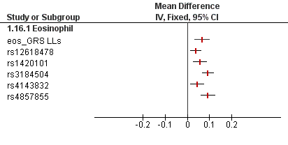

Supplementary Figure S1: Multivariate association analysis results of the individual genetic variants and eosinophil genetic risk score (eos_GRS_{LLs}) on eosinophil count as a determinant in LifeLines cohort study. The analyses were done by regression of mean standardized eosinophil count on genetic variants allele count, while adjusted for age and gender, and effect sizes are given in SD unit increase of eosinophil count.
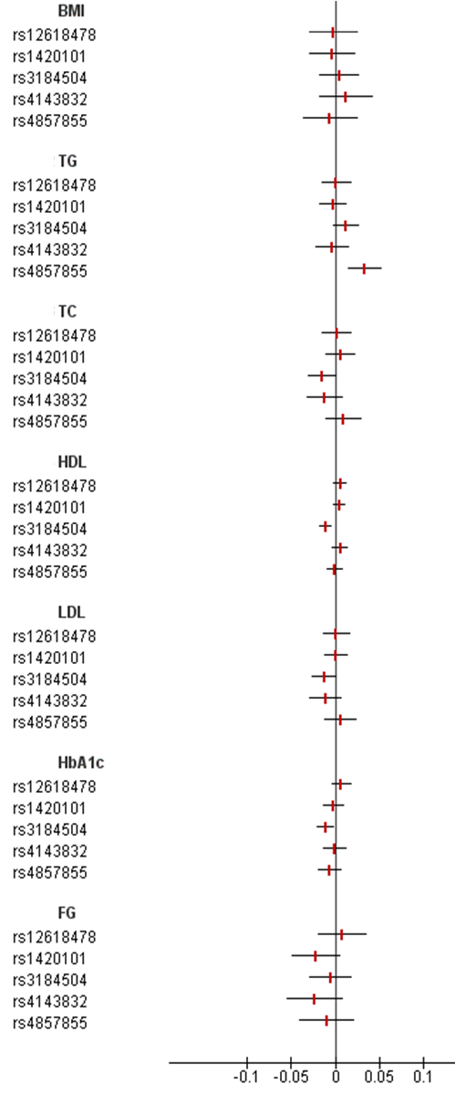  S2a | 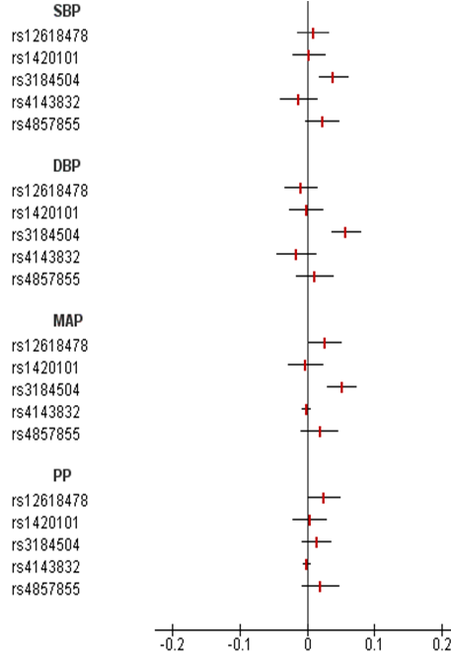  S2b
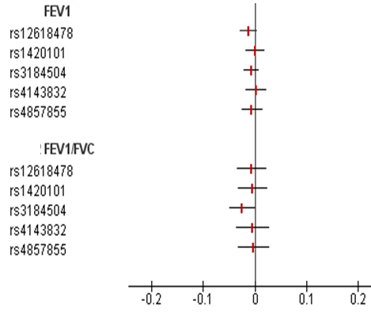
S2c
Supplementary Figure S2. Meta-analysis association effects of five genetic variants on quantitative traits in metabolic (S2a) and cardiac (S2b) classes from two LifeLines and WGHS cohort studies. Regression effects in pulmonary traits (S2c) were based on linear regression of eosinophil genetic variants on pulmonary traits in LifeLines cohort study. Data are given in β ± SD.

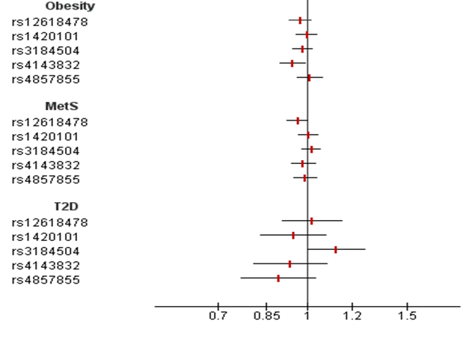
S3a
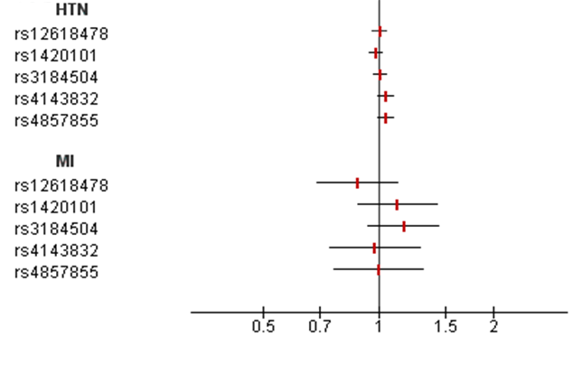
S3b
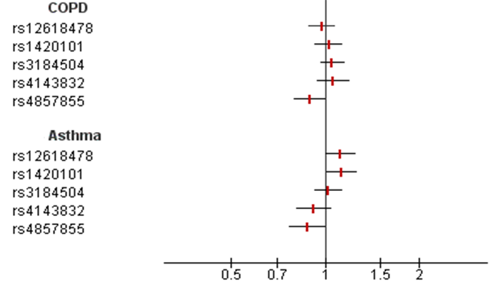
S3c
Supplementary Figure S3: Meta-analysis results of five eosinophil genetic variants on diseases in metabolic (S3a) and cardiac (S3b) classes from two LifeLines and WGHS cohort studies. Odds ratios in pulmonary diseases (S3c) were based on logistic regression of eosinophil genetic variants on pulmonary diseases in the LifeLines cohort study. Data are given in odds ratio and 95% confidence intervals.

iv. Eosinophil genetic variants association effect versus traits and diseases from public available consortia data
S4a- Metabolic Class Traits

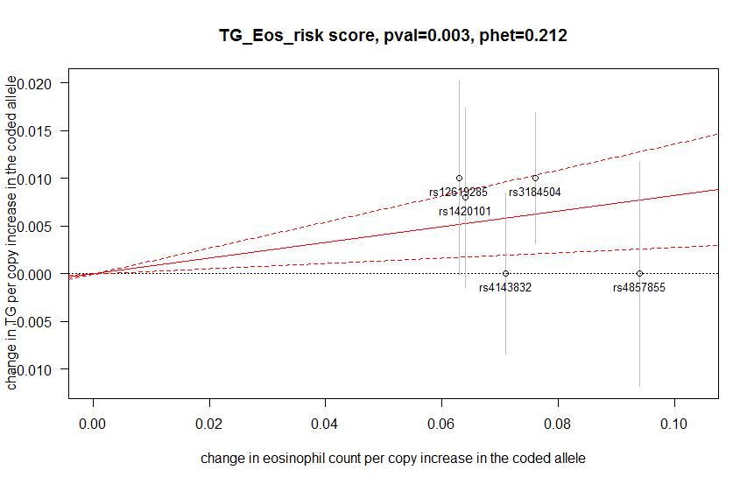
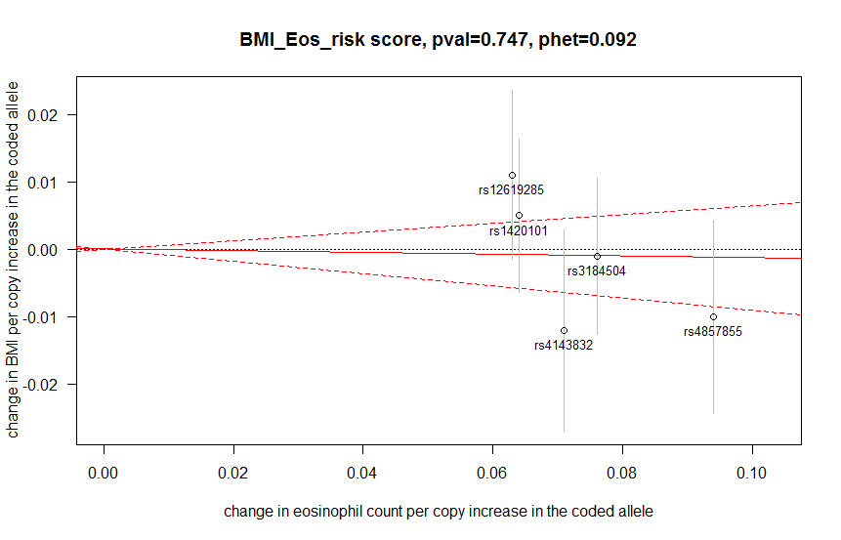
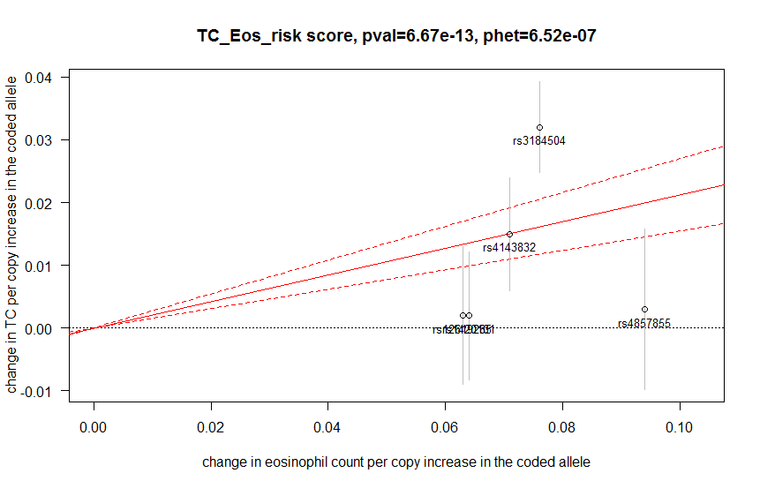
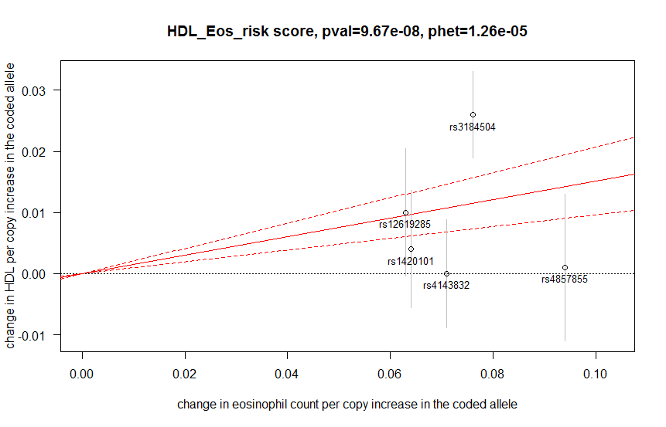
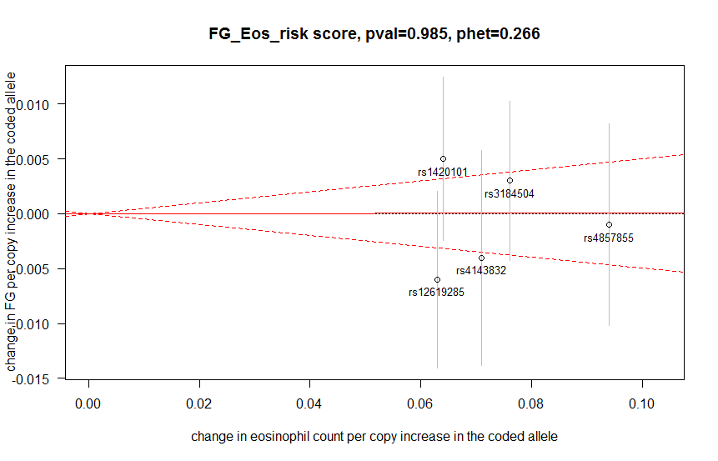
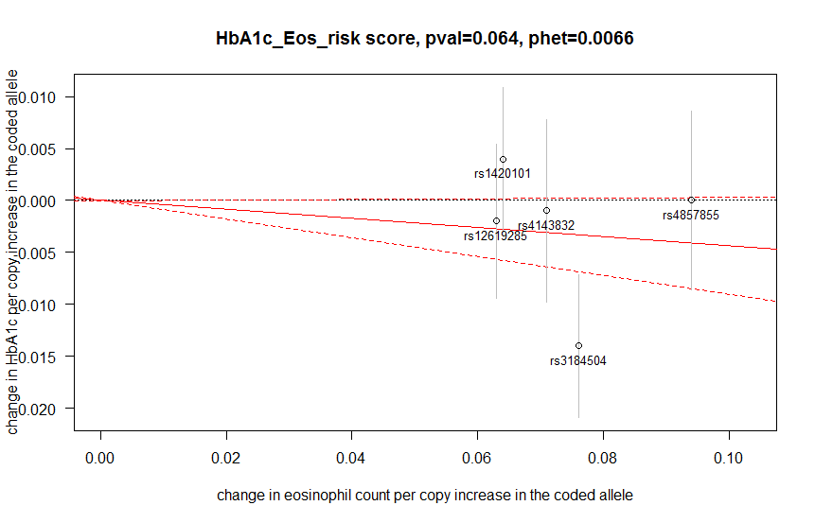
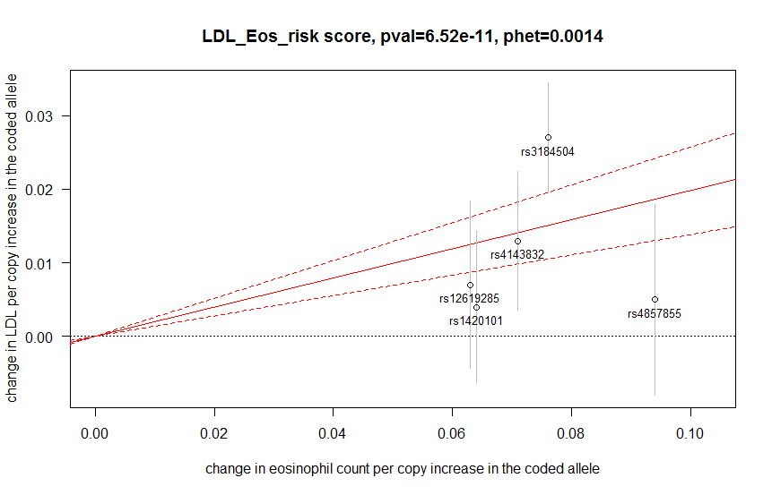
S4b- Cardiac Class Traits
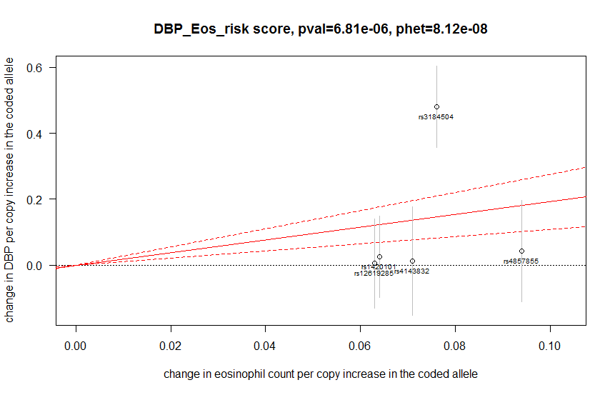
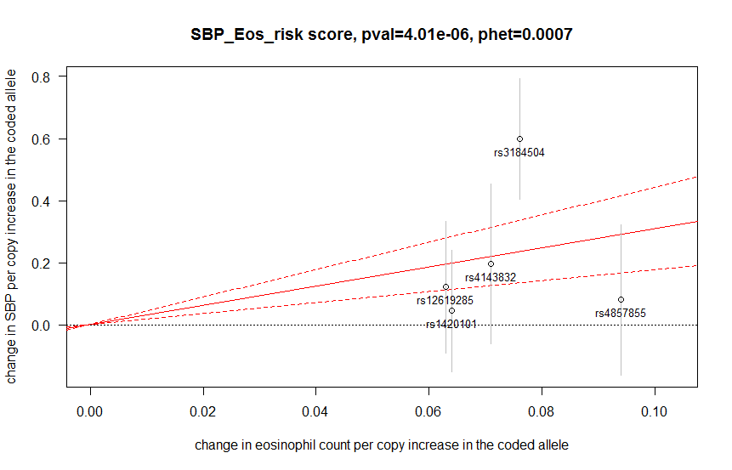
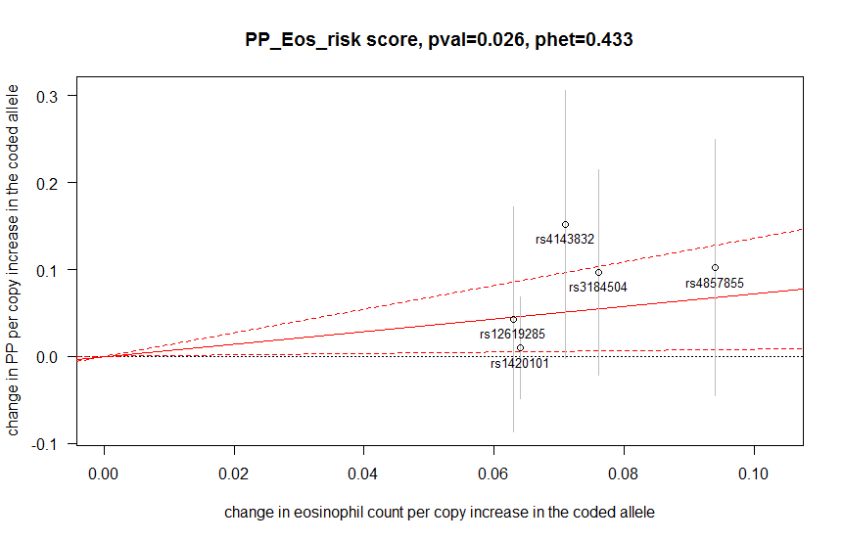
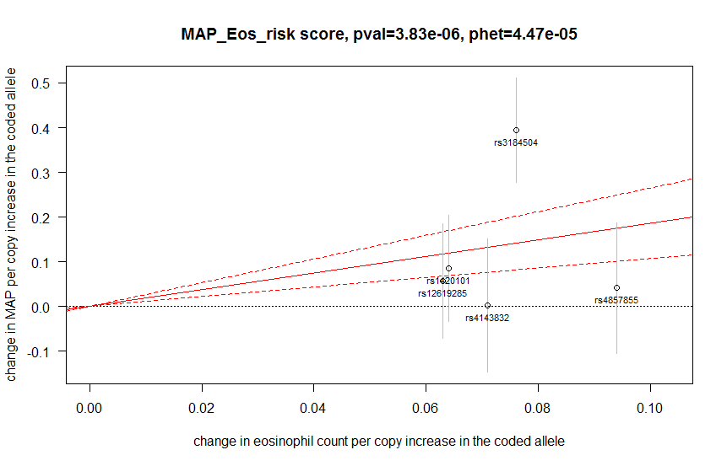
Supplementary Figure S4. Plots of eosinophil genetic variants versus quantitative traits derived from public available consortia data. The grey vertical lines indicate the 95% confidence interval (CI) for each individual genetic variants. The effect estimate of eosinophil count on traits level is represented by a red solid line with gradient α. The 95% CI of this α estimate is represented by red dashed lines.
Abbreviations: phet: p-value heterogeneity, BMI: body mass index, TG: triglycerides, TC: total cholesterol, HDL: high density lipoprotein, LDL: low density lipoprotein, HbA1c: hemoglobin A1c, FG: fasting glucose, SBP: systolic blood pressure, DBP: diastolic blood pressure, MAP: mean arterial pressure, PP: pulse pressure.

S5a- Metabolic Class Diseases

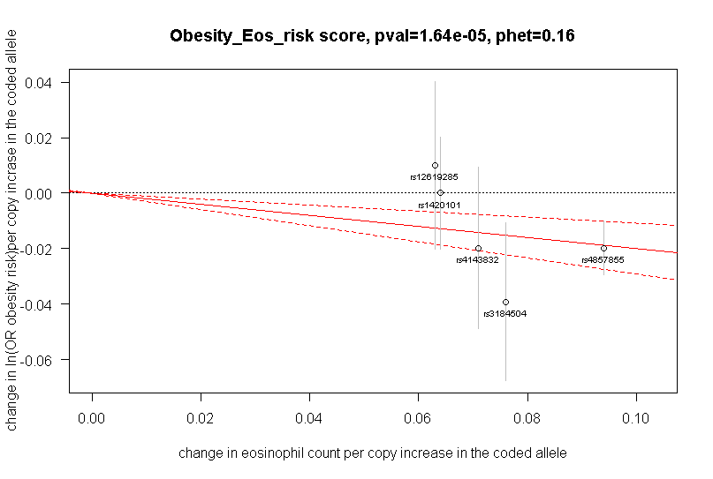
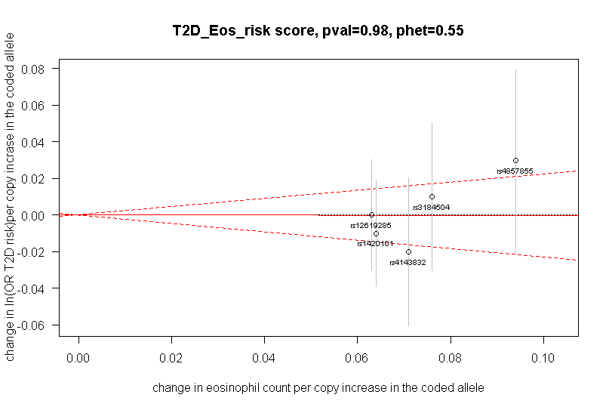
S5b- Cardiac Class Disease

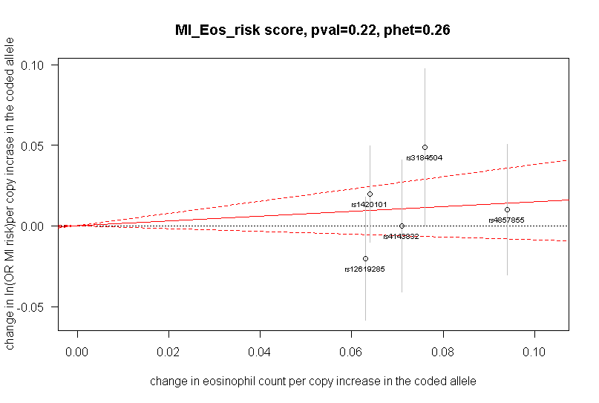
Supplementary Figure S5. Plots of eosinophil genetic variants versus diseases outcomes derived from public available consortia data. The grey vertical lines indicate the 95% confidence interval (CI) for each individual genetic variants. The effect estimate of eosinophil count on diseases risk is represented by a red solid line with gradient α. The 95% CI of this α estimate is represented by red dashed lines.
Abbreviation: phet: p-value heterogeneity, T2D: type 2 diabetes, MI: myocardial infarction.

Supplementary References
Gudbjartsson, D. F., Bjornsdottir, U. S., Halapi, E., Helgadottir, A., Sulem, P., Jonsdottir, G. M., . . . Stefansson, K. (2009). Sequence variants affecting eosinophil numbers associate with asthma and myocardial infarction. Nat Genet, 41(3), 342-347. doi:10.1038/ng.323
Klijs, B., Scholtens, S., Mandemakers, J. J., Snieder, H., Stolk, R. P., & Smidt, N. (2015). Representativeness of the LifeLines cohort study. PloS One, 10(9), e0137203. doi:10.1371/journal.pone.0137203 [doi]
Ridker, P. M., Chasman, D. I., Zee, R. Y., Parker, A., Rose, L., Cook, N. R., . . . Women's Genome Health Study Working Group. (2008). Rationale, design, and methodology of the women's genome health study: A genome-wide association study of more than 25,000 initially healthy american women. Clinical Chemistry, 54(2), 249-255. doi:clinchem.2007.099366 [pii]
Scholtens, S., Smidt, N., Swertz, M. A., Bakker, S. J., Dotinga, A., Vonk, J. M., . . . Stolk, R. P. (2014). Cohort profile: LifeLines, a three-generation cohort study and biobank. International Journal of Epidemiology, doi:dyu229 [pii]
Stolk, R. P., Rosmalen, J. G., Postma, D. S., de Boer,R.A., Navis, G., Slaets, J. P., . . . Wolffenbuttel, B. H. (2008). Universal risk factors for multifactorial diseases: LifeLines: A three-generation population-based study. Eur J Epidemiol, 23(1), 67-74. doi:10.1007/s10654-007-9204-4

