Twin Research and Human Genetics
Structural Brain MRI Trait Polygenic Score Prediction of Cognitive Abilities
Luciano M, Marioni RE, Valdés Hernández M, Munoz Maniega S, Hamilton IF, Royle NA, Generation Scotland, Chauhan G, Bis JC, Debette S, DeCarli C, Fornage M, Schmidt R, Ikram MA, Launer LJ, Seshadri S, the CHARGE Consortium, Bastin ME, Porteous DJ, Wardlaw J, Deary IJ

Supplementary Table 1
Age Characteristics (Range, Mean, SD) at the Time of Cognitive Testing in the Prediction Cohorts and of MRI Scanning in the Discovery Cohort
LBC1921 | LBC1936 | GS:SFHS | CHARGE (Discovery Cohorts)
77.7 to 80.6  79.1 ±0.6* | 67.6 to 71.3  69.5 ±0.8 | 18 to 98  55.5 ±11.4 | 76.2 ±5.4, 63.2 ±4.4, 65.3 ±8, 71.7 ±4.8, 63.9 ±11.3, 72.9 ±7.9, and 67.2 ±5.3
Note: Age range in CHARGE cohorts is unpublished.
*83.3 ±0.54 for Digit Symbol.

Supplementary Table 2
Number of SNPs Included in the Varying Threshold Polygenic Scores for TBV
(variable for which the number of GWAS SNPs was maximal)
p < | GS:SFHS | LBC1936 | LBC1921
.01 | 1 216 | 1 241 | 1 212
.05 | 5 731 | 5 840 | 5 796
.10 | 11 384 | 11 541 | 11 452
.50 | 55 212 | 56 305 | 55 801
1 | 110 178 | 111 729 | 111 153

Supplementary Table 3
Correlations Between MRI Trait Polygenic Scores and Their Corresponding Phenotype in the LBC1936

p < | r | P
Brain infarct (n = 629)
.01 | -.13 | .69
.05 | .21 | .51
.10 | -.07 | .82
.50 | .11 | .74
1 | -.02 | .94
White matter hyperintensities (n = 573)
.01 | .02 | .66
.05 | .09 | .040
.10 | .07 | .09
.50 | .09 | .036
1 | .08 | .049
Intracranial volume (n = 624)
.01 | .08 | .008
.05 | .10 | .001
.10 | .10 | .001
.50 | .09 | .003
1 | .08 | .006
Hippocampal volume (n = 611)
.01 | .01 | .86
.05 | .05 | .21
.10 | .04 | .25
.50 | .08 | .039
1 | .07 | .054
Total brain volume (n = 623)
.01 | .08 | .02
.05 | .06 | .09
.10 | .04 | .24
.50 | .03 | .30
1 | .04 | .28
Note: . Significant correlations at a Bonferroni corrected level are bolded.

Supplementary Table 4
Mean (SD) of MRI Traits and their Correlations (p value) With the Main Cognitive Variables in the LBC1936

 | ICV  (n = 620-624) | TBV  (n = 619-623) | HV  (n = 607-611) | WMH  (n = 570-573) | BI  (n = 625-629)
Mean (SD): | 1451851 mm³ (141604) | 1124236 mm³ (107666) | 6426.44 mm³ (868.04) | 2.09 (.99)* | Yes: 93  No: 537
Correlation:  Digit symbol | -0.02 (.70) | 0.28 (4.83⁻¹³) | 0.06 (.12) | -0.21 (5.62⁻⁷) | -0.12 (.002)
Verbal fluency | 0.04 (.38) | 0.15 (2.24⁻⁴) | 0.00 (.98) | -0.07 (.07) | -0.15 (2.21⁻⁴)
Logical memory | 0.02 (.58) | 0.09 (.022) | 0.06 (.13) | -0.03 (.53) | -0.10 (.009)
NART | 0.08 (.042) | 0.06 (.12) | 0.06 (.16) | -0.05 (.23) | -0.11 (.004)
General ability | 0.05 (.18) | 0.20 (8.94⁻⁷) | 0.07 (.09) | -0.12 (.005) | -0.16 (7.37⁻⁵)
Note: Significant correlations are bolded. TBV and HV correlations are for the head size (ICV)-corrected measure.
*Natural logarithm (WMH burden in mL +1)

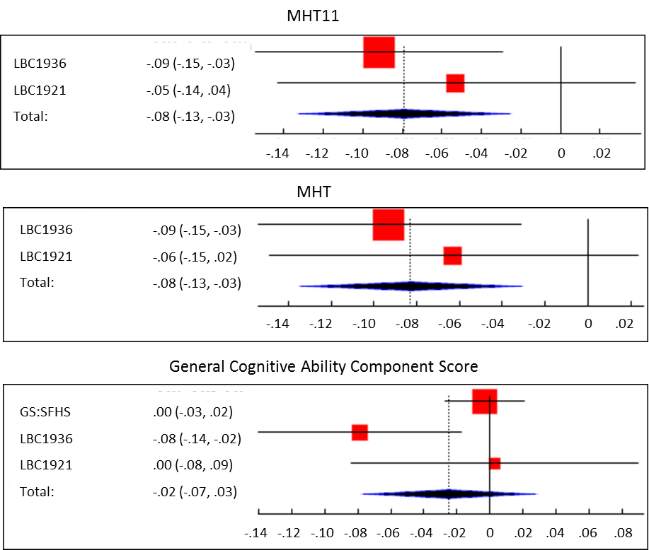

Supplementary Figure 1. Forest plots depicting the correlation between HV polygenic scores (p<1 inclusion threshold) for two general cognitive ability measures, MHT (measured at age 11 and at 70/80 years) and the general cognitive ability principal component.

