animal journal

Carbohydrate and amino acid metabolism and oxidative status in Holstein heifers precision-fed diets with different forage-to-concentrate ratios

J. Zhang1, H. T. Shi2, Y. C. Wang3, S. L. Li1, Z. J. Cao1, H. J. Yang1, and Y. J. Wang1 *

¹ State Key Laboratory of Animal Nutrition, Beijing Engineering Technology Research Center of Raw Milk Quality and Safety Control, College of Animal Science and Technology, China Agricultural University, Beijing 100193, China
² College of Life Science and Technology, Southwest Minzu University, Chengdu, Sichuan 610041, China
³ Key Laboratory of Animal Genetics, Breeding and Reproduction, Ministry of Agriculture and Rural Affairs, National Engineering Laboratory for Animal Breeding, College of Animal Science and Technology, China Agricultural University, Beijing 100193, China

∗ Corresponding author:
Yajing Wang, China Agricultural University, No.2 Yuanmingyuan West Road, Haidian District, Beijing 100193, China. E-mail: yajingwang@cau.edu.cn.

Short title: Forage:concentrate affects heifer metabolism
Supplementary Material S1
Materials and methods
Statistical analysis
The statistic codes used in R:
install.packages("lsmeans")
library("lsmeans")
setwd("c:/Users/desktop")
AN<-read.csv("metabolomic data.csv", head=T)
results<-rep(0,13)
for(i in 3:ncol(AN)){
lm <- lm(AN[,i] ~ 1 + Group, data=AN)
lsm<-lsmeans(lm, list(poly ~ Group, pairwise ~ Group))
lsmp<-lsm$`polynomial contrasts of contrast`
pvalue<-summary(lsmp)$p.value
mean<-lsm$`lsmeans of Group`
lsmean<-summary(mean)$lsmean
pdiff<-lsm$`pairwise differences of contrast`
pdif<-summary(pdiff)$p.value
result<-c(lsmean,pdif,pvalue)
results<-cbind(results,result)
}
results
write.table(results, file="p.txt", quote=FALSE, sep="\t")

Table S1. Basic information for the identified metabolites and significant metabolites between heifers fed diets with different forage-to-concentrate ratios. RT, retention time; VIP, variable importance projection; QC, quality control. The C20, C40, C60, and C80 diets contained 20%, 40%, 60%, and 80% of concentrate, respectively.

See ‘Table S1 basic information of metabolites and DEG-PEAK.xlsx’ file

Figure S1. High-resolution GC-TOF/MS total ion chromatograms (TIC) of plasma samples from different forage-to-concentrate ratio diets fed heifers. GC-TOF/MS TIC chromatograms of plasma samples for heifers fed 20% (A), 40% (B), 60% (C), and 80% (D) concentrate. GC-TOF/MS, gas chromatography time-of-ﬂight/mass spectrometry.

Figure S2. Total principal component analysis plot of the plasma samples from different forage-to-concentrate ratio diets fed heifers. The C20 diet contained 20% of concentrate, while the C40, C60 and C80 diets contained 40%, 60% and 80% concentrate, respectively. PC, principal component; QC, quality control.

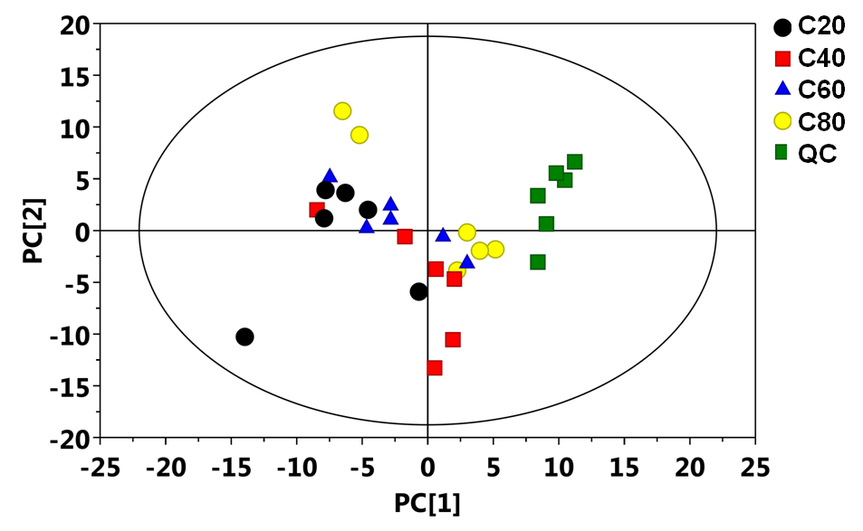

Figure S3. Corresponding validation plots derived from the GC-TOF/MS metabolite profiles of plasma samples between heifers fed diets with different forage-to-concentrate ratios. Corresponding validation plots (respectively) for: (A) the C80 group vs. C60 group; (B) the C80 group vs. C40 group; (C) the C80 group vs. C20 group; (D) the C60 group vs. C40 group; (E) the C60 group vs. C20 group; (F) the C40 group vs. C20 group. GC-TOF/MS, gas chromatography time-of-ﬂight/mass spectrometry; R2, the interpretability of this model; Q2, the predictability of this model. The C20 diet contained 20% of concentrate, while the C40, C60 and C80 diets contained 40%, 60%, and 80% concentrate, respectively.

